**JAVA PROGRAMS**

Program 1:

Aim : Write a program to find the GCD of two numbers

Source code :

import java.util.Scanner;

public class Gcd

{

public static void main(String args[])

{

int n1,n2;

Scanner sc=new Scanner(System.in);

System.out.println("Enter first number : ");

n1=sc.nextInt();

System.out.println("Enter second number : ");

n2=sc.nextInt();

while(n1!=n2)

{

if(n1>n2)

n1=n1-n2;

else

n2=n2-n1;

}

System.out.println("GCD of given number is : "+n2);

}

}

Output :

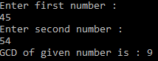

Program :2

Aim :Write a program to print first n prime numbers

Source code :

import java.util.Scanner;

class Primen

{

public static void main(String args[])

{

int n,i=1,p=2,count,flag;

Scanner sr=new Scanner(System.in);

System.out.println("Enter the limit : ");

n=sr.nextInt();

System.out.println("First "+n+" prime numbers are : ");

while(i<=n)

{

flag=1;

for(count=2;count<=p-1;count++)

{

if(p%count==0)

{

flag=0;

break;

}

}

if(flag==1)

{

System.out.println(p);

i++;

}

p++;

}

}

}

Output :

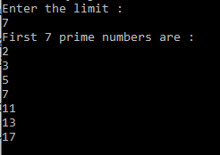

Program : 3

Aim : write a program to print first n Fibonacci numbers

Source code :

import java.util.*;

class Fibonacci

{

public static void main(String args[])

{

int n,a=0,b=0,c=1;

Scanner s=new Scanner(System.in);

System.out.println("Enter the limit : ");

n=s.nextInt();

System.out.println("First "+n+" fibonacci numbers are : ");

for(int i=1;i<=n;i++)

{

a=b;

b=c;

c=a+b;

System.out.println(a);

}

}

}

Output :

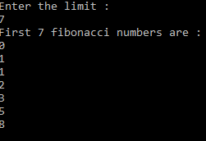

Program : 4

Aim : Write a java program to check whether a given number is perfect, abundant or deficient

Source code :

import java.util.Scanner;

class Checkno

{

public int num=0;

public void getnum()

{

Scanner sc=new Scanner(System.in);

System.out.println("Enter a number : ");

num=sc.nextInt();

}

void check()

{

int sum=0,dnum=0;

for(int i=1;i<=num;i++)

{

if(num%i==0)

sum+=i;

}

dnum=2*num;

if(sum<dnum)

System.out.println(num+" is a defficient number");

else if(sum==dnum)

System.out.println(num+" is a perfect number");

else

System.out.println(num+" is a abundant number");

}

public static void main(String args[])

{

Checkno ob=new Checkno();

ob.getnum();

ob.check();

}

}

Output :

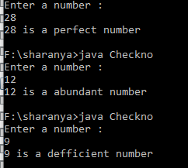

Program : 5

Aim : Write a java program to count the number of even numbers, odd numbers, positive numbers, negative numbers, and zeros in an array

Source code :

import java.util.*;

class Count

{

public static void main(String args[])

{

int x,i,s,a[]=new int[20];

int n=0,p=0,e=0,o=0,z=0;

Scanner sc=new Scanner(System.in);

System.out.println("enter the size of array :");

s=sc.nextInt();

System.out.println("Enter "+s+" numbers :");

for(i=0;i<s;i++)

{

a[i]=sc.nextInt();

}

for(i=0;i<s;i++)

{

if(a[i]<0)

n++;

else if(a[i]==0)

z++;

else

p++;

x=a[i]%2;

if(x==0)

e++;

else

o++;

}

System.out.println("Total even numbers in array = "+e);

System.out.println("Total odd numbers in array = "+o);

System.out.println("Total zeroes in array = "+z);

System.out.println("Total positive numbers in array = "+p);

System.out.println("Total negative numbers in array = "+n);

}

}

Output :

