**TABLES**

Login

**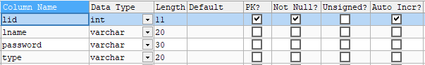**

Student

**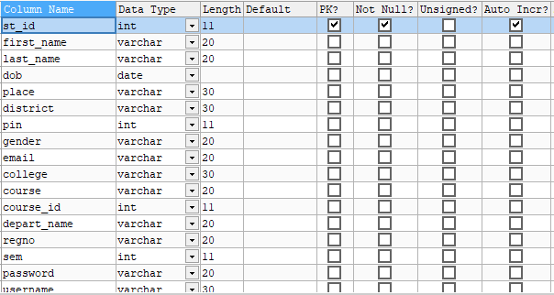**

Course

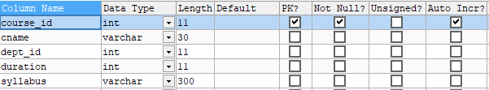

Department

**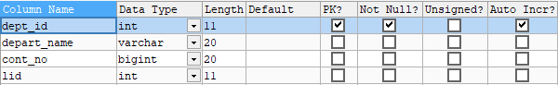**

College

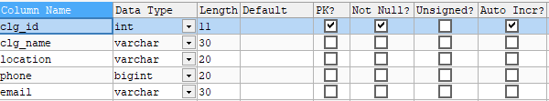

College\_course

C:\Users\hai\Desktop\sk\chat\college_course.PNG

Doubt

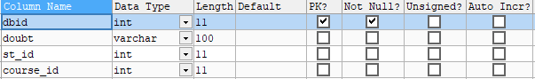

Response

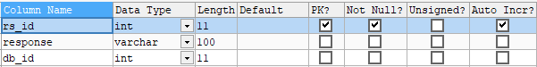

Course



Admission

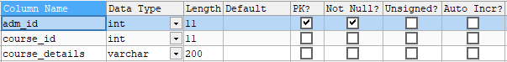

Notification

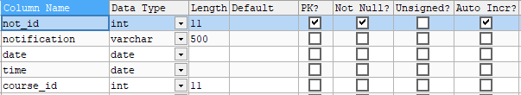

Fee

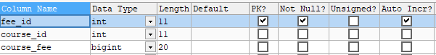

Exam

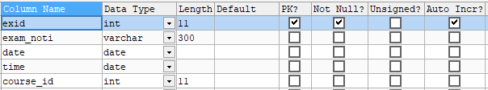

Result

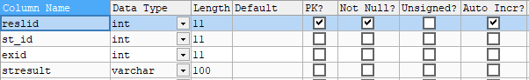

Dataset

