MIA without PCA on Dataset A
Hyperparameters used for all dataset cases:

MLPClassifier(
hidden_layer_sizes=(128, 64),
activation='relu',
solver='adam',
alpha=0.0001,
learning_rate_init=0.001,
max_iter=1000,
random_state=42,
)
TEST_SIZE = 0.3
RANDOM_STATE = 42
FEATURES = ["max_prob", "entropy", "loss", "correct"]
Stratify = y

Case 1:
Full dataset shape: (6000, 52)

0 – legitimate
1 – phishing

Label distribution:

1 3000
0 3000

Target pool shape: (3000, 52)
Shadow pool shape: (3000, 52)

Target Train (Members): (2100, 52)

0 1050
1 1050

Target Test (Non-members): (900, 52)

0 450
1 450

Shadow Train: (2100, 52)

0 1050
1 1050

Shadow Test: (900, 52)

0 450
1 450

Final attack dataset shape: (25200, 5)

Member distribution:

is_member
1 12600
0 12600

Train size: (17640, 4)
Test size: (7560, 4)

3000 Phishing + 3000 Legitimate
 | Accuracy | Precision | Recall | F1 Score
Target Model | 0.8367 | 0.8272 | 0.8512 | 0.8389
Attack Model | 0.5720 | 0.5448 | 0.8759 | 0.6718

Target Model:
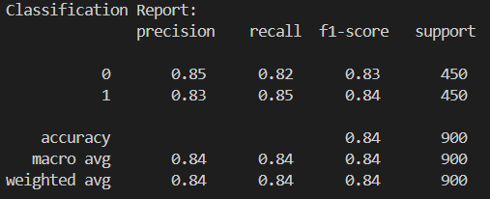
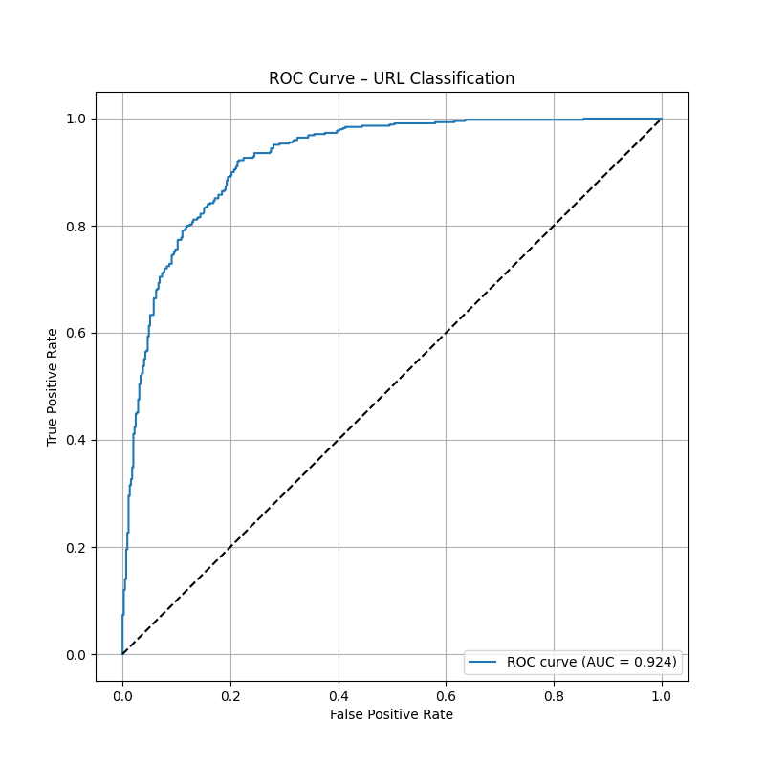
Attack Model:
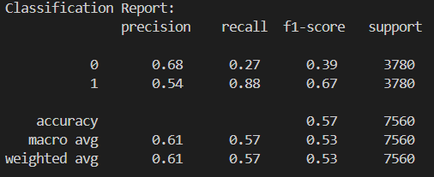
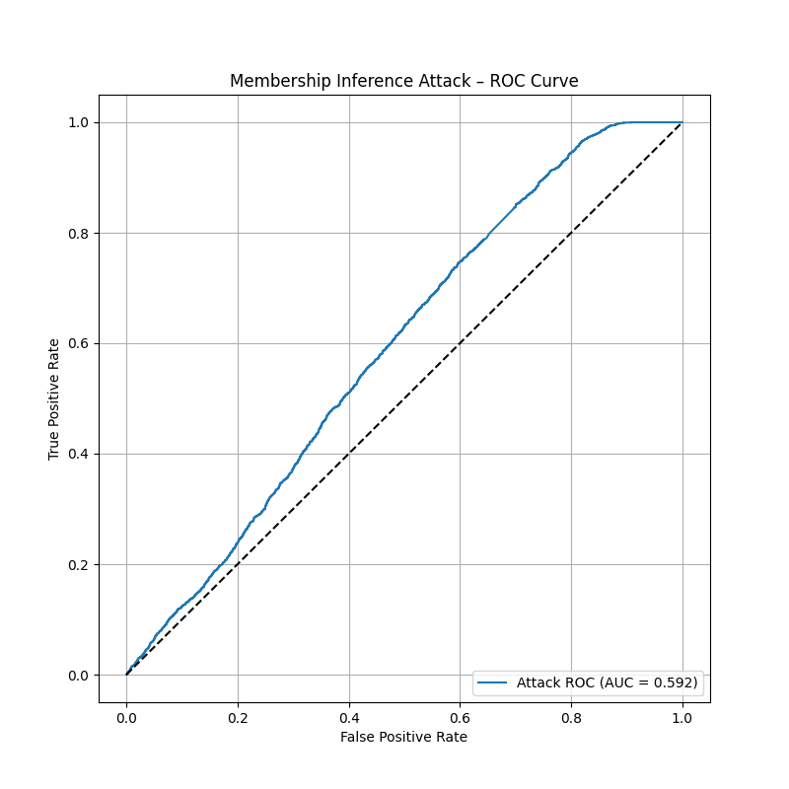

—----------------------------------------------------------------------------------------------------------------------------

Case 2:
Full dataset shape: (4000, 52)

Label distribution:

1 2000
0 2000

Target pool shape: (2000, 52)
Shadow pool shape: (2000, 52)

Target Train (Members): (1400, 52)
label
0 700
1 700

Target Test (Non-members): (600, 52)

0 300
1 300

Shadow Train: (1400, 52)

0 700
1 700

Shadow Test: (600, 52)

0 300
1 300

Final attack dataset shape: (16840, 5)

Member distribution:

is_member
0 8420
1 8420

2000 Phishing + 2000 Legitimate
 | Accuracy | Precision | Recall | F1 Score
Target Model | 0.79 | 0.7514 | 0.8667 | 0.8049
Attack Model | 0.5882 | 0.5509 | 0.9544 | 0.6986
Target Model:
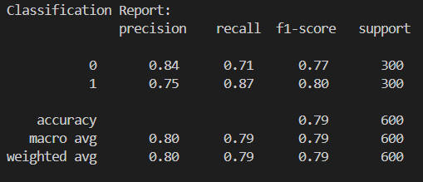
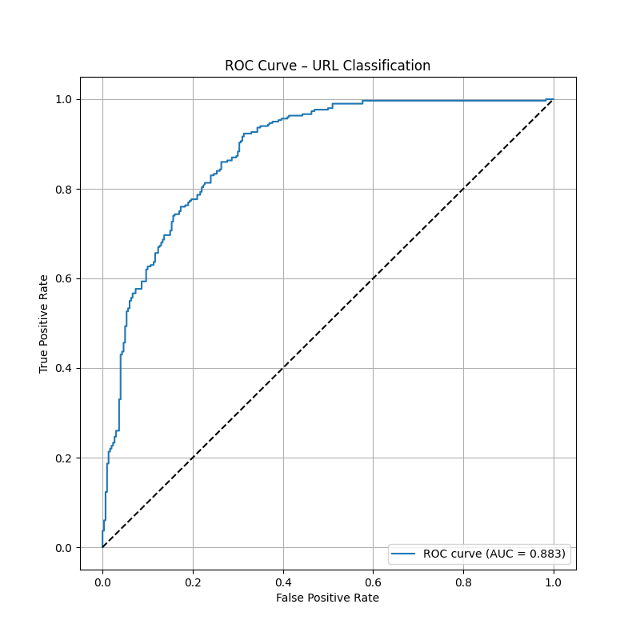
Attack Model:
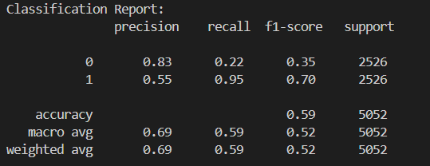

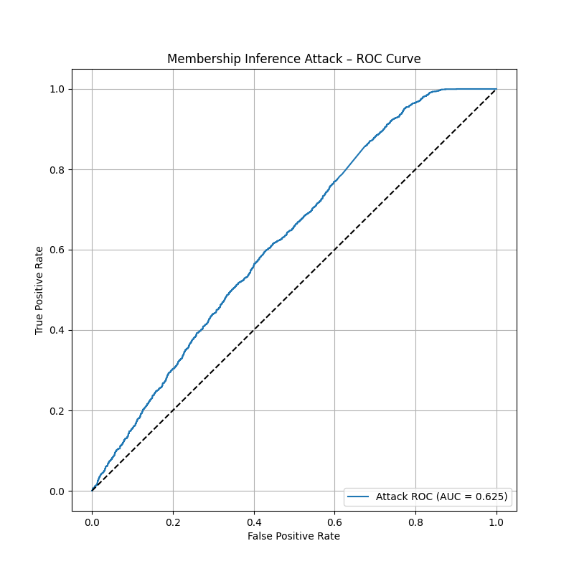
Case 3:

Full dataset shape: (3000, 52)

Label distribution:

0 1500
1 1500

Target pool shape: (1500, 52)
Shadow pool shape: (1500, 52)

Target Train (Members): (1050, 52)

1 525
0 525

Target Test (Non-members): (450, 52)

1 225
0 225

Shadow Train: (1050, 52)

1 525
0 525

Shadow Test: (450, 52)

1 225
0 225

Final attack dataset shape: (12600, 5)

Member distribution:
is_member
1 6300
0 6300

1500 Phishing + 1500 Legitimate
 | Accuracy | Precision | Recall | F1 Score
Target Model | 0.8 | 0.7947 | 0.8089 | 0.8017
Attack Model | 0.5870 | 0.5502 | 0.9529 | 0.6976
Target model:

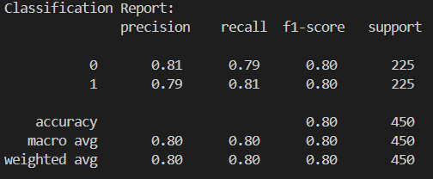
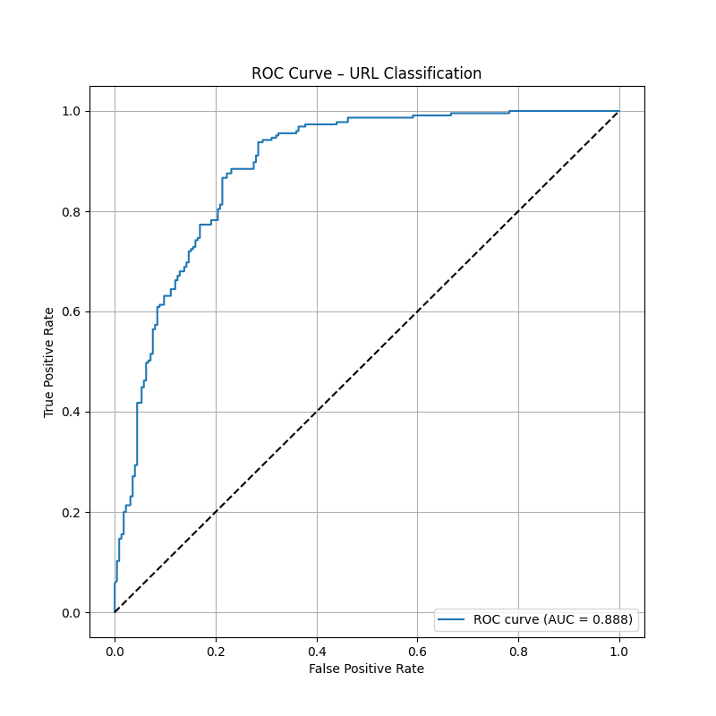

Attack Model:
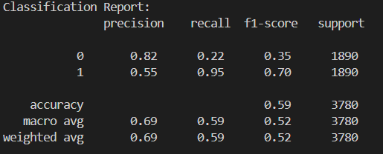

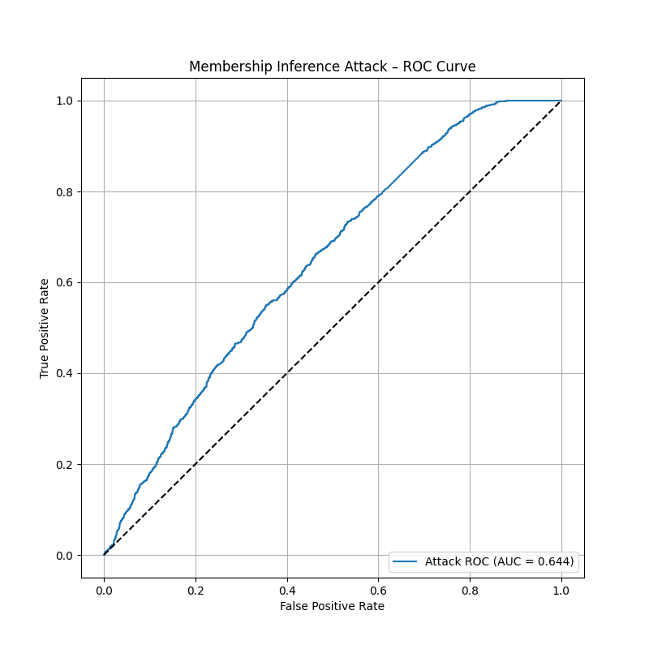

Case 4:
Full dataset shape: (2000, 52)

Label distribution:

0 1000
1 1000

Target pool shape: (1000, 52)
Shadow pool shape: (1000, 52)

Target Train (Members): (700, 52)

1 350
0 350

Target Test (Non-members): (300, 52)

1 150
0 150

Shadow Train: (700, 52)

1 350
0 350

Shadow Test: (300, 52)

1 150
0 150

Final attack dataset shape: (8440, 5)

Member distribution:
is_member
0 4220
1 4220

1000 Phishing + 1000 Legitimate
 | Accuracy | Precision | Recall | F1 Score
Target Model | 0.79 | 0.7806 | 0.8067 | 0.7934
Attack Model | 0.5663 | 0.5485 | 0.7504 | 0.6337

Target model:
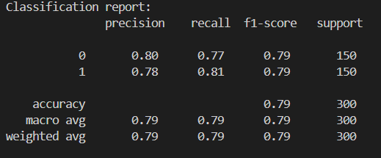
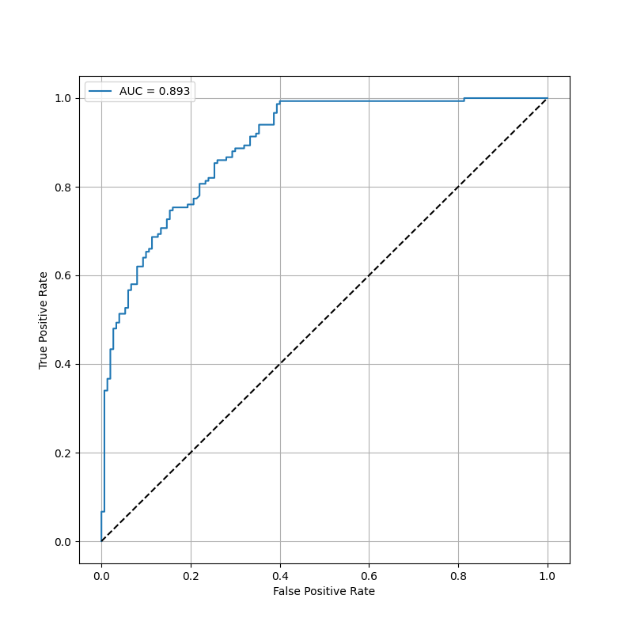
Attack model:
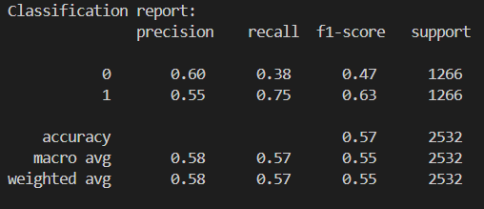
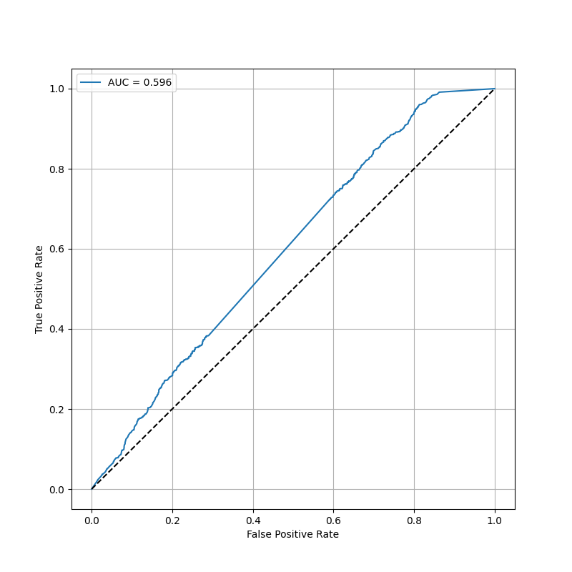

Dataset splitting for each model same as MLP.

RF without PCA
pipeline = Pipeline([
("imputer", SimpleImputer(strategy="mean")),
("rf", RandomForestClassifier(
n_estimators=300,
max_depth=None,
min_samples_split=2,
min_samples_leaf=1,
max_features="sqrt",
class_weight="balanced",
random_state=42,
n_jobs=-1
))
])

Case 1: 6000
Target model
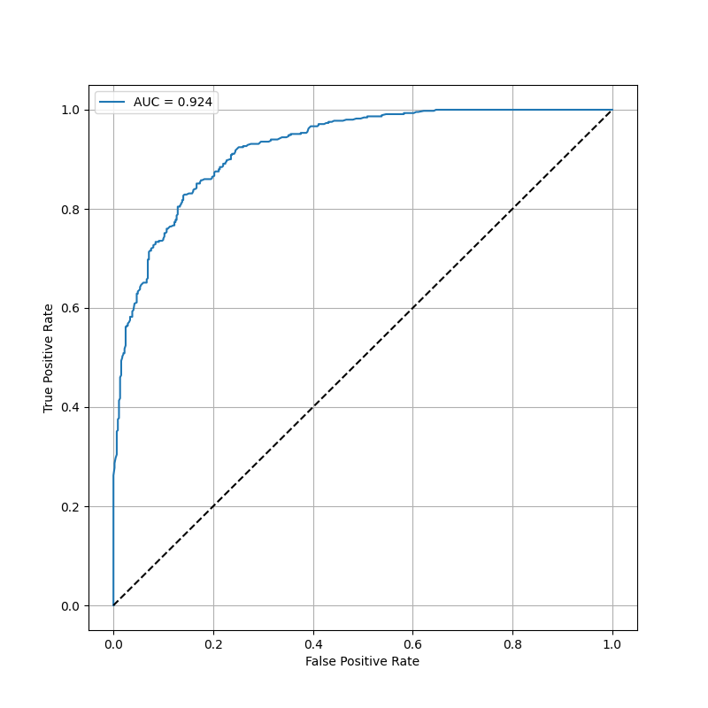
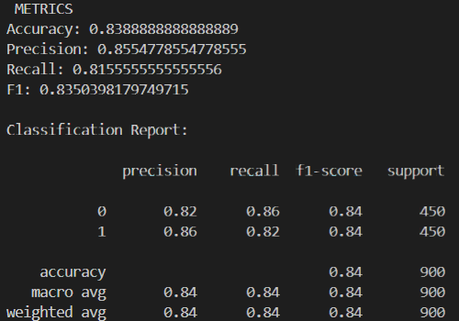

Attack model
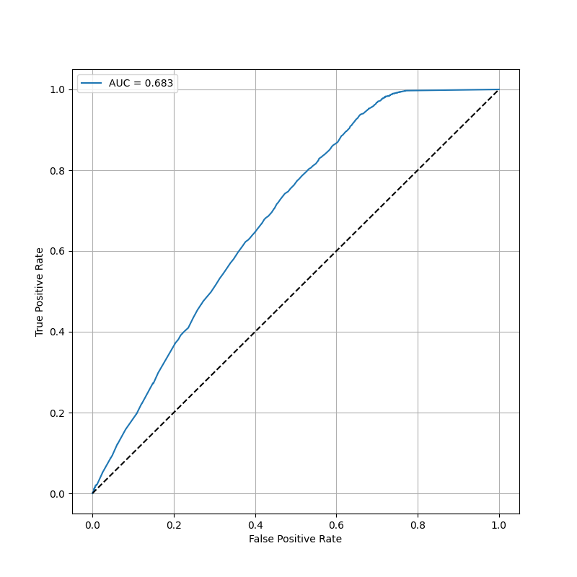
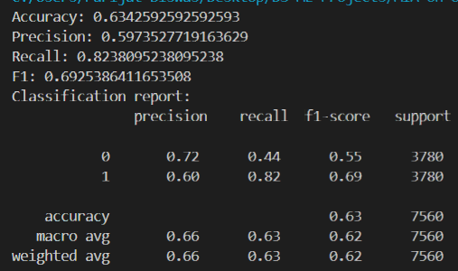

Case 2: 4000

Target model
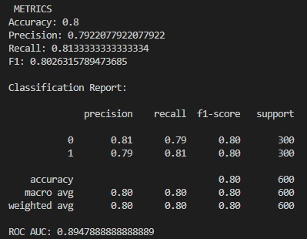
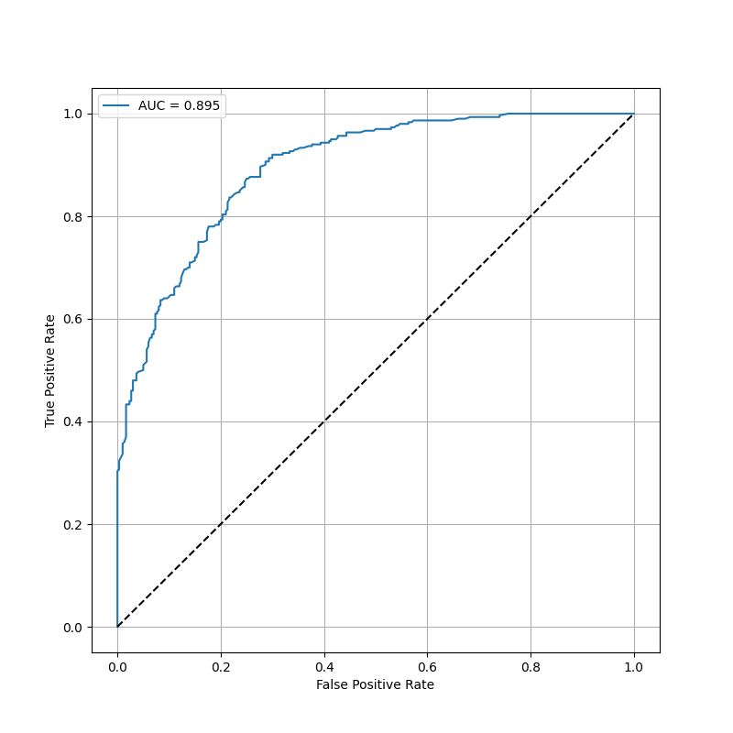
Attack model

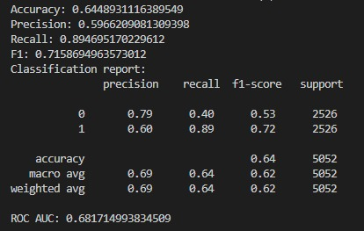
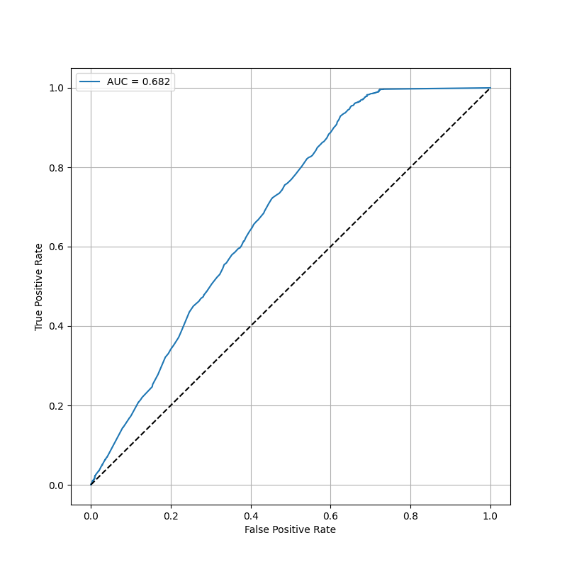

Case 3: 3000

Target model
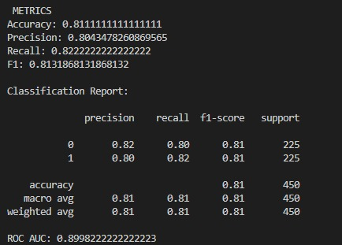
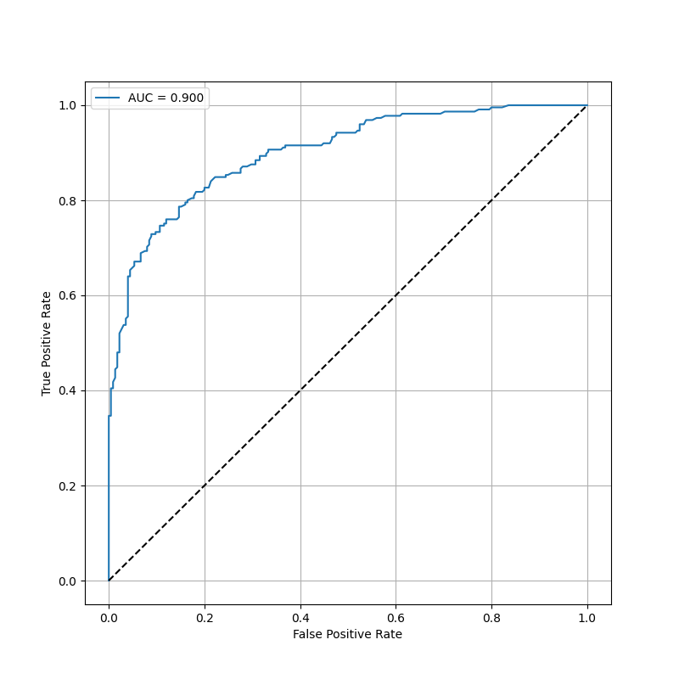
Attack model

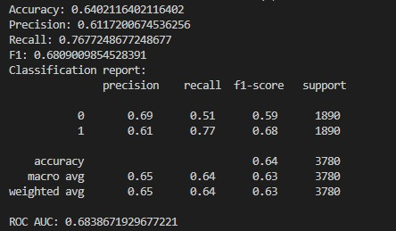
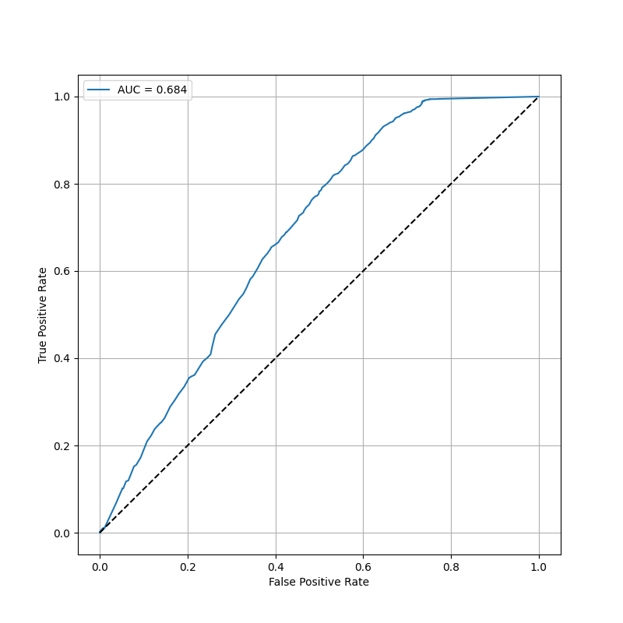

Case 4: 2000

Target model

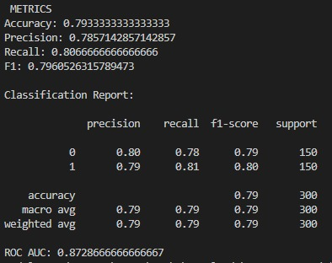
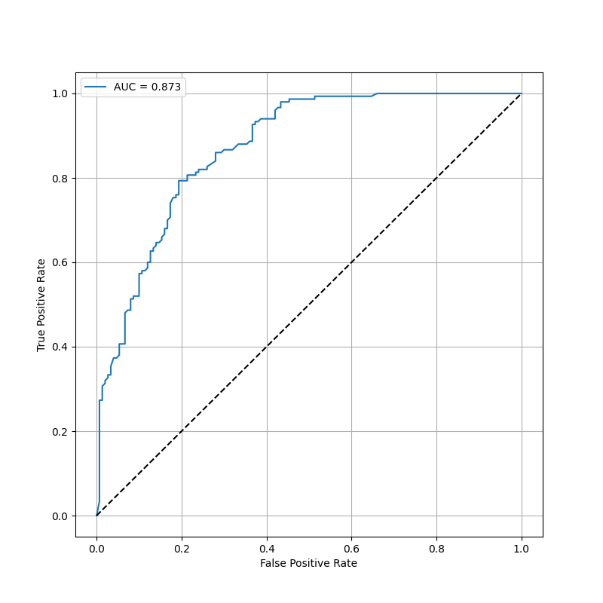
Attack model

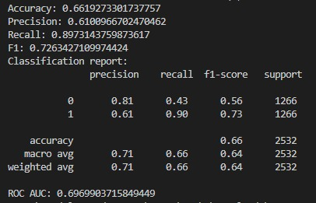
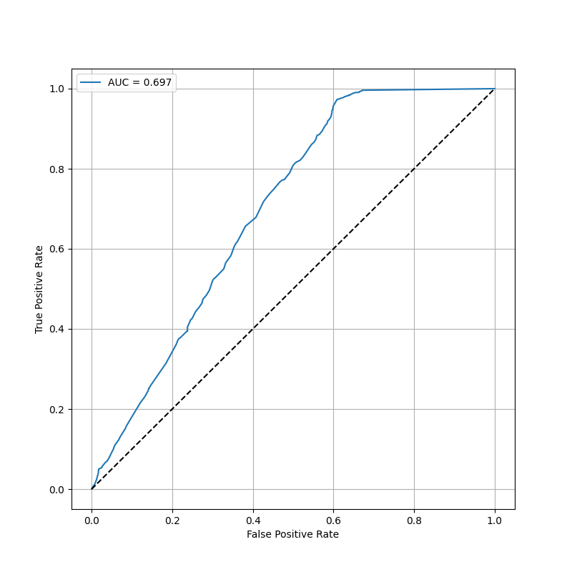

XGBoost without PCA

pipeline = Pipeline([ ("imputer", SimpleImputer(strategy="median")),
("scaler", StandardScaler()),
("clf", XGBClassifier
( n_estimators=500,
max_depth=6,
learning_rate=0.05,
subsample=0.8,
colsample_bytree=0.8,
objective="binary:logistic",
eval_metric="logloss",
random_state=42,
n_jobs=-1 )) ])

Case 1: 6000
Target model
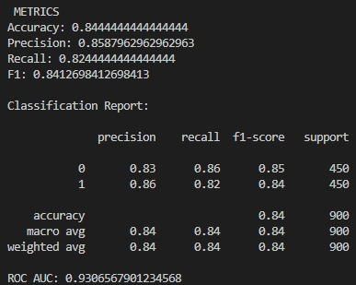
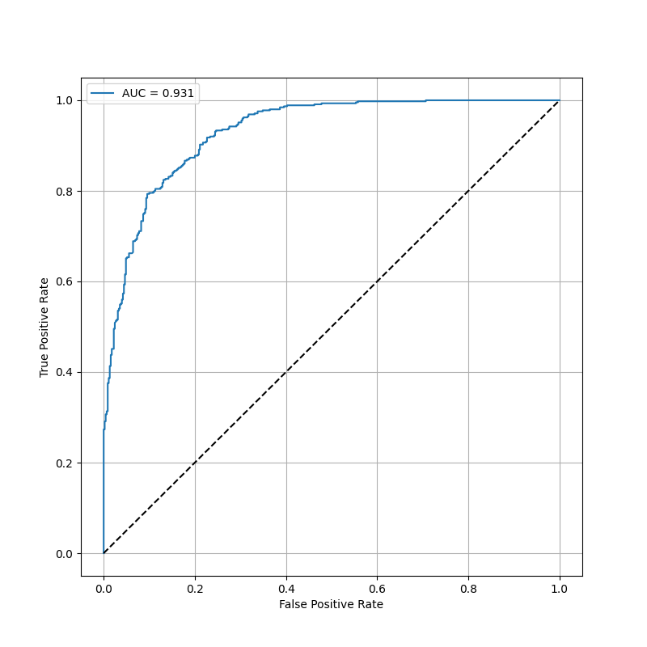
Attack model
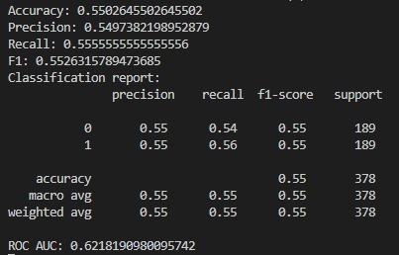
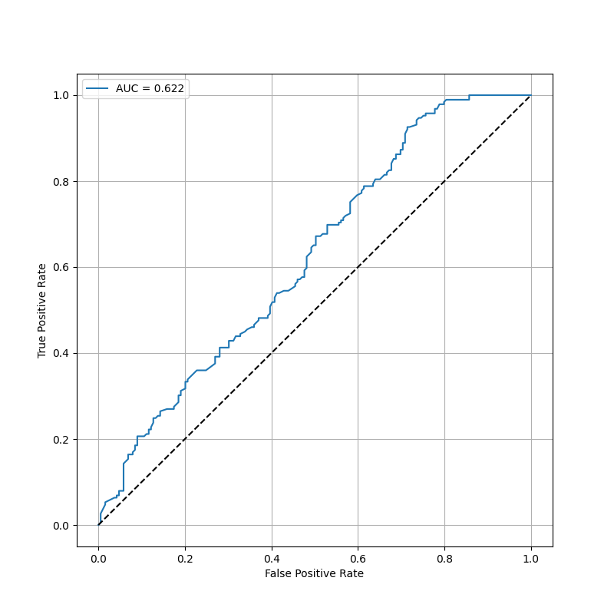
Case 2: 4000
Target model
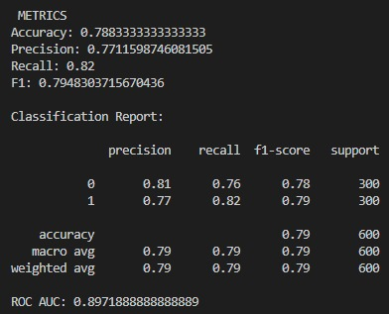
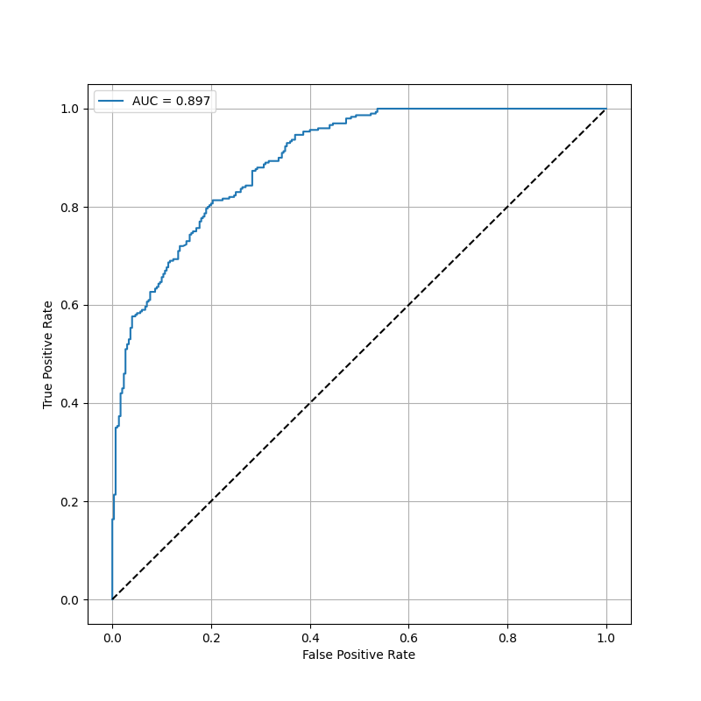
Attack model
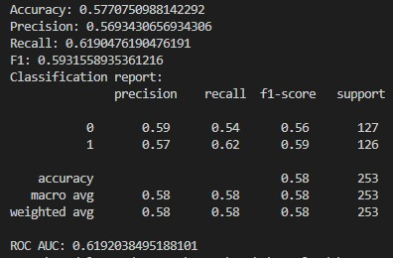
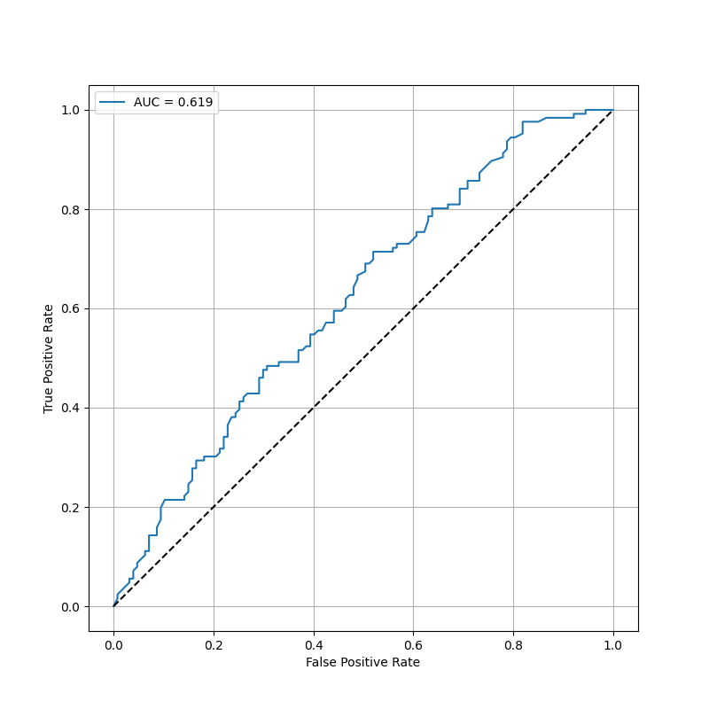
Case 3: 3000
Target model
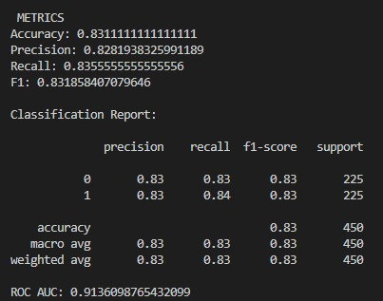
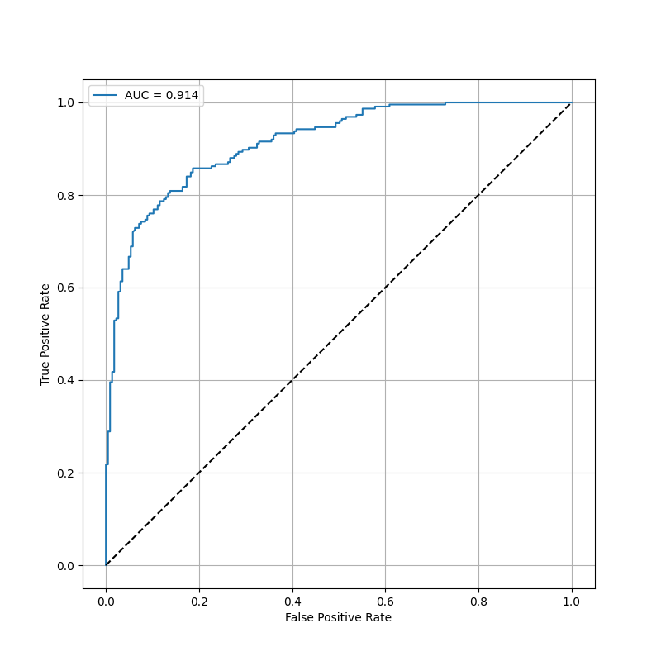
Attack model
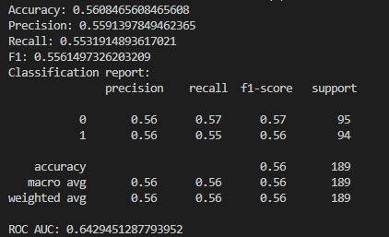
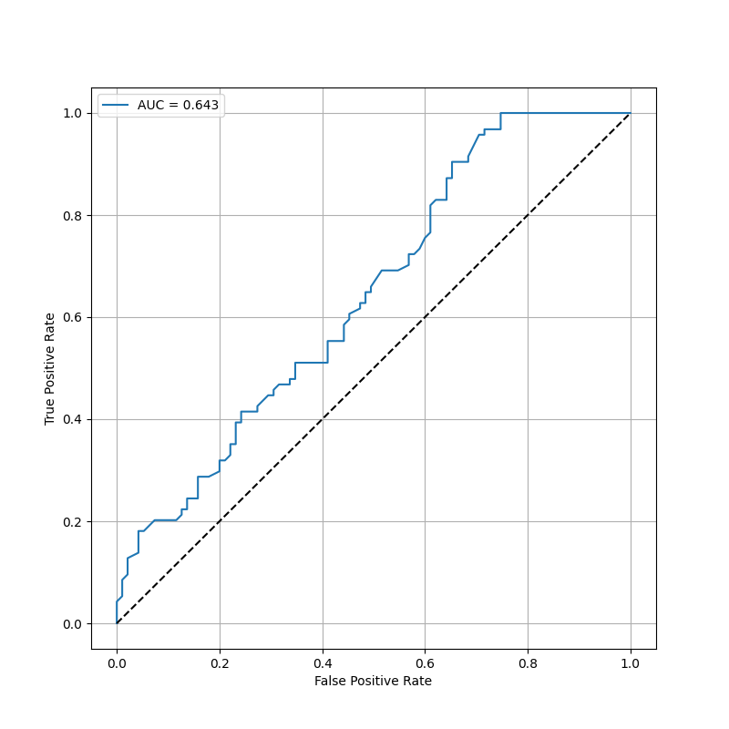
Case 4: 2000
Target model
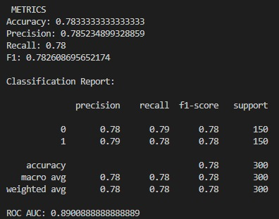
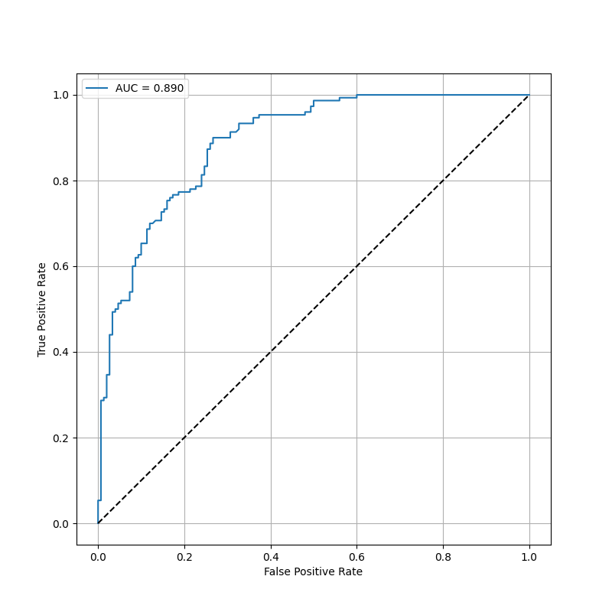
Attack model
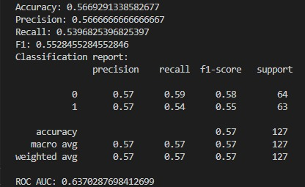
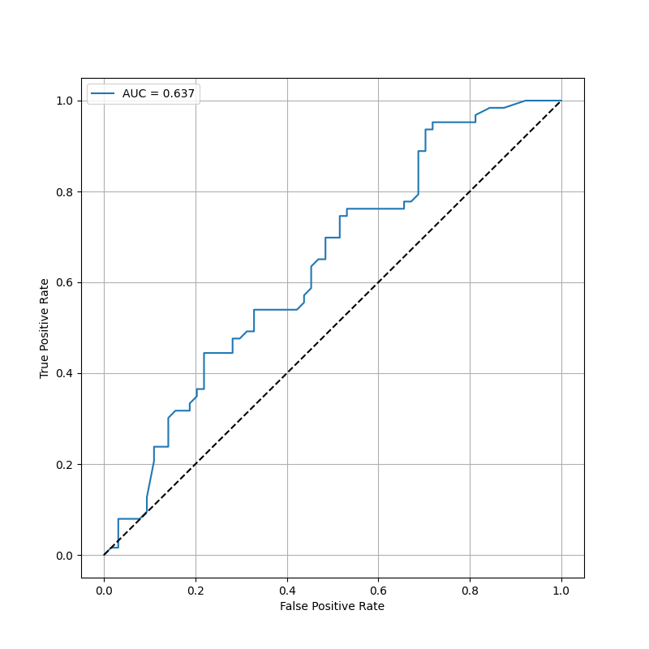

SVM without PCA
pipeline = Pipeline([
("imputer", SimpleImputer(strategy="median")),
("scaler", StandardScaler()),
("clf", SVC(
kernel="rbf",
C=1.0,
gamma="scale",
probability=True,
class_weight="balanced",
random_state=42
))
])

Case 1: 6000

Target model
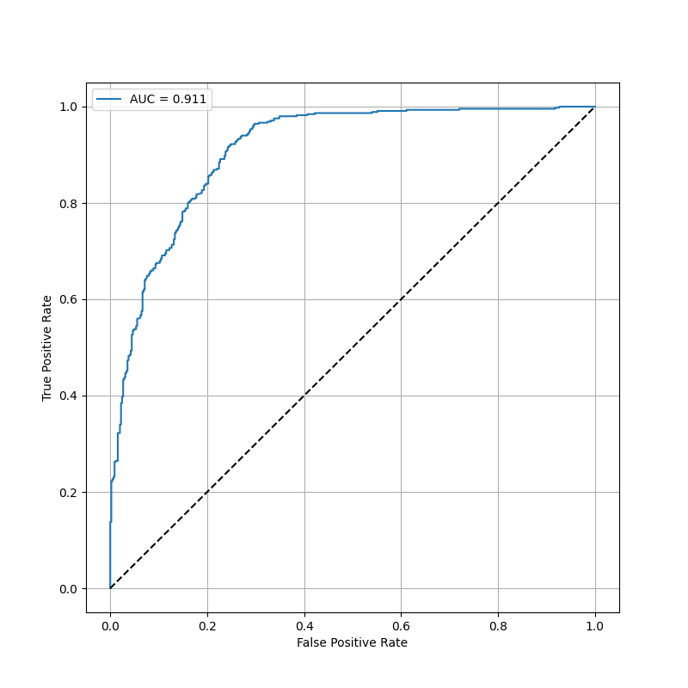
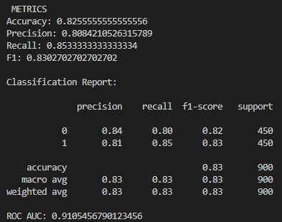

Attack model
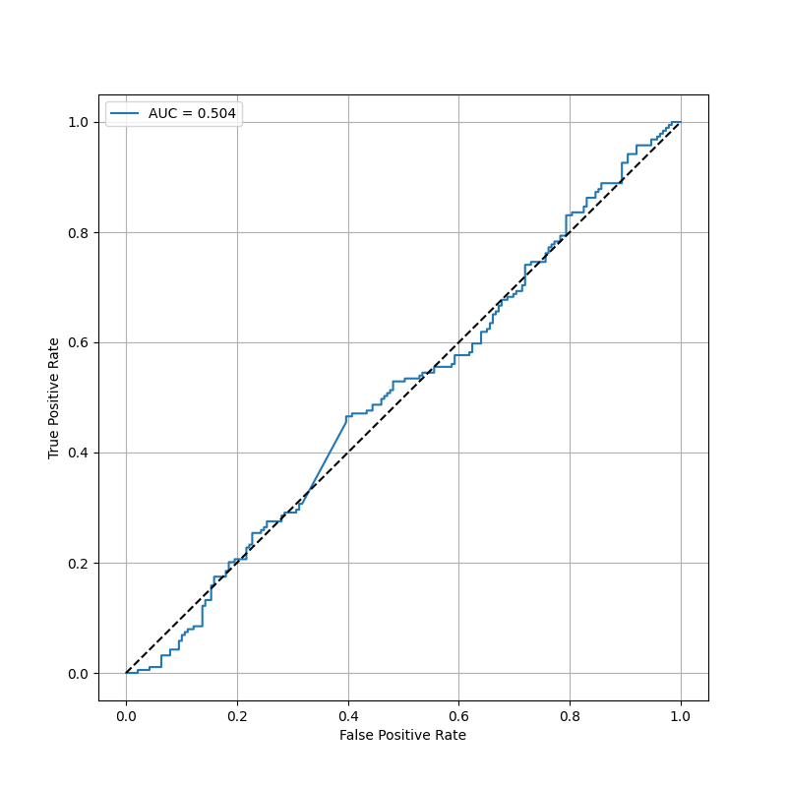
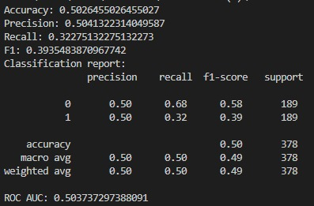
Case 2: 4000

Target model
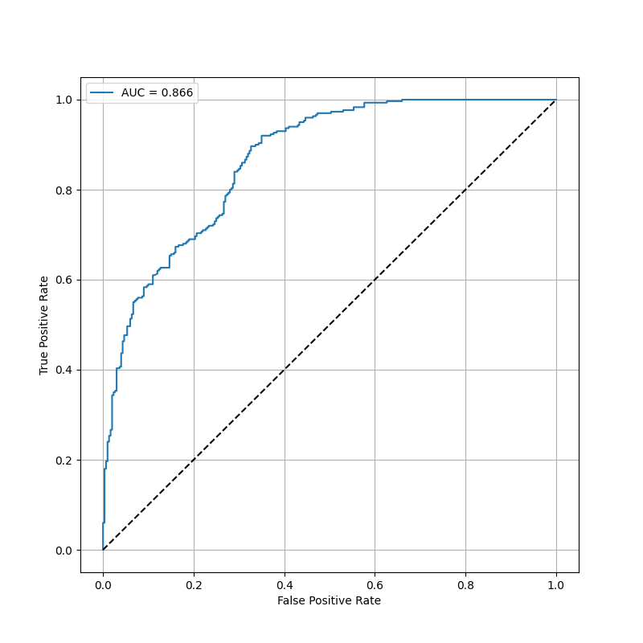
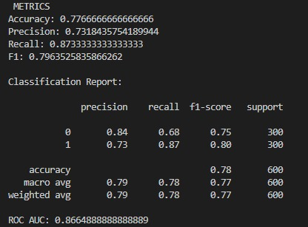
Attack model
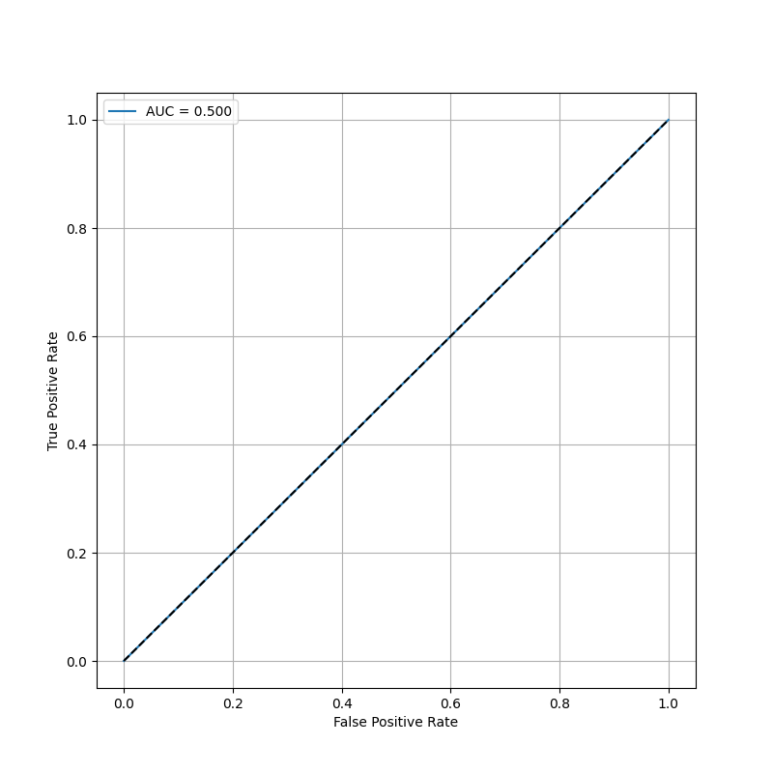
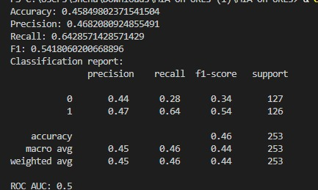
Case 3: 3000

Target model
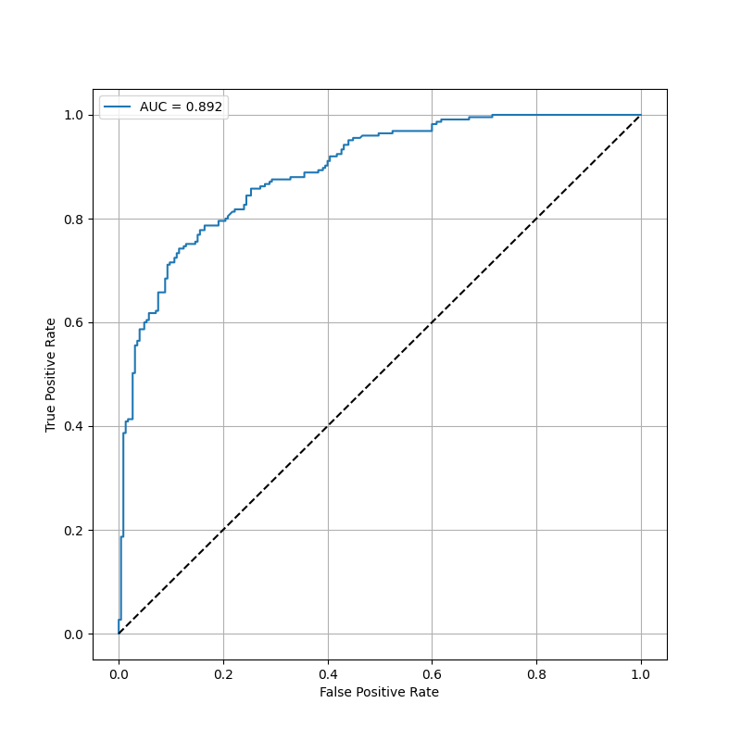
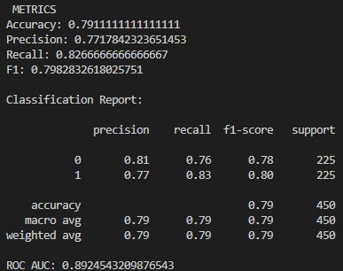
Attack model

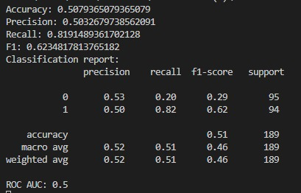
Case 4: 2000

Target model
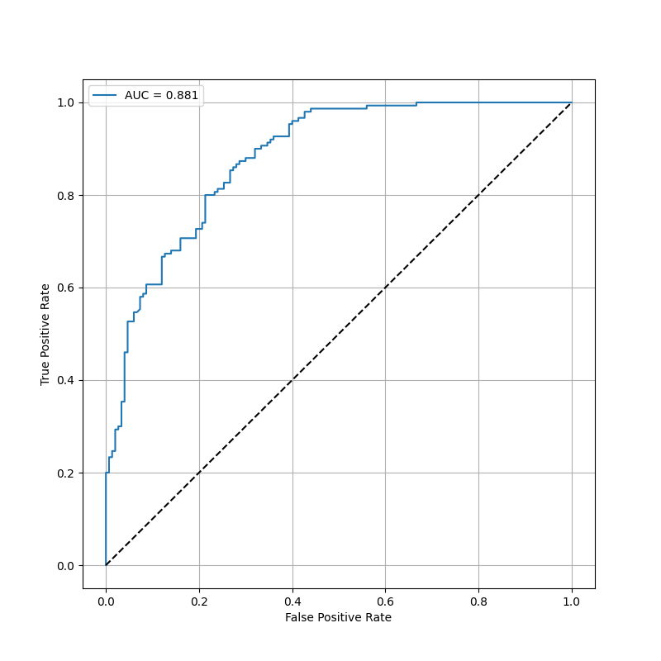
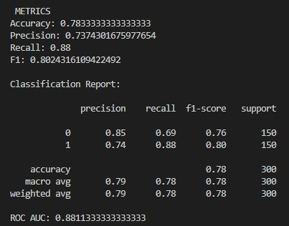
Attack model
