OVERALL WORKING OF THE APP
Anybody who wants to this app should first register with this app. The registration is free of cost. When a user registers through the Blood donation app to donate blood, details about his/her blood group, name, location and phone numbers are stored in the donor database. The messaging system used was Ozeki message server with connectivity set up to Access database. This server runs 24X7 so that request for blood sent at any time from any place can be met. Whenever a request for blood for is sent, the request is first received in the ozeki message server, which is connected to the Access database and the donors list is retrieved from this donor database. A program compares the blood group of the donors with the requested one. The matching blood donors are selected and a test message is sent to each of them to track their current location. This is essential because the user will be roaming. He need not be in the same location at that time as he had provided during registration. The most common ways of retrieving a person’s location is by using GPS. Since retrieving the user’s location using GPS drains battery, the location is retrieved in the form of latitude and longitude using the location manager API of the donors. All the donors who are near to the requestor's location are chosen. A message regarding the requirement of blood units are then conveyed to all the matching donors. A message containing all the matching donors phone numbers is also sent to the requestor so that he can contact them personally.
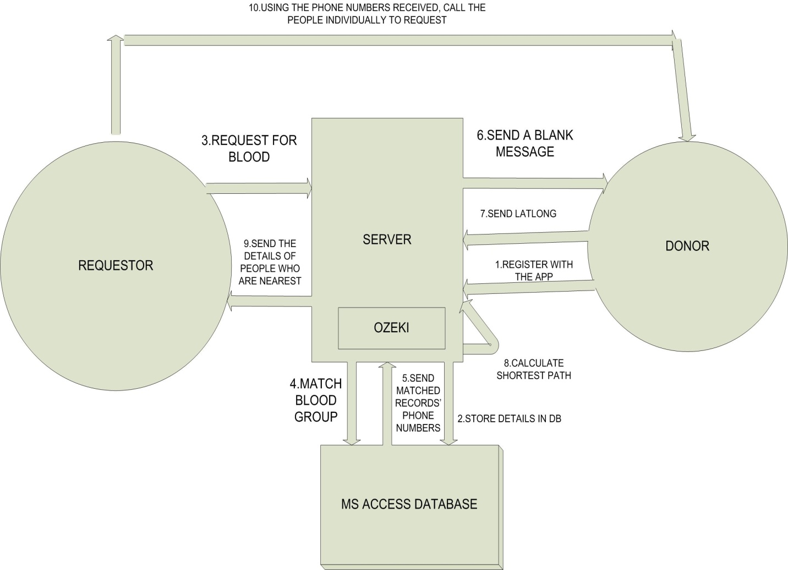
CLIENT UI PART :
The UI part of the android blood donation automator is designed as follows:
1. One part of the UI is for the blood donor .Through this UI, the donor can register for the application. This UI contains fields for name, blood group, age and location. The blood group alone is given in the form as a drop down list for the ease of entering. These details, once entered, are stored in the database of the server.

REGISTRATION FORM
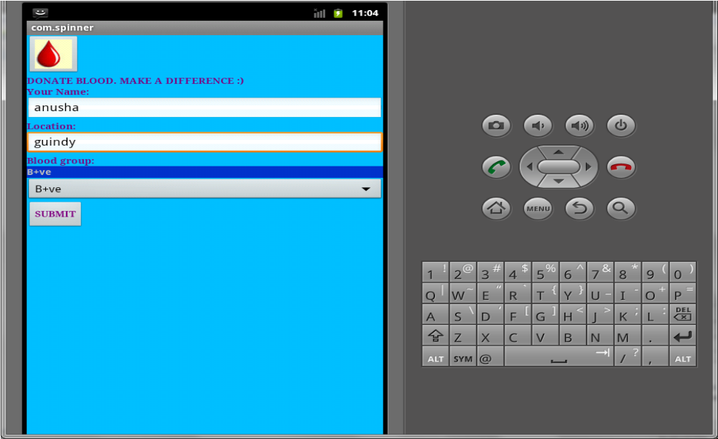

2. The other part of the UI is designed for the requestor of blood . This has fields like name of the hospital, blood group required and the no of units of blood required. For the ease and the urgency of the blood request, this page is made very simple. Once these details are received, these are also stored in the database

REQUISITION FORM
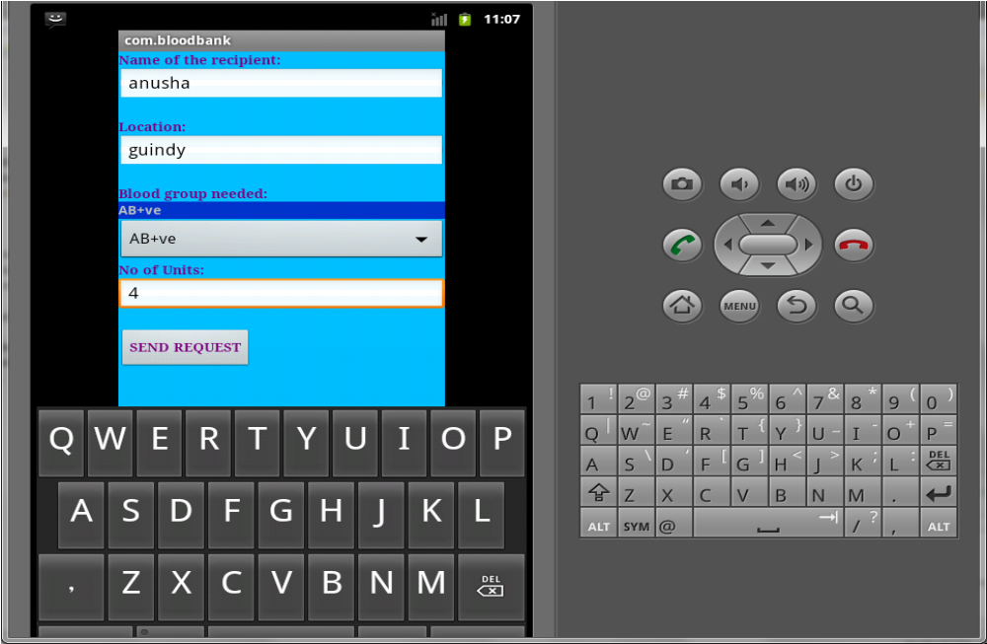

AutoLatLong(The module which returns the location of the user to the server):

SmsIntentReceiver.java:
It uses the BroadcastReceiver for the receipt of SMS messages. If the message is in a certain format (here, the message starts with “get location”), Android Intent (An intent is an abstract description of an operation to be performed. It can be used with startActivity to launch an Activity) triggers the launch of the app for obtaining the location i.e. it starts the activity

AutoLatLong.java:
To obtain the location, it makes use of the Location Manager (available in Android). The location manager selects the Network Provider** to obtain the location, through the mobile networks. The location is returned as the latitude and longitude of the current location. Then the location is sent to the server number as a SMS through the SmsManager.

**To enable this, go to location and security in settings and check “use wireless networks” option.

WORKING OF OZEKI MESSAGE SERVER PART
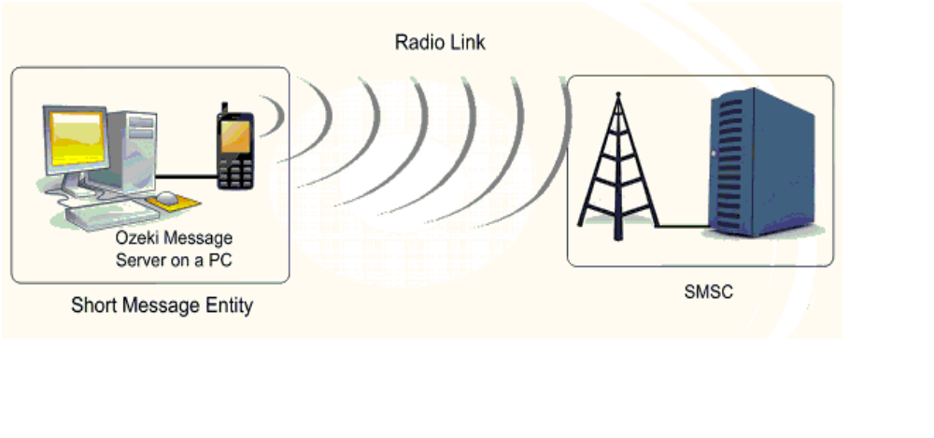
Ozeki message server is used for sending and receiving messages. It uses access for its database backend. This server will be running 24X7 in order to process the messages received by the server. The server mainly consists of two database tables
Ozeki messagein – to store the incoming messages
Ozeki messageout – to store the outgoing messages
There are actually three types of messages which will be stored in the ozeki messagein table.
- TYPE 1: Message sent by the donor for registering with the app
- TYPE 2: Message sent by a requestor requesting blood for a certain blood group
- TYPE 3: Test message sent back from the donors mobile which will have the latitude and longitude of the matching donors’ location
The messages are processed in the following way. The messages are differentiated by preceding each of the message by the word ‘reg’ if the message is of type 1, ‘req’ if the message is of type 2 and ‘loc’ if the message is of type 3.
There are other database tables for the working of the app namely
Donors table – to store the donors list
Whenever a user registers with this app, the message is first received in the ozeki messagein table.
Matching donors table – to store all the donors in the increasing order of the distance
Whenever a request for a blood is received, a program runs in the backend which will retrieve only those donors who matches with the blood group requested by the sender from the donors table. This is achieved by using a simple database query. Since the requestor has to be sent back a message containing the matching donors’ phone number, the phone number of the requestor will be stored in the ozeki messageout table with the status as ‘pending’.
It is of interest to note that the messages in the ozeki messageout table only when the status is set as ‘send’. Now among all the donors who match for the requested blood group, it is obvious that all of them will not be near to the location of the requestor. So our app tries to locate the donors who are nearer to the location of the requestor and sends them the blood request first. Upon failure in this step, say no response from the donor or message not sent only, the server sends message to all of the matching donors. The location of the all the matching donors is received by sending a test message. The reply to this message will be the location of each of the donor in the form of latitude and longitude. This message is now stored by preceding this message with ‘loc’ word and stored in the ozeki messagein table. In the same manner, the location of the requestor is also obtained. Now, among all the matching donors, the donors who are nearer to the requestor’s location is found out by calculating the distance between all of the matching donors and the requestor. A program again is run automatically by the app which calculates the distance between the donors and requestors and stores them in the matching donors table sorted in the increasing order of distance. For instance, assume 20 donors actually matched the requested blood group and the donors list is now stored in the matching donors table in the order of the distance. First, a message, say xxx blood group of xx units is required, is sent to the first, say 8-10 donors who are more closer to the requestor. Upon failure, the server automatically sends the same message to the next 8-10 donors and repeats the same process again and again.
In order to send a message to the matching donors, the corresponding row from the matching donors table is placed in the ozeki messageout table with the status of the message as ‘send’. In a similar manner, a message is sent to all the matching donors. Similarly, the status in the requestor’s row in the ozeki messageout table is also set to ‘send’ so that the requestor can also contact the donors personally. Once a message is sent from the ozeki messageout table, the corresponding row is deleted from the table in order to avoid repeated delivery of messages to the same person again and again. Once a particular request is processed by the server, the entries in the matching donors table are deleted to make the server ready to process the remaining request. However, the donors table is a static table and is not modified at all.

