Multi-Asset Machine Learning Trading System
Final Experimental Report

1. Executive Summary
This project develops and evaluates a multi-asset machine-learning trading pipeline using OHLCV data. The experiment uses asset-wise forward-return targets, engineered technical features, multiple tree-based regression models, an ensemble predictor, and date-based walk-forward validation with a five-period purge. The final experiment contains 14 assets, 17 engineered features, 1,175 dates after feature construction and cleaning, and five non-overlapping evaluation folds.
The experiment is an out-of-sample forecasting and portfolio-ranking study rather than a classification problem. Therefore, conventional classification accuracy is not the primary metric. IC and RankIC measure the relationship between model predictions and subsequent returns, while portfolio return, Sharpe ratio, win rate, and drawdown evaluate the trading use of those predictions.

2. Dataset and Preprocessing
- Raw dataset: 16,800 rows and 8 columns.
- Assets: 14.
- Date range after cleaning: 2016-02-01 to 2020-07-31.
- Rows after cleaning: 15,770.
- Rows removed during cleaning: 1,030.
- Forward target: asset-wise 5-period forward return.

3. Feature Engineering
The final feature set contains 17 engineered predictors:
momentum_1, momentum_2, momentum_5, momentum_10, momentum_20, ma_ratio_5, ma_ratio_10, ma_ratio_20, volatility_5, volatility_20, volume_ratio, hl_range, oc_change, high_close_ratio, low_close_ratio, volume_change_1, range_ratio

4. Model and Validation Design
Three tree-based regression models were trained independently: ExtraTrees, Random Forest, and Gradient Boosting. Their predictions were also combined into an ensemble. The evaluation uses expanding-window, date-based walk-forward validation with 470 initial training dates, 140 requested test-window dates, a 5-period purge, and exactly five folds. Evaluation dates do not overlap across folds.
The experiment explicitly reports zero duplicate prediction rows and zero overlapping evaluation dates, providing an internal consistency check for the stored out-of-sample results.

5. Model Performance
Model | Mean IC | Mean RankIC | LS Cumulative Return | LS Sharpe
Ensemble | -0.0968 | 0.0768 | 19.83% | 0.861
ExtraTrees | -0.0394 | 0.0749 | 23.39% | 1.416
GradientBoosting | -0.1259 | 0.0329 | 5.16% | -0.101
RandomForest | -0.0640 | 0.0787 | 13.02% | 0.724
Across the five folds, RankIC is positive on average for all four model configurations, while mean IC is negative. This distinction is important: RankIC evaluates whether the model preserves the ordering of assets by future return, whereas IC uses the signed numerical relationship. The two metrics therefore provide complementary information.
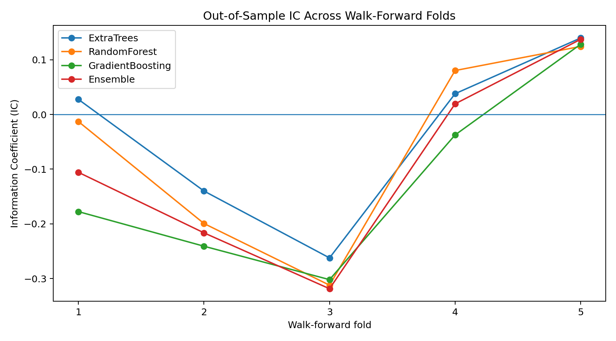
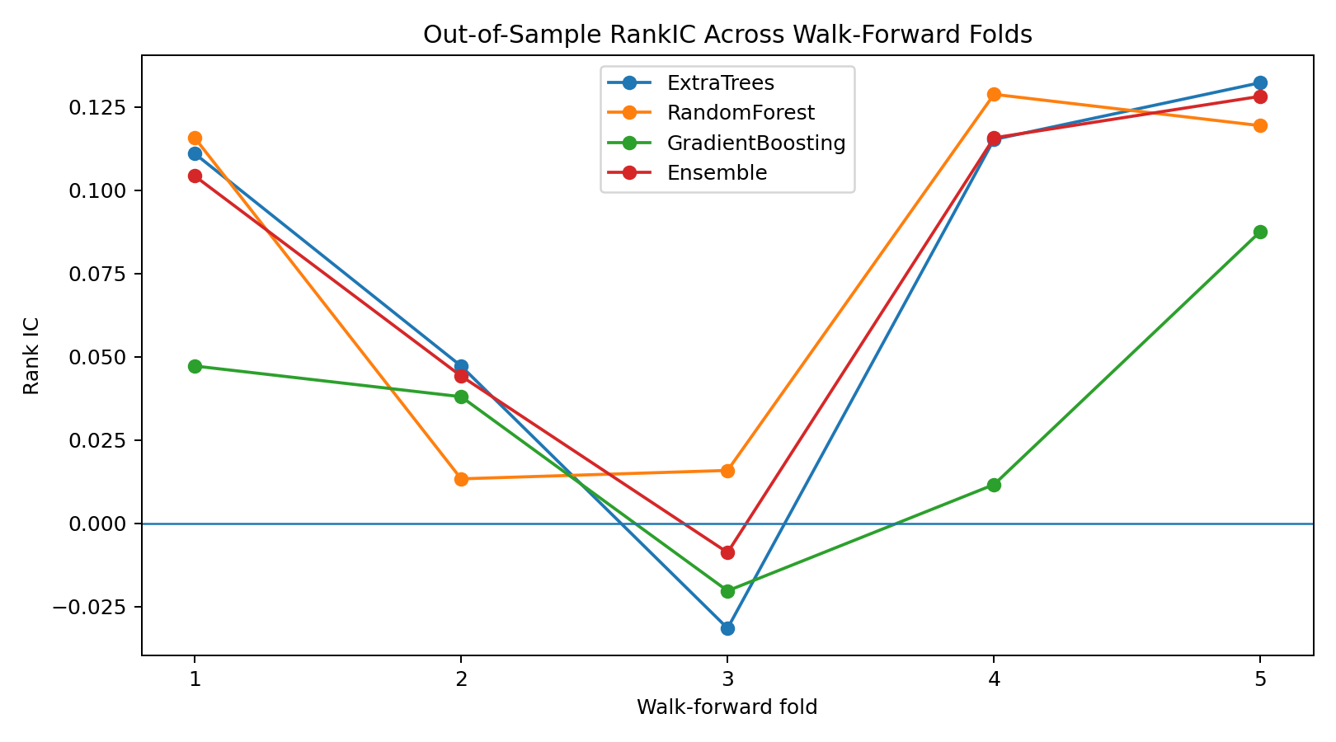

6. Portfolio Evaluation
The supplied experiment evaluates long, short, and long-short portfolios at 10%, 20%, and 30% selection widths. For a compact headline comparison, the table below uses the 10% long-short configuration reported in the experiment.
Model | Average Return | Cumulative Return | Sharpe | Max Drawdown
Ensemble | 0.537% | 19.83% | 0.861 | -11.26%
ExtraTrees | 0.659% | 23.39% | 1.416 | -10.91%
GradientBoosting | 0.141% | 5.16% | -0.101 | -14.82%
RandomForest | 0.396% | 13.02% | 0.724 | -10.99%
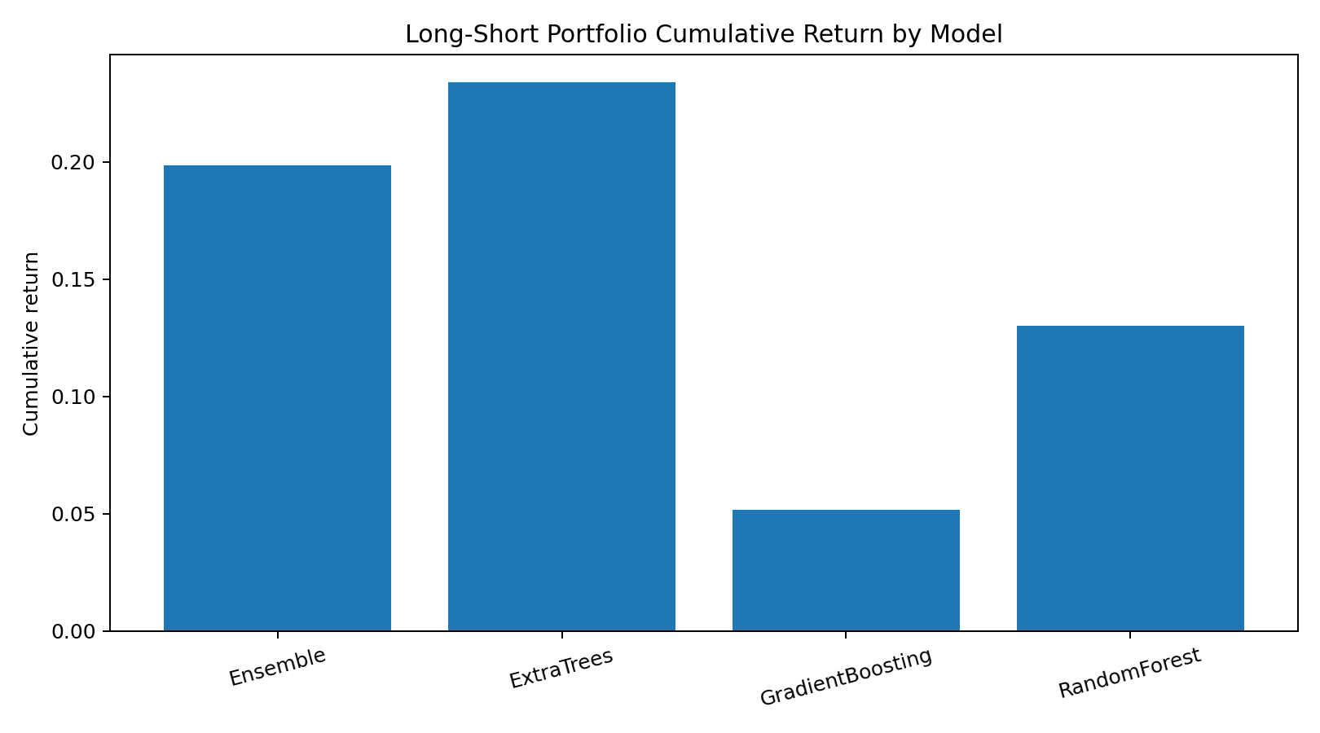

7. Fold Stability
The signal is not stationary across all historical periods. For example, the ensemble IC moves from positive in Fold 1 to negative in Folds 2 and 3 and back to positive in Folds 4 and 5. This is a material limitation and should be reported rather than hidden. The positive RankIC averages and portfolio results indicate useful ranking information in the tested sample, but the fold variation shows that performance is regime-dependent.

8. Important Interpretation
There is no single classification-style 'accuracy percentage' for this experiment. Reporting a statement such as 'the model is 90% accurate' would be inappropriate for the regression target used here. The correct headline metrics are out-of-sample IC/RankIC and the portfolio metrics generated from the predictions.
The current experiment should therefore be described as a walk-forward machine-learning trading experiment with mixed predictive stability, rather than as a universally accurate price predictor.

9. Limitations and Next Improvements
- The five-fold sample shows substantial variation in IC across time.
- Mean IC is negative even though mean RankIC is positive.
- The reported backtest does not by itself establish live-trading performance.
- Transaction costs, slippage, market impact, and execution constraints should be incorporated in a future version.
- Further work can test alternative prediction horizons, cross-sectional normalization, additional features, and hyperparameter tuning while preserving the same walk-forward protocol.

10. Conclusion
The project successfully implements an end-to-end multi-asset machine-learning trading workflow with asset-wise target construction, technical feature engineering, multiple regression models, ensemble predictions, purged walk-forward validation, and portfolio evaluation. The experiment demonstrates that the models contain measurable ranking information in the tested data, while also revealing substantial time variation in predictive performance. The resulting framework is suitable as a research prototype and provides a clear foundation for further robustness testing.

Appendix: Reproducibility Checks
- Required folds: 5; observed prediction/result/portfolio folds: 1–5.
- Duplicate prediction rows: 0.
- Overlapping evaluation dates: 0.
- All reported headline figures are taken from the experiment output supplied for this project.

