MESSAGE BROKER USING KAFKA:

1 . Booking a ticket :
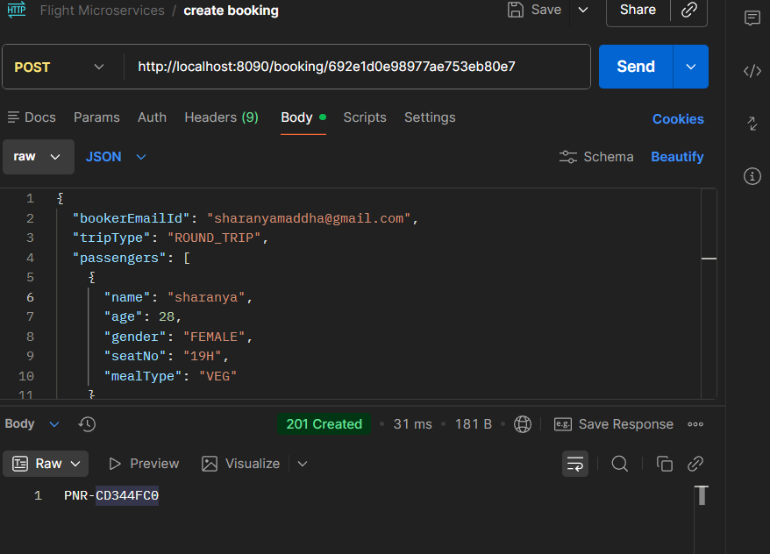

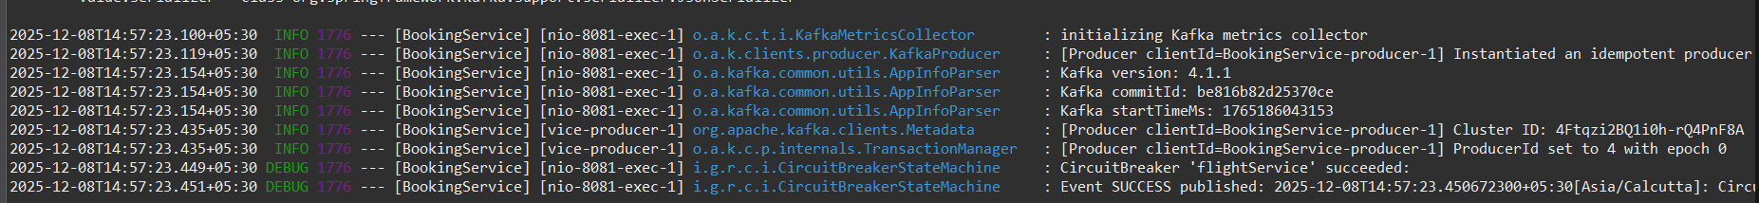

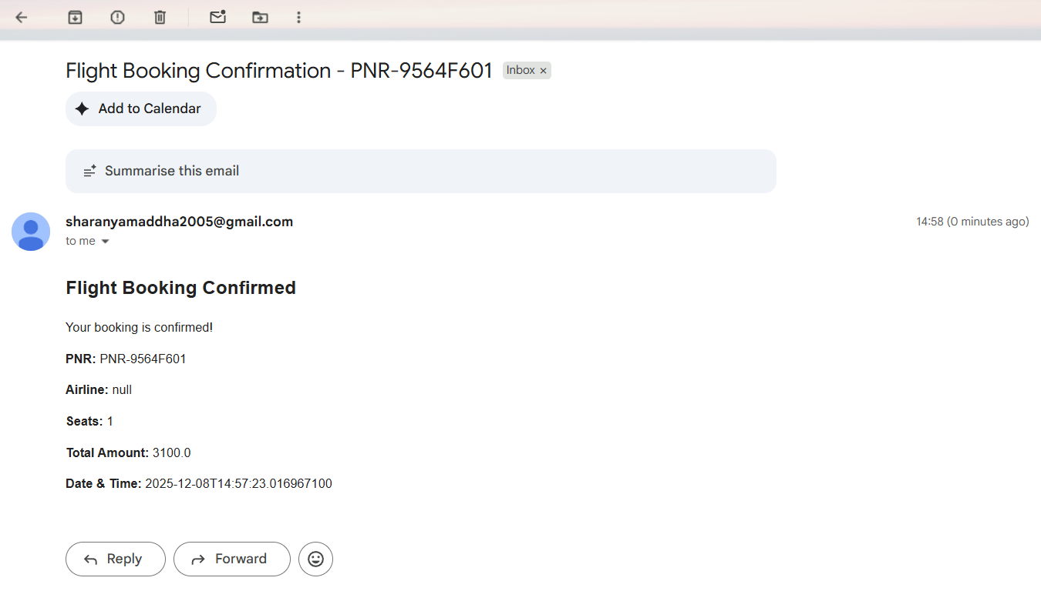
Confirmation mail :

2 . Booking Cancellation :
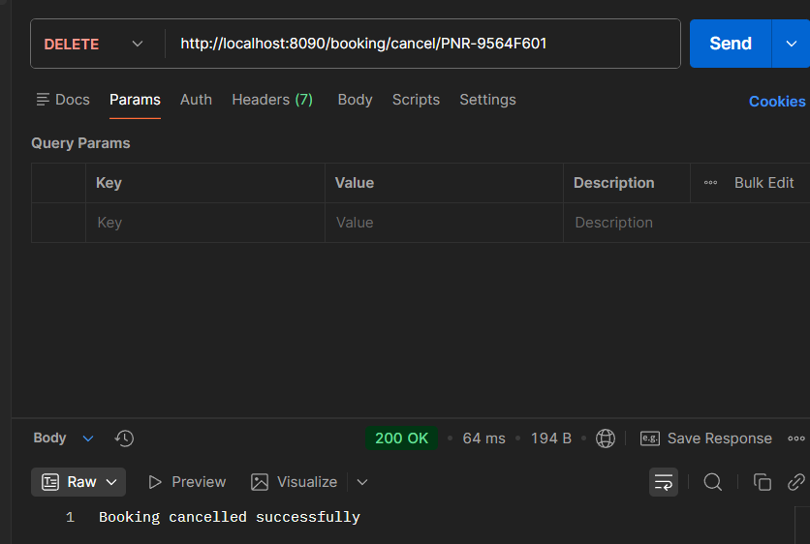

Cancellation mail :
