HOME PAGE :
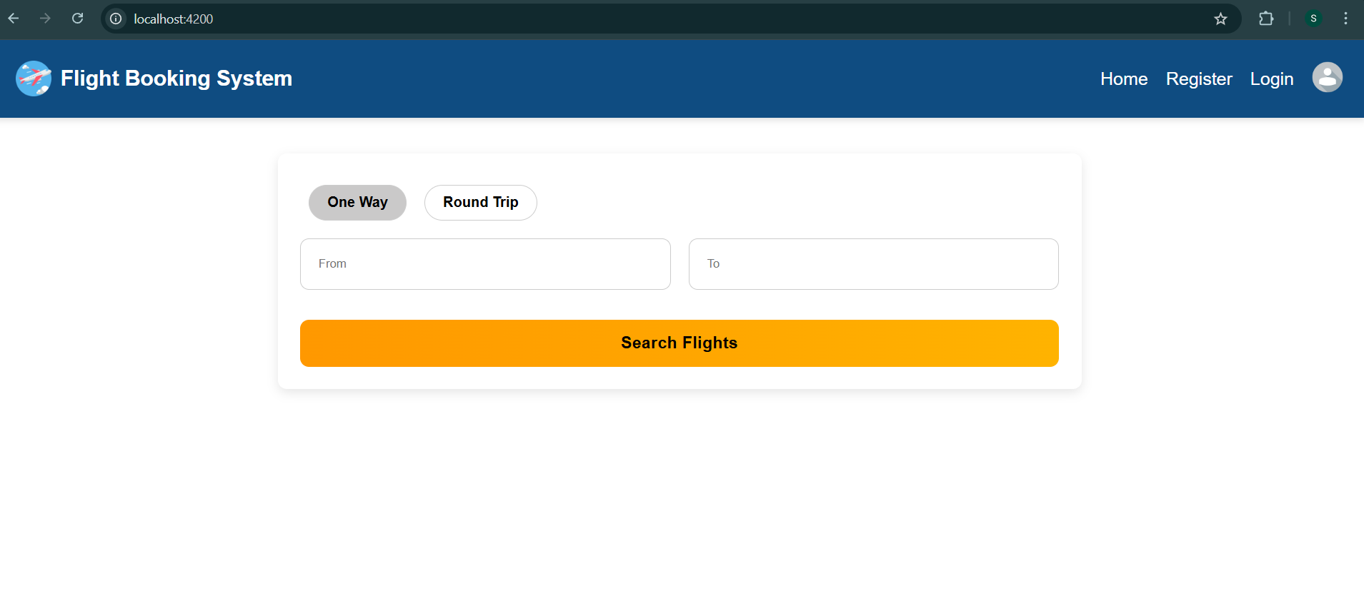REGISTRATION PAGE :
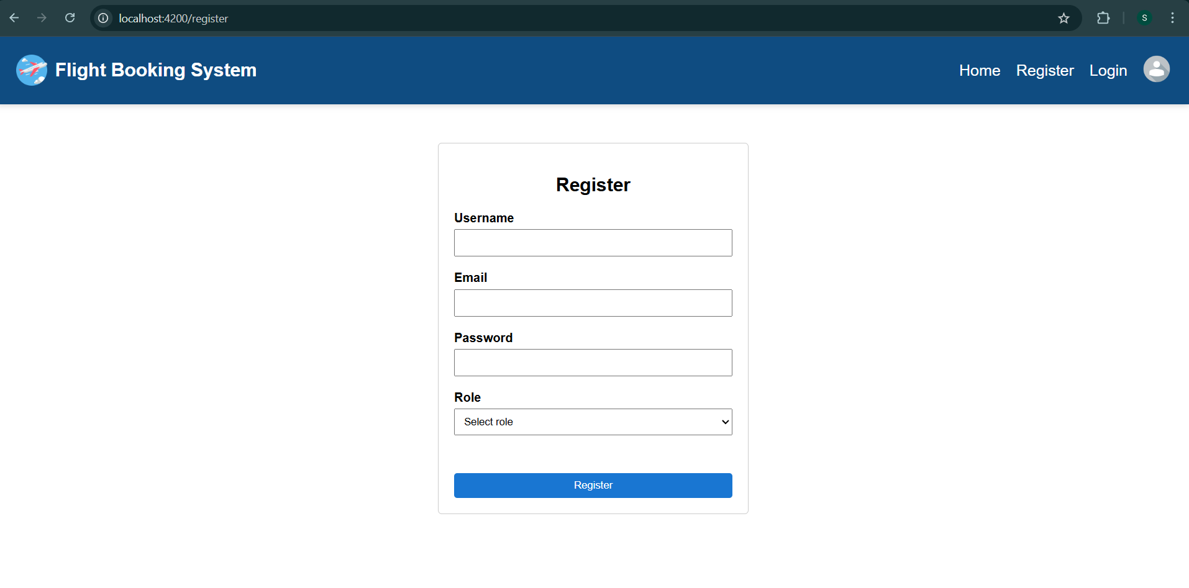
LOGIN PAGE :
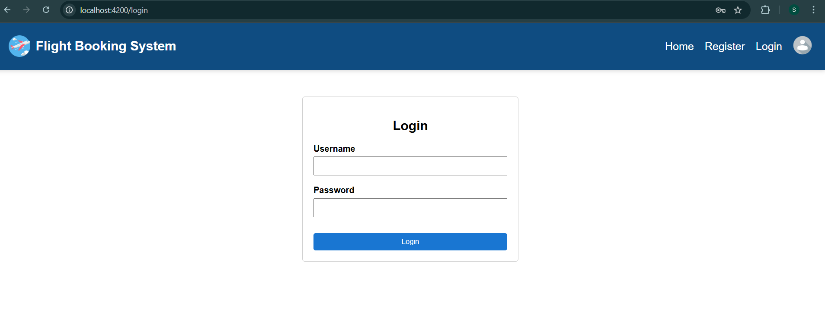
PROFILE - No user logged in :
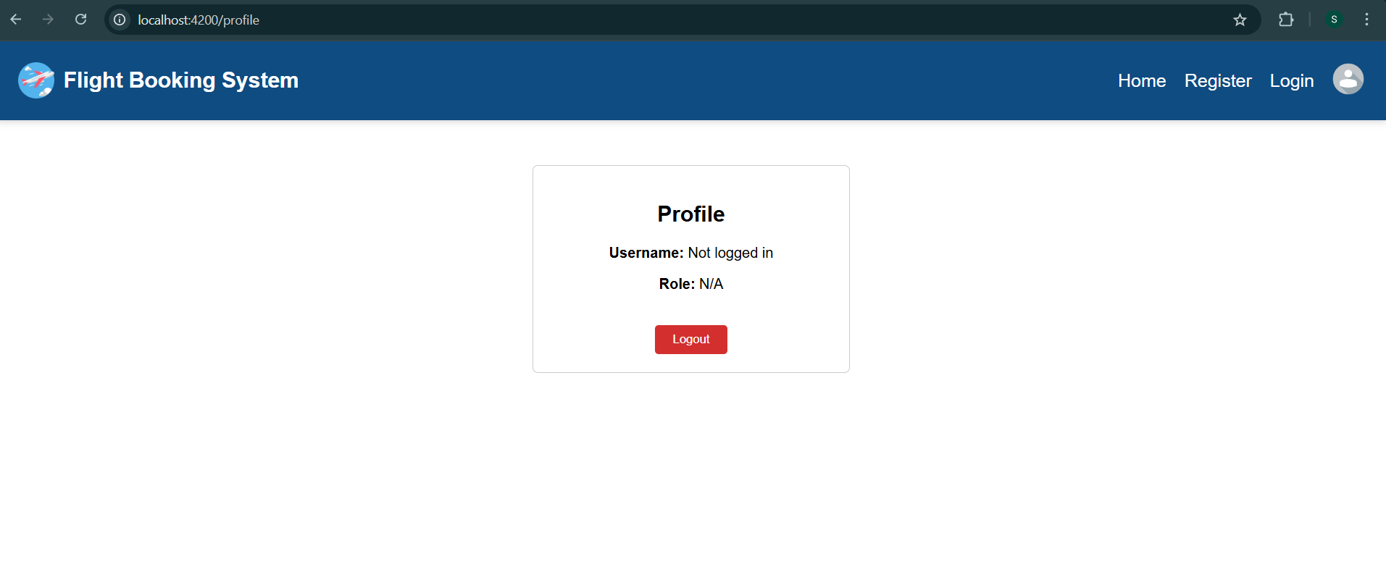
Creating account as Role - USER :
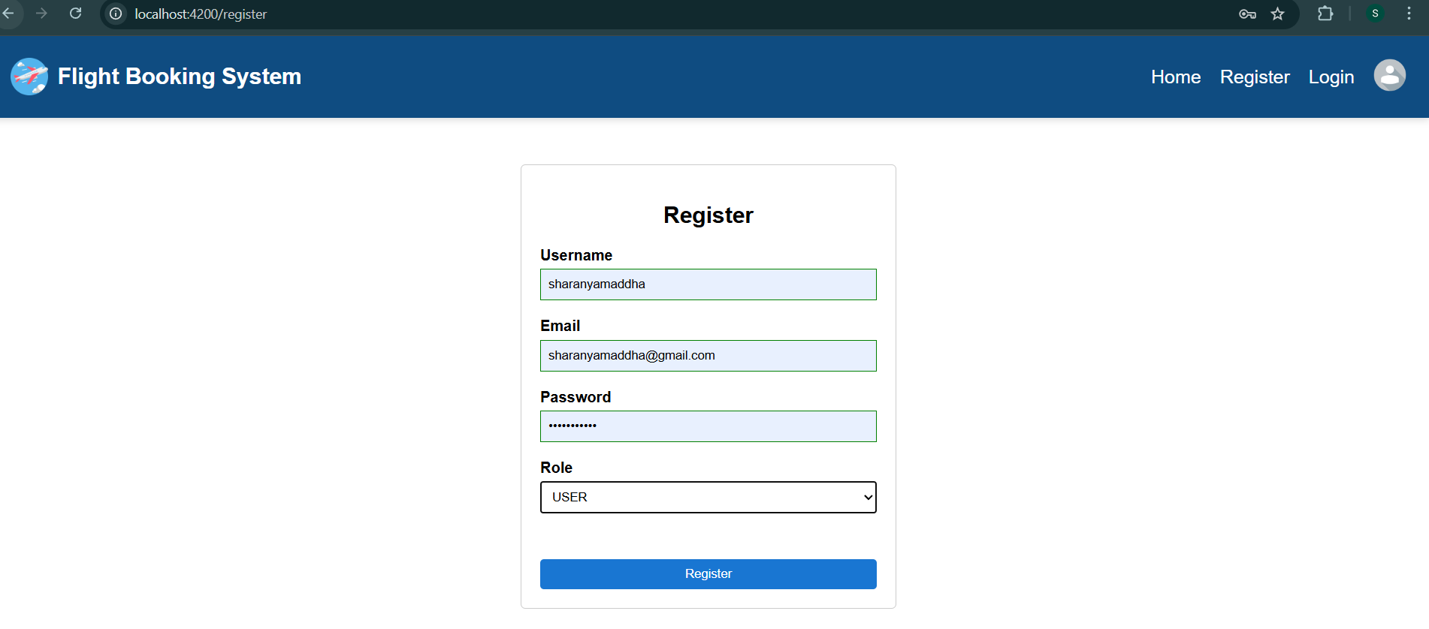
Registered successfully as USER:
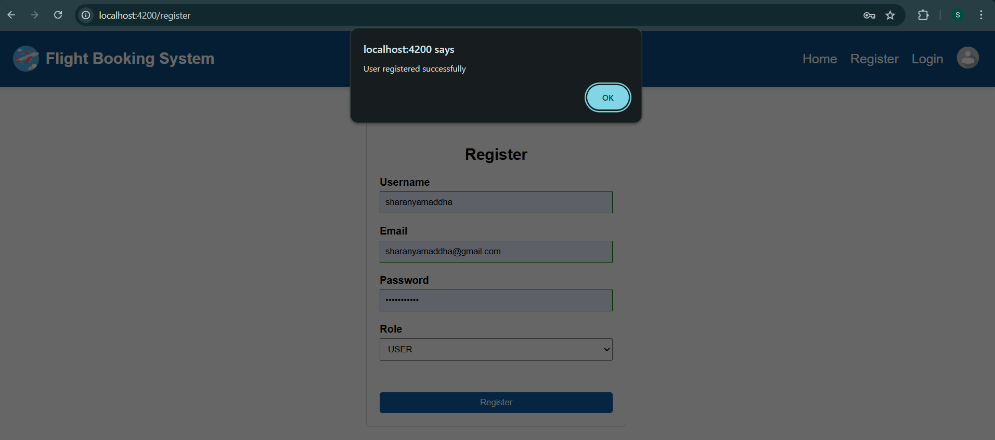
Saved to DB (Mongodb Collections) :
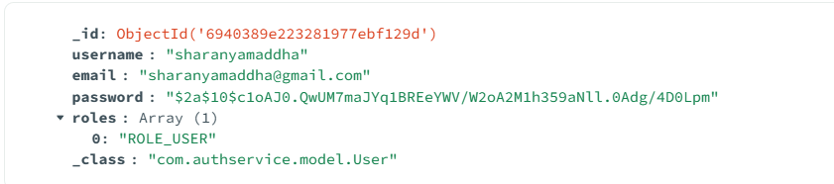
Logging in as USER :
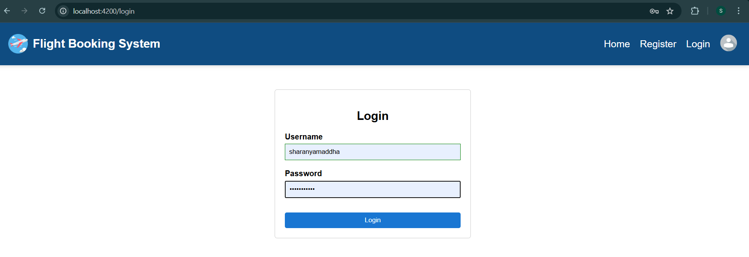
Successfully logged in as USER:
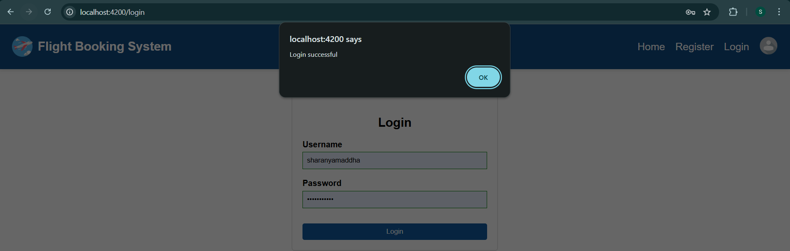
Profile : Role – USER
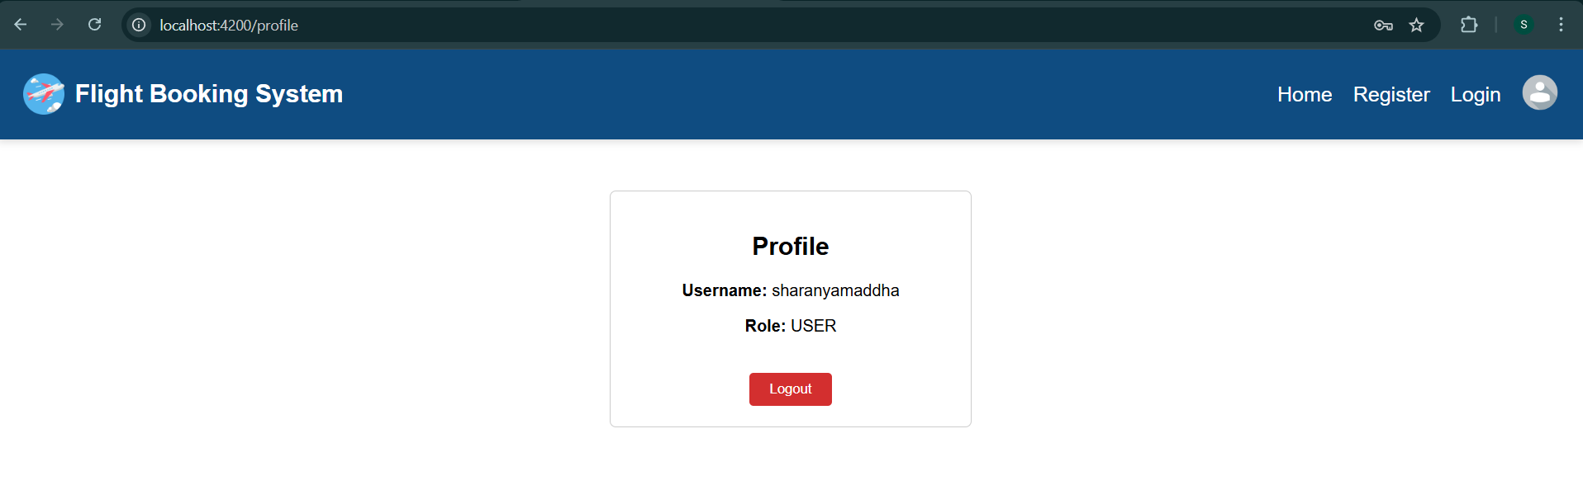

Creating account as Role - ADMIN :
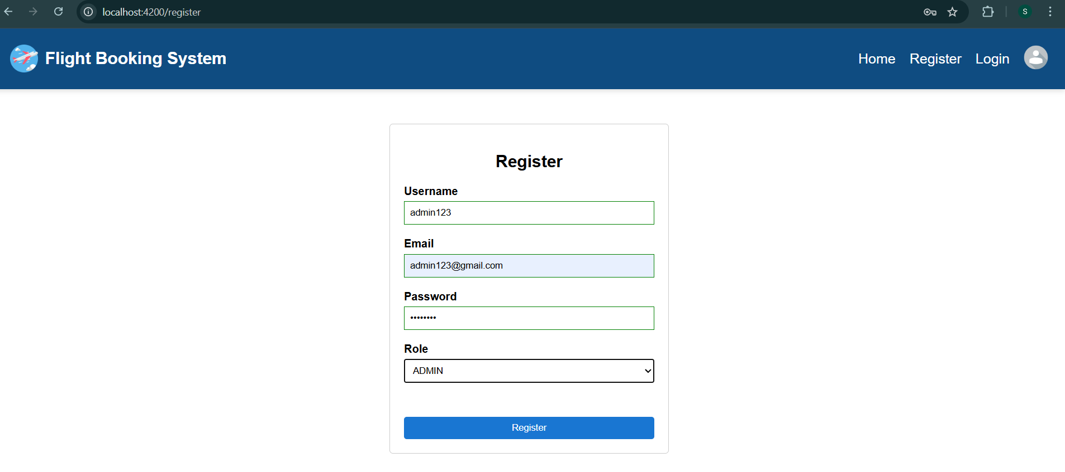
Registered successfully as ADMIN:
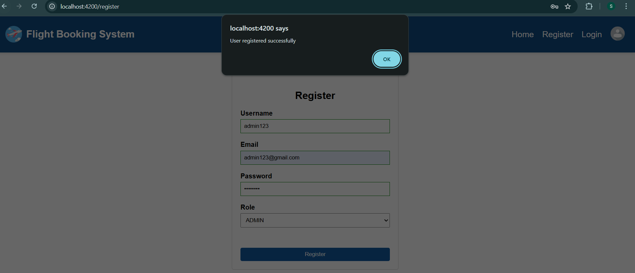
Logging in as ADMIN:
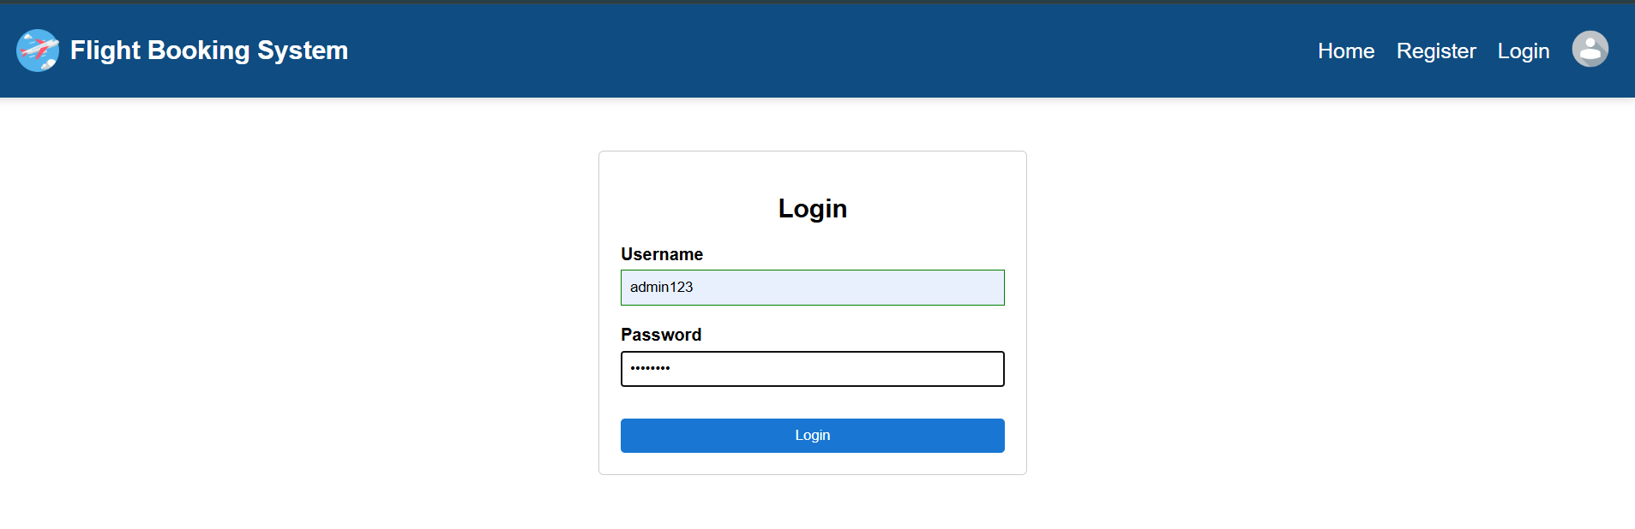

Successfully logged in as ADMIN:
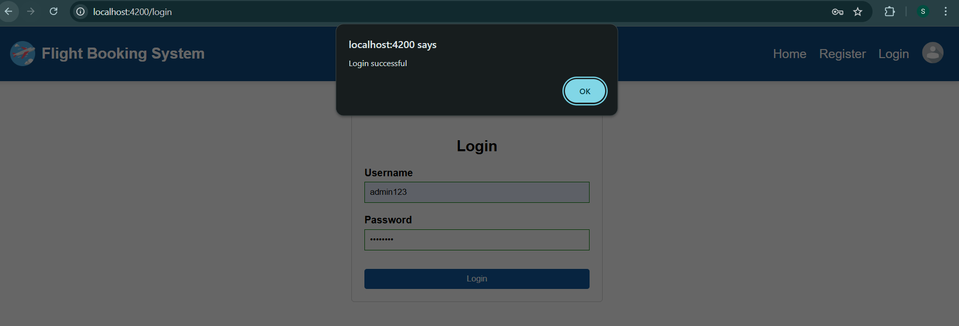

Saved to DB (Mongodb Collections) :
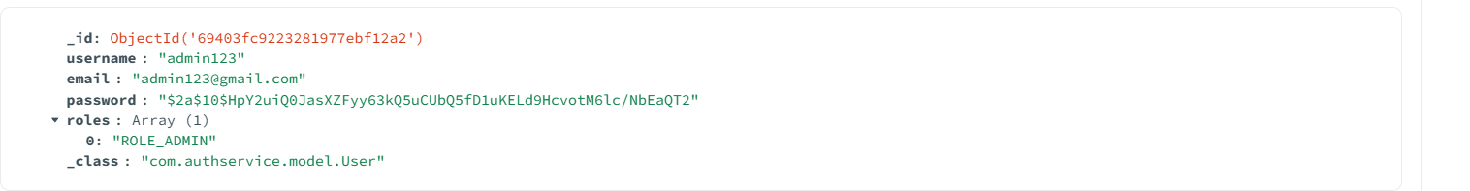

Profile : Role – ADMIN
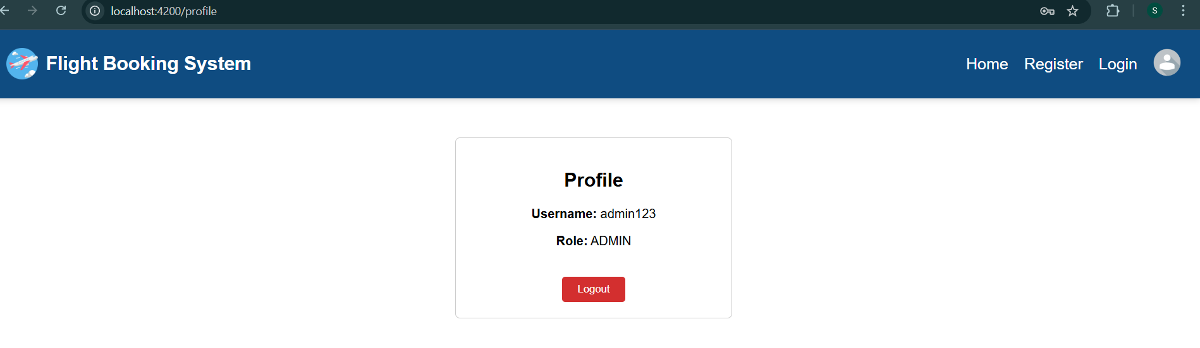

VALIDATIONS :
1. Registration Form :-
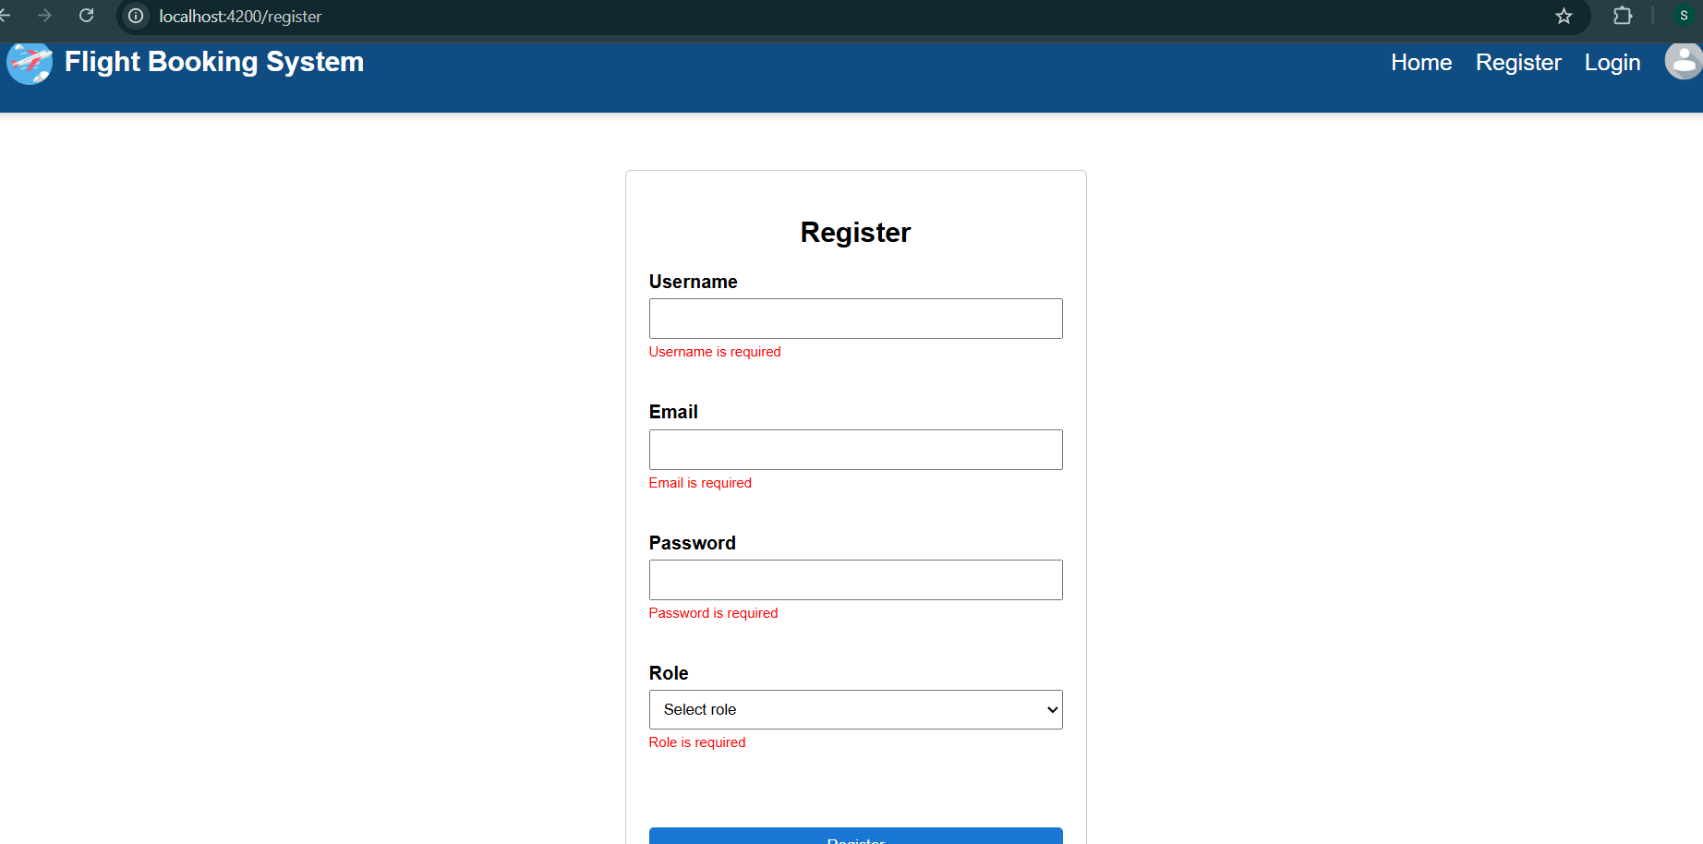

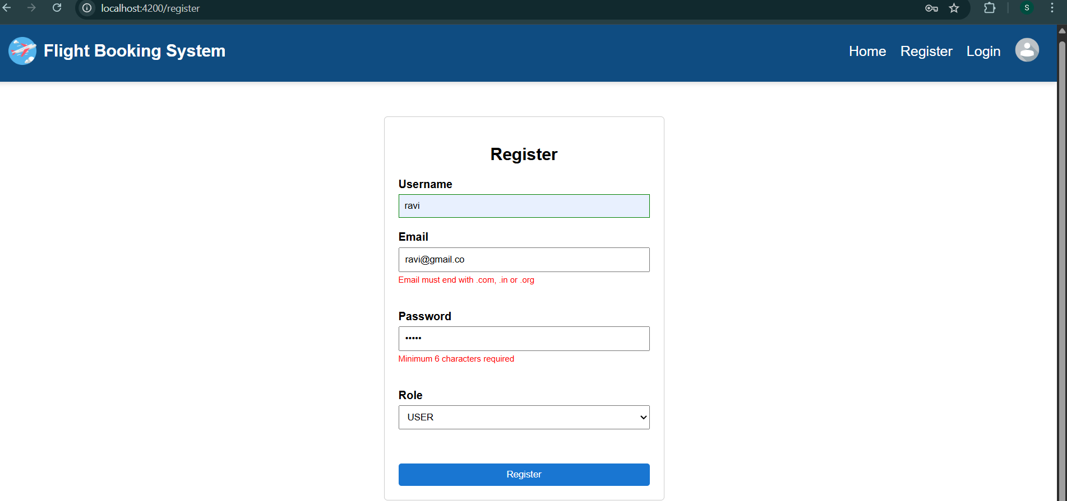
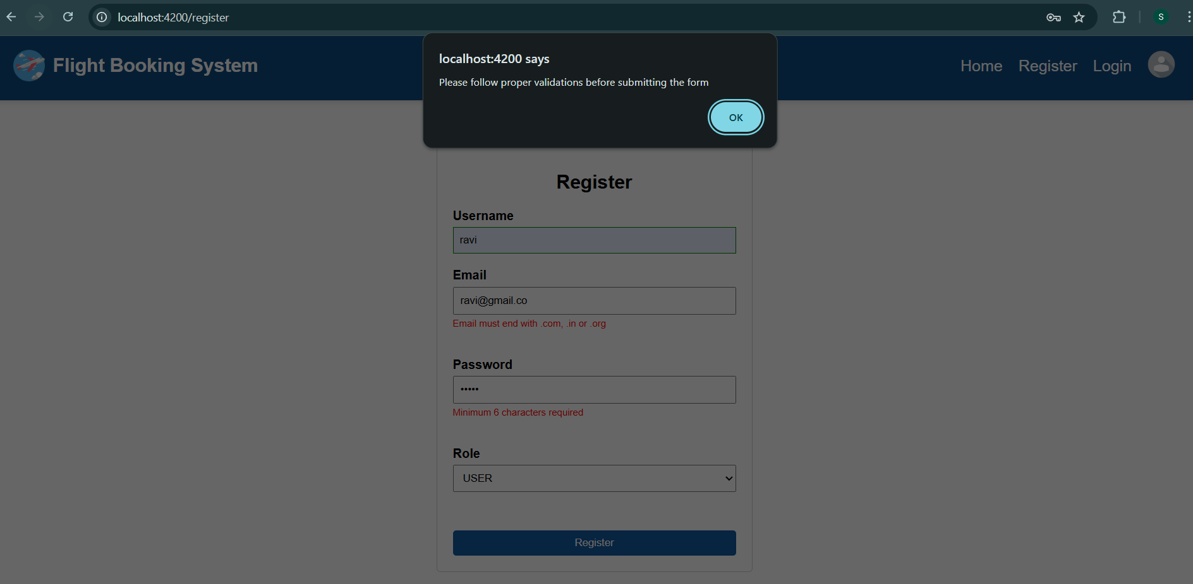
2. Login Form :-
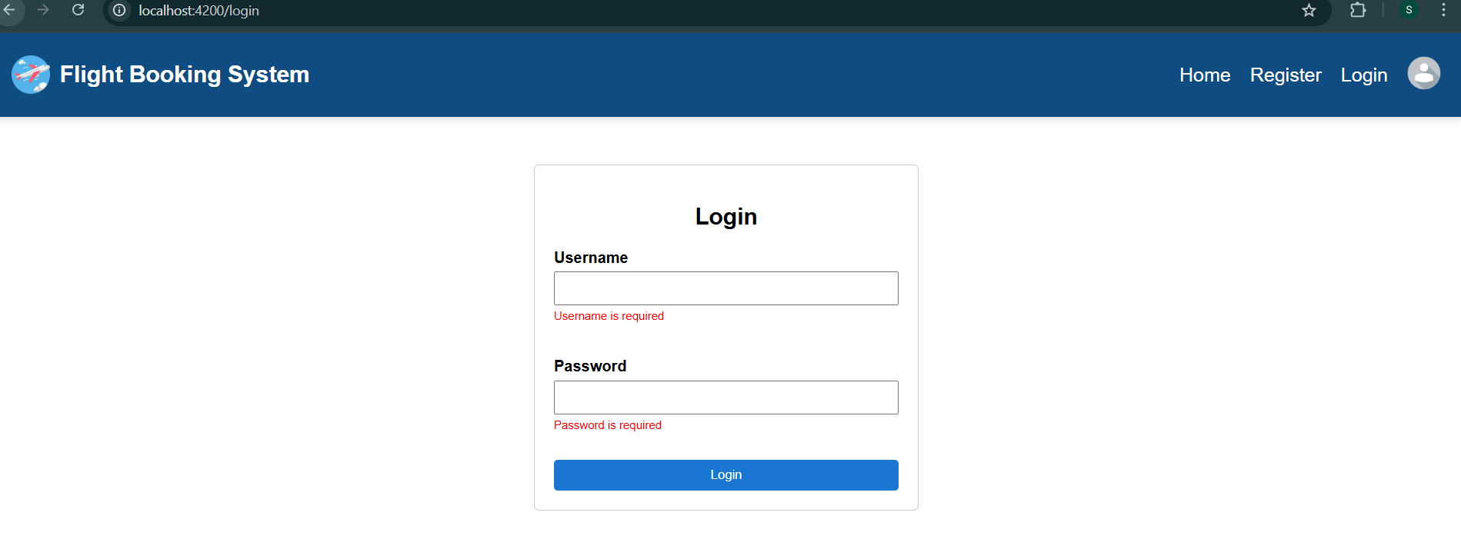

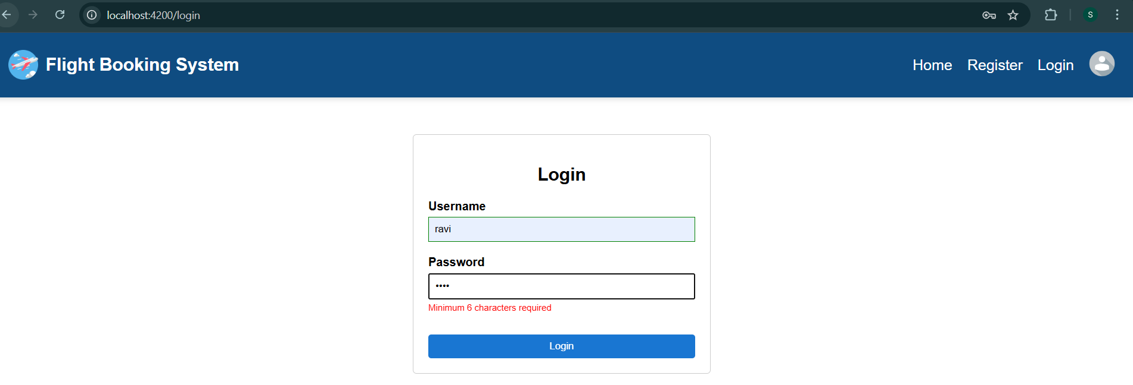
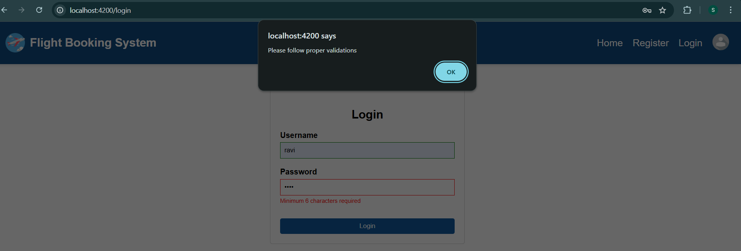

Searching Flights :
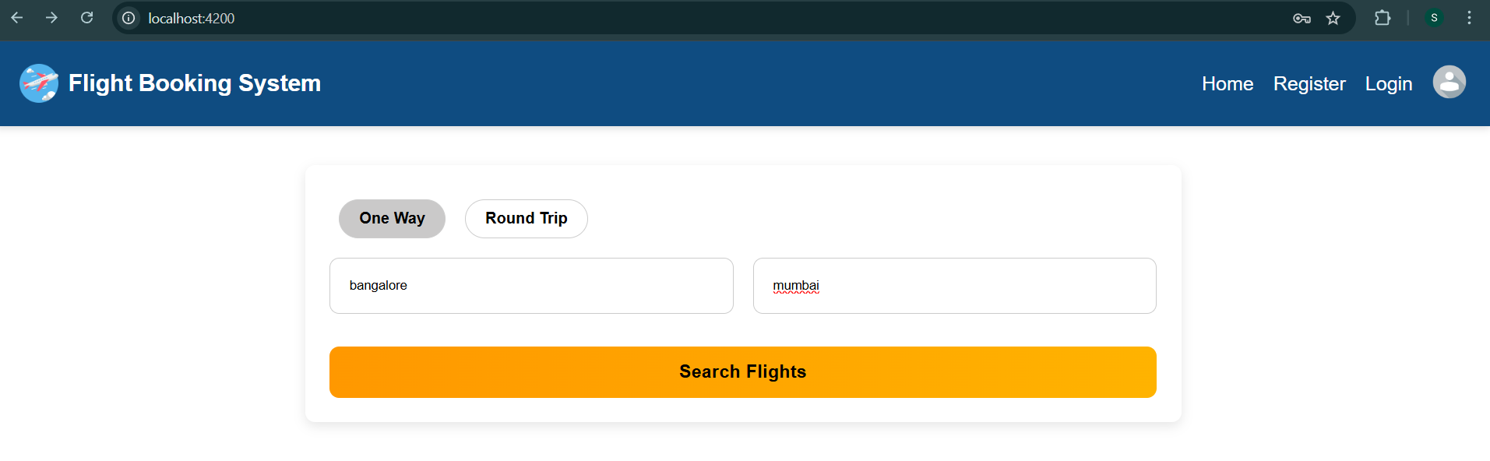

Fetching available flight details based on Search:
