- Add Flights:
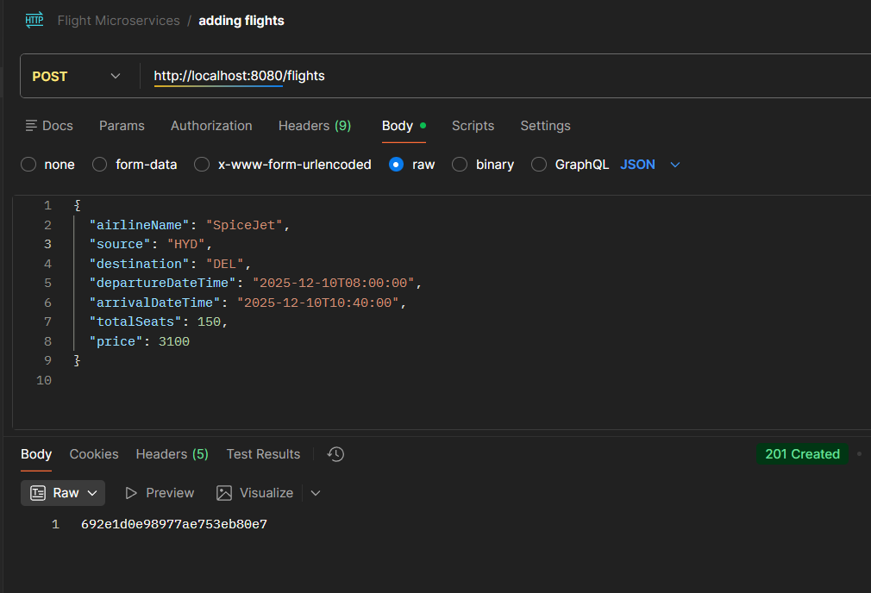
- Search Flights:
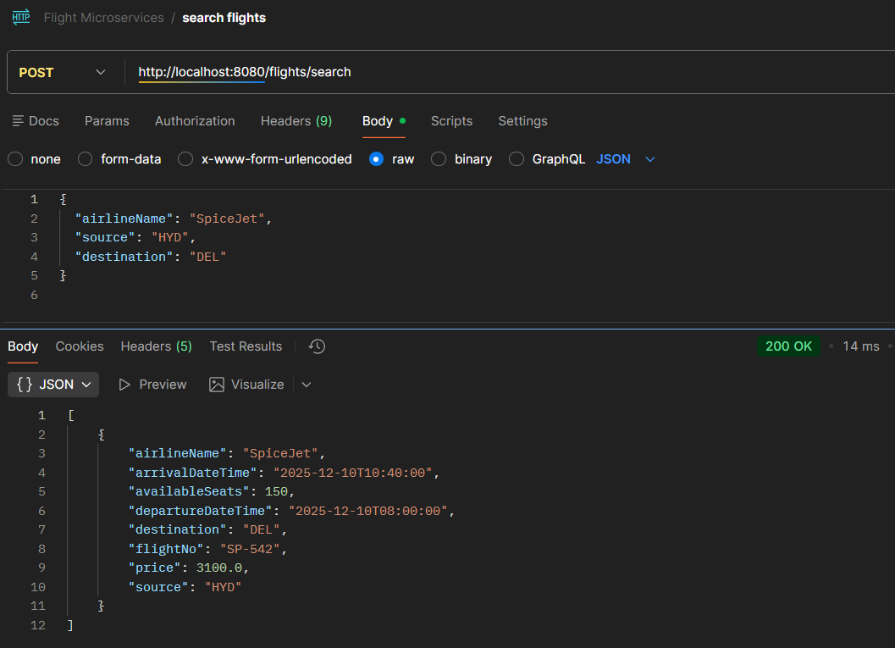
- Book a ticket:
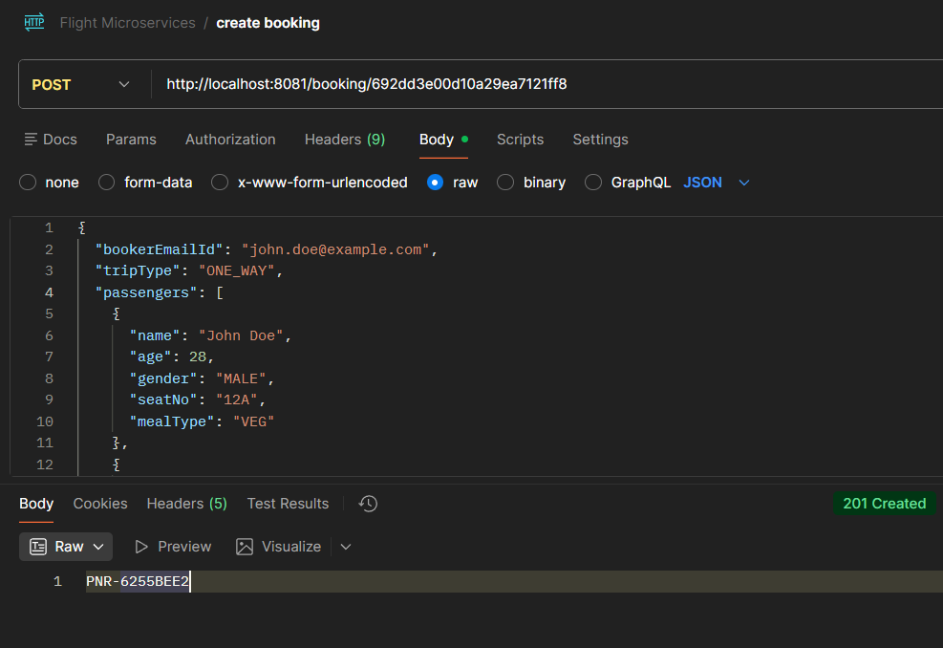
4.search by PNR : 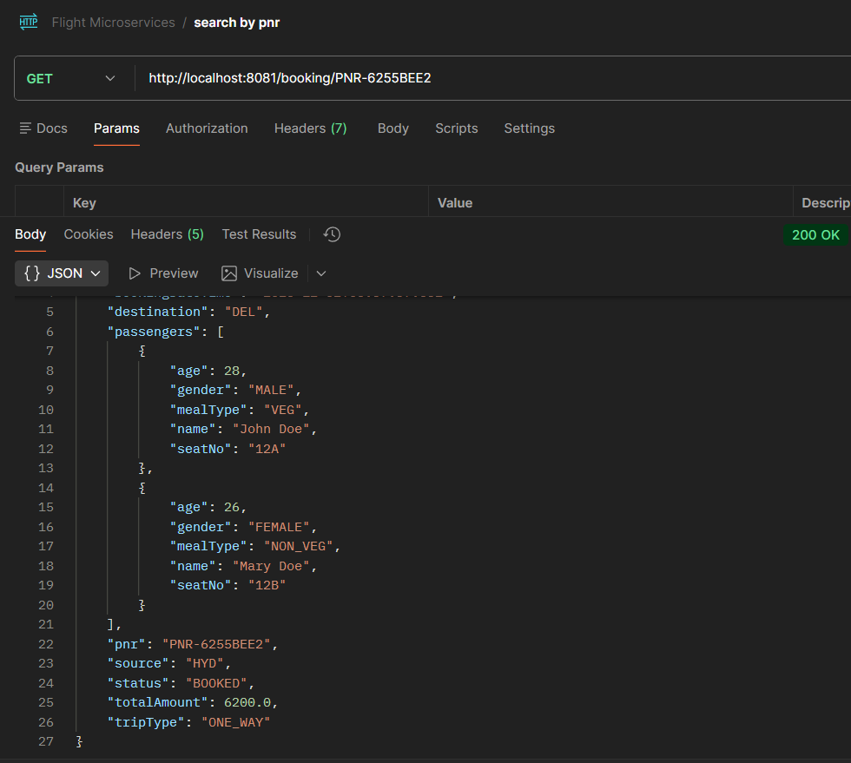
- Search by Email :
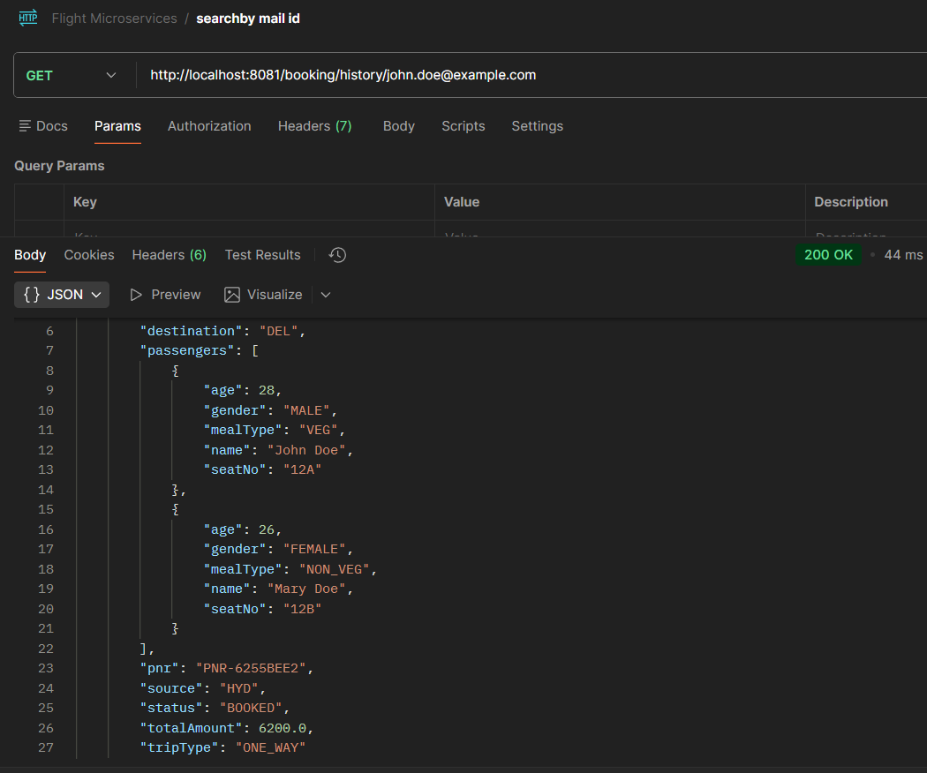

- Cancel by pnr :

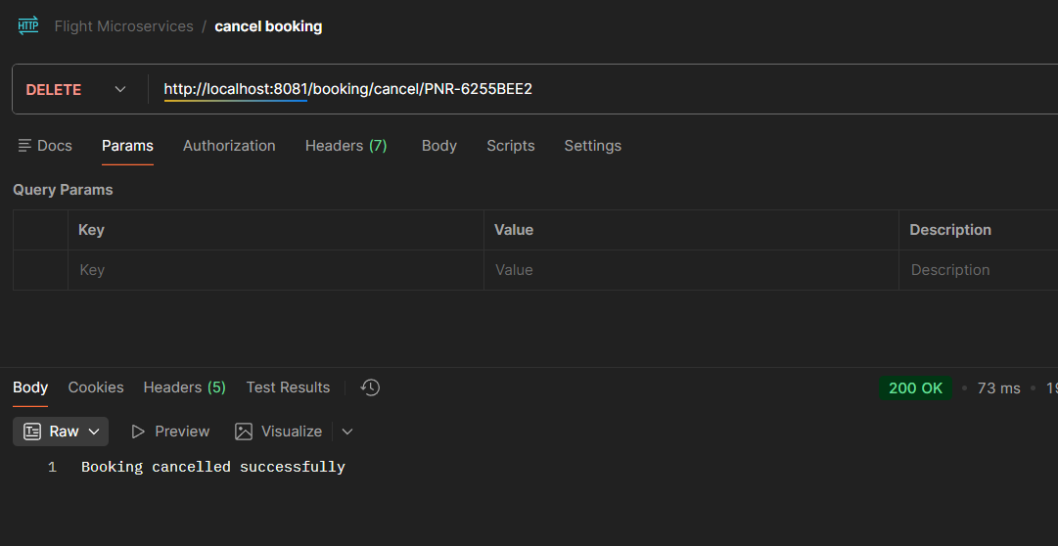

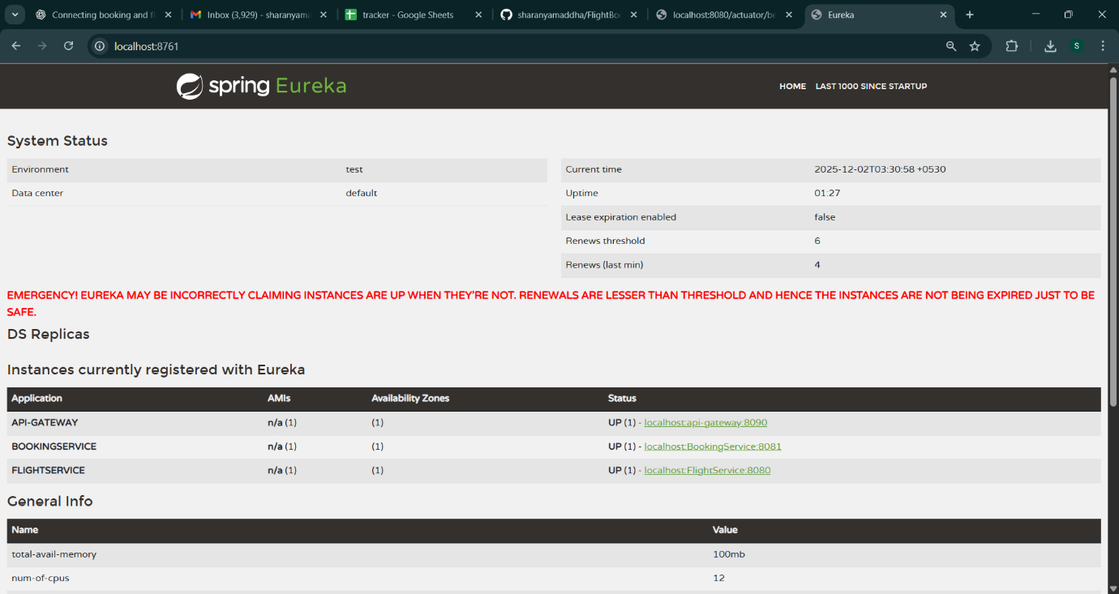
SERVICE- REGISTRY : EUREKA

CONFIG-SERVER :
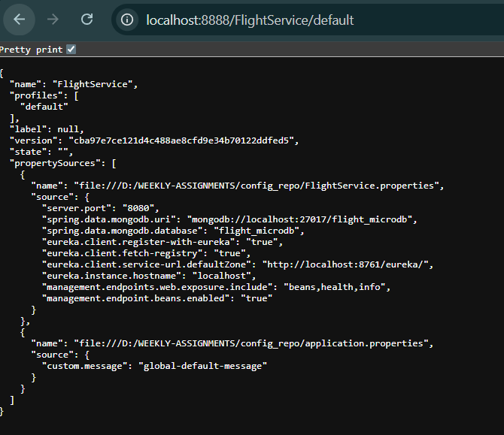
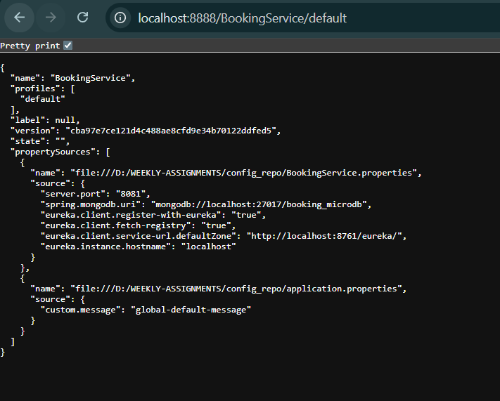
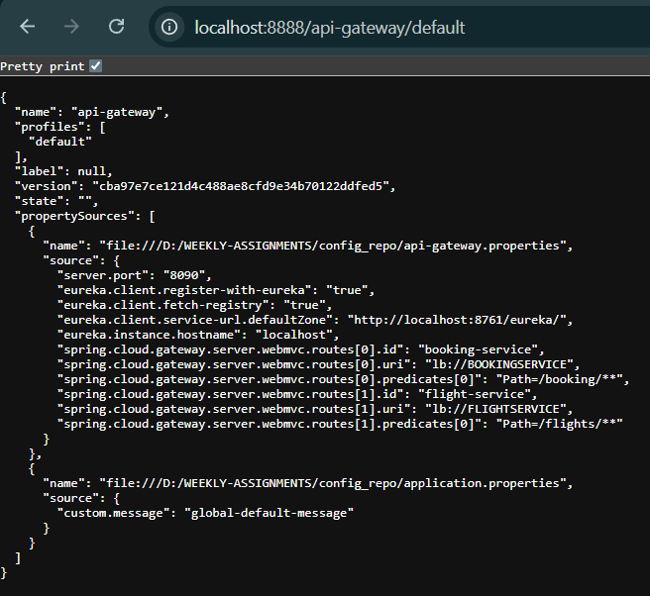

sJMETER TESTING:
Get request(Get Booked ticket details based on PNR)
1 . 20 requests :-

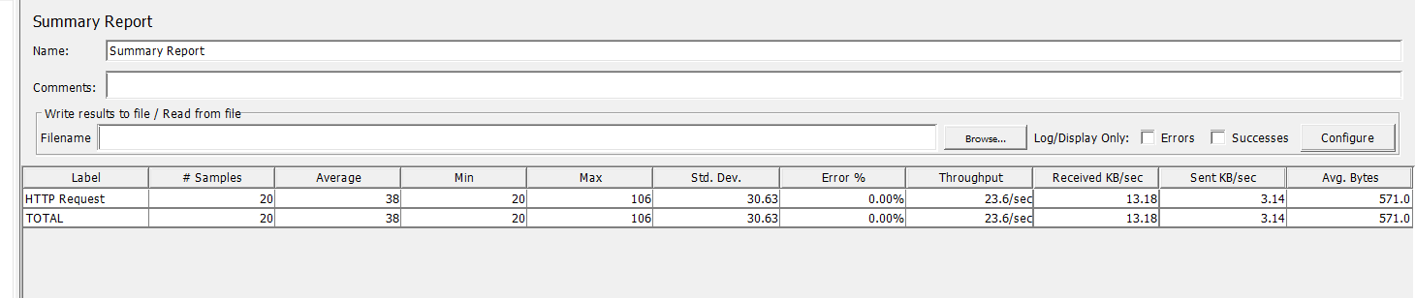

2. 50 requests :-
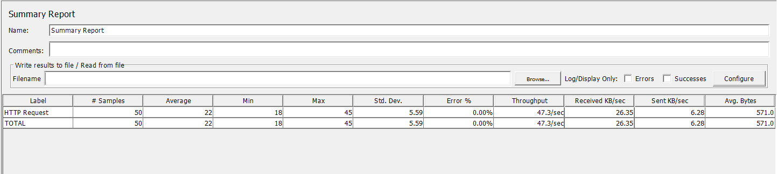

3. 100 requests :-
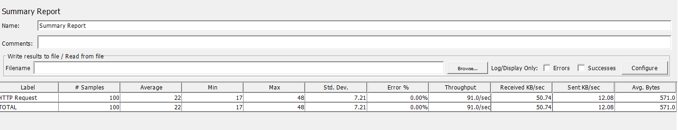

Get request(Get Booked ticket details based on email)
1 . 20 requests :-
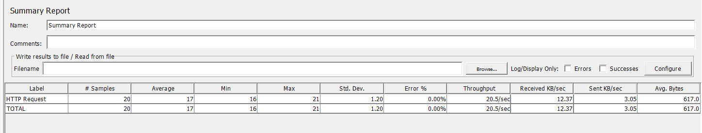

2. 50 requests :-
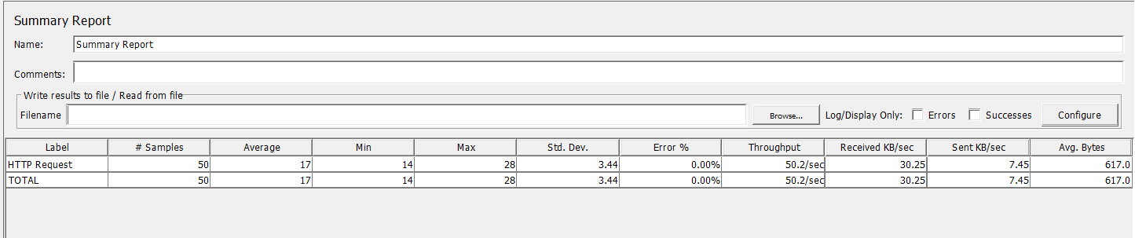

3. 100 requests :-
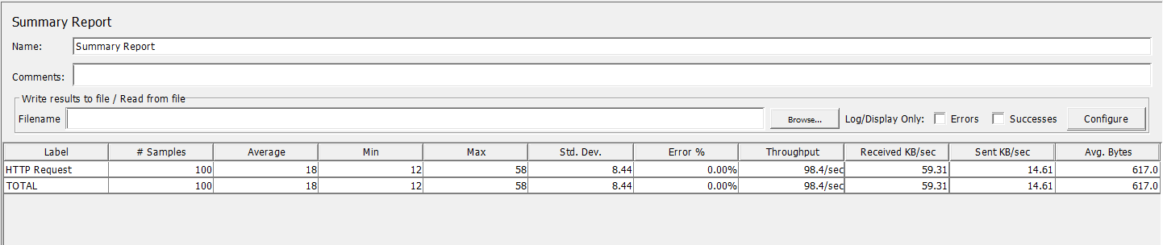

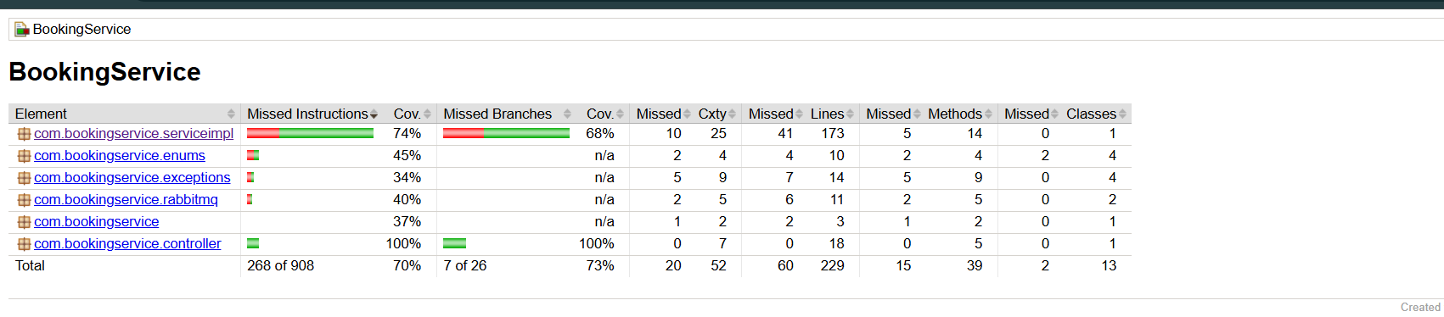

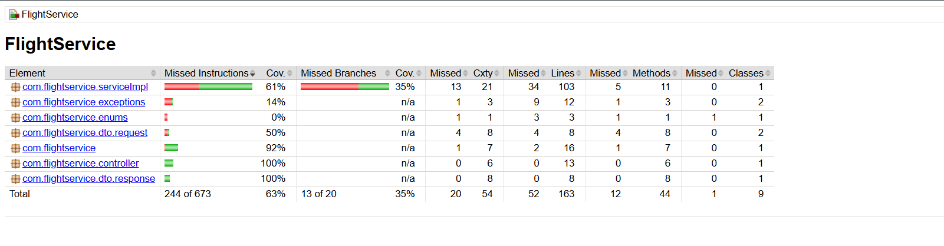

MESSAGE BROKER :
