SonarQube Analysis Report
Before :
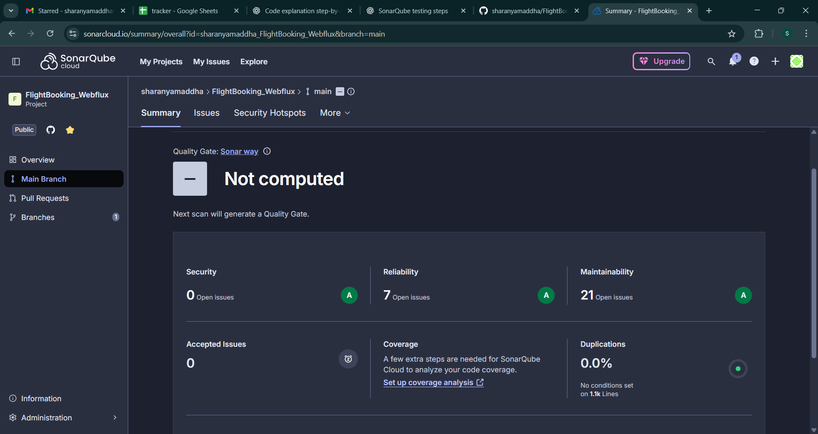
After :
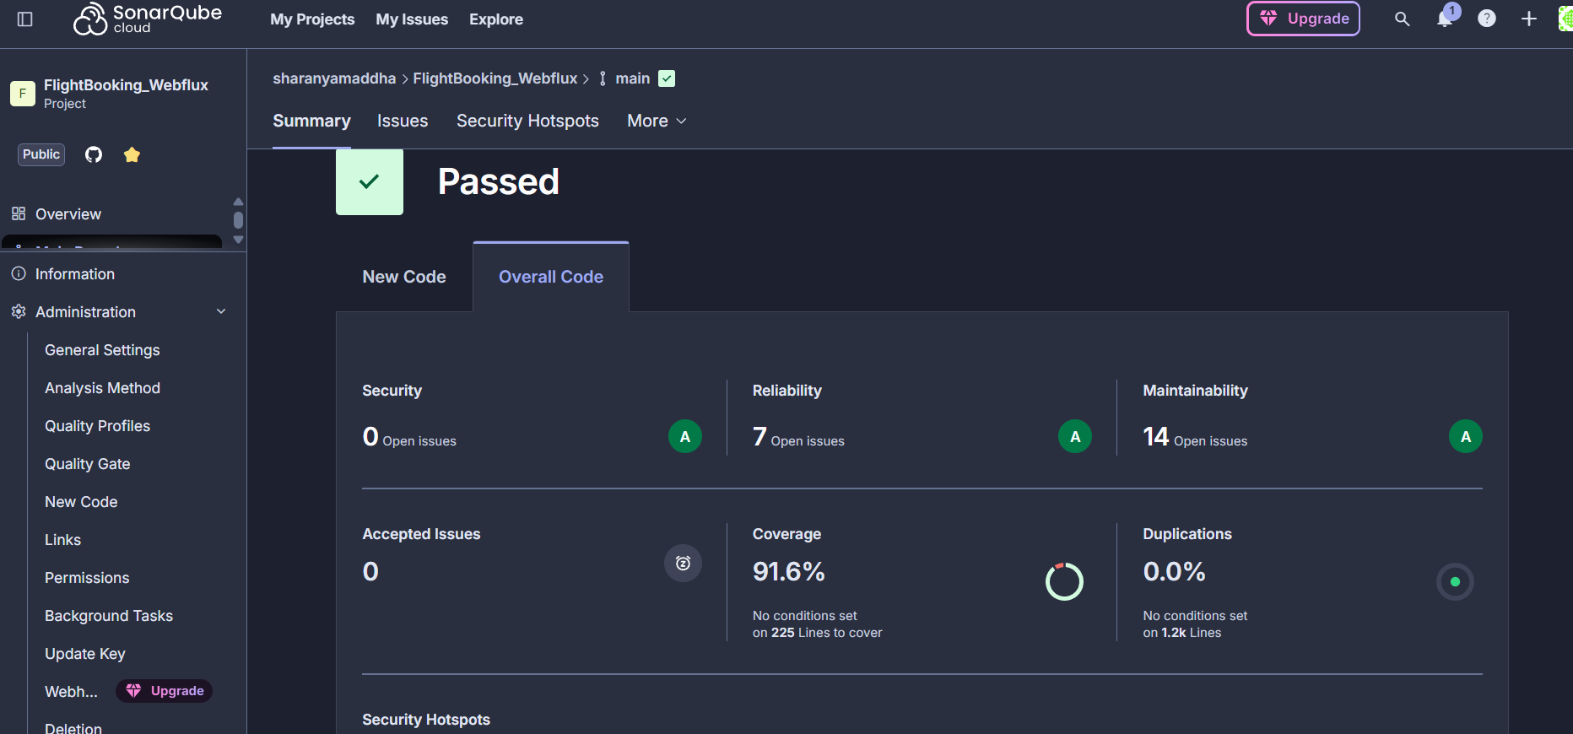
Jacoco report :
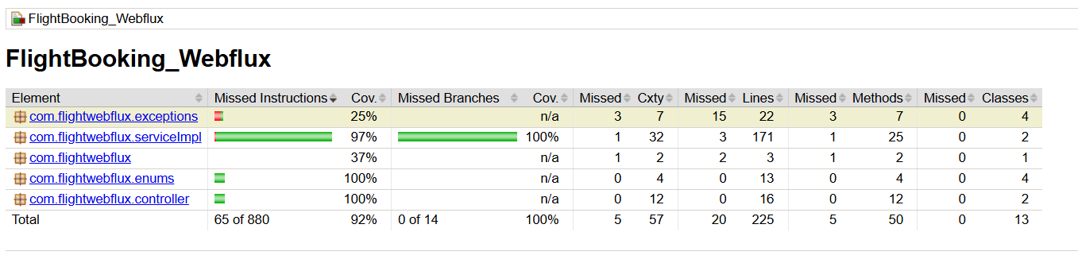
Jmeter Testing:
Get request(Get Booked ticket details based on PNR)
1 . 20 requests :-
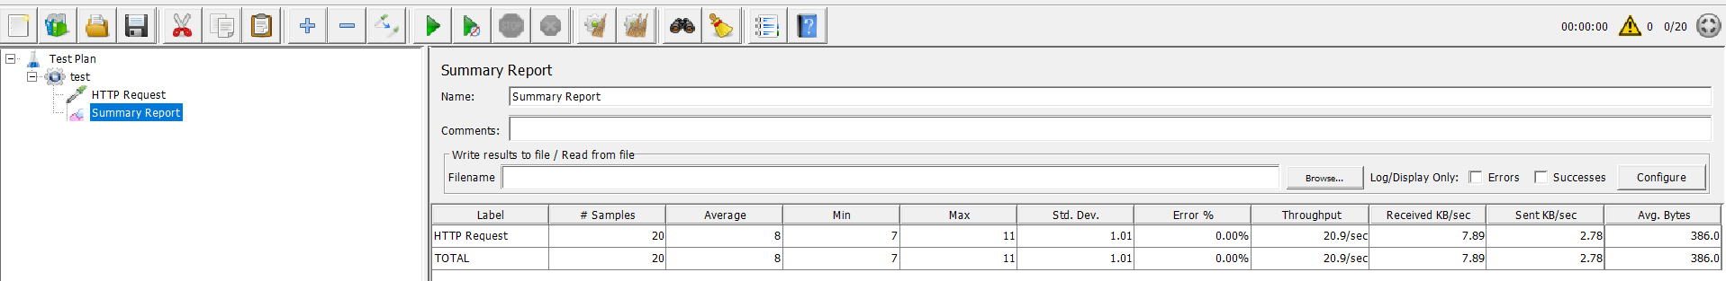
2. 50 requests :-
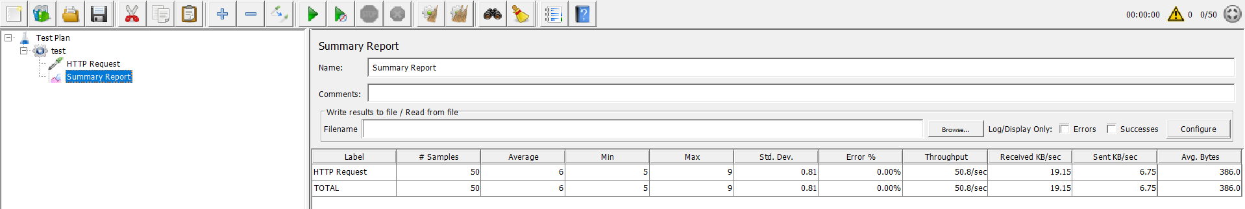
3. 100 requests :-
