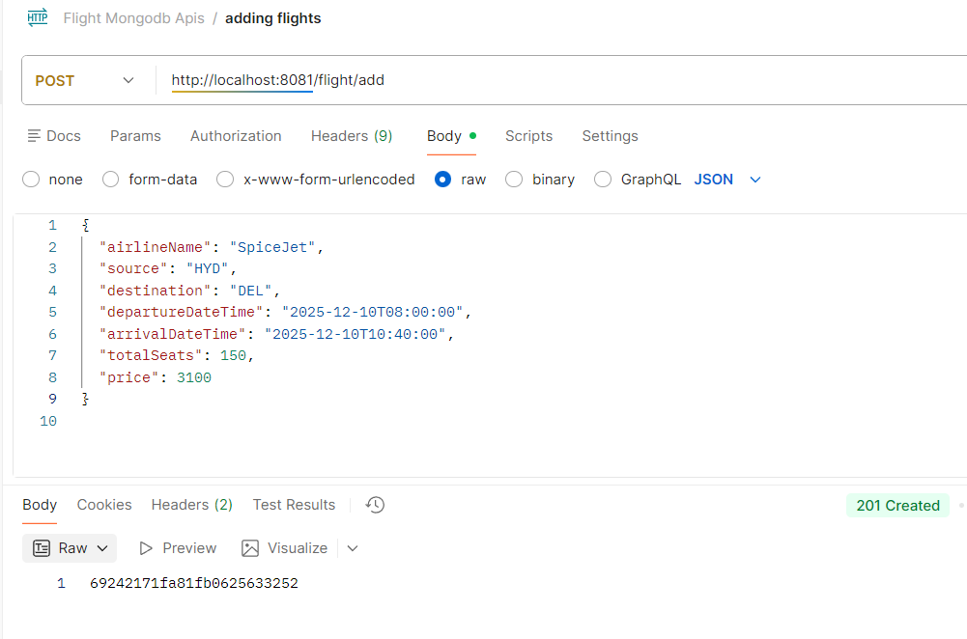
1. POST Request (Add Inventory/Schedule of an existing Airline)

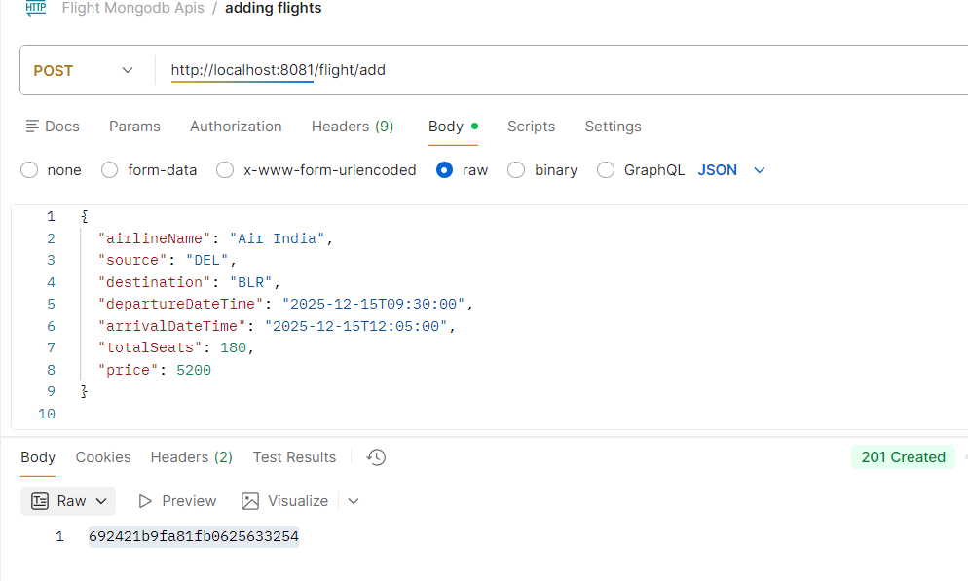
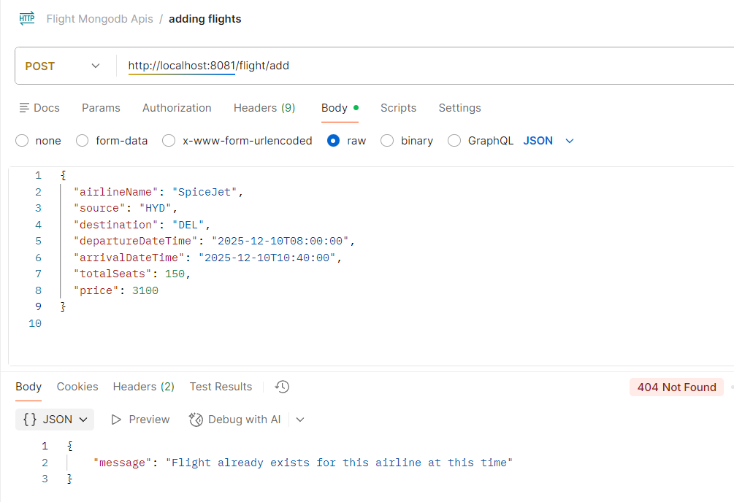
Adding duplicate flights : 404 – Not Found
2. POST Request (Searches for flight)
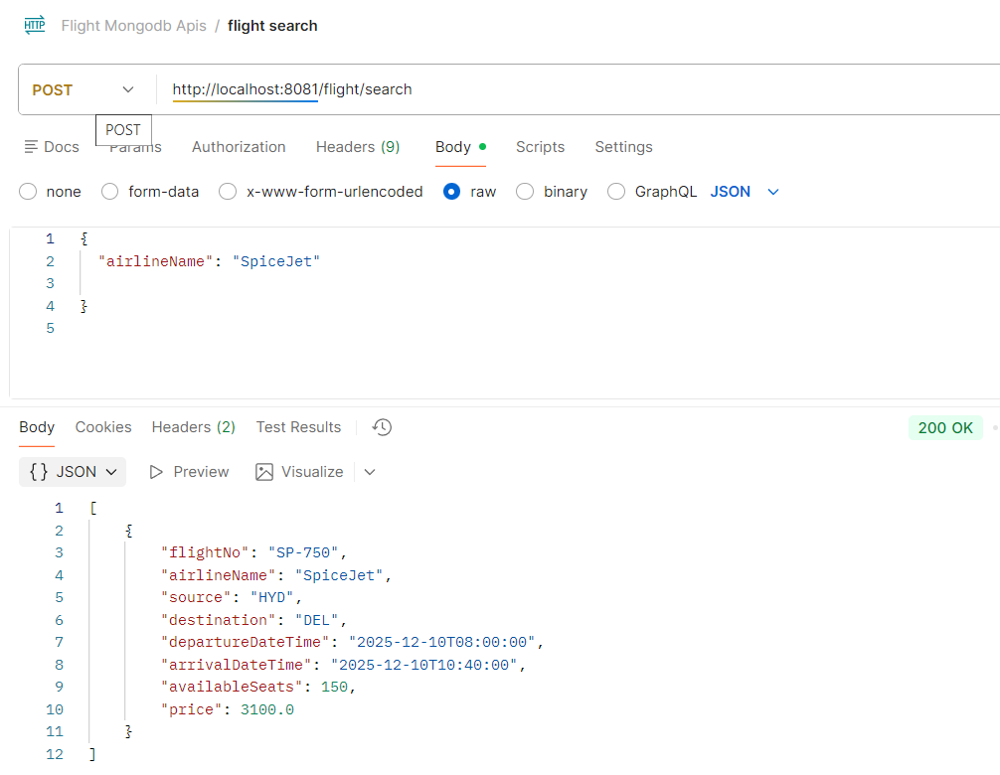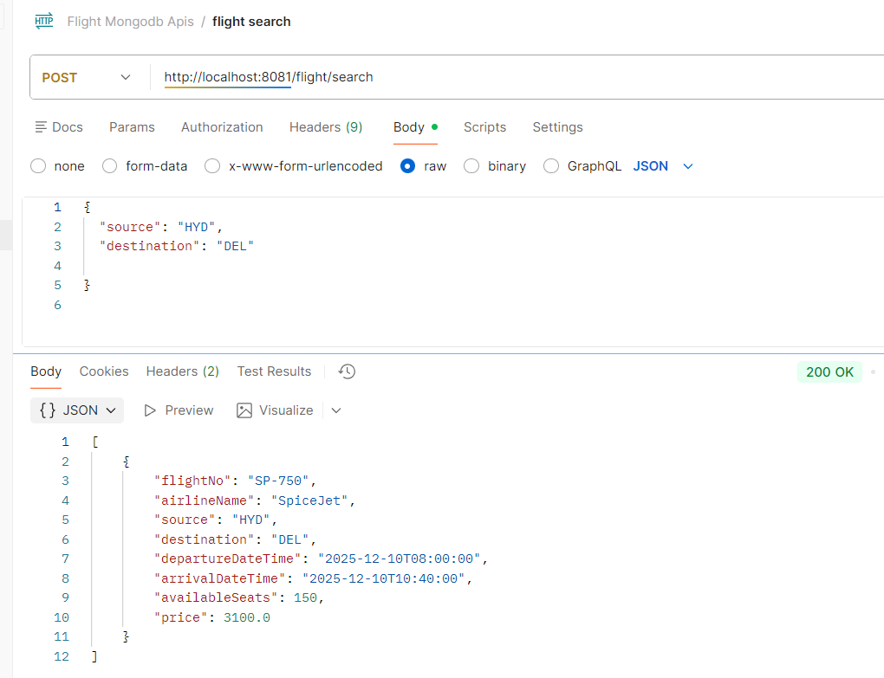

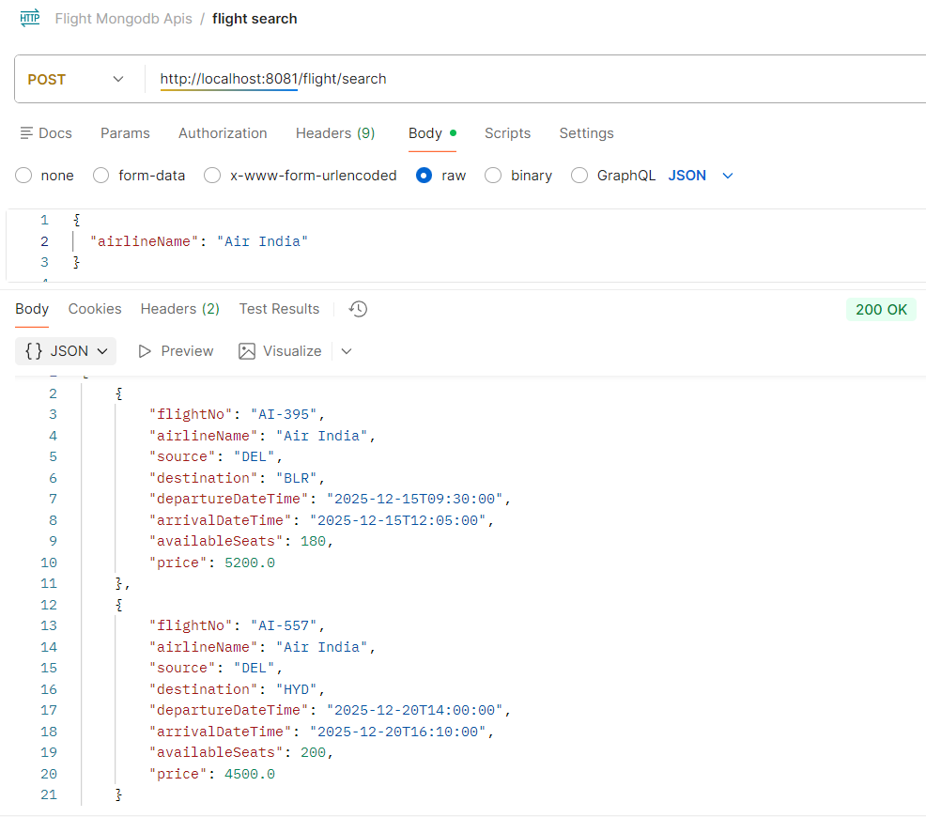

Searching for non-existing flights : 404 – Not Found 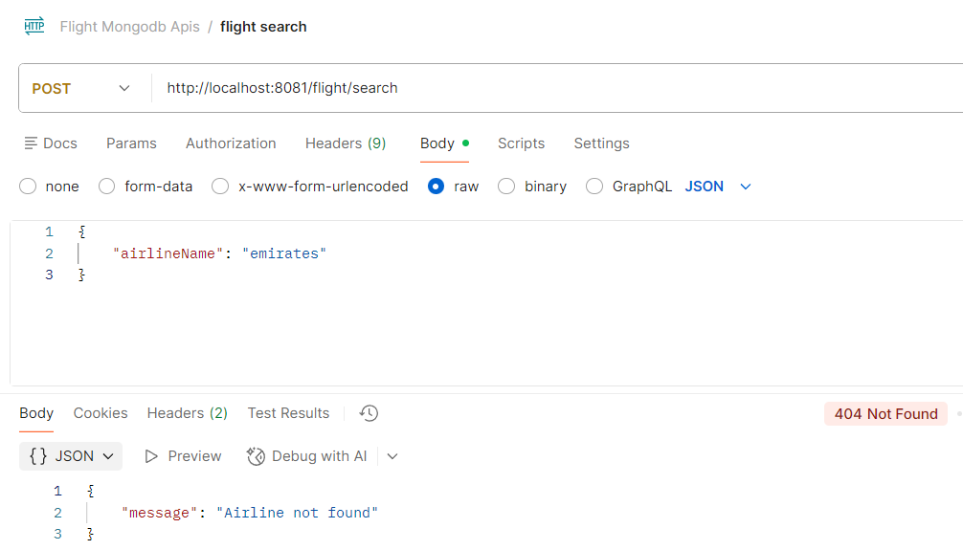
3. POST Request (Book ticket)
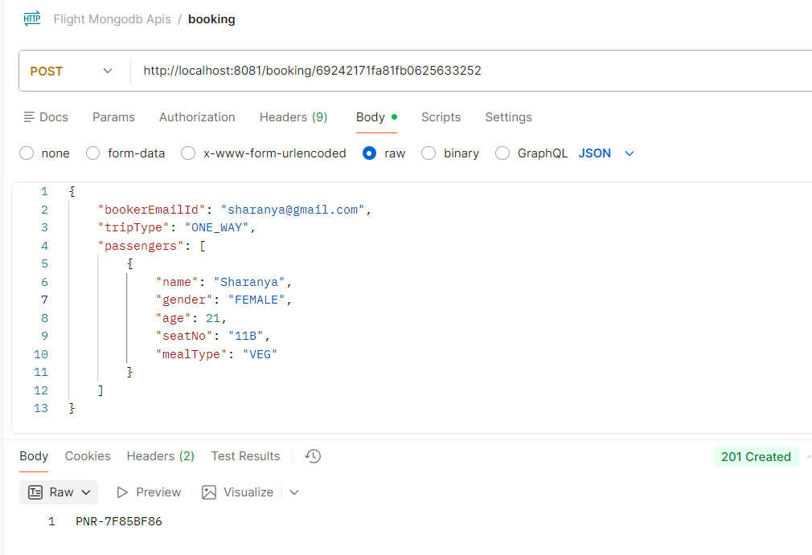
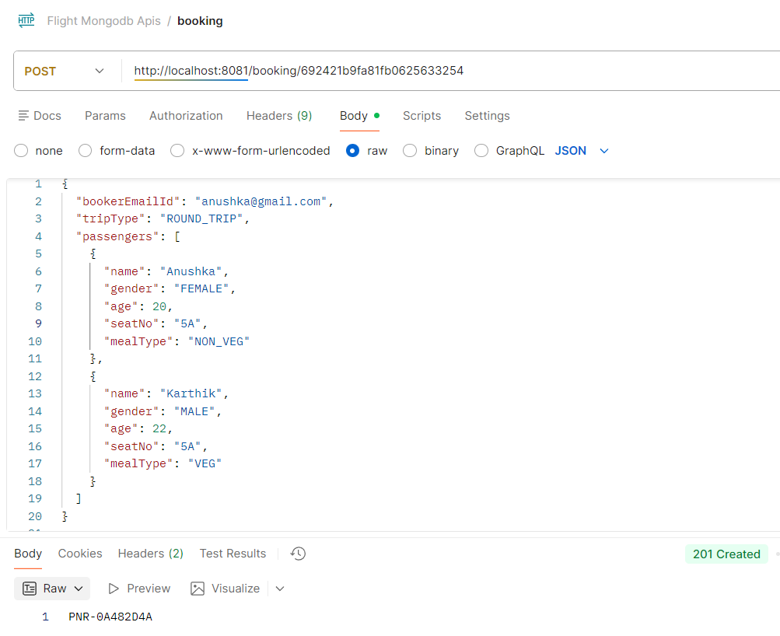
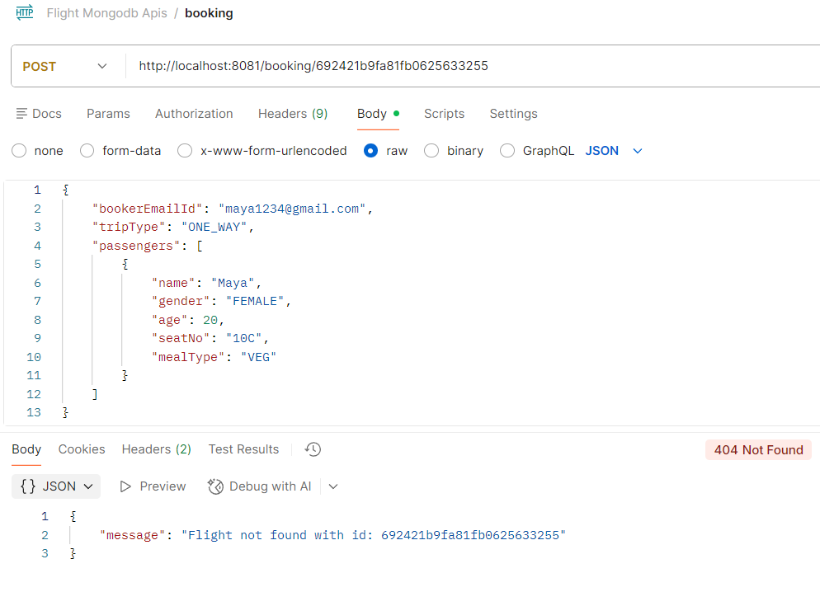
booking using invalid flightId : 404 – Not Found
booking duplicate seats : 404 – Not Found
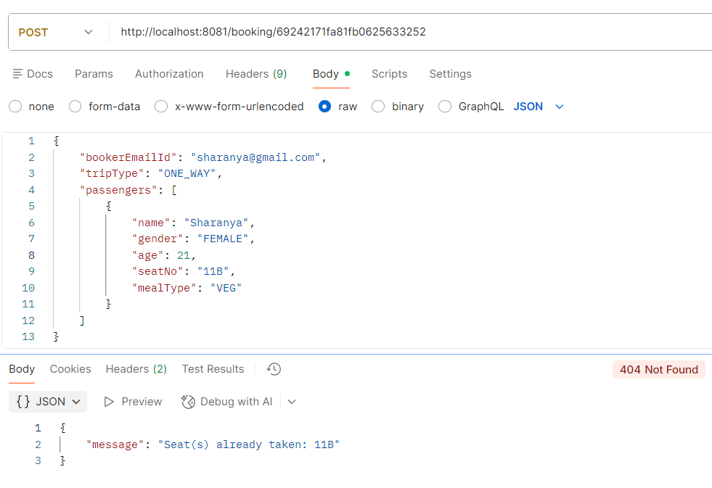
4.GET Request (Get Booked ticket details based on PNR)
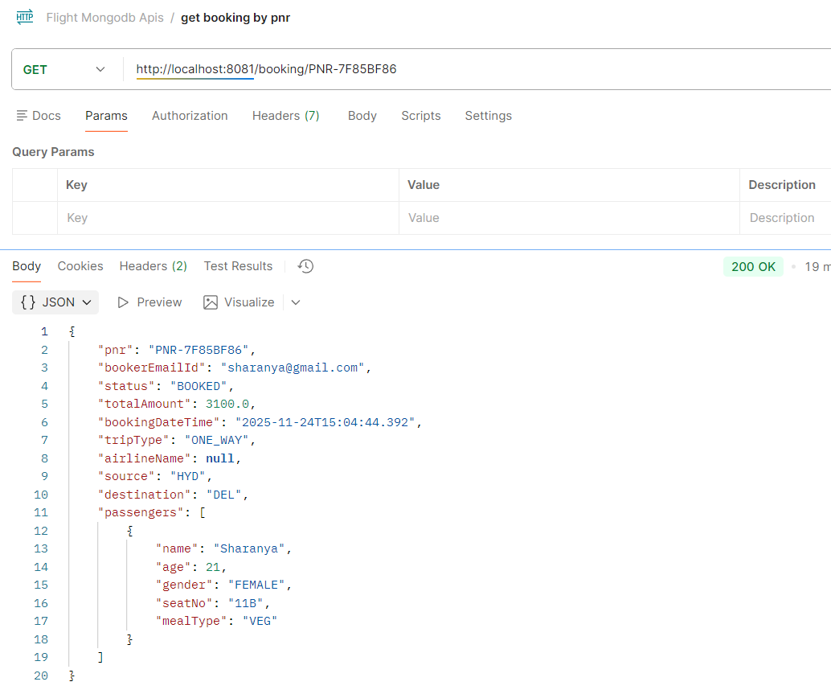
invalid pnr : 404 – Not Found
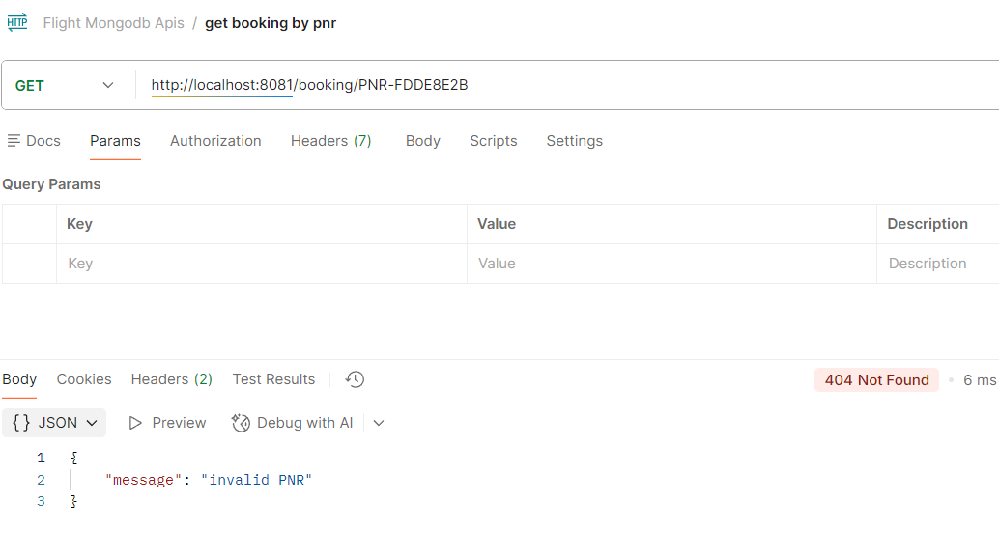
5. GET Request (Get Booked tickets history based on Email ID)
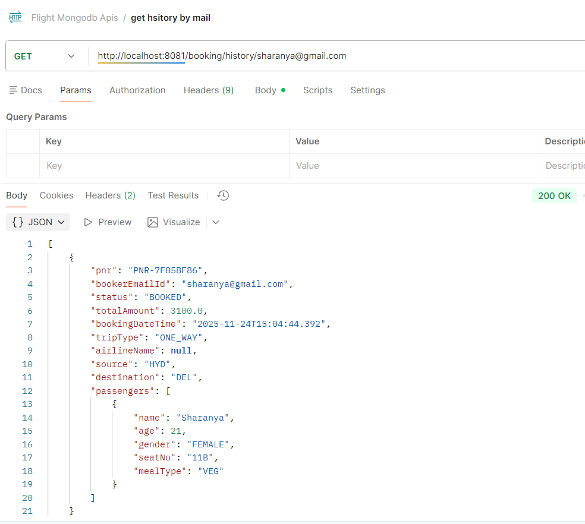

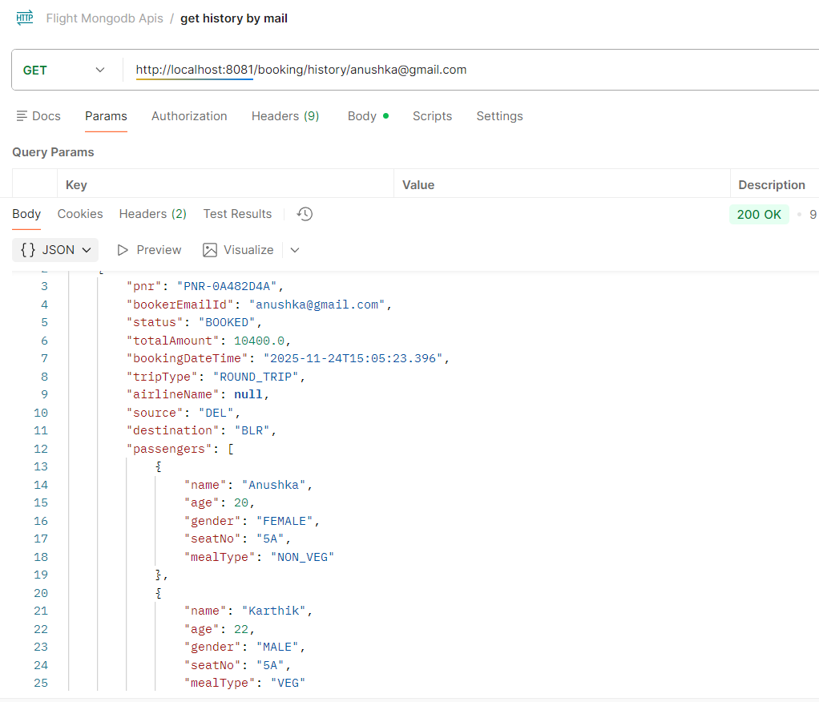
Invalid Email : 404 – Not Found
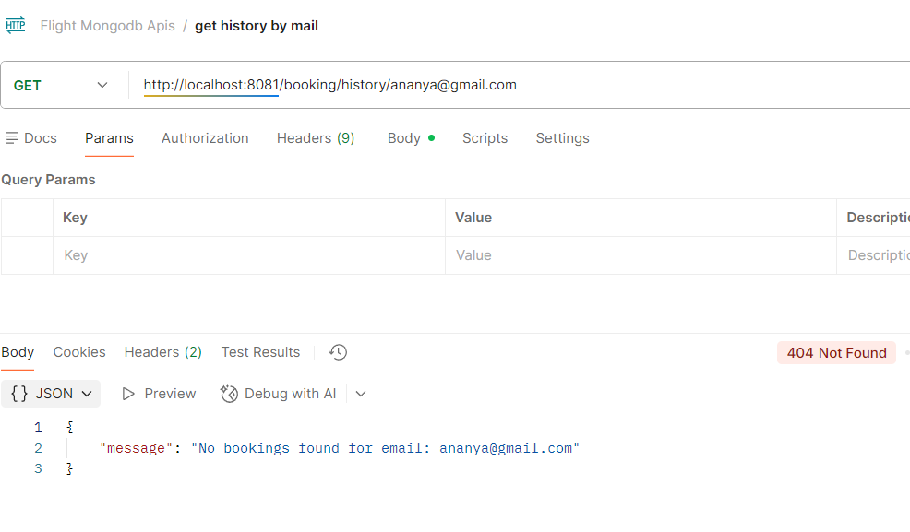

6. DELETE Request (Cancel a booked ticket)
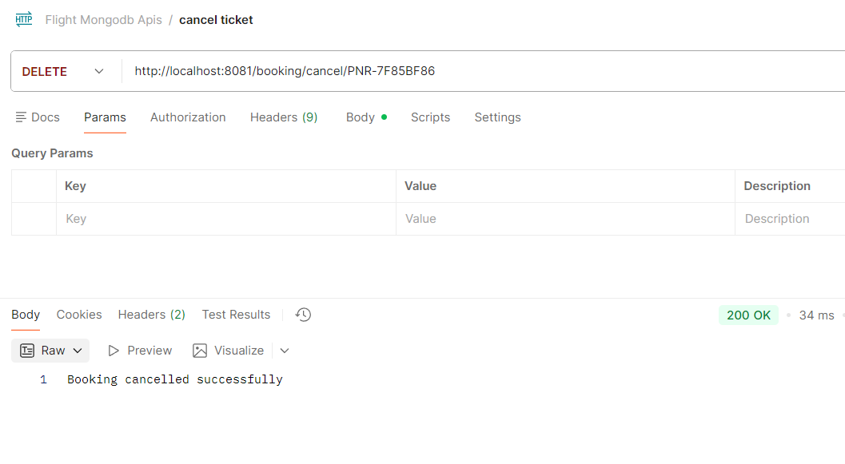
Invalid pnr : 404 – Not Found
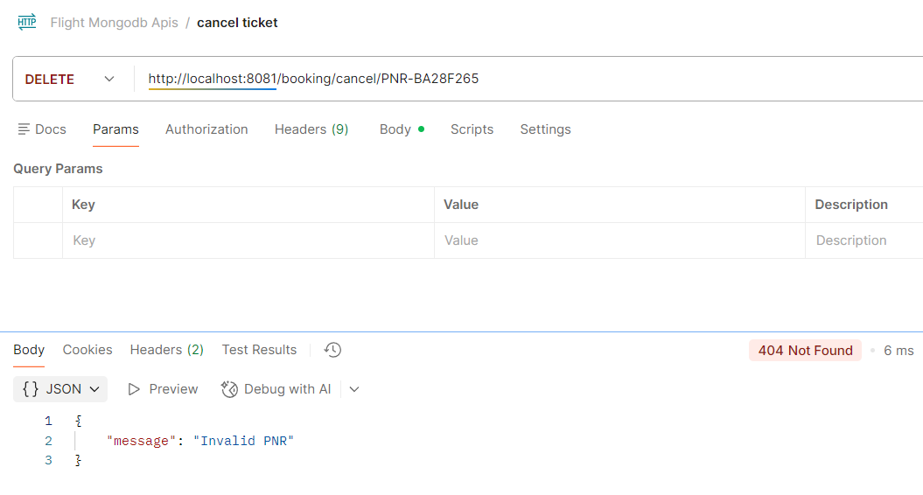

Cancelling booking which is already cancelled : 409 - Conflict
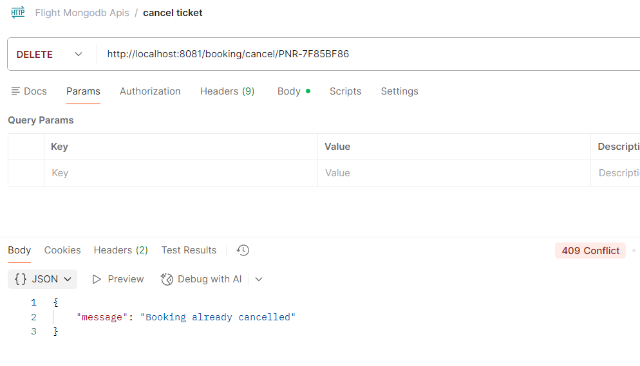
Cannot cancel after 24 hours : 400 - Conflict
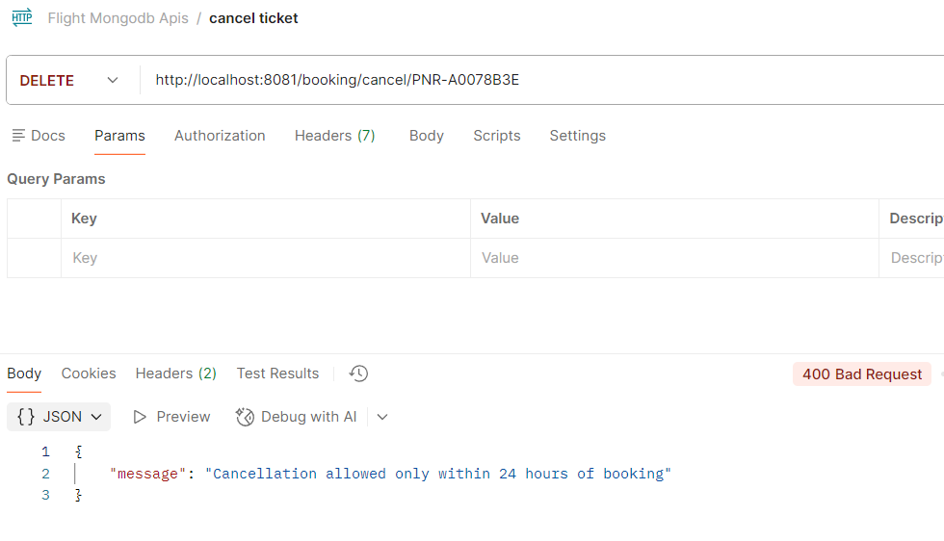

SonarQube Analysis Report
Before :
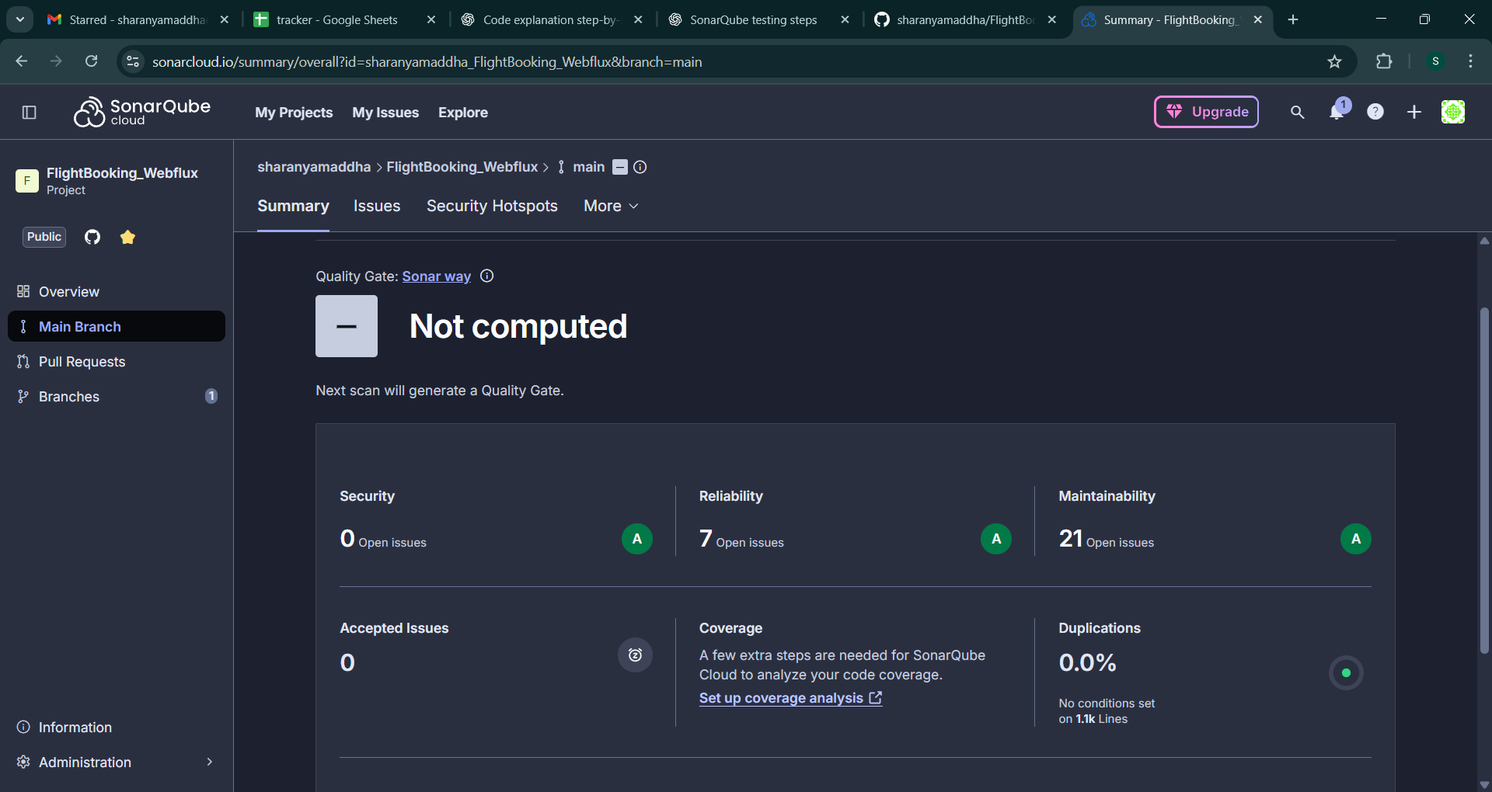
After :
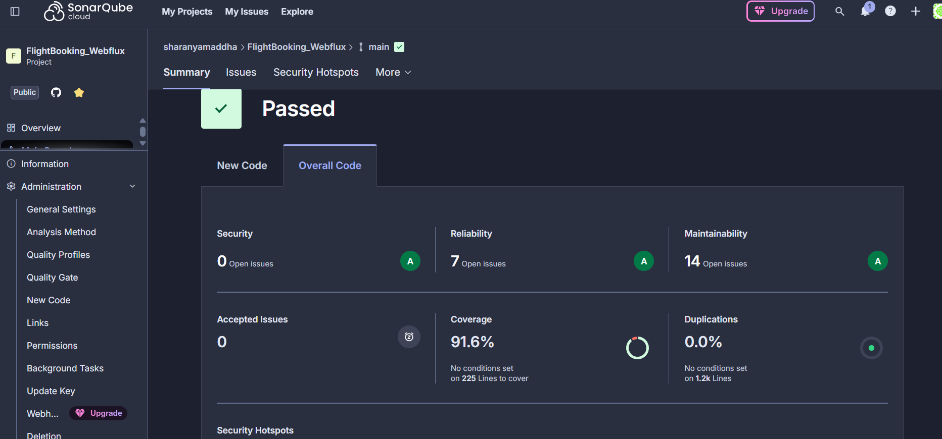
Jacoco report :
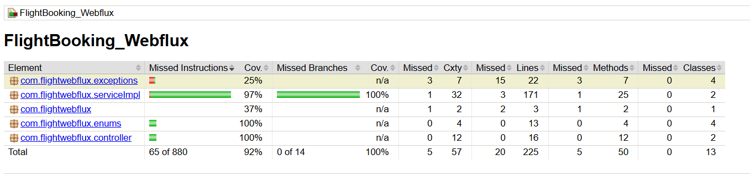
Jmeter Testing
Get request(Get Booked ticket details based on PNR)
1 . 20 requests :-
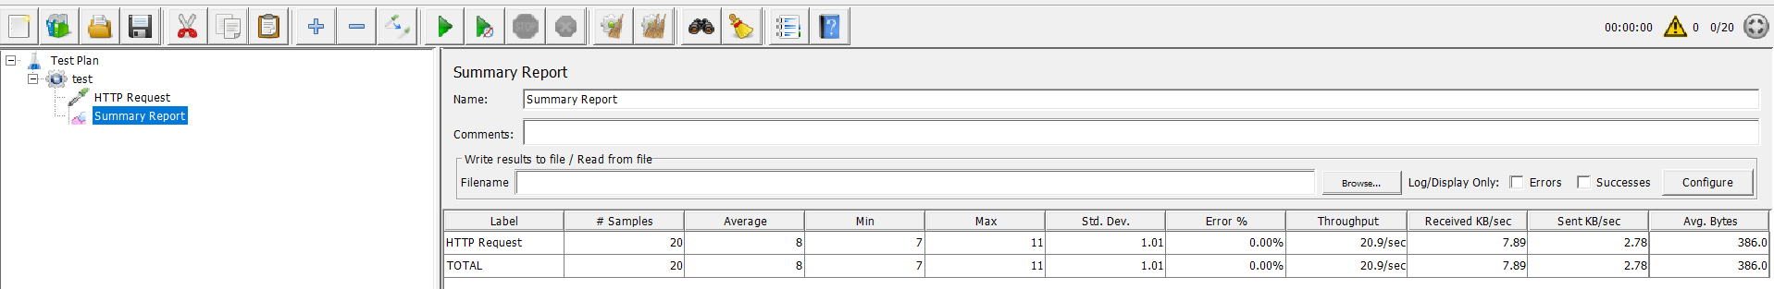

2. 50 requests :-
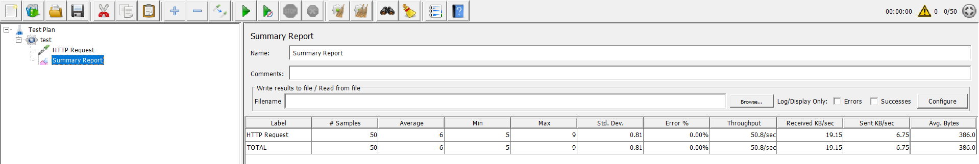

3. 100 requests :-
