SOFTWARE DESIGN DOCUMENT (SDD)

Vehicle Service Management System
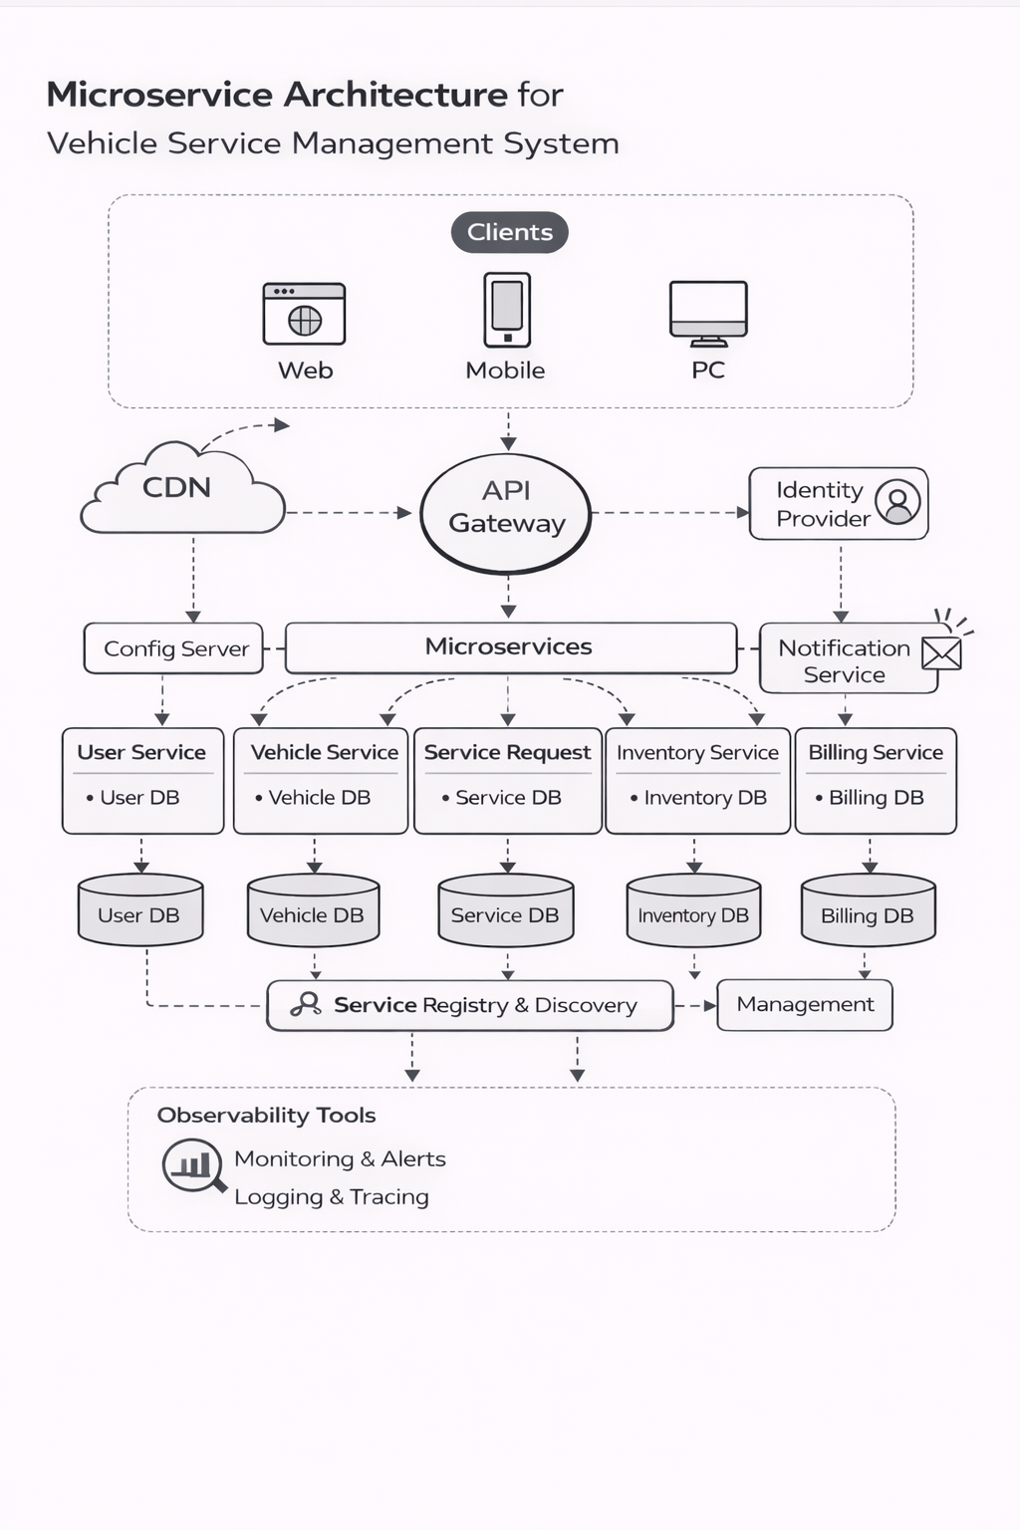

1. DOCUMENT CONTROL
Item | Details
Project Name | Vehicle Service Management System
Version | 1.0
Author | (Maddha Sharanya)
Date | (Date)
Status | Final

2. PURPOSE OF THE DOCUMENT
This document describes the system architecture, design decisions, component structure, APIs, data models, and non-functional aspects of the Vehicle Service Management System.
It is intended for:
- Developers
- Reviewers
- Interview discussions
- Maintenance & enhancement planning

3. SYSTEM OVERVIEW
Business Objective
Provide a scalable, secure, and maintainable system to:
- Manage users
- Manage vehicles
- Manage service requests
- Manage spare parts inventory and billing
High-Level Features
- User registration & login
- Role-based access (Customer / Technician / Manager / Admin)
- Vehicle management and service booking
- Service lifecycle tracking
- Technician assignment and workload management

4. ARCHITECTURE OVERVIEW (HLD)

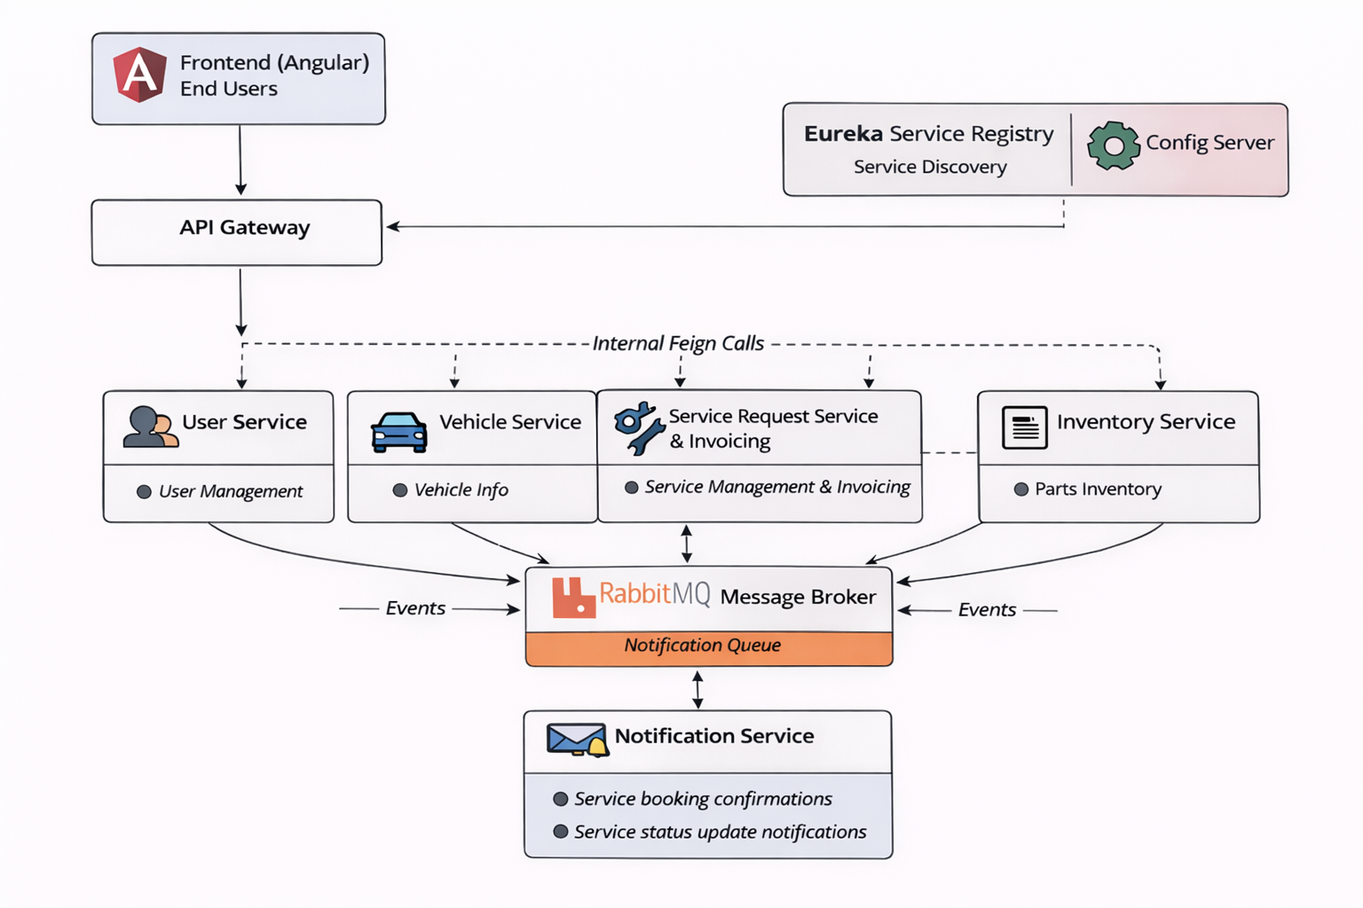
Architecture Style
- Microservices Architecture
- REST-based communication
- Containerized deployment
Core Components
- Angular Frontend
- API Gateway
- User Service
- Service request Service
- Vehicle Service
- Inventory Service
- Billing Service
- Notification Service
- MongoDB (per service)
- Eureka Server
- Config Server
- CI/CD Pipeline

5. TECHNOLOGY STACK
Backend
- Java 17
- Spring Boot
- Spring Web
- Spring Data MongoDB
- Spring Validation
Frontend
- Angular
- Angular Material
- RxJS
Database
- MongoDB (one DB per microservice)
DevOps
- Docker
- Docker Compose
- Jenkins
- SonarQube
Testing
- JUnit 5
- Mockito
- Spring Boot Test
- Jasmine / Karma

6. MICROSERVICES DESIGN
6.1 User Service
Responsibilities
- User registration (customers only)
- Authentication using JWT
- Role management (ADMIN, MANAGER, TECHNICIAN, CUSTOMER)
- Enable / Disable users
- Technician profile & workload tracking

APIs
POST /api/auth/register
POST /api/auth/login
POST /api/users/internal/create
GET /api/users
GET /api/users/role/{role}
PATCH /api/users/{id}/enable
PATCH /api/users/{id}/disable
PATCH /api/users/technicians/{id}/increment
PATCH /api/users/technicians/{id}/decrement

Database
- users collection
- technicians collection

6.2 Vehicle Service
Responsibilities
- Register customer vehicles
- Fetch customer vehicles
- Delete vehicles

APIs
POST /api/vehicles
GET /api/vehicles/customer/{customerId}
DELETE /api/vehicles/{vehicleId}

Database
- products collection

6.3 Service Request Service
Responsibilities
- Create service requests
- Assign technician & service bay
- Manage service lifecycle (REQUESTED → ASSIGNED → IN_PROGRESS → COMPLETED → CLOSED)
- Handle parts request & approval
- Trigger billing & inventory deduction
- Publish service status notifications
- Generate invoice after service closure
- Calculate service cost using inventory & service request data
- Fetch customer invoices
APIs
POST /api/service-requests
GET /api/service-requests/customer/{customerId}
GET /api/service-requests/manager
GET /api/service-requests/technician/{technicianId}
PATCH /api/service-requests/{id}/assign
PATCH /api/service-requests/{id}/status
POST /api/service-requests/{id}/parts/request
PATCH /api/service-requests/{id}/parts/approve
POST /api/invoices/generate/{serviceRequestId}
GET /api/invoices/customer/{customerId}

Database
- service_requests collection
- service_bays collection
- invoices collection

6.4 Inventory Service
Responsibilities
- Maintain spare parts inventory
- Deduct stock during service
- Provide low-stock alerts
- Fetch part details

APIs
POST /api/parts
GET /api/parts
GET /api/parts/{id}
POST /api/parts/deduct
GET /api/parts/alerts/low-stock

Database
- inventory_parts collection

7. DATA DESIGN (LLD)
User Document
{
"id": "u101",
"username": "Sharanya",
"email": "user@test.com",
"password": "encrypted_password",
"role": "CUSTOMER",
"active": true,
"createdAt": "2026-01-01T10:00:00"
}

Technician Document
{
"id": "t201",
"userId": "u102",
"specialization": "ENGINE",
"workload": 2,
"active": true
}

Vehicle Document
{
"id": "v301",
"customerId": "u101",
"registrationNumber": "KA01AB1234",
"make": "Honda",
"model": "City",
"year": 2022,
"vehicleType": "CAR",
"color": "White"
}

Service Request Document

{
"id": "sr401",
"requestNumber": "SR-2AF19C",
"customerId": "u101",
"vehicleId": "v301",
"technicianId": "t201",
"bayNumber": 3,
"priority": "HIGH",
"issue": "Engine overheating",
"status": "IN_PROGRESS",
"usedParts": [
{ "partId": "p501", "qty": 2 }
],
"partsStatus": "PARTS_ISSUED",
"createdAt": "2026-01-01T11:00:00",
"version": 1
}

Inventory Part Document

{
"id": "p501",
"name": "Oil Filter",
"price": 500,
"stock": 50,
"reorderLevel": 10
}

Invoice Document

{
"id": "i601",
"serviceRequestId": "sr401",
"customerId": "u101",
"total": 3500,
"status": "PENDING",
"generatedAt": "2026-01-01T14:00:00"
}

Service Bay Document

{
"id": "b701",
"bayNumber": 3,
"available": false
}

8. API DESIGN & VALIDATION
- RESTful principles
- JSON request/response
- Bean Validation at DTO layer
- Service-level business rule enforcement
- Standard HTTP status codes

9. ERROR HANDLING STRATEGY
Global Exception Handling
- Centralized using @ControllerAdvice
- Standard error response format
{
"timestamp": "2025-01-01T10:00:00",
"status": 400,
"error": "Validation Error",
"message": "Price must be greater than zero"
}

10. SECURITY DESIGN
- Password encryption (BCrypt)
- Role-based access control
- JWT authentication (optional enhancement)
- Secure API access

11. NON-FUNCTIONAL REQUIREMENTS
Area | Design Decision
Scalability | Stateless services, Docker
Performance | Pagination, async calls
Availability | Independent services
Maintainability | POM-like layered backend
Security | Validation, encryption
Observability | Logging & monitoring

12. TESTING STRATEGY
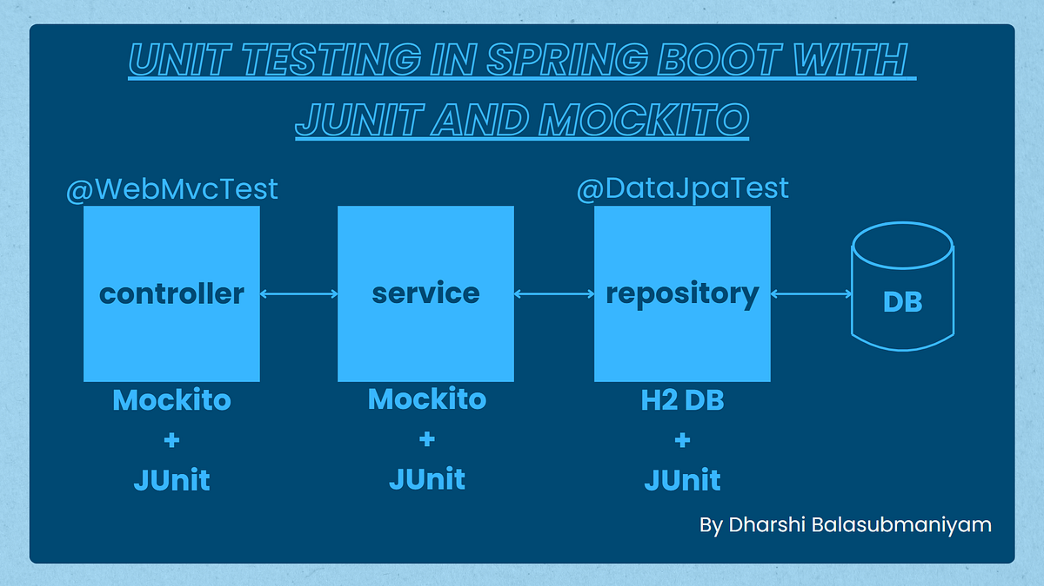

Backend
- Unit tests (Service layer)
- Controller tests (MockMvc)
- Minimum 90% coverage
Frontend
- Component tests
- Service tests
Quality Gates
- SonarQube enforced
- Build fails on violations

13. CI/CD DESIGN
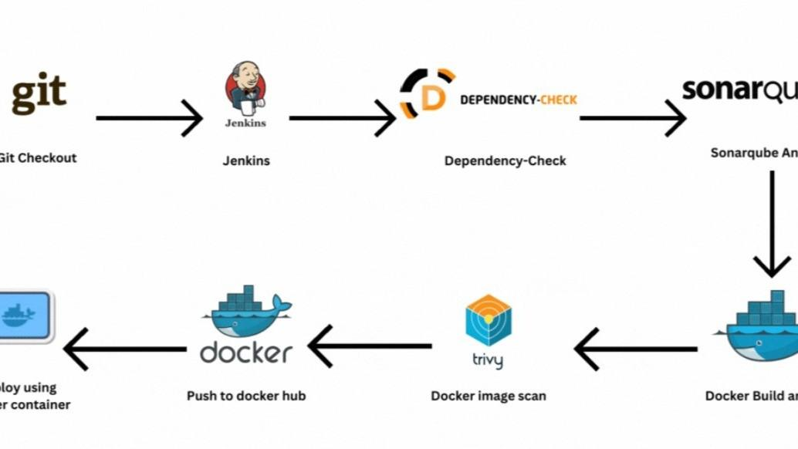

Pipeline Flow
- Git Commit
- Jenkins Build
- Unit Tests
- SonarQube Scan
- Quality Gate Check
- Docker Build
- Docker Compose Deploy

14. DEPLOYMENT DESIGN
- Docker image per microservice
- docker-compose for orchestration
- Environment-specific configs

15. ASSUMPTIONS & CONSTRAINTS
Assumptions
- Services communicate over REST
- MongoDB available
- Docker environment present
Constraints
- No distributed transactions
- Event-driven architecture out of scope

16. FUTURE ENHANCEMENTS
- Spring Cloud Gateway
- Kafka-based async communication
- Kubernetes deployment
- Centralized logging (ELK)

17. CONCLUSION
This design ensures:
✔ Clean separation of concerns
✔ Scalability & maintainability
✔ Testability & CI/CD readiness
✔ Interview-ready explanation

SEQUENCE DIAGRAMS — VEHICLE SERVICE MANAGEMENT SYSTEM

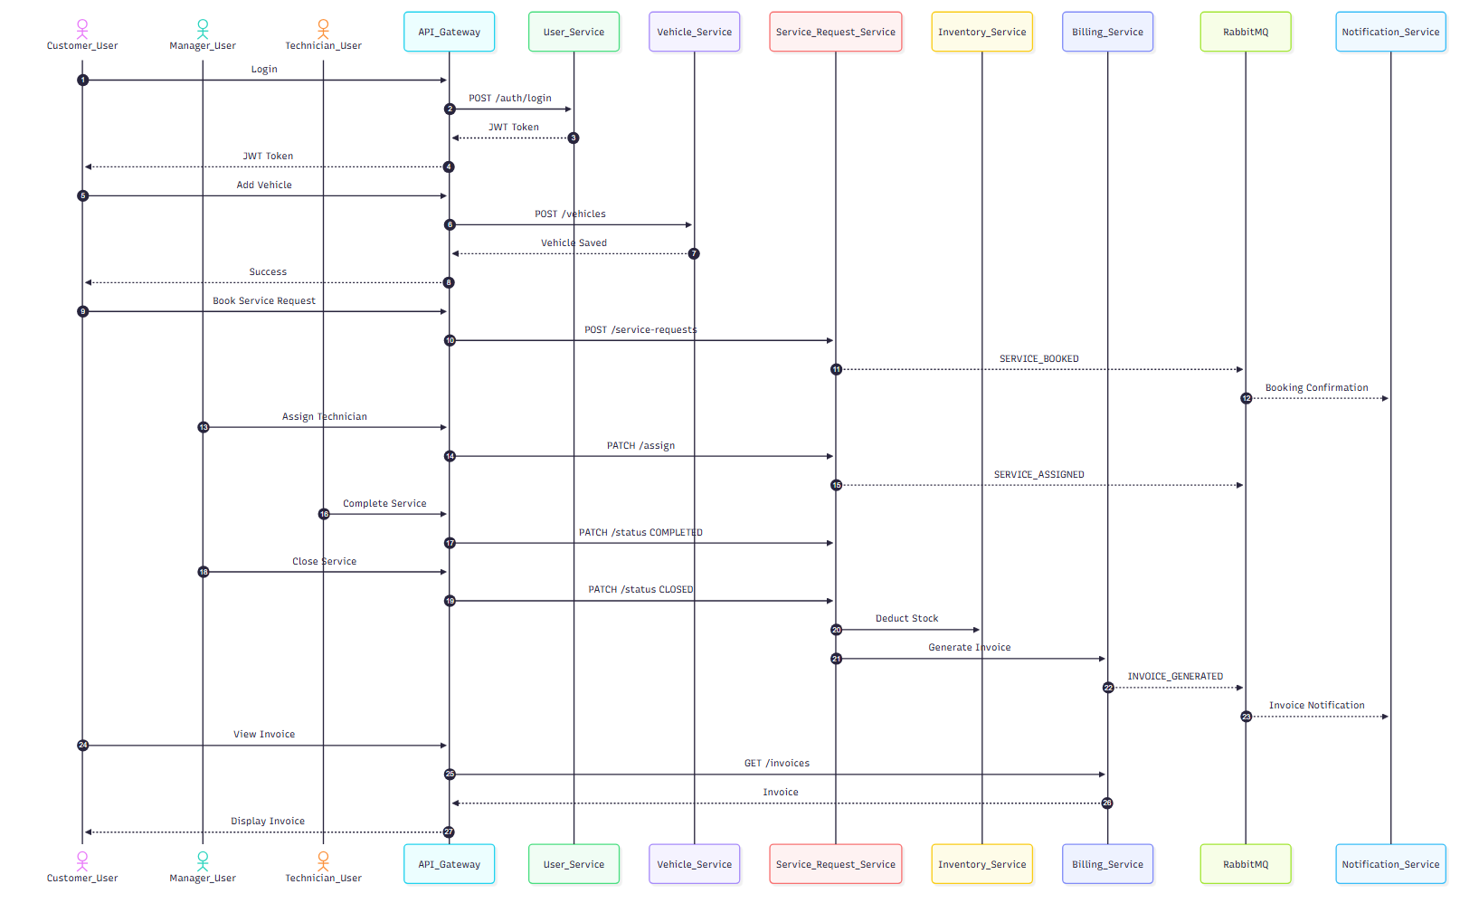

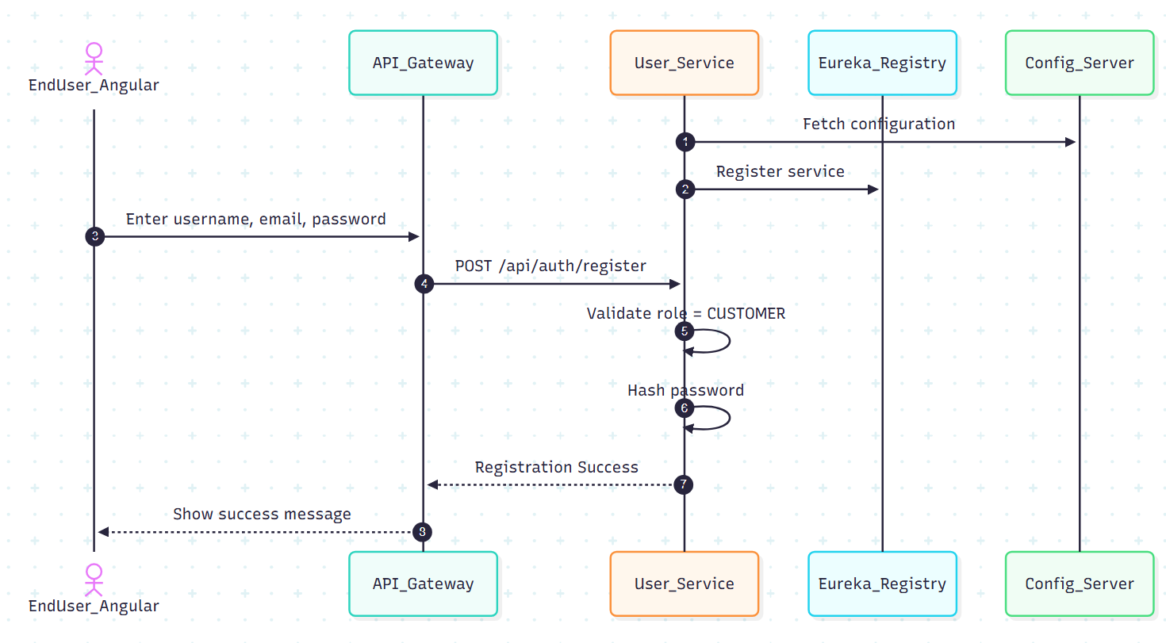
1. User Registration — Sequence Diagram

Scenario
A new user registers using the Angular UI.
Flow
- User enters details in Angular UI
- Angular sends POST /api/auth/register to API Gateway
- API Gateway routes request to User Service
- User Service validates request (email, password)
- User Service checks email uniqueness in MongoDB
- Password is encrypted
- User is saved in MongoDB
- Success response sent back to UI
Participants
- User
- Angular UI
- API Gateway
- User Service
- MongoDB
Key Design Points
- Validation at API boundary
- Encryption at service layer
- No direct DB access from UI

2. User Login — Sequence Diagram
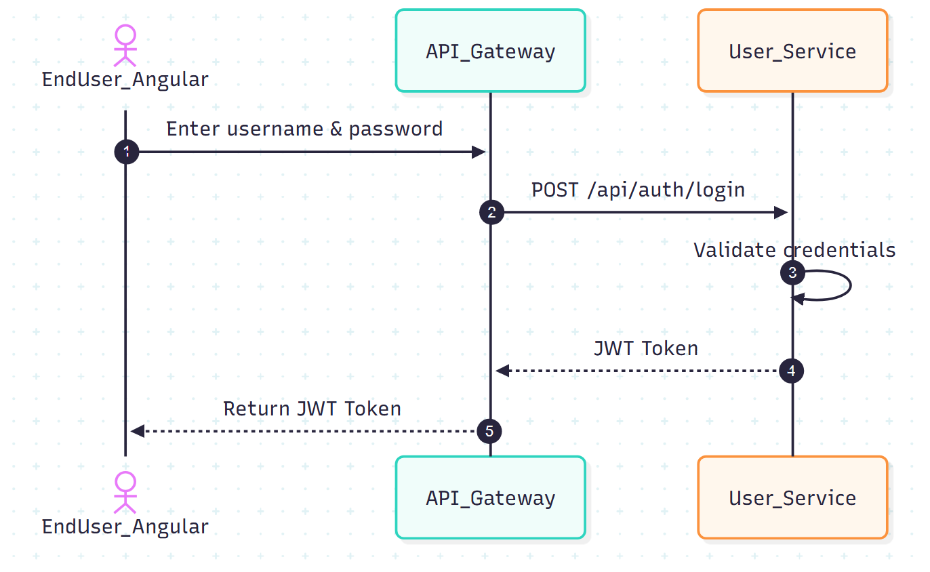

Scenario
A registered user logs into the system.
Flow
- User submits login form
- Angular calls POST /api/auth/login
- API Gateway routes request to User Service
- Password is verified
- JWT token generated
- Response sent to Angular
Participants
- User
- Angular UI
- API Gateway
- User Service
- MongoDB

Key Design Points
- Stateless authentication using JWT
- Token-based authorization

Failure Cases
- Invalid credentials → 401
- Inactive user → 403

3. Vehicle Registration — Sequence Diagram
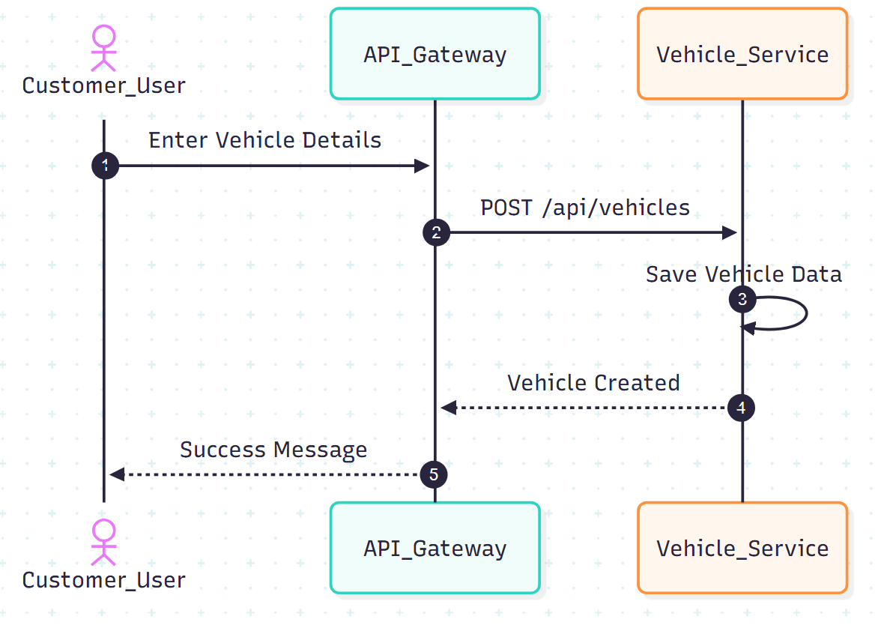

Scenario
Customer registers a vehicle.

Flow
1. Customer enters vehicle details
2. Angular sends POST /api/vehicles to API Gateway
3. API Gateway validates token
4. Password is verified
5. Vehicle Service saves vehicle details in MongoDB
6. Success response returned
Participants
- Customer
- Angular UI
- API Gateway
- Vehicle Service
- MongoDB
Failure Cases
- Invalid credentials → 401
- Inactive user → 403

4. Service Booking — Sequence Diagram
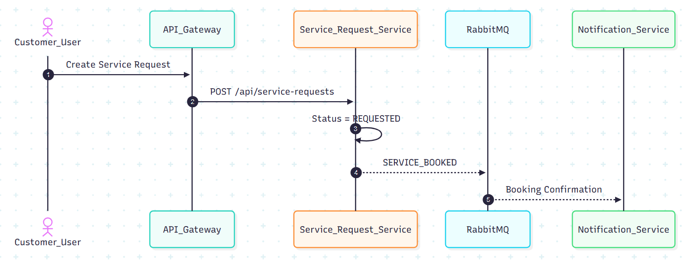
Scenario
Customer books a service request.
Flow
- Customer enters service issue
- Angular sends POST /api/service-requests
- API Gateway routes to Service Request Service
- Service Request created with status REQUESTED
- SERVICE_BOOKED event published to RabbitMQ
- Notification Service sends confirmation

Participants
- Customer
- Angular UI
- API Gateway
- Service Request Service
- RabbitMQ
- Notification Service

Failure Cases
- Invalid credentials → 401
- Inactive user → 403

4. Service Request Management — Sequence Diagram
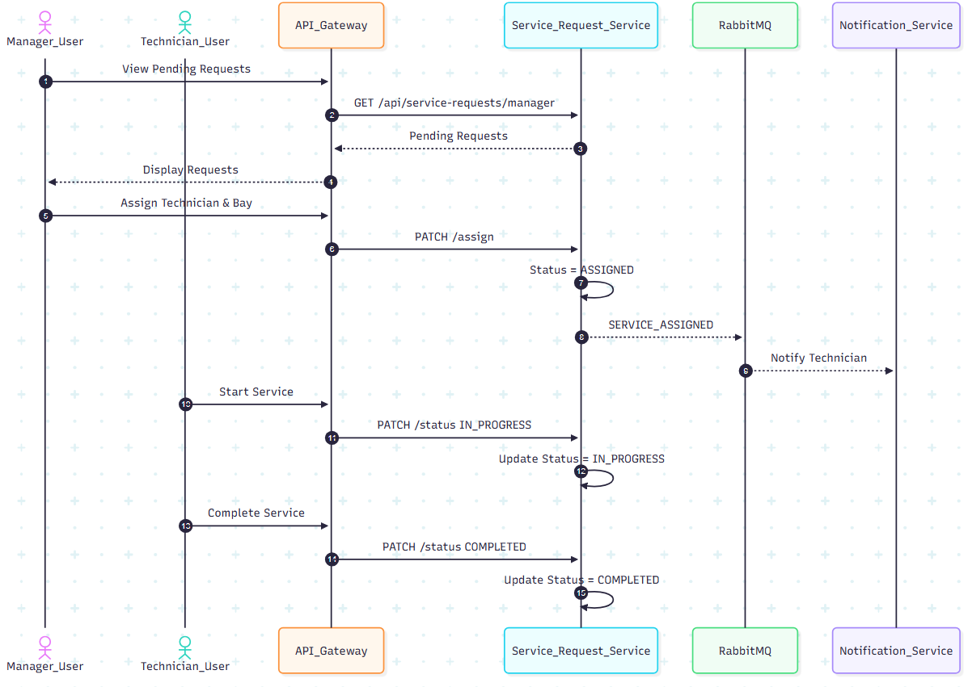

Scenario
Manager assigns technician and technician completes service.
Flow
- Manager fetches pending requests
- Manager assigns technician & bay
- Status updated to ASSIGNED
- Technician updates status to IN_PROGRESS
- Technician completes job → status COMPLETED
Participants
- Manager
- Technician
- Angular UI
- API Gateway
- Service Request Service

Key Design Points
- Optimistic locking
- Role based access control

5. Invoice Generation — Sequence Diagram
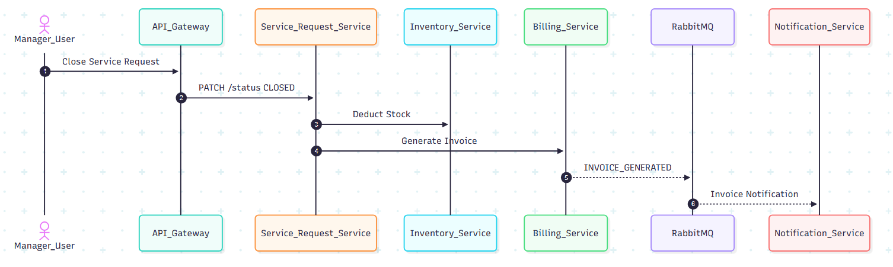

Scenario
Manager closes service & invoice is generated.
Flow
- Manager closes service
- Service Request Service deducts inventory
- Billing Service calculates cost
- Invoice stored in MongoDB
- INVOICE_GENERATED event sent
- Customer receives notification

Participants
- Manager
- Angular UI
- API Gateway
- Service Request Service
- Inventory Service
- Billing Service
- Notification Service
Key Design Decisions
- Inter-service communication using Feign
- Billing only after service closure

6. CI/CD Pipeline — Sequence Diagram
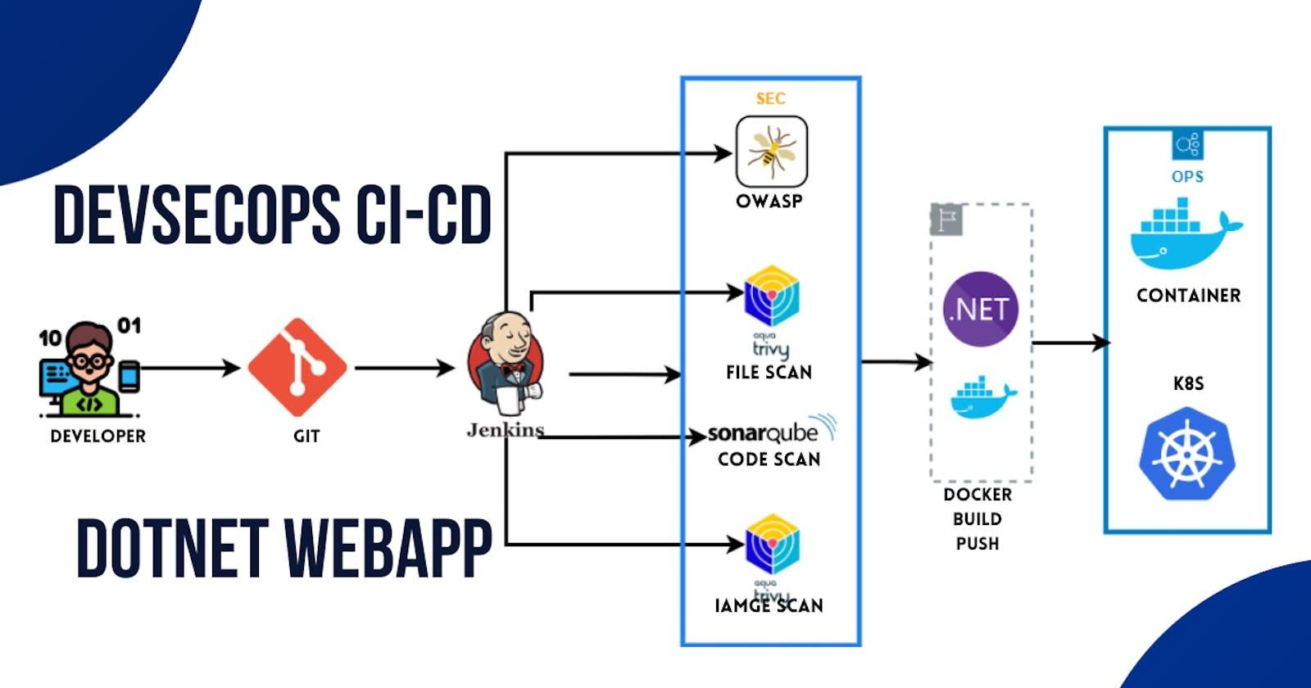

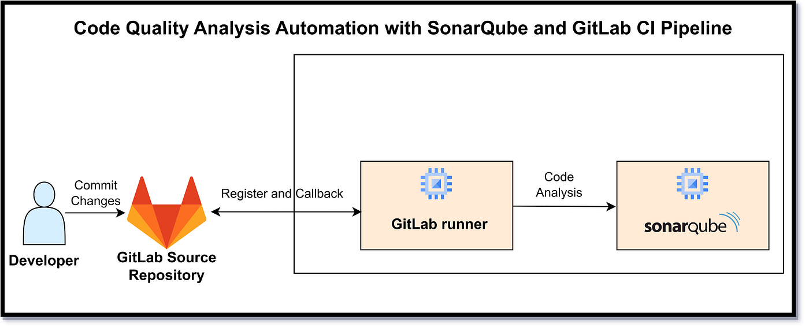
Scenario
Developer pushes code to Git repository.
Flow
- Developer pushes code
- Jenkins pipeline triggered
- Jenkins runs unit tests
- Jenkins runs SonarQube scan
- Quality gate checked
- Docker images built
- Docker Compose deploys services
Participants
- Developer
- Git
- Jenkins
- SonarQube
- Docker

7. Error Handling — Sequence Diagram
Scenario
Invalid request sent to backend.
Flow
- Angular sends invalid request
- Controller validation fails
- Global exception handler triggered
- Standard error response returned
Key Point
- Consistent error structure across services

HOW TO EXPLAIN IN INTERVIEWS
“We use sequence diagrams to show runtime behavior.
Each diagram highlights service boundaries, validation points, and data ownership, ensuring clean microservices communication.”
----- upto here ------

SEQUENCE → CODE CLASS MAPPING
1) User Registration
Sequence Steps
- User submits registration form
- API receives request
- Validate input & business rules
- Encrypt password
- Persist user
- Return response

Code Mapping (User Service)
Step | Layer | Class | Responsibility
1 | Angular | RegisterComponent | Collect form data
2 | Angular | AuthService | POST /users/register
3 | API | AuthController | Request mapping
4 | DTO | UserRegisterRequest | Bean validation
5 | Service | UserServiceImpl | Uniqueness checks
6 | Security | PasswordEncoderConfig | BCrypt encryption
7 | Repo | UserRepository | Save user
8 | API | AuthController | Return response
Key Methods
- UserController.register(UserRegisterRequest)
- UserService.registerCustomer(...)
- UserRepository.existsByEmail(...)

2) User Login
Sequence Steps
- User submits login form
- Validate credentials
- Generate JWT token
- Return token
Code Mapping
Step | Layer | Class | Responsibility
1 | Angular | LoginComponent | Capture credentials
2 | Angular | AuthService | POST /users/login
3 | API | AuthController | Handle login
4 | Repo | UserRepository | Find by email
5 | Service | AuthService | Password match
6 | Security | JwtTokenProvider | Create JWT
7 | API | AuthController | Return token
Key Methods
- AuthController.login(LoginRequest)
- UserService.login(...)

3) Vehicle Registration
Sequence Steps
- Customer submits vehicle details
- Validate ownership
- Persist vehicle
Code Mapping (Product Service)
Step | Layer | Class | Responsibility
1 | Angular | AddVehicleComponent | Load products
2 | Angular | VehicleService | POST/api/vehicles
3 | API | VehicleController | Request Mapping
4 | DTO | ProductService | Bean validation
5 | Service | ProductRepository | Map DTO to entity
6 | Repo | VehicleRepository | Save Vehicle

Key Methods
- VehicleController.create(VehicleRequest)
- VehicleService.addVehicle(...)

4) Service Booking
Sequence Steps
- Customer submits service issue
- Create service request
- Publish booking event
Code Mapping (Service Request Services)
Step | Layer | Class | Responsibility
1 | Angular | BookServiceComponent | Collect issue
2 | Angular | ServiceRequestService | POST /api/service-requests
3 | API | ServiceRequestController | Request mapping
4 | DTO | ServiceRequestCreateDTO | Validate input
5 | Service | ServiceRequestServiceImpl | Create service request
6 | Repository | ServiceRequestRepository | Save request
7 | Messaging | RabbitPublisher | Publish SERVICE_BOOKED
Key Methods
- ServiceRequestController.create()
- ServiceRequestServiceImpl.createRequest()

5) Service Management
Sequence Steps
- Manager assigns technician
- Technician updates status
- Manager closes service
Code Mapping
Step | Layer | Class | Responsibility
1 | Angular | ManagerDashboard | Fetch pending requests
2 | Angular | ServiceRequestService | PATCH /assign/{id}
3 | API | ServiceRequestController | Request mapping
4 | DTO | AssignTechnicianDTO | Validate request
5 | Service | ServiceRequestServiceImpl | Assign technician
6 | Repository | ServiceRequestRepository | Save changes
Key Methods
- assignTechnician(id,dto)
- updateStatus(id,dto)

6) Invoice Generation
Sequence Steps
- Manager closes service
- Deduct inventory
- Generate invoice
Code Mapping
Step | Layer | Class | Responsibility
1 | Angular | BillingComponent | Trigger invoice
2 | Angular | BillingService | POST /api/invoices/generate/{id}
3 | API | BillingController | Request mapping
Key Classes
- BillingController.generate()
- BillingServiceImpl.generateInvoice()

7) CI/CD with SonarQube
Sequence Steps
- Git push
- Build & tests
- Sonar scan
- Quality gate
- Docker build
- Deploy
Code/Config Mapping
Step | Tool | File/Class
1 | Git | Repository
2 | Jenkins | Jenkinsfile
3 | Maven | pom.xml
4 | SonarQube | sonar-project.properties
5 | Docker | Dockerfile
6 | Compose | docker-compose.yml

TRACEABILITY (WHY THIS MATTERS)
- Sequence step → Controller → Service → Repository
- Every business rule is enforced either in DTO validation or service logic
- Easy to explain end-to-end flow in interviews

How to explain succinctly
“Each sequence diagram step maps directly to a controller endpoint, a service orchestration method, and a repository call. Validation is enforced at DTO and service layers, and failures are handled centrally.”
CODE SKELETON — PACKAGES & CLASSES

1. USER SERVICE (user-service)
user-service
└─ src/main/java/com/example/user
├─ UserServiceApplication.java
│
├─ controller
│ └─ UserController.java
│
├─ service
│ ├─ UserService.java
│ └─ UserServiceImpl.java
│
├─ repository
│ └─ UserRepository.java
│
├─ model
│ └─ User.java
│
├─ dto
│ ├─ UserRegisterRequest.java
│ ├─ LoginRequest.java
│ └─ UserResponse.java
│
├─ exception
│ ├─ UserNotFoundException.java
│ ├─ DuplicateUserException.java
│ └─ GlobalExceptionHandler.java
│
└─ config
└─ SecurityConfig.java
Key Responsibilities
- UserController → API layer
- UserService → Business rules
- UserRepository → MongoDB access
- SecurityConfig → Password encoding / JWT (optional)

2. PRODUCT SERVICE (product-service)
product-service
└─ src/main/java/com/example/product
├─ ProductServiceApplication.java
│
├─ controller
│ └─ ProductController.java
│
├─ service
│ ├─ ProductService.java
│ ├─ ProductServiceImpl.java
│ └─ InventoryService.java
│
├─ repository
│ └─ ProductRepository.java
│
├─ model
│ └─ Product.java
│
├─ dto
│ ├─ ProductRequest.java
│ └─ ProductResponse.java
│
└─ exception
├─ ProductNotFoundException.java
└─ GlobalExceptionHandler.java
Key Responsibilities
- InventoryService → Stock validation & update
- ProductServiceImpl → Core business logic

3. ORDER SERVICE (order-service)
order-service
└─ src/main/java/com/example/order
├─ OrderServiceApplication.java
│
├─ controller
│ └─ OrderController.java
│
├─ service
│ ├─ OrderService.java
│ ├─ OrderServiceImpl.java
│ └─ OrderStatusValidator.java
│
├─ client
│ ├─ ProductClient.java
│ └─ UserClient.java
│
├─ repository
│ └─ OrderRepository.java
│
├─ model
│ ├─ Order.java
│ └─ OrderItem.java
│
├─ dto
│ ├─ OrderRequest.java
│ ├─ OrderItemRequest.java
│ └─ OrderResponse.java
│
└─ exception
├─ OrderNotFoundException.java
└─ GlobalExceptionHandler.java
Key Responsibilities
- ProductClient → Calls Product Service
- OrderStatusValidator → Valid status transitions
- OrderServiceImpl → Orchestrates order flow

4. COMMON / SHARED CONCEPTS (Optional)
common
└─ src/main/java/com/example/common
├─ exception
│ └─ ApiErrorResponse.java
│
├─ util
│ └─ Constants.java
│
└─ config
└─ SwaggerConfig.java

5. ANGULAR FRONTEND (angular-ui)
angular-ui
└─ src/app
├─ core
│ ├─ services
│ │ ├─ auth.service.ts
│ │ ├─ product.service.ts
│ │ └─ order.service.ts
│ │
│ └─ guards
│ └─ auth.guard.ts
│
├─ modules
│ ├─ auth
│ │ ├─ login.component.ts
│ │ └─ register.component.ts
│ │
│ ├─ product
│ │ └─ product-list.component.ts
│ │
│ └─ order
│ ├─ checkout.component.ts
│ └─ order-history.component.ts
│
├─ shared
│ └─ models
│ ├─ user.model.ts
│ ├─ product.model.ts
│ └─ order.model.ts
│
└─ app.module.ts

6. TEST STRUCTURE (IMPORTANT)
src/test/java
└─ com/example
├─ controller
│ └─ UserControllerTest.java
├─ service
│ ├─ UserServiceTest.java
│ └─ OrderServiceTest.java
└─ repository
└─ ProductRepositoryTest.java

7. DEVOPS & CI/CD FILES
capstone-project
├─ Jenkinsfile
├─ docker-compose.yml
├─ user-service/Dockerfile
├─ product-service/Dockerfile
├─ order-service/Dockerfile
├─ angular-ui/Dockerfile
└─ README.md

HOW TO EXPLAIN THIS IN INTERVIEWS
“Each microservice follows a layered architecture: Controller → Service → Repository.
Clients handle inter-service communication.
DTOs isolate API contracts.
Business rules live in the service layer.
This makes the system scalable, testable, and maintainable.”
STARTER REPO
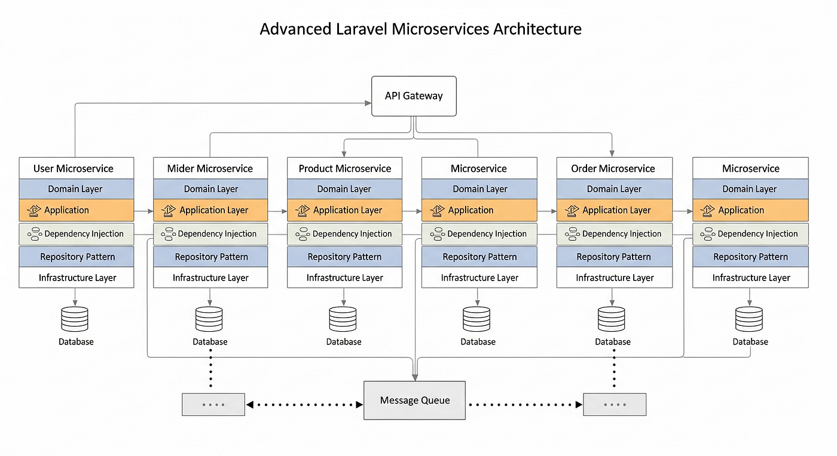

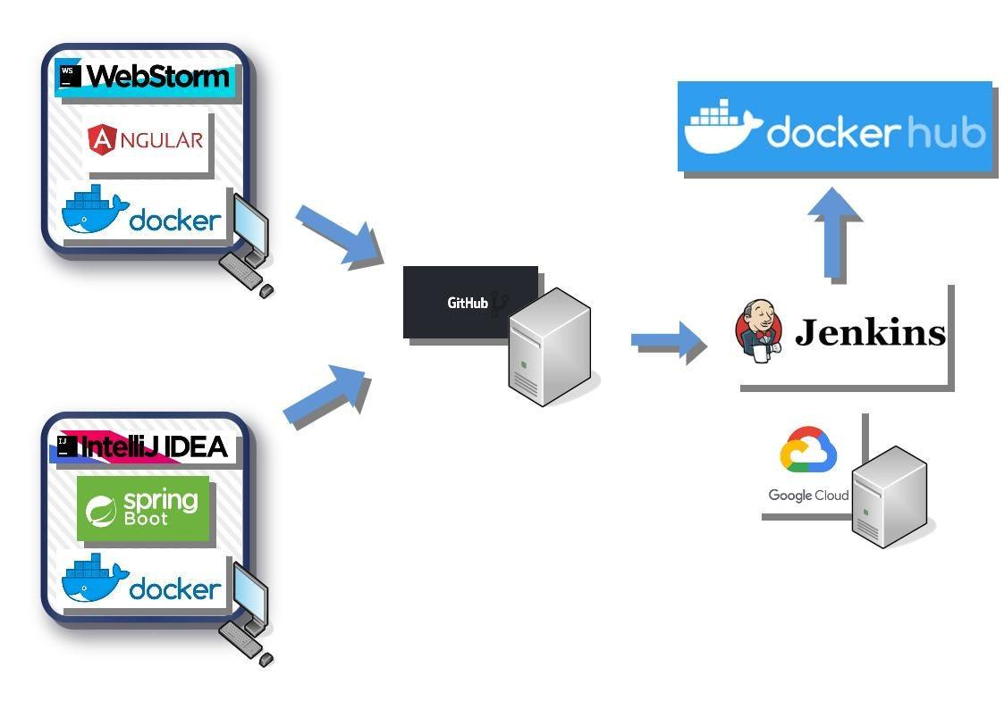

1. REPOSITORY STRUCTURE (ROOT)
smart-order-management/
│
├─ user-service/
├─ product-service/
├─ order-service/
├─ angular-ui/
│
├─ common/
│
├─ docker-compose.yml
├─ Jenkinsfile
├─ .gitignore
├─ README.md
You can create this repo as-is in GitHub.

2. USER SERVICE (Spring Boot)
user-service/
├─ src/main/java/com/example/user
│ ├─ UserServiceApplication.java
│ │
│ ├─ controller
│ │ └─ UserController.java
│ │
│ ├─ service
│ │ ├─ UserService.java
│ │ └─ UserServiceImpl.java
│ │
│ ├─ repository
│ │ └─ UserRepository.java
│ │
│ ├─ model
│ │ └─ User.java
│ │
│ ├─ dto
│ │ ├─ UserRegisterRequest.java
│ │ ├─ LoginRequest.java
│ │ └─ UserResponse.java
│ │
│ ├─ exception
│ │ ├─ DuplicateUserException.java
│ │ └─ GlobalExceptionHandler.java
│ │
│ └─ config
│ └─ SecurityConfig.java
│
├─ src/test/java/com/example/user
│ ├─ controller/UserControllerTest.java
│ └─ service/UserServiceTest.java
│
├─ Dockerfile
├─ pom.xml
└─ application.yml

3. PRODUCT SERVICE
product-service/
├─ src/main/java/com/example/product
│ ├─ ProductServiceApplication.java
│ ├─ controller/ProductController.java
│ ├─ service
│ │ ├─ ProductService.java
│ │ ├─ ProductServiceImpl.java
│ │ └─ InventoryService.java
│ ├─ repository/ProductRepository.java
│ ├─ model/Product.java
│ ├─ dto/ProductRequest.java
│ └─ exception/GlobalExceptionHandler.java
│
├─ src/test/java/com/example/product
│ └─ service/ProductServiceTest.java
│
├─ Dockerfile
├─ pom.xml
└─ application.yml

4. ORDER SERVICE
order-service/
├─ src/main/java/com/example/order
│ ├─ OrderServiceApplication.java
│ ├─ controller/OrderController.java
│ ├─ service
│ │ ├─ OrderService.java
│ │ ├─ OrderServiceImpl.java
│ │ └─ OrderStatusValidator.java
│ ├─ client
│ │ ├─ ProductClient.java
│ │ └─ UserClient.java
│ ├─ repository/OrderRepository.java
│ ├─ model
│ │ ├─ Order.java
│ │ └─ OrderItem.java
│ └─ dto/OrderRequest.java
│
├─ src/test/java/com/example/order
│ └─ service/OrderServiceTest.java
│
├─ Dockerfile
├─ pom.xml
└─ application.yml

5. ANGULAR FRONTEND
angular-ui/
├─ src/app
│ ├─ core
│ │ ├─ services
│ │ │ ├─ auth.service.ts
│ │ │ ├─ product.service.ts
│ │ │ └─ order.service.ts
│ │ └─ guards/auth.guard.ts
│ │
│ ├─ modules
│ │ ├─ auth
│ │ │ ├─ login.component.ts
│ │ │ └─ register.component.ts
│ │ ├─ product/product-list.component.ts
│ │ └─ order/checkout.component.ts
│ │
│ └─ shared/models
│ ├─ user.model.ts
│ ├─ product.model.ts
│ └─ order.model.ts
│
├─ Dockerfile
└─ angular.json

6. DOCKER COMPOSE
version: '3.8'

services:
mongodb:
image: mongo
ports:
- "27017:27017"

user-service:
build: ./user-service
ports:
- "8081:8081"
depends_on:
- mongodb

product-service:
build: ./product-service
ports:
- "8082:8082"
depends_on:
- mongodb

order-service:
build: ./order-service
ports:
- "8083:8083"
depends_on:
- mongodb

angular-ui:
build: ./angular-ui
ports:
- "4200:80"

7. JENKINSFILE (CI/CD + SONARQUBE)
pipeline {
agent any

stages {
stage('Checkout') {
steps { git 'https://github.com/your-org/smart-order-management.git' }
}

stage('Build & Test') {
steps { sh 'mvn clean test' }
}

stage('SonarQube Scan') {
steps {
withSonarQubeEnv('SonarQube') {
sh 'mvn sonar:sonar'
}
}
}

stage('Quality Gate') {
steps {
timeout(time: 2, unit: 'MINUTES') {
waitForQualityGate abortPipeline: true
}
}
}

stage('Docker Build & Deploy') {
steps {
sh 'docker-compose up -d --build'
}
}
}
}

8. README.md (MINIMAL TEMPLATE)
# Smart Order Management System

## Tech Stack
- Spring Boot Microservices
- Angular
- MongoDB
- Docker
- Jenkins + SonarQube

## Run Locally
docker-compose up -d

## Services
- User Service: 8081
- Product Service: 8082
- Order Service: 8083
- UI: http://localhost:4200

Map design → code structure
Tell me what you want to generate next.

