Architecture Diagram :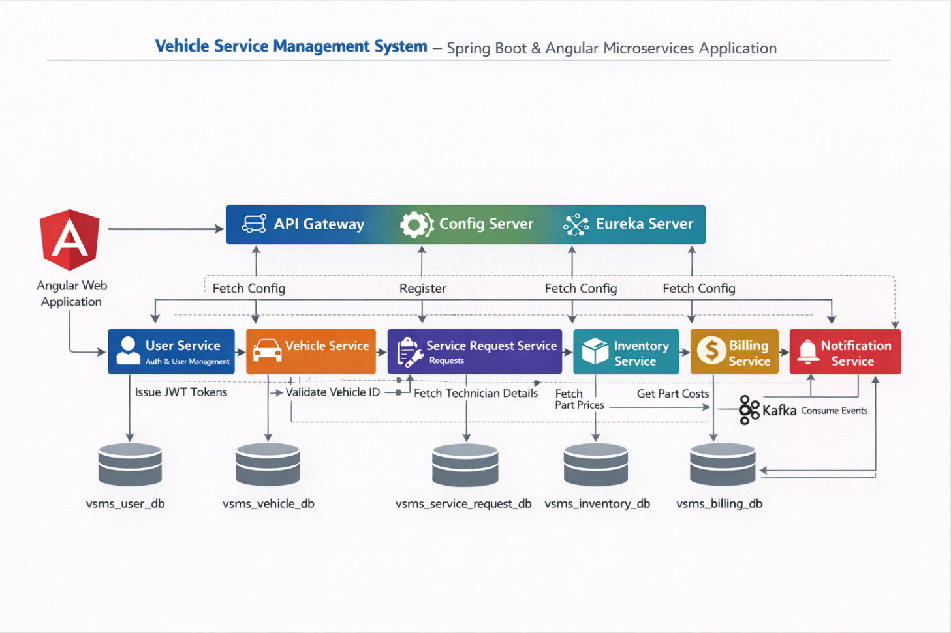

ER DIAGRAM :
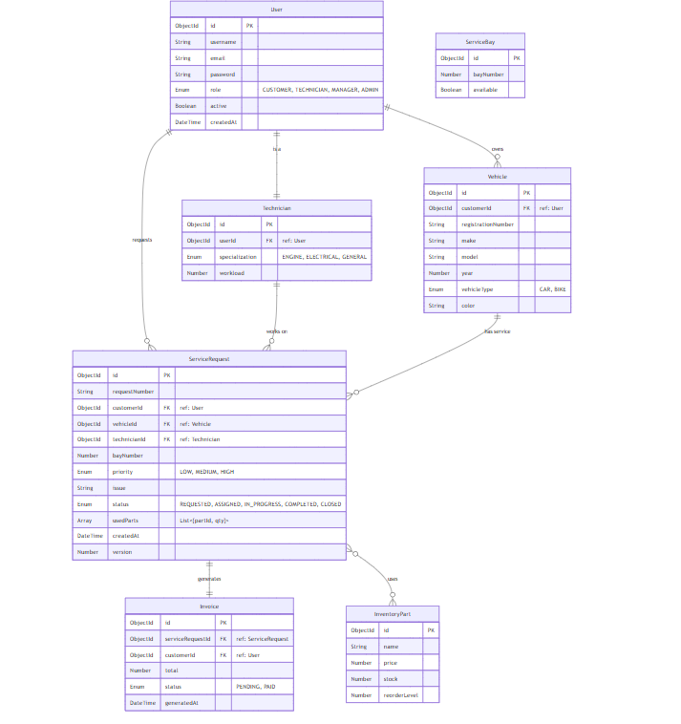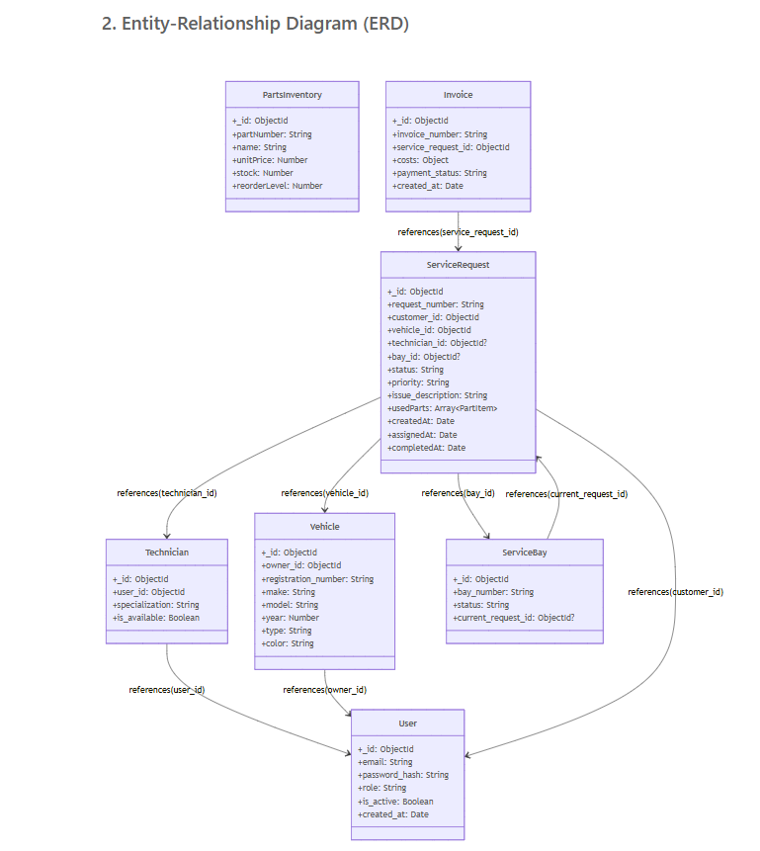

Final Microservices
config-server
eureka-server
notification-service
user-service
vehicle-service
service-request-service
inventory-service
billing-service
api-gateway
Data Model :

1️. User
User {
_id: String,
email: String,
passwordHash: String,
role: Enum,
active: Boolean,
createdAt: Date
}

2️. Technician
Technician {
_id: String,
userId: String,
specialization: Enum,
available: Boolean,
managerId: String | null
}

3️. Vehicle
Vehicle {
_id: String,
ownerId: String,
registrationNumber: String,
make: String,
model: String,
year: Number,
type: Enum, // CAR | BIKE | TRUCK
color: String
}

4️. UsedPart (Embedded Object)
UsedPart {
partId: String, // p501
qty: Number
}

5️. ServiceRequest
ServiceRequest {
_id: String,
requestNumber: String,
vehicleId: String,
customerId: String,
technicianId: String,
bayId: String,
priority: Enum, // LOW | NORMAL | HIGH
status: Enum, // REQUESTED | ASSIGNED | IN_PROGRESS | COMPLETED
issue: String,
usedParts: UsedPart[],
createdAt: Date
}

6️. InventoryPart
InventoryPart {
_id: String,
name: String,
price: Number,
stock: Number,
reorderLevel: Number
}

7️. Invoice
Invoice {
_id: String,
serviceRequestId: String,
total: Number,
status: Enum // PENDING | PAID
}

DB DESIGN :
1.USER-SERVICE → USER_DB

users
{
"_id": "u101",
"email": "user@test.com",
"passwordHash": "...",
"role": "CUSTOMER",
"active": true,
"createdAt": "2024-12-28"
}

technicians
{
"_id": "t301",
"userId": "u301",
"specialization": "Engine",
"available": true
}

2. VEHICLE-SERVICE → VEHICLE_DB
{
"_id": "v201",
"ownerId": "u101",
"registrationNumber": "KA01AB1234",
"make": "Honda",
"model": "City",
"year": 2022,
"type": "CAR",
"color": "White"
}

3. SERVICE-REQUEST-SERVICE → SERVICE_REQUEST_DB
{
"_id": "sr301",
"requestNumber": "SR-001",
"vehicleId": "v201",
"customerId": "u101",
"technicianId": "t301",
"bayId": "b801",
"priority": "NORMAL",
"status": "REQUESTED",
"issue": "Engine noise",
"usedParts": [
{ "partId": "p501", "qty": 2 }
],
"createdAt": "2024-12-28"
}

4. INVENTORY-SERVICE → INVENTORY_DB
{
"_id": "p501",
"name": "Engine Oil",
"price": 2500,
"stock": 40,
"reorderLevel": 10
}

5. BILLING-SERVICE → BILLING_DB
{
"_id": "i701",
"serviceRequestId": "sr301",
"total": 5900,
"status": "PENDING"
}

API DESIGN

Vehicle Service Management System

Core API Design – Request & Response Payloads

1. USER SERVICE
Method | Endpoint | Request Payload | Response Payload
POST | /api/auth/register | { "email":"tech@test.com", "password":"123456", "role":"TECHNICIAN" } | { "message":"Registration successful. Pending admin approval." }
POST | /api/auth/login | { "email":"admin@test.com", "password":"123456" } | { "token":"jwt-token", "role":"ADMIN", "userId":"u001" }
GET | /api/auth/profile | — | { "userId":"u001", "email":"admin@test.com", "role":"ADMIN" }
GET | /api/users | — | [ { "_id":"u101", "email":"user@test.com", "role":"CUSTOMER", "active":true } ]
GET | /api/users/pending | — | [ { "_id":"u301", "email":"tech@test.com", "role":"TECHNICIAN", "active":false } ]
PATCH | /api/users/{id}/approve | — | { "message":"User approved" }
POST | /api/users/technicians | { "userId":"u301", "specialization":"Engine", "available":true } | { "_id":"t301", "userId":"u301", "managerId":null }

3. VEHICLE SERVICE
Method | Endpoint | Request Payload | Response Payload
POST | /api/vehicles | { "ownerId":"u101","registrationNumber":"KA01AB1234","make":"Honda","model":"City","year":2022,"type":"CAR","color":"White" } | { "_id":"v201","ownerId":"u101" }
GET | /api/vehicles/customer/{userId} | — | [ { "_id":"v201","registrationNumber":"KA01AB1234","model":"City" } ]
PUT | /api/vehicles/{id} | { "color":"Black" } | { "message":"Vehicle updated" }
DELETE | /api/vehicles/{id} | — | { "message":"Vehicle deleted" }

4. SERVICE REQUEST SERVICE
Method | Endpoint | Request Payload | Response Payload
POST | /api/service-requests | { "vehicleId":"v201","customerId":"u101","priority":"NORMAL","issue":"Engine noise" } | { "_id":"sr301","status":"REQUESTED" }
GET | /api/service-requests/customer/{id} | — | [ { "_id":"sr301","status":"REQUESTED" } ]
GET | /api/service-requests/manager/{id} | — | [ { "_id":"sr301","technicianId":"t301" } ]
PATCH | /api/service-requests/{id}/assign | { "technicianId":"t301","bayId":"b801" } | { "message":"Assigned successfully" }
PATCH | /api/service-requests/{id}/status | { "status":"COMPLETED" } | { "message":"Status updated" }

5.INVENTORY SERVICE
Method | Endpoint | Request Payload | Response Payload
POST | /api/parts | { "name":"Engine Oil","price":2500,"stock":40,"reorderLevel":10 } | { "_id":"p501","name":"Engine Oil" }
GET | /api/parts | — | [ { "_id":"p501","stock":40 } ]

6.BILLING SERVICE
Method | Endpoint | Request Payload | Response Payload
POST | /api/invoices/generate/{serviceRequestId} | — | { "_id":"i701","total":5900,"status":"PENDING" }
GET | /api/invoices/customer/{customerId} | — | [ { "_id":"i701","total":5900,"status":"PENDING" } ]
PATCH | /api/invoices/{id}/pay | — | { "message":"Payment successful" }

ADDITIONAL APIS

USER SERVICE – ADDITIONAL APIs
Method | Endpoint | Description
GET | /api/users/{id} | Get user by ID
GET | /api/users/technicians/available | List only available technicians
GET | /api/users/technicians/manager/{managerId} | Technicians under a manager
GET | /api/users/technicians/status/{status} | Technicians by availability

SERVICE REQUEST – FILTER APIs
Method | Endpoint | Description
GET | /api/service-requests/status/{status} | Filter by status
GET | /api/service-requests/priority/{priority} | Filter by priority
GET | /api/service-requests/date/{date} | Filter by date

