**ML-Flow tracking**

**Introduction to Experiment Tracking**

**Terminologies:**

1. Experiment
2. Run
3. Metadata (i.e. Tags, Parameters, Metrics)
4. Artifacts (i.e. Output files associated with experiment runs)

**What do you want to track for each Experiment Run?**

1. Training and Validation Data Used
2. Hyperparameters
3. Metrics
4. Models

**Why Track?**

Organization Optimization Reproducibility

**Tool – MLFlow**

MLFlow helps you to organize your experiments into runs.

**MLFlow keeps track of:**

Tags,Parameters  
Metrics  
Models  
Artifact  
Source code, Start and End Time, Authors etc..

**Run below mentioned commands to install mlflow on your system:**

pip install mlflow

mlflow ui --backend-store-uri sqlite:///mlflow.db

**Step1:**

Pip install mlflow (at cmd)

mlflow ui( port number will be poped out use that in your local system use that for tracking your’s experiment)

in the highlighted part error occurred because of invalid path

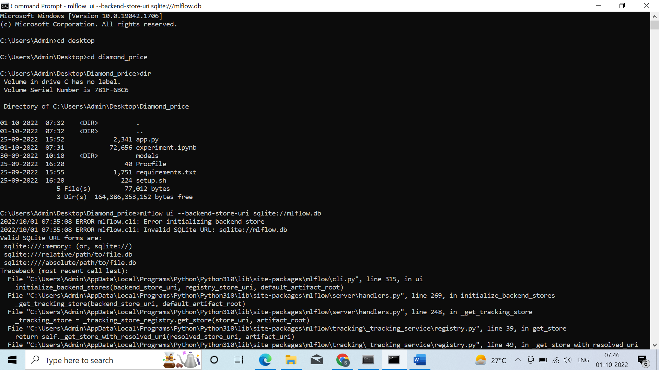



In this highlighted part error is resolved by giving correct path and on local host error will be also resolved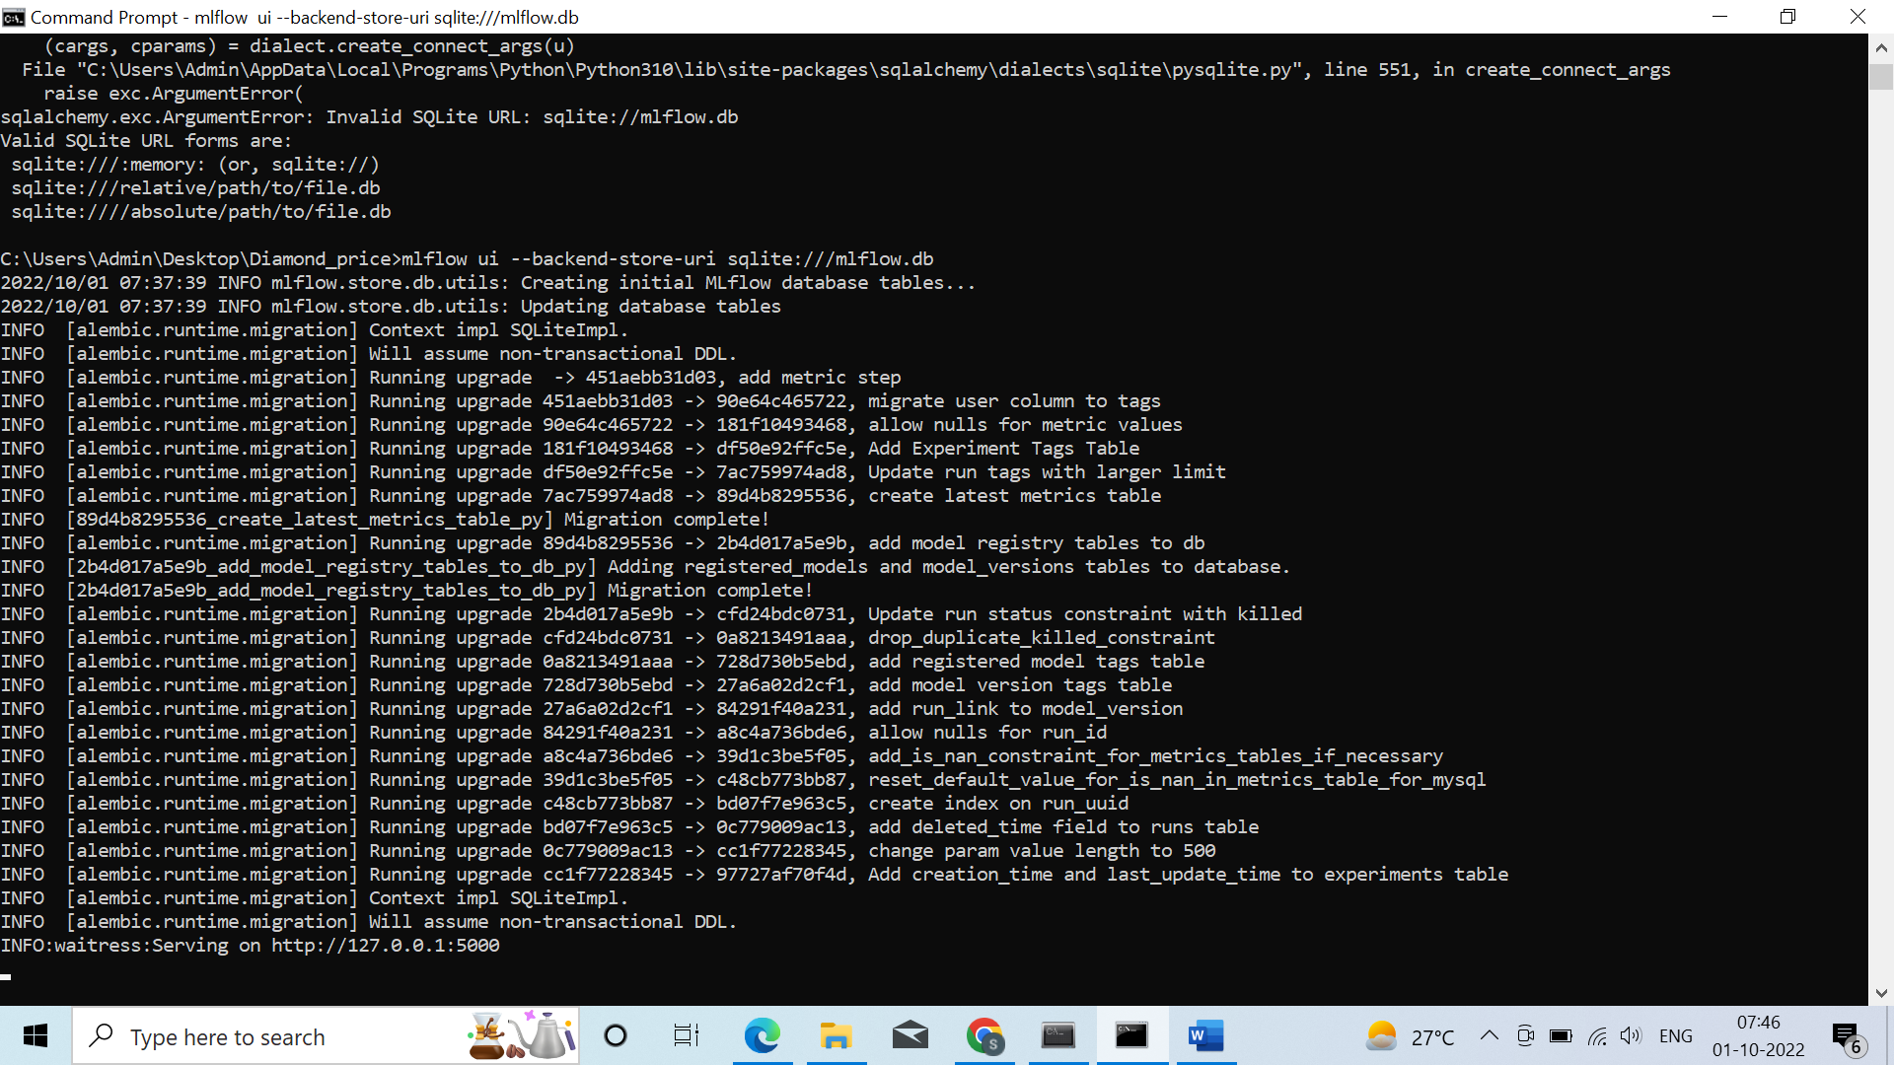



Local host interface after giving correct path:



After giving the port number in your local system it will display it ,but over here no experiment we created yet so its showing by default

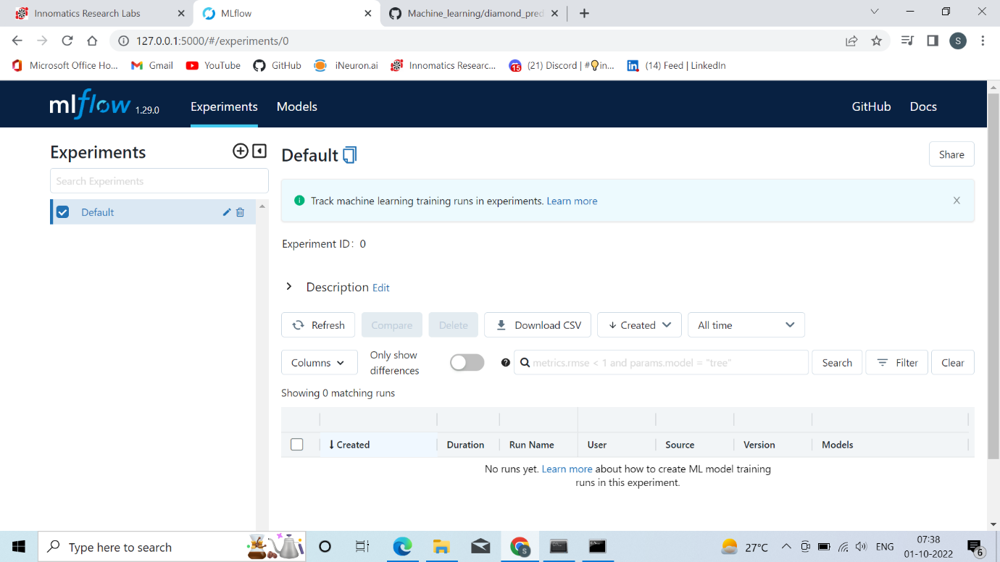

Over here we can track all the models that whether the models is in Staging area,Production area or Archived area

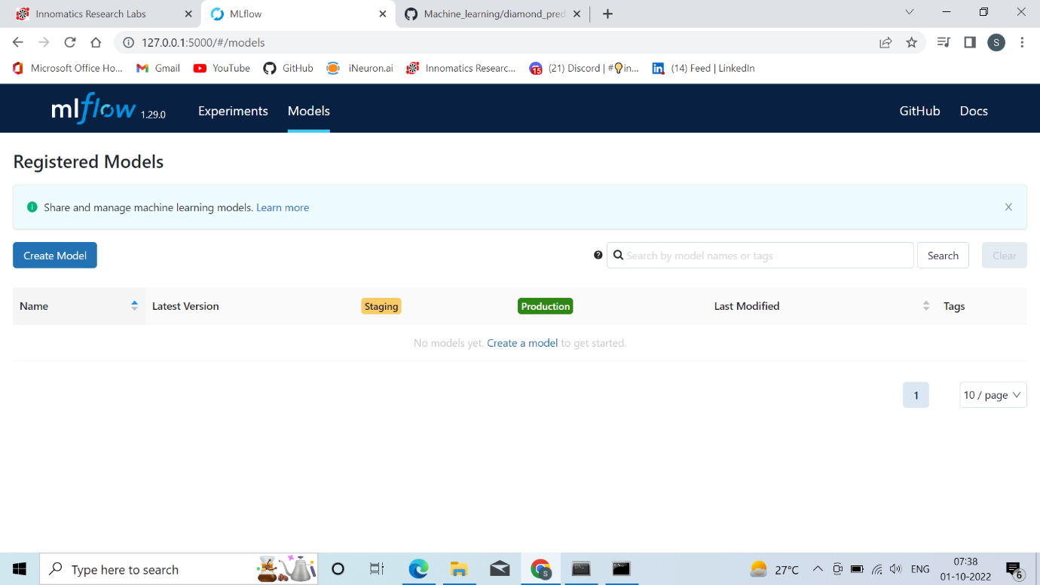



**Step2:**  **Set the tracker and experiment**

mlflow.set_tracking_uri(DATABASE_URI)  
mlflow.set_experiment("EXPERIMENT_NAME")

try to do it on the jupyter notebook after completing with the step1:

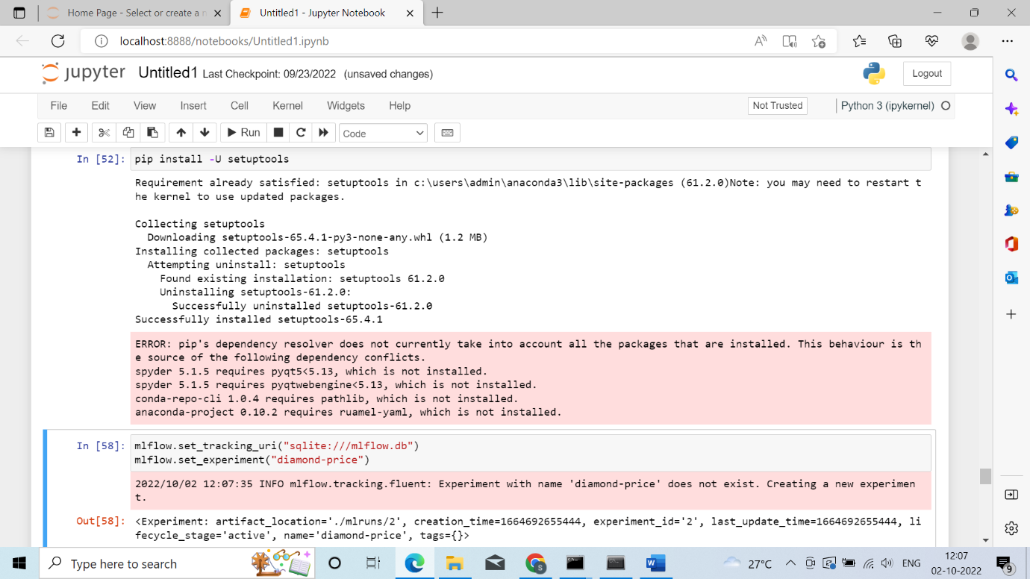



If its not executing as per the screenshot given below than try to refresh the page:



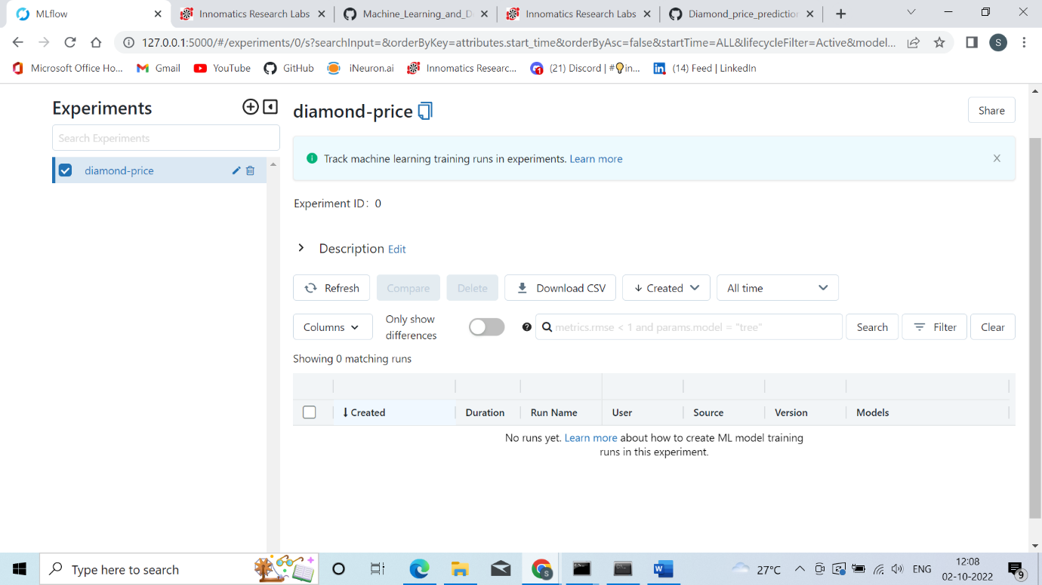



**Step3:** **Start a experiment run**

with mlflow.start_run():

**Step4:** **Logging the metadata**

mlflow.set_tag(KEY, VALUE)  
mlflow.log_param(KEY, VALUE) mlflow.log_metric(KEY, VALUE)

**Step5:** **Logging the model and other files (2 ways)**

**Way 1 -** mlflow.<FRAMEWORK>.log_model(MODEL_OBJECT, artifact_path="PATH")  
**Way 2 -** mlflow.log_artifact(LOCAL_PATH, artifact_path="PATH")

**Eg:Step3,Step4,Step 5 had been done on the jupyter notebook and all the tracking is done on the local host.**

**Here I’ll take one of the algorithm and show the tracking, in the same manner need to continue with n-number of experiment as per the requirement.**

**Here is my github link:** **https://github.com/sharanyamanohar/MLflow**

**In which I have tracked with 6 algorithms**

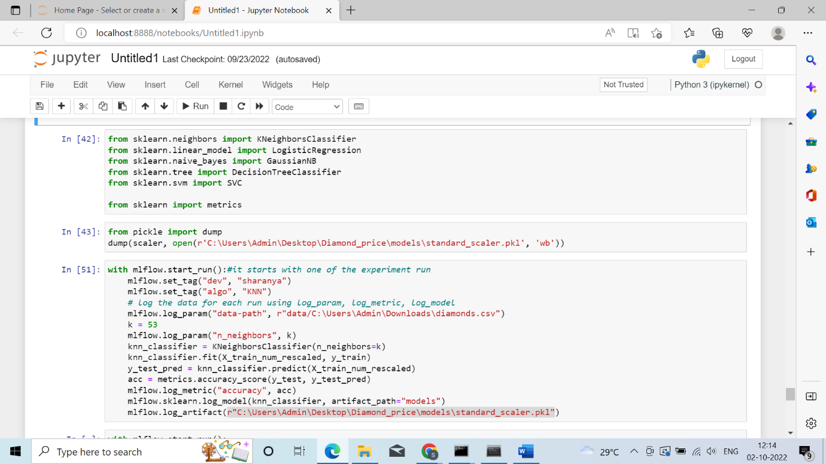

**Thanks**