Team Name:
Neural Ninjas

Team
Department: CSE(AI&ML)

Name: N. Lalitha
RollNo:21131a4227
Mail: 21131a4227@gvpce.ac.in
Mobile:9014998380


Name: I. Dileep Kumar
RollNo:21131a4255
Mail: 21131a4255@gvpce.ac.in
Mobile:9949362144


Name: Y. Tarun
RollNo : 21131a4243
Mail:
21131a4243@gvpce.ac.in
Mobile:9392440350

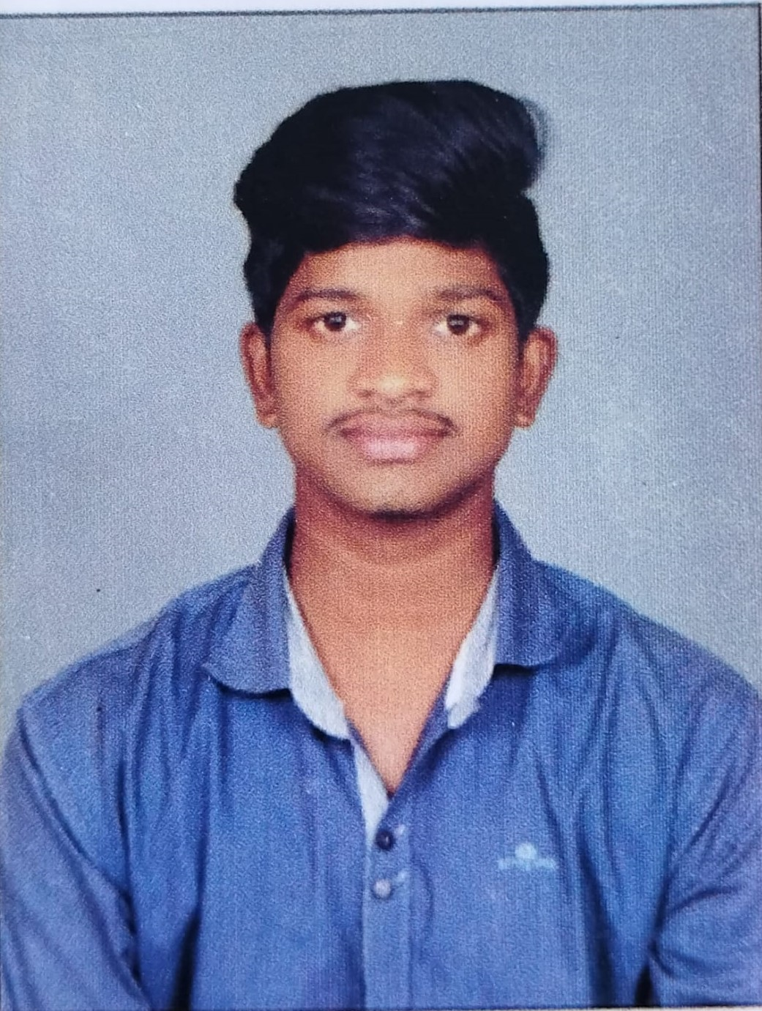

Name: P. Udai Aksheeth
RollNo:21131a4244
Mail: 21131a4244@gvpce.ac.in
Mobile:7013388309
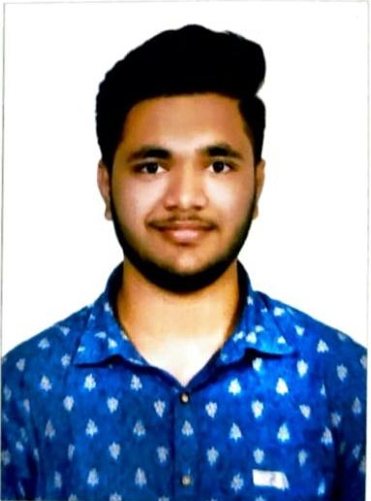
Project Guide
Name: Dr. K.Narasimha Raju Mail:drknarasimharaju @gvpce.ac.in Mobile: 9381395778



Abstract
Vitamin deficiency creates significant health risks worldwide. Early detection is crucial to prevent irreversible damage. There is a critical need for accessible, cost-effective methods for diagnosing vitamin deficiencies. Modern technologies, particularly image processing and artificial intelligence, offer promising avenues for vitamin deficiency detection. Deep learning models can analyze images, but existing works suffer from providing real-time analysis and easy access solutions. In this project, hybrid deep learning model-based application to address the issue of vitamin deficiency detection through images such as lips, tongue, nails, and eyes. The present application reduces the time of detection and provides a cost-effective solution.deficiency detection through images such as lips, tongue, nails and eyes. The present application reduces the time of detection and provides cost effective solution.

Domains where our solution can be implemented
Health care analysis
Health Monitoring Apps
Nutrition and Wellness Centers

Our solution helping the selected domains
This application helps medical experts or end users to easily diagnose vitamin deficiency issues

Our engineering solution
To provide a platform to diagnose vitamin deficiency through images.

.

Team’s vision
Our vision is to make advanced vitamin deficiency diagnostics accessible, empowering individuals and healthcare providers to proactively manage health and prevent related ailments.

