###### University of Dhaka

#### Department of Electrical and Electronic Engineering

EEE-3102: Numerical Technique Laboratory

Experiment-06:Determination of roots of a function by using Newton-Raphson method.

|  |  |  |
| --- | --- | --- |
| Section | : |  |
| Registration No.. | : |  |
| Name | : |  |
| Date | : |  |

**Roots of a function:**

Roots of a function f(x) relating variable x are the values of x for which f(x) =0. For example, the roots of the function is obtained by settingwhich gives

………………. (1)

Solution of Eq. (1) gives



Thus



are two roots of f(x). Note that the order of Eq. (1) is two. Thus it has two roots. Similarly, a function of order n has n roots.

**The Newton-Raphson Method**

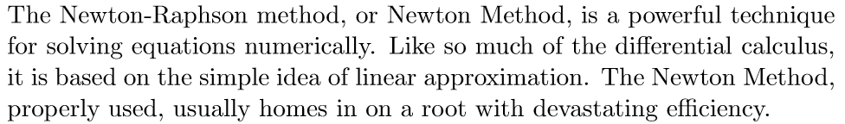

**Using linear approximations to solve equations**

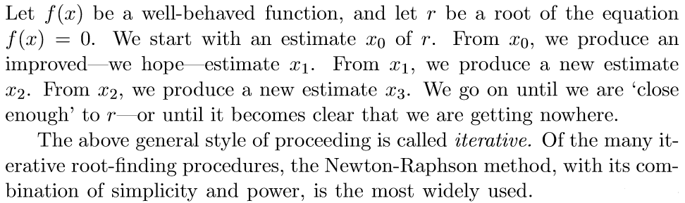

**The Newton-Raphson Iteration**

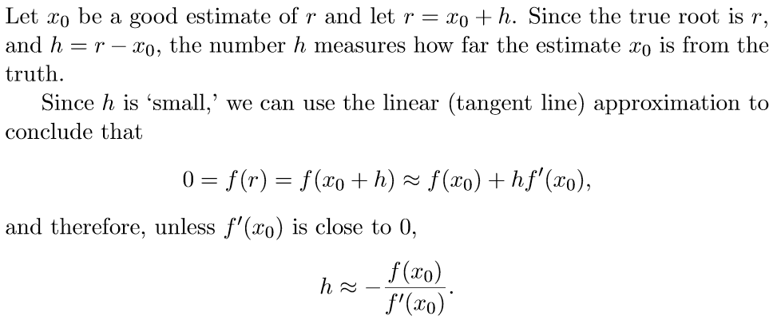

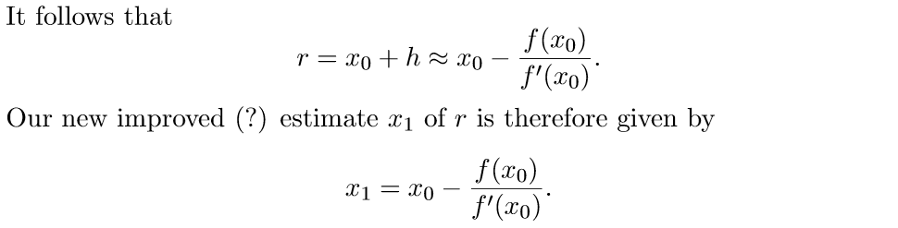

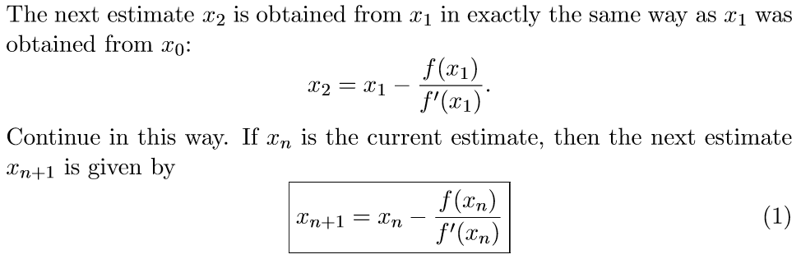

**A geometric interpolation of the Newton-Raphson Iteration**

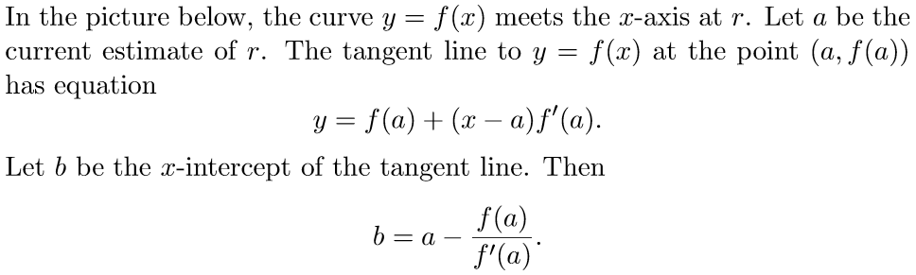

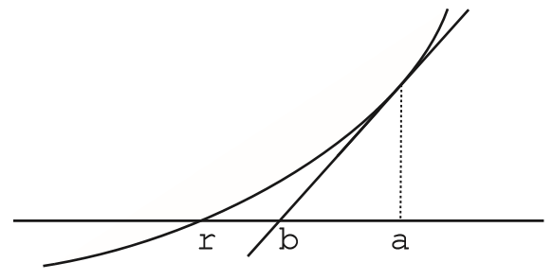

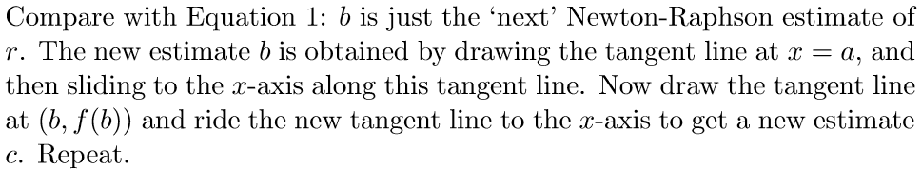

**Matlab Implementation of the Newton-Raphson Iteration**

% Newton Raphson Method

clc;close all;clear all;

% Change here for different functions

f=@(x) x^3-x-1;

% this is the derivative of the above function

df=@(x) 3*x^2-1;

r=input ('please input the value of r : ');

tol=input('Percentage of relative error tolerance : ');

rel_error=1; % Error must be greater than tol

xr=r;

i=1;

% xri=xr;

while(rel_error>tol)

xr_old=xr;

xr=xr-(f(xr)/df(xr));

xrnew(i)=xr; %%%% xr updatecd after ithiteratiom

rel_error(i)=abs((xr-xr_old)/xr*100);

i=i+1;

end

fprintf('Root of given function is %f',xr)

n=1:1:i-1;

figure;

plot(n,rel_error,'-ro')

grid on

xlabel('number of iteration n')

ylabel('percentage of relative error')

%%%%%%%%%%%%%%%%%%%%%%%%%%%%%

m=0:1:i-1;

xru=[r xrnew];

figure;

plot(m,xru,'-bs')

xlabel('number of iteration n')

ylabel('updated xr at each iteration')

grid on

f_xru=subs(f,xru);

figure;

plot(m,f_xru,'-gp')

xlabel('number of iteration n')

ylabel('function value for each updated xr')

grid on

**The End**

**References**

[1] S.K. Mitra, Digital Signal Processing, 3rd Edition, McGraw-Hill Education (Asia), 2009.

[2] J.G. Proakis and D.G. Manolakis, Digital Signal Processing: Principles, Algorithms and Applications, 4th Edition, Pearson International Edition, 2007.

[3] McClellan, Schafer and Yoder, *DSP FIRST: A Multimedia Approach*. Prentice Hall, Upper Saddle River, New Jersey, 1998 Prentice Hall.

[4] *Using Matlab*, The Math Works Inc.