Hand Gesture Recognition

Abstract :
We propose a fast algorithm for automatically recognizing a limited set of hand gestures like fist and number of fingers from 1 up to 5 !we present a novel real-time method for hand gesture recognition. In our framework, the hand region is extracted from the background with the background subtraction method. Then, the palm and fingers are segmented so as to detect and recognize the fingers. Finally, a rule classifier is applied to predict the labels of hand gestures. in this project ,we are using Python, NumPy and OpenCV .

Introduction :
Gesture recognition has been a very interesting problem in Computer Vision community for a long time. This is particularly due to the fact that segmentation of foreground object from a cluttered background is a challenging problem in real-time. The most obvious reason is because of the semantic gap involved when a human looks at an image and a computer looking at the same image. Humans can easily figure out what’s in an image but for a computer, images are just 3-dimensional matrices. It is because of this, computer vision problems remains a challenge. Look at the image below.

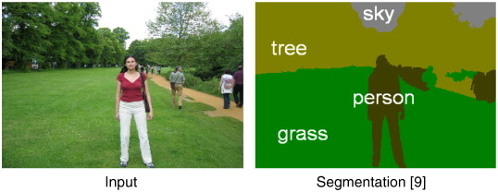
This image describes the semantic segmentation problem where the objective is to find different regions in an image and tag its corresponding labels. In this case, “sky”, “person”, “tree” and “grass”. A quick Google search will give you the necessary links to learn more about this research topic. As this is a very difficult problem to solve, we will restrict our focus to nicely segment one foreground object from a live video sequence.

Our Problem statement?
- Find and segment the hand region from the video sequence.
- Count the number of fingers from the segmented hand region in the video sequence.

Steps of this project :

Segment the Hand region

Background Subtraction

Motion Detection and Thre-sholding

Contour Extraction

Implementation

Count My Fingers

Segment the Hand region :
The first step in hand gesture recognition is obviously to find the hand region by eliminating all the other unwanted portions in the video sequence.

Background Subtraction :
First, we need an efficient method to separate foreground from background. To do this, we use the concept of running averages. We make our system to look over a particular scene for 30 frames. During this period, we compute the running average over the current frame and the previous frames. After figuring out the background, we bring in our hand and make the system understand that our hand is a new entry into the background, which means it becomes the foreground object. But how are we going to take out this foreground alone? The answer is Background Subtraction.
Look at the image below which describes how Background Subtraction works.
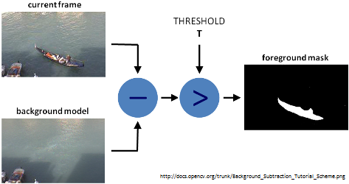

After figuring out the background model using running averages, we use the current frame which holds the foreground object (hand in our case) in addition to the background. We calculate the absolute difference between the background model (updated over time) and the current frame (which has our hand) to obtain a difference image that holds the newly added foreground object (which is our hand). This is what Background Subtraction is all about.

Motion Detection and Thre-sholding :
To detect the hand region from this difference image, we need to threshold the difference image, so that only our hand region becomes visible and all the other unwanted regions are painted as black. This is what Motion Detection is all about.

Contour Extraction :

After thre-sholding the difference image, we find contours in the resulting image. The contour with the largest area is assumed to be our hand.

Steps of counting fingers :
- Find the convex hull of the segmented hand region (which is a contour) and compute the most extreme points in the convex hull (Extreme Top, Extreme Bottom, Extreme Left, Extreme Right).
- Find the center of palm using these extremes points in the convex hull.
- Using the palm’s center, construct a circle with the maximum Euclidean distance (between the palm’s center and the extreme points) as radius.
- Perform bit-wise AND operation between the thre-sholded hand image (frame) and the circular ROI (mask). This reveals the finger slices, which could further be used to calculate the number of fingers shown.
- Input -(Thre-sholded Image) and (Segmented hand Region or Contour)
- Output -(Number of fingers).

Count My Fingers :
We will use the segmented hand region which was obtained in the variable (hand). Remember, this (hand) variable is a tuple having (thre-sholded image) and (segmented hand region). We are going to utilize these two variables to count the fingers shown. Look at the image below.
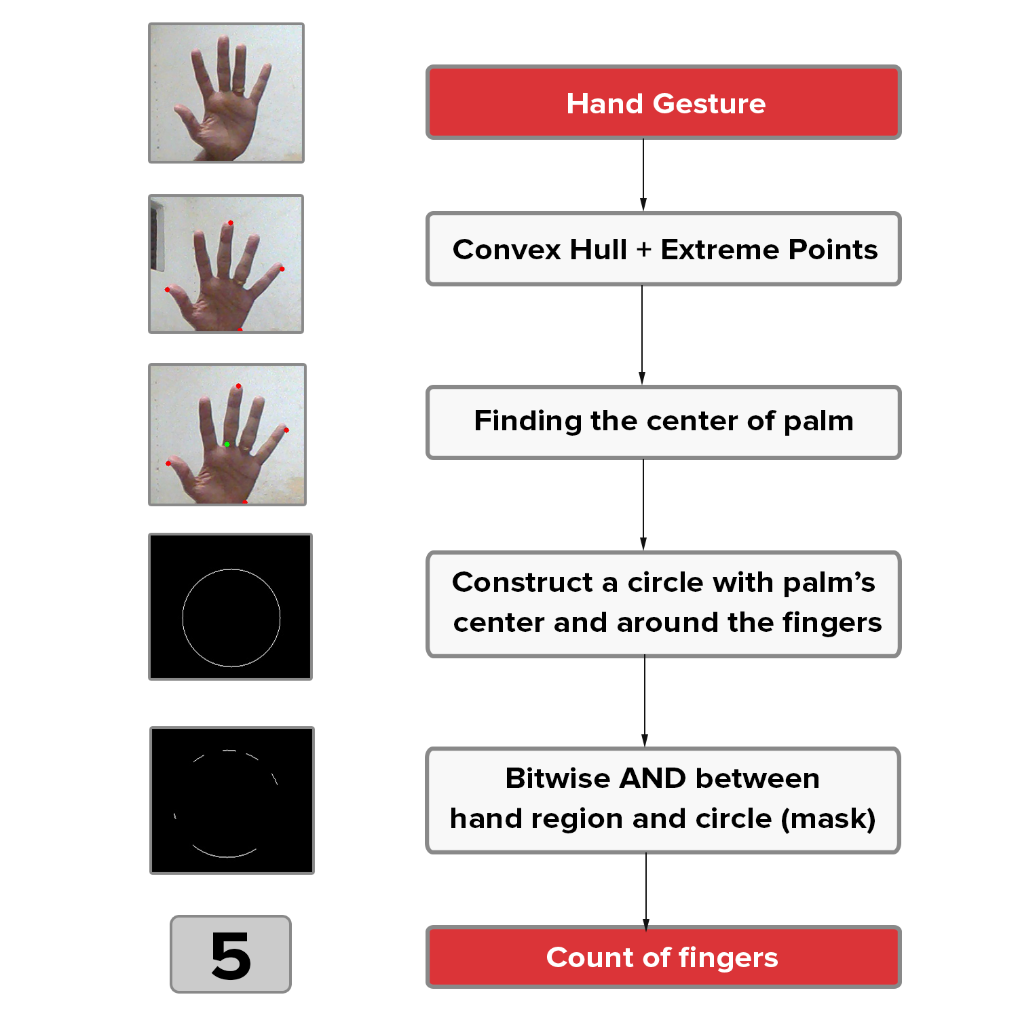

Contours :

The outline or the boundary of the object of interest. This contour could easily be found using OpenCV’s cv2.findcontours() function.

Bit wise-AND :

Performs bit-wise logical AND between two objects. We could visually think of this as using a mask and extracting the regions in an image that lie under this mask alone. OpenCV provides cv2.bitwise_and() function to perform this operation -Bitwise AND.

Euclidean Distance :

This is the distance between two points given by the equation . Scikit-learn provides a function called pairwise.eucildean_distancees() to calculate the Euclidean distance from one point to multiple points in a single line of code -Pairwise Euclidean Distance. After that, we take the maximum of all these distances using NumPy’s argmux() function.

Convex Hull :
You can think of convex hull as a dynamic, stretchable envelope that wraps around the object of interest.

Requirement:
- Use Python and OpenCV(cv2) , Numpy , Imutils , Sklearn.metrics Libraries
- Remember to update the background model by keeping the camera static without any motion. After 5-6 seconds, show your hand in the recognizing zone to reveal your hand region Alone.
- If you bring in some large object inside this frame which is larger than your hand, then this algorithm fails. So, you must make sure that your hand occupies the majority of the region in the frame and use smooth background.
- Press “ q keyword ” for exiting the project !

- Sharare zolghadr ,610395109, Artificial Intelligence

