Hill climbing algorithm and the Simulated annealing algorithm
for solving 8queens!

In order to evaluate the relative performance of the random restart hill climbing algorithm and the simulated annealing algorithm, I have considered two different specific measurements, the first is the number of iterations that the algorithm took to solve the puzzle, and the second one is the speed. The median of these values was taken considered the skewed distribution of the results, some iterations took considerably more (or less) time or considerably more (or less) moves, hence why the median is shown.

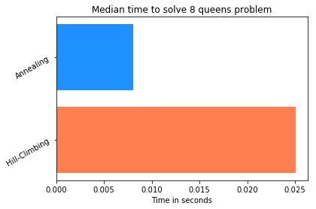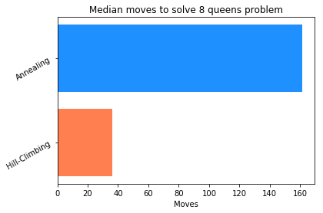

To collect this data, I have taken 50 random iterations of the 8 queens algorithm, stored how long did the algorithm take to finish and how many moves did they take to solve the problem.

For the 8 queens problem, as shown above, the annealing algorithm takes roughly a third of the time of the hill-climbing, while taking about 4 times more moves, however the performances here highlight the clear advantage over time of the Annealing algorithm.

Instructions:
1) Generate a random initial state. An initial state in your problem will be n queens positioned randomly on the board. Weshould have decided on an appropriate representation before generating a state.

2) A heuristic function that will take in a given state and return a heuristic value for that state.

3) We will need to provide code that will generate neighbouring states. There are many different ways you can generate a neighbour. Implement a simple mechanism. For example, you could generate a new neighbouring state by moving the position of a single queen by one place. It is important in hill climbing that you make only small alterations to the current state to produce a neighbouring state.

4) Develop a basic steepest ascent/descend hill climbing algorithm. This function will use the code you developed in part 3 to generate a number of neighbouring states. It will then search all neighbouring states. It will return the neighbour state with the best heuristic value, assuming the best neighbouring state is better than the current state. If none of the neighbours have a better heuristic value than the current state then the algorithm stops and returns the current state (we refer to this as convergence).

5) We will have noticed that the hill climbing algorithm can often converge to a sub optimal solution. Use the code you developed in part 4 to implement a random restart hill climbing (RR-HC) algorithm. Initially set the maximum number of restarts to 500. Each time the algorithm restarts it should generate a new random configuration for the initial state of the board. If the algorithm identifies a solution to the problem it should exit and provide the details of the solution obtained. make sure that the code keeps track of the total number of moves taken by the hill climber to arrive at an optimal solution.

6) Create a random restart simulated annealing (RR-SA) algorithm. We should be able to reuse much of the code you wrote for the hill climbing version in part 5.

7) When running optimization algorithms on a problem such as the n-Queens we are interested in their relative performance. For this experiment we will based performance on the total number of cumulative moves taken in order to reach an optimal solution for boards ranging in size n= 8.

