Sentiment Analysis of Educational Institutions for getting Admissions

In this project we have gather reviews from all colleges of India and then calculated reviews sentiments score which is based on positive, negative and neutral. If students are happy with particular college then they will write review with more positivity and if not satisfy then their word contains negativity.

By analysing such reviews we can predict performance of any college and these predictions may help new students in identifying which college is performing well to seek admission. Each college performance we are displaying in percentage in both numbers and graph format.

Our dataset contains information of all major colleges from India and user can select desired college or educational institution and then that college review will get saved in CSV file. Later we will load this CSV file to calculate sentiments of each review and then display that college performance as graph and number format.

In below screen we are showing dataset used in this project

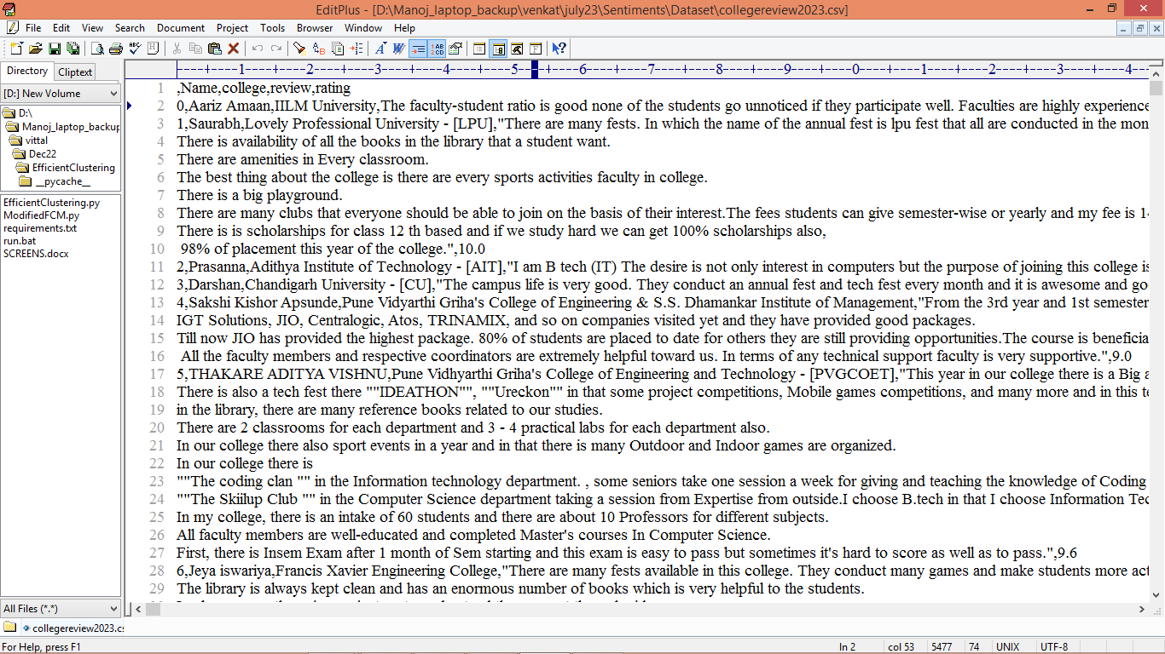

In above dataset first row represents college name, review and student name who is writing review on particular college and by using this dataset we will predict performance of each educational institutions.

To implement this project we have designed following modules

1. Upload College Reviews Dataset: using this module we will upload and display dataset details
2. Process Reviews Different Colleges: using this module we will find process reviews and then display each college name in drop down box
3. Perform Sentiment Analysis: user can select desired college from drop down box and then process each review to calculate college performance and then display performance values in numbers
4. College Overall Admission Graph: using this module we will plot institution performance graph and by seeing that graph student can identify whether he has to take admission or not.

SCREEN SHOTS

To run project double click on run.bat file to get below screen

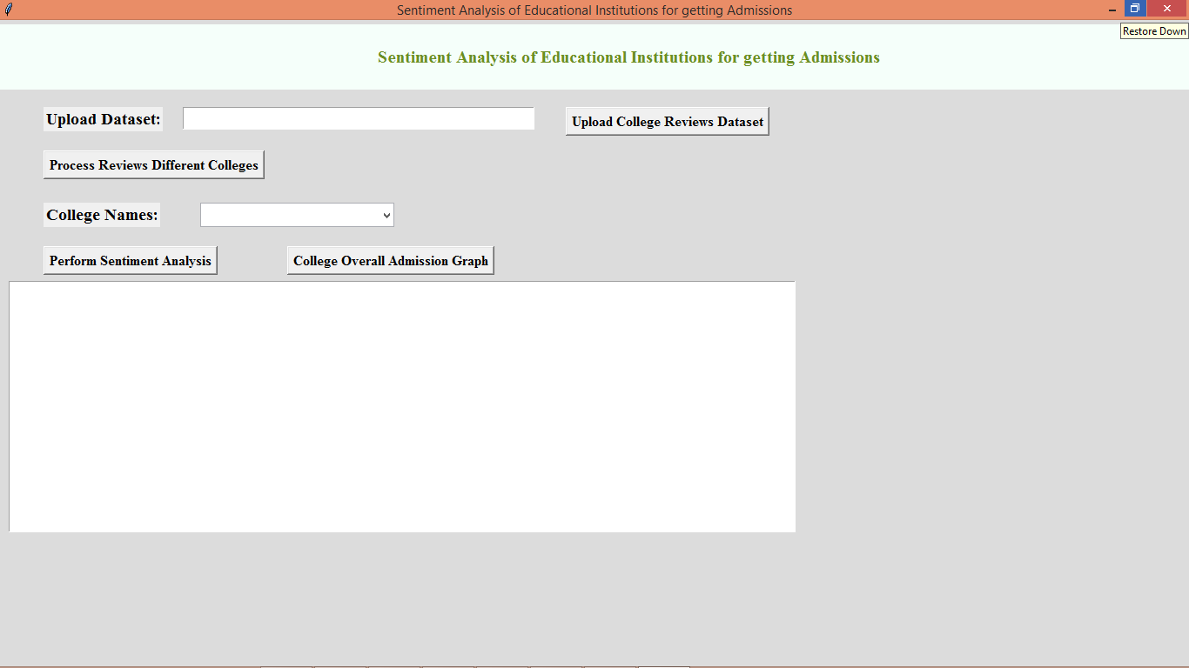

In above screen click on ‘Upload College Reviews Dataset’ button to upload college dataset and get below output

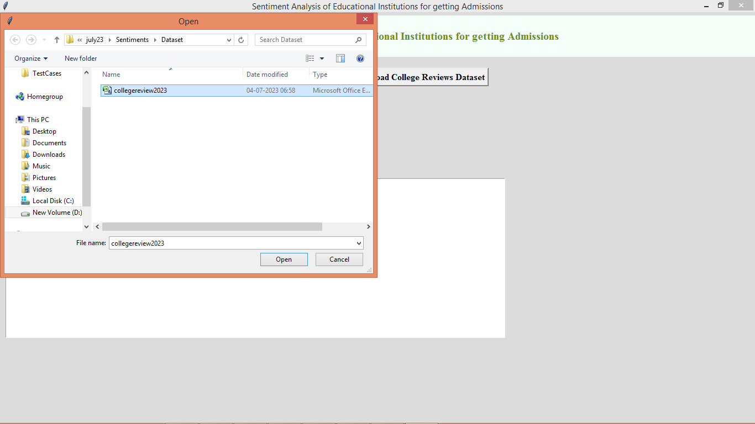

In above screen selecting and uploading reviews dataset file and then click on ‘Open’ button to load dataset and get below output

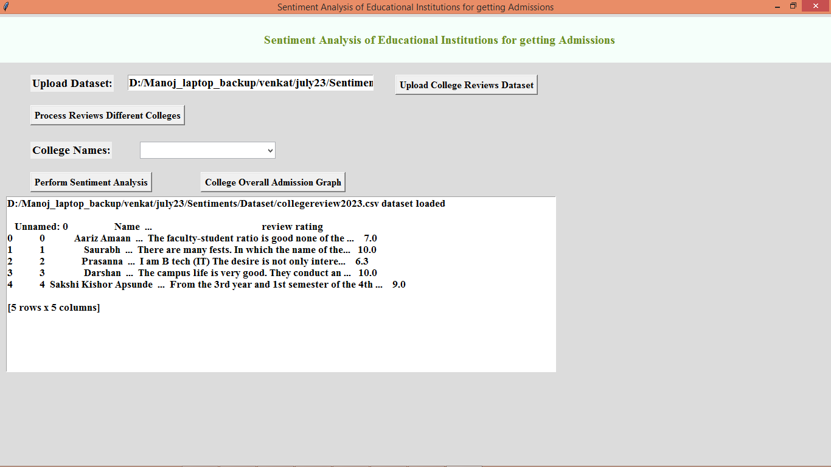

In above screen dataset loaded and now click on ‘Process Reviews Different Colleges’ button to read each college from dataset and add to drop down list and will get below output

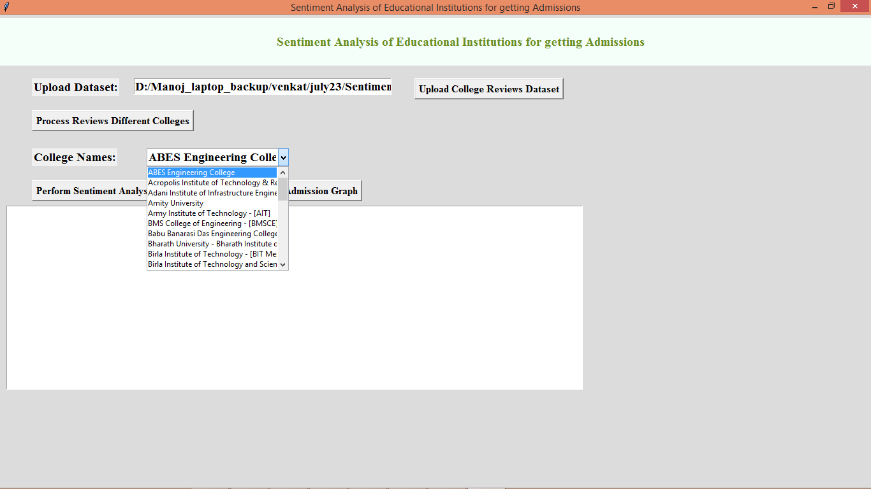

In above screen entire dataset process and we can see all colleges names added to drop down list and then user can select college name and then click on ‘Perform Sentiment Analysis’ button to calculate sentiments from each review of selected college and then will get output

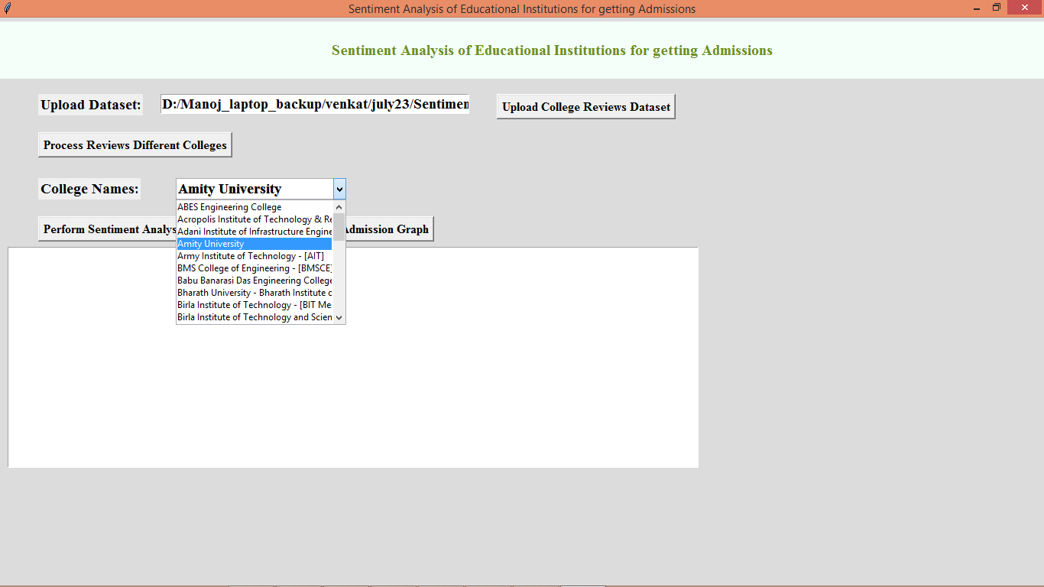

In above screen i am selecting ‘Amity University’ and then click on ‘Perform Sentiment Analysis’ button to get below output

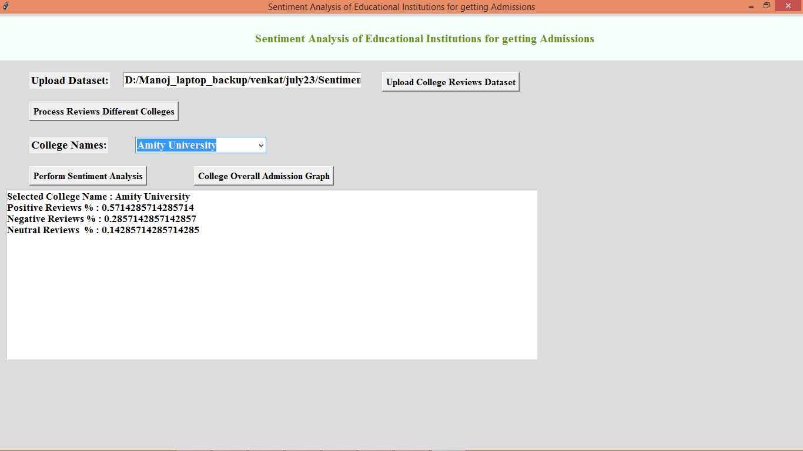

In above screen we can see sentiment percentage of Amity university as positive, negative and neutral sentiment percentage from that college reviews and now click on ‘College Overall Admission Graph’ button to get below graph

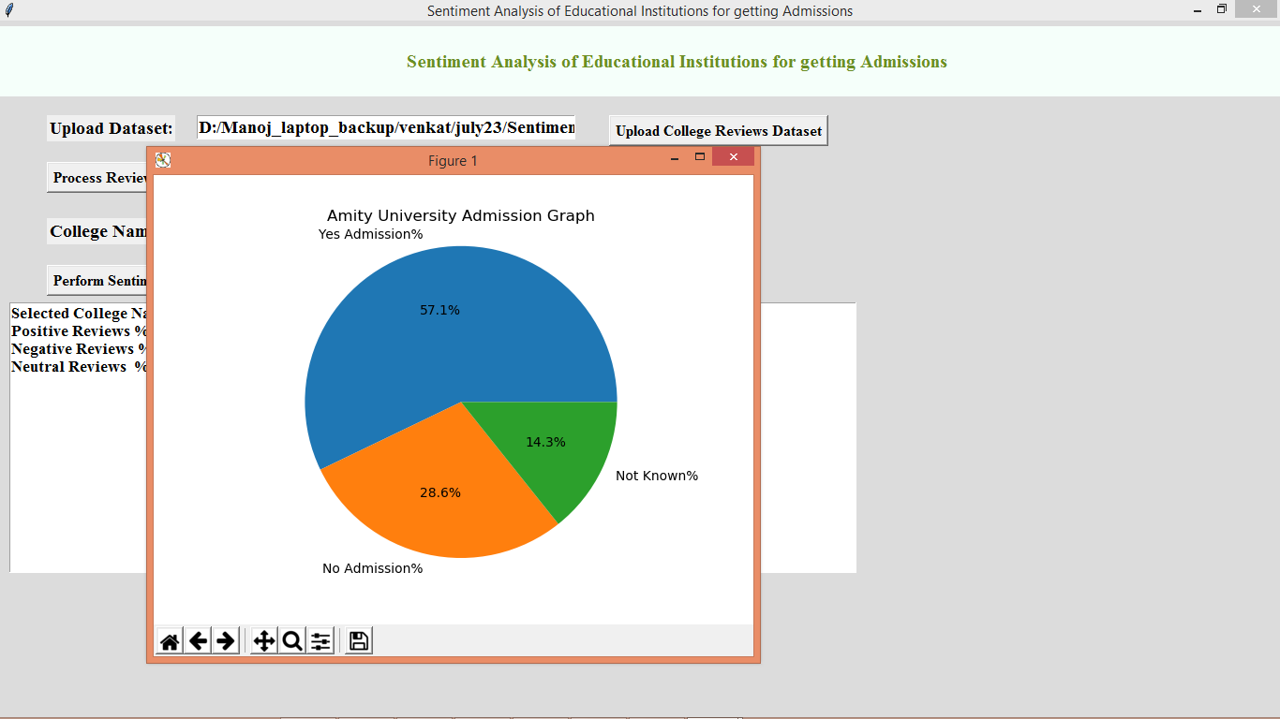

In above graph application suggesting to student about taking admission as ‘Yes or No or not known’ in percentage and similarly you can select any other education institution and get above output

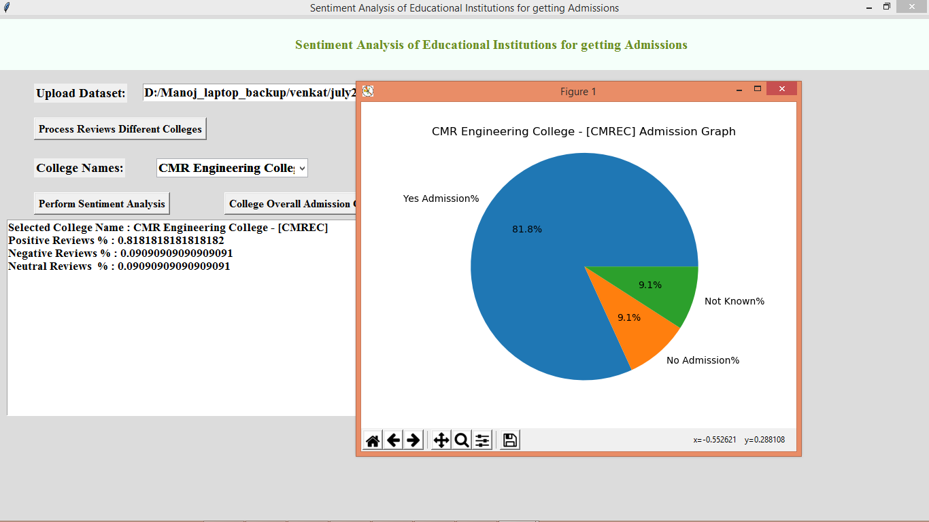

In above screen we got output for CMR college and below is another institution output

