Non index:

EXPLAIN SELECT COUNT(*) FROM test;



ANALYZE SELECT COUNT(*) FROM test;



EXPLAIN SELECT * FROM test;





ANALYZE SELECT * FROM test;



EXPLAIN SELECT * FROM test WHERE value > 500;



ANALYZE SELECT * FROM test WHERE value > 500;





EXPLAIN SELECT * FROM test t1 CROSS JOIN test t2 LIMIT 100;





ANALYZE SELECT * FROM test t1 CROSS JOIN test t2 LIMIT 100;



Indexed data:  
EXPLAIN SELECT COUNT(*) FROM test2;



ANALYZE SELECT COUNT(*) FROM test2;



[EXPLAIN](http://localhost/phpmyadmin/url.php?url=https://dev.mysql.com/doc/refman/8.0/en/explain.html) [SELECT](http://localhost/phpmyadmin/url.php?url=https://dev.mysql.com/doc/refman/8.0/en/select.html) * FROM test2;

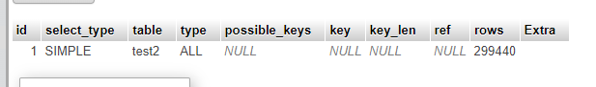



ANALYZE SELECT * FROM test2;



EXPLAIN SELECT * FROM test2 WHERE value > 500;





ANALYZE SELECT * FROM test2 WHERE value > 500;



EXPLAIN SELECT * FROM test2 t1 CROSS JOIN test2 t2 LIMIT 100;

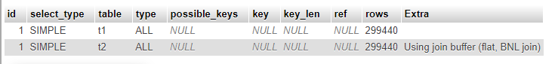



ANALYZE SELECT * FROM test2 t1 CROSS JOIN test2 t2 LIMIT 100;



Partitioned Table:

EXPLAIN SELECT COUNT(*) FROM test_partitioned;



ANALYZE SELECT COUNT(*) FROM test_partitioned;



EXPLAIN SELECT * FROM test_partitioned;



ANALYZE SELECT * FROM test_partitioned;



EXPLAIN SELECT * FROM test_partitioned WHERE value > 500;

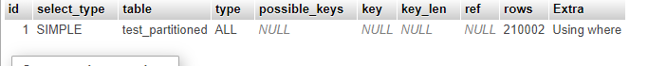

ANALYZE SELECT * FROM test_partitioned WHERE value > 500;



EXPLAIN SELECT * FROM test_partitioned t1 CROSS JOIN test_partitioned t2 LIMIT 100;

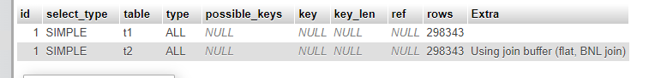

ANALYZE SELECT * FROM test_partitioned t1 CROSS JOIN test_partitioned t2 LIMIT 100;

