**Birla Institute of Technology and Science, Pilani**

**CS F241 Microprocessors and Interfacing**

**Design Assignment**



**By:**

**Akanksha Dara 2014A7PS104P**

**Ishaan Negi 2014A7PS105P**

**Ameesha Mittal 2014A7PS107P**

**Sharat Chandra 2014A7PS108P**

**Submitted to: Nitin Chaturvedi (Instructor-in-Charge)**

**Date: 24th April, 2016**

**System to be Designed: FIRE ALARM SYSTEM**

**Description:**

This system checks for abnormal smoke content in a room every two seconds. Under abnormal conditions it throws open two doors and two windows and opens a valve that releases the gas to put-out the fire. An Alarm is also sounded; this alarm is sounded until the smoke level in the room drops to an acceptable level. The smoke detection system is made up of two smoke sensors placed on the ceiling of the room. When the smoke level comes back below the danger level, the doors, windows and valves are closed.

**Specifications of the problem:**

1. Two smoke detecting sensors are placed on the ceiling, which detects the smoke content in the room.

2. A fire alarm that is sounded when smoke exceeds normal levels.

3. Two doors, two windows and valves are controlled by motors.

4. The motors and alarms are activated only when **both** the sensors detect an abnormal level in smoke levels.

**Assumptions made:**

1. Clockwise direction closes all doors, valves and windows and anticlockwise direction opens all doors, valves and windows.

2. We are using MC145010 as the smoke sensor. The IC is used with an infrared photoelectric chamber and detection is accomplished by sensing scattered light from minute smoke particles or other aerosols. The output of the smoke sensor ranges from 0V to 5V. An ADC connected to variable voltage source is used in the design to model the output of the smoke sensor.

3. We have interfaced memory as follows:

RAM – minimum 2k chip - 4k ROM – minimum 4k chip - 8k

ROM1 08000H - 09FFFH

RAM1 0A000H – 0AFFFH

4. When we power on the system, all the doors, windows and valve are closed by passing the appropriate control signals through PPI. After this, interrupts are continuously raised to measure the sensor outputs. If both the sensors exceed a threshold value then only doors, windows and valve are opened. In addition to this, an alarm is also sounded.

5. As long as both the sensors are above threshold value, all the doors, windows and valve will remain open. If any sensor falls below the threshold value then close all the doors, windows and valve and alarm is also turned off.

6. The opening of all doors, windows and valve is controlled by a stepper motor which operates in steps with the use of gears. A stepper motor can be programmed to stop rotating after a certain number of steps, which can be programmed through our code.

**Components used:**

• **6116 (RAM)** – 2 units used

• **2732 (ROM)** – 2 units used

• **ADC0808** (1 unit):

– 8-bit ADC

– 8 channel

– 1 MHz clock input

• **8253 (Programmable interval timer)**

– 24 pin IC

– 1 counter used with a count value of 18

– Counter operated at a clock speed of 1Hz

• **8255 (Programmable Peripheral Interface (PPI) chip)**

– Contains three 8-bit ports.

– 24 input/output pins.

– Port A and Port C lower are input lines

– Port B and port C upper are output lines

• **8259(Programmable Interrupt Controller)**

– Interrupt generated at interval of 100 micro seconds.

• **8086(Microprocessor)**

– Operating Clock Speed – 5MHz

– 40 pins – 20 de-multiplexed Address Lines and 16 de-multiplexed Data lines

• **74LS373(octal latch)** – 3 Latches used

• **74LS245 (Octal Bus Transmitter/Receiver)** – 2 units used

**• 74LS04 (Hex inverter)** – 2 not gates used.

**• 74LS32 (OR Gate IC)** – 8 OR Gates used

**• 74LS08 (AND Gate)** – 1 AND Gate used

**• L297 (Stepper motor controller):**

Signals from your microprocessor and translates them into stepping signals to send to the L298.

• **L298 (Motor driver)**

– Drives the stepper motor

– 4 output pins connected to one motor

• **Smoke Sensor MC145010**

– Used with an infrared photoelectric chamber

• **Red LEDs**

– Used to represent the doors and windows

**Address mapping of memory and I/O devices:**

**We first initialize all the I/O devices i.e. 8255, 8253 and 8259 with the required values.**

* 8259 (0018h to 001Ah) has been programmed as follows:

|  |  |  |
| --- | --- | --- |
| **Control Word** | **Binary Value** | **Memory Location** |
| ICW1 | 00010011 | 0018h |
| ICW2 | 10000000 | 001Ah |
| ICW3 | Not needed | - |
| ICW4 | 00000011 | 001Ah |
| OCW1 | 11111110 | 001Ah |

* 8253 (0010h to 0016h) has been programmed as follows:

|  |  |  |
| --- | --- | --- |
| **Control Word** | **Binary Value** | **Memory Location** |
| Cnt0 | 00010011 | 0018h |
| Cnt1 | 10000000 | 001Ah |
| Cnt2 | not needed | - |
| CReg | 00000011 | 001Ah |

* Programming 8255(PPI chip):

|  |  |  |
| --- | --- | --- |
| **Port** | **I/O** | **Address** |
| Port A | Input | 0000h |
| Port B | Output | 0002h |
| Port C – Lower | Input | 0004h |
| Port C – Upper | Output | 0006h |

**IVT Table:**

|  |  |  |  |
| --- | --- | --- | --- |
| Vector No. | Priority | Offset | Use |
| 80h | 1(only one int) | 200h | 8259 calls this  interrupt to  check for smoke |

**Flowchart for the Software:**

**Initialize**

**8255**

**Initialize**

**8253**

**Initialize**

**8259**

**Interrupt raised when counter reaches zero.**

**Reads the sensors from ADC**

No

**Sensor 0 high?**

Yes

No

**Sensor 1 high?**

Yes

**Load the count value in the counter**

**Open valve, doors and windows and sound alarm.**

Yes

Yes

No

**Sensor 1 high?**

No

**Sensor 0 high?**

**Reads the sensors from ADC**

**Close the valve, doors and windows and stop alarm.**

**Overview of the Design:**

Stepper motor L 297

S. motor controller L 297

8253

8086

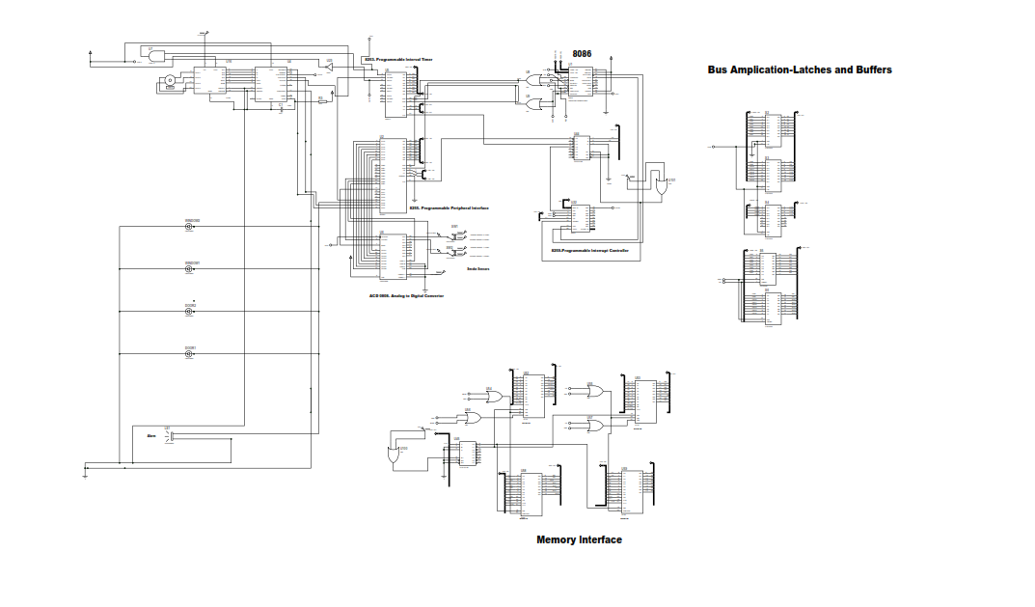

Smoke Sensors **MC145010**

Bus Applications & Buffers

Memory Interface

Alarm

LEDs

(Doors & Windows)

ADC(0808)

Decoderr

8259

**8086 & 8284:**

(8284 - used for clock generation)

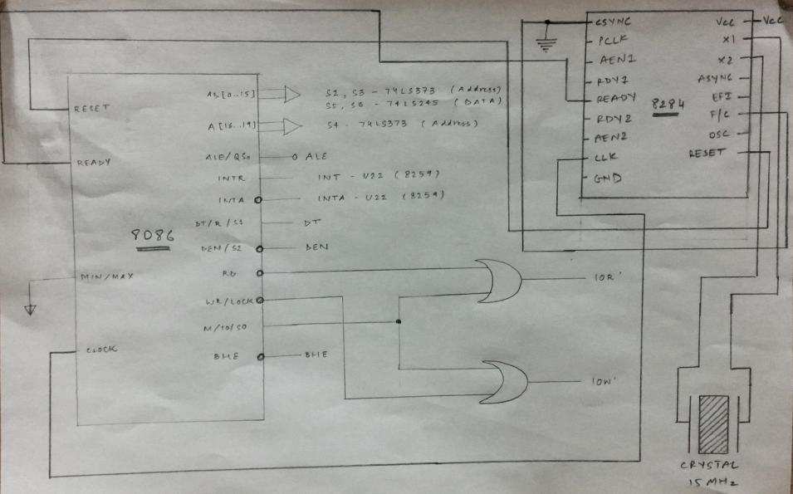

**Memory Interfacing:**

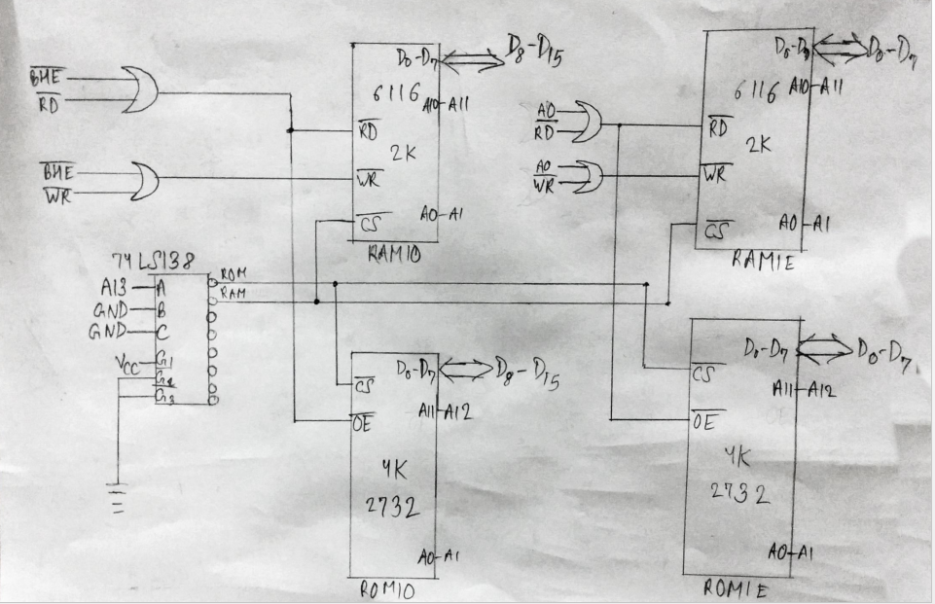

**ASM Code:**

#make_bin#

#LOAD_SEGMENT=FFFFh#

#LOAD_OFFSET=0000h#

#CS=0000h#

#IP=0000h#

#DS=0000h#

#ES=0000h#

#SS=0000h#

#SP=FFFEh#

#AX=0000h#

#BX=0000h#

#CX=0000h#

#DX=0000h#

#SI=0000h#

#DI=0000h#

#BP=0000h#

jmp st1

db 509 dup(0) ;IVT entry for 80H

dw t_isr

dw 0000

db 508 dup(0)

st1: cli

; intialize ds, es,ss to start of RAM

mov ax,0100h

mov ds,ax

mov es,ax

mov ss,ax

mov sp,0FFFEH

;initialize 8255

;portA equ 0000h

;portB equ 0002h

;portC equ 0004h

;creg equ 0006h

;portA = input(ADC output)

;portB = output(selection lines for ADC)

;portC lower = input(PC0 connected to EOC of ADC)

;portC upper = output(To valve,windows,doors and Alarm)

mov al, 10010001b

out 0006H, al

;Resets ADC

mov al, 00000000b

out 0004H, al

;8259 - 18H to 1AH

;8259 - enable IRO alone use AEOI

mov al,00010011b

out 18h,al ;icw1

mov al,80H

out 1Ah,al ;icw2

mov al,03h

out 1Ah,al ;icw4

mov al,0FEh

out 1Ah,al ;ocw1

x11:

mov al, 11010000b

out 0004H, al

;initialize 8253

sti

x12:

;cnt0 equ 0010h

;cnt1 equ 0012h

;cnt2 equ 0014h

;creg equ 0016h

mov al, 00110000b

out 0016H, al

mov al, 0Ah ;Assuming clock to be 2.5hz

out 0010H, al

mov al, 00h

out 0010H, al

mov al,00010000b

out 0004h,al ; port C gate enable

mov al, 00000000b

out 0002h, al ;send address 000 to ADC

mov al, 01000000b ;set ALE

out 0002h, al

mov al, 01100000b ;set start

out 0002h, al

mov al, 01000000b ;set ALE and clear start

out 0002h, al

x13:in al, 0004h ;polls for EOC signal

and al, 01h

cmp al, 01h

jnz x13 ;if EOC is low, loop back to x13, else proceed

mov al, 00000000b

out 0002h, al

in al, 0000h ;since EOC is high, take the input from the ADC of smoke sensor 0

out 0002h, al

mov cl, 90h ;CL has threshold smoke value(90h)

cmp al, cl ;compare al with the threshold value

jna x0 ;if al < danger level, jump to x0

mov bl, al

mov al, 00h

mov al, 10000000b

out 0002h, al ;send address 001 to ADC

mov al, 11000000b ;set ALE

out 0002h, al

mov al, 11100000b ;Set Start

out 0002h, al

mov al, 11000000b ;Reset start

out 0002h, al

x14: in al, 0004h ;polls for EOC signal

and al, 01h

cmp al, 01h

mov al, 00000000b ;reset ADC

out 0002h, al

jnz x14 ;if EOC is low, loop back to x4, else proceed

mov al, 00h

in al, 0000h ;since EOC is high, take input from ADC of smoke sensor 1

in al, 0000h

out 0002h, al

mov cl, 90h ;CL has threshold smoke value(90h)

cmp al, cl ;compare al with the threshold value

jna x0

mov al, 00000000b

out 0002h, al

mov al, 10110000b

out 0004h, al ;rotating the motors in clockwise direction

mov dl, 01h ;set state of doors, windows, valves as open and raise alarm

; checking if the smoke has reduced

mov al, 00000000b

out 0002h, al ;send address 000 to ADC

mov al, 01000000b

out 0002h, al

mov al, 01100000b

out 0002h, al

mov al, 01000000b

out 0002h, al

x23:

in al, 0004h ;polls for EOC signal

and al, 01h

cmp al, 01h

jnz x23 ;if EOC is low, loop back to x23, else proceed

mov al, 00000000b

out 0002h, al

in al, 0000h ;since EOC is high, take the input from the ADC of smoke sensor 0

out 0002h, al

mov cl, 93h

cmp al, cl ;compare al with an arbitrary value

jna x17 ;if al <= danger level, jump to x7

mov bl, al

mov al, 00h

mov al, 10000000b

out 0002h, al ;send address 001 to ADC

mov al, 11000000b

out 0002h, al

mov al, 11100000b

out 0002h, al

mov al, 11000000b

out 0002h, al

x24:

in al, 0004h ;polls for EOC signal

and al, 01h

cmp al, 01h

mov al, 00000000b

out 0002h, al

jnz x24 ;if EOC is low, loop back to x24, else proceed

mov al, 00h

in al, 0000h ;since EOC is high, take input from ADC of smoke sensor 1

in al, 0000h

out 0002h, al

mov cl, 93h

cmp al, cl ;compare al with the arbitrary value

jna x17 ;if al <= danger level, jump to x7

jmp x12 ;if al > danger level for both smoke sensors, jump to x12

x17:

;close doors, windows, valve and alarm sound

mov al, 11010000b

out 0004h, al

mov dl, 00h ;set previous state bit back to 0

jmp x0

x0: jmp x0 ; initial run till an interrupt is raised

t_isr:

; IVT code

x2: ;cnt1 equ 0012h

;cnt2 equ 0014h

;creg equ 0016h

mov al, 00110000b

out 0016H, al

mov al, 15h

out 0010H, al

mov al, 00h

out 0010H, al

mov al,00010000b

out 0004h,al ; port C gate enable

mov al, 00000000b

out 0002h, al

mov al, 01000000b

out 0002h, al

mov al, 01100000b

out 0002h, al

mov al, 01000000b

out 0002h, al

x3: in al, 0004h ;polls for EOC signal

and al, 01h

cmp al, 01h

jnz x3

;if EOC is low, loop back to x3, else proceed

mov al, 00000000b

out 0002h, al

in al, 0000h

;since EOC is high, take the input from the ADC of smoke sensor 0

out 0002h, al

mov cl, 93h

cmp al, cl ;compare al with an arbitrary value

pushf

pop bx

and bx, 0080h

cmp bx, 0000h

jnz x20 ;if al < danger level, jump to x20

mov bl, al

mov al, 00h

mov al, 10000000b

out 0002h, al ;send address 001 to ADC

mov al, 11000000b

out 0002h, al

mov al, 11100000b

out 0002h, al

mov al, 11000000b

out 0002h, al

x4: in al, 0004h ;polls for EOC signal

and al, 01h

cmp al, 01h

mov al, 00000000b

out 0002h, al

jnz x4 ;if EOC is low, loop back to x4, else proceed

mov al, 00h

in al, 0000h ;since EOC is high, take input from ADC of smoke sensor 1

in al, 0000h

out 0002h, al

mov cl, 93h

cmp al, cl ;compare al with the arbitrary value

pushf

pop bx

and bx, 0080h

cmp bx, 0000h

jnz x20 ;if al < danger level, jump to x20

; rotating the motors in clockwise direction and enabling gate 0

mov al, 00000000b

out 0002h, al

mov al, 10110000b

out 0004h, al

mov dl, 01h ;set state of doors, windows, valves as open

; checking if the smoke has reduced

mov al, 00000000b

out 0002h, al ;send address 000 to ADC

mov al, 01000000b

out 0002h, al

mov al, 01100000b

out 0002h, al

mov al, 01000000b

out 0002h, al

x5: in al, 0004h ;polls for EOC signal

and al, 01h

cmp al, 01h

jnz x5 ;if EOC is low, loop back to x5, else proceed

mov al, 00000000b

out 0002h, al

in al, 0000h ;since EOC is high, take the input from the ADC of smoke sensor 0

out 0002h, al

mov cl, 93h

cmp al, cl ;compare al with the arbitrary smoke threshold value.

jle x7

;if al <= danger level, jump to x7

mov bl, al

mov al, 00h

mov al, 10000000b

out 0002h, al ;send address 001 to ADC

mov al, 11000000b

out 0002h, al

mov al, 11100000b

out 0002h, al

mov al, 11000000b

out 0002h, al

x6: in al, 0004h ;polls for EOC signal

and al, 01h

cmp al, 01h

mov al, 00000000b

out 0002h, al

jnz x6 ;if EOC is low, loop back to x6, else proceed

mov al, 00h

in al, 0000h ;since EOC is high, take input from ADC of smoke sensor 1

in al, 0000h

out 0002h, al

mov cl, 93h

cmp al, cl ;compare al with the arbitrary value

jna x7

;if al <= danger level, jump to x7

jmp x2 ;if al > danger level for both smoke sensors, jump to x2 (checks again)

x7:

;close doors, windows and valve

mov al, 11010000b

out 0004h, al

mov dl, 00h ;set previous state bit back to 0

x20:

iret

**Specifications of the Smoke Sensor used:**

**MC145010**

1. Operating Voltage Range: 6V to 12V

2. Operating Temperature Range: -10°C to 60°C

3. Average Supply Current: 12 µA

The pin assignment is as follows:

