EPD
English and Personality Development
Started as a simple idea by a handful of volunteers who were an integral part of NSS BITS Pilani in the year 2013 and led on as a legacy and a dream by a small team led by them.
We started with separate batches for boys and girls from 8th to 12th classes. Monday, Wednesday and Friday 1 hour classes for boys batch (8 students) and Sunday 3 hour classes for Girls batch (16 students). Classes were conducted in the foyer or the rooftop of PRC{Pilani Resource Center: located just outside the BITS Pilani campus, is a unique BITS alumni initiative}
This was the first semester of EPD, The next semester 3 of our volunteers were trained under
Teach India (an initiative of CSR department of Times of India along with British Council as Content designer){English for Employability : teaching people how to communicate effectively in English in order to make them employable} the girls batch classes were shifted to NSS School {where around 200 students are tutored everyday} as it was nearer for the students and for the boys batch we got a room for teaching with white board. The average attendance however dropped to 4 for boys and 9 for girls owing to proximity to final exams in March.
Though all of the students improved, not only in English and body language but also in their comprehensive abilities that affect their studies, but one student showed clearly identifiable growth. Below is his testimony
: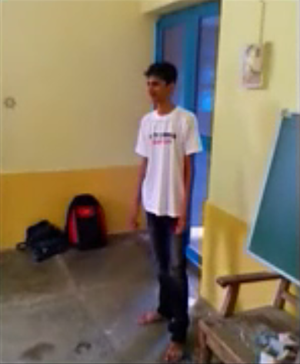
"I feel my vocabulary has improved and I am confident that i can now have conversations in English. Also I got to learn about behavior and body language which helps me in my daily life. I also find myself finishing my school syllabus faster than before." - Dinesh Rohilla

In the second year {2014} EPD was recognized as a permanent department of NSS BITS Pilani. Starting the year with a new enthusiasm and new recruits the team increased to 12 members. This year another 2 volunteers were trained under Teach India.
The classes were now conducted MWF for boys and TTS for girls and a 2 hour common class on Sunday
The modules were followed serially, apart from TOI curriculum, teaching them how to give their introduction was the first activity, followed by tongue twisters to improve their pronunciation, teaching them about basic things in general knowledge like history and geography, current affairs. Teaching them etiquette and manners was followed afterwards along with examples and practice sessions in body language. We also conducted tests to find out the level of understanding of the students. Along with all this we also tried to help the students in their personal lives and counseled them informally whenever they needed counseling.

With an aim to create a difference in the personality and communication skills of the students of Pilani, We continued our work with new zeal as it entered into its third year 2015-16. 14 new volunteers joined the EPD family as our working areas expanded to teaching college graduates and starting with the School English Program(SEP) for 8th,9th students. We started off with the goal to take EPD to a new level by utilizing our resources in the right direction. For the work to be systematic and planned we made different teams for different work. The students were encouraged to participate in activities that would boost their social skills, such as mock telephonic conversations and sales, that would aid them to work at call centers and similar communicative sectors of work. To trigger and develop thought process, we started “Food for thought”.

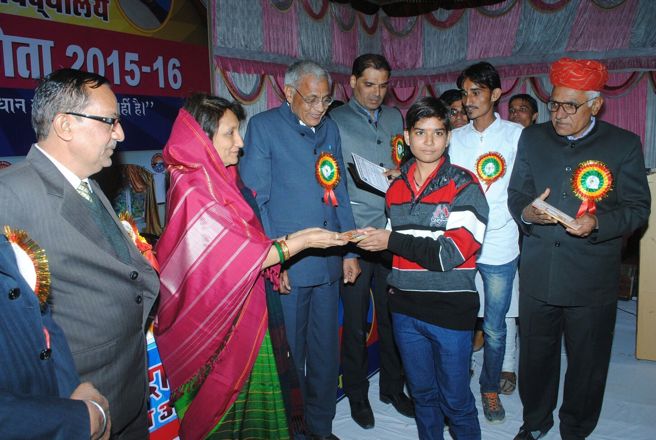
One of the very regular and sincere students of EPD, Ms. Savita Verma, has brought laurels to NSS by bagging a series of prizes in district and state level debating competitions. We witnessed this sapling grow into a tree under EPD and school for the past 2 years. Her story of determination and perseverance has also inspired others to follow in her footsteps.

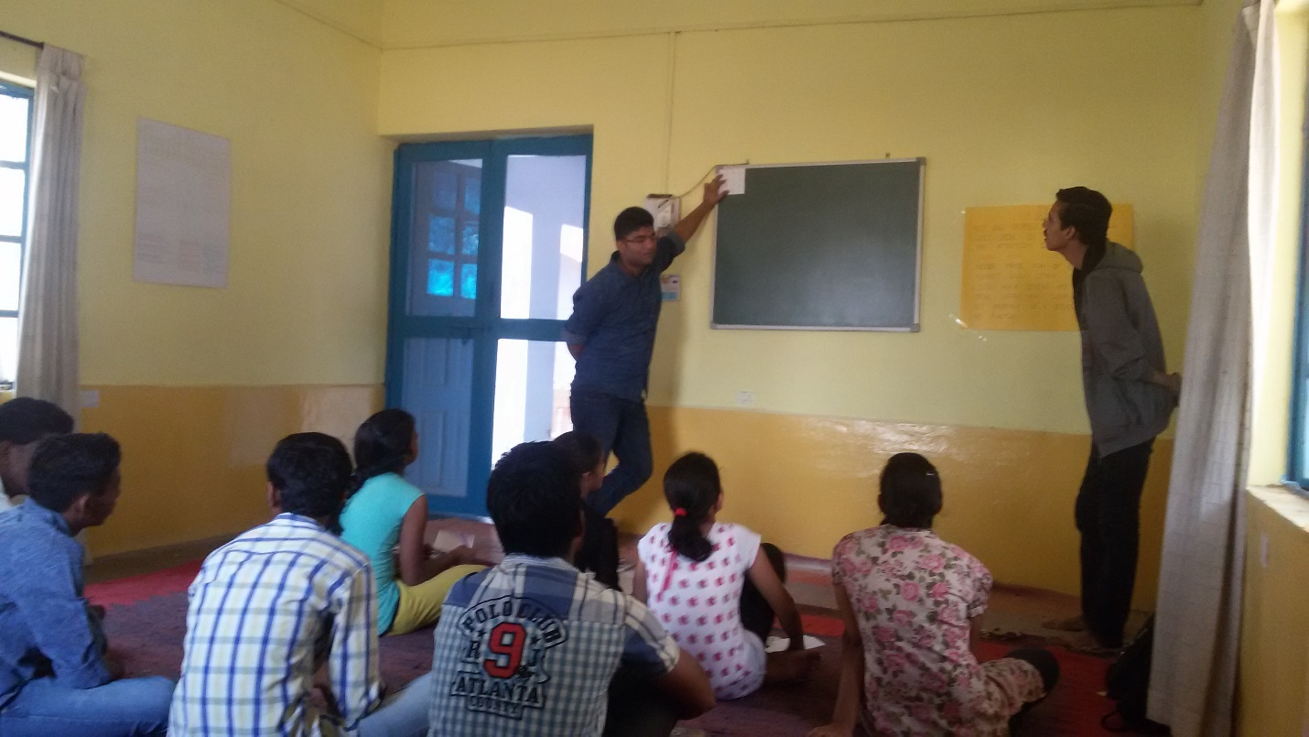
TWO OF OUR VOLUNTEER TEACHING IN EPD

