**‘Custom’ database is created.**

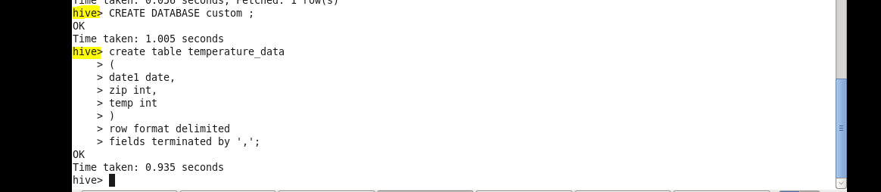

**temperature_data table is created.**

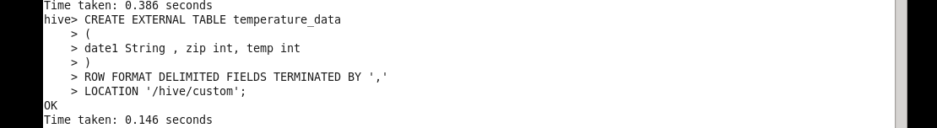

**Dataset set successfully fetched using select query.**

