**1. Fetch date and temperature from temperature_data where zip code is greater than 300000 and less than 399999.**

***Query:***

**SELECT * FROM temperature_data where zip > 30000 and zip <39999;**

***Result:***

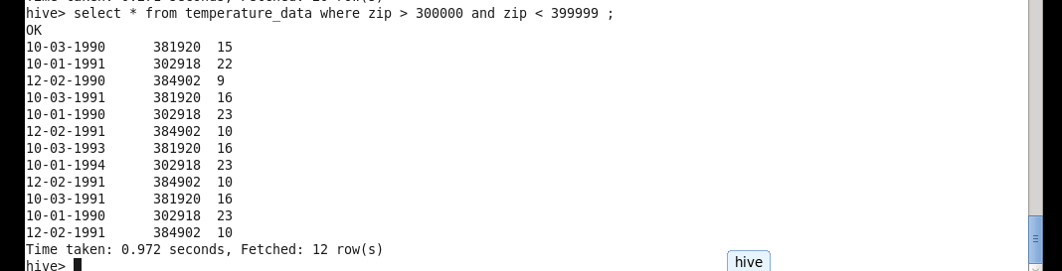

**2. Calculate maximum temperature corresponding to every year from temperature_data table.**

***Query:***

**SELECT SUBSTR(date1,7,4), max(int(temp)) from temperature_data group by SUBSTR(date1,7,4);**

***Result:***

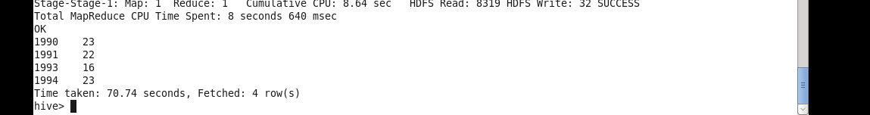

**3. Calculate maximum temperature from temperature_data table corresponding to those years which have at least 2 entries in the table.**

***Query:***

**SELECT SUBSTR(date1,7,4), count(*) as count1 , max(int(temp)) from temperature_data group by SUBSTR(date1,7,4) having count1 >= 2 ;**

***Result:***

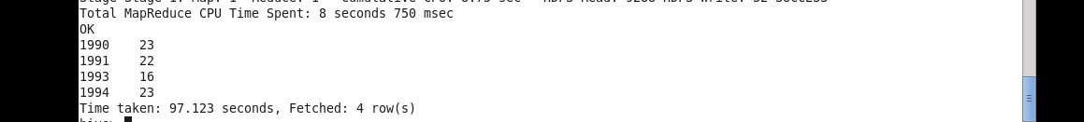

**4. Create a view on the top of last query, name it temperature_data_vw.**

***Query:***

**CREATE VIEW temperature_data_vw AS**

**SELECT SUBSTR(date1,7,4), count(*) as count1 , max(int(temp))**

**FROM temperature_data**

**Group By SUBSTR(date1,7,4) having count1 >= 2 ;**

***Result:***



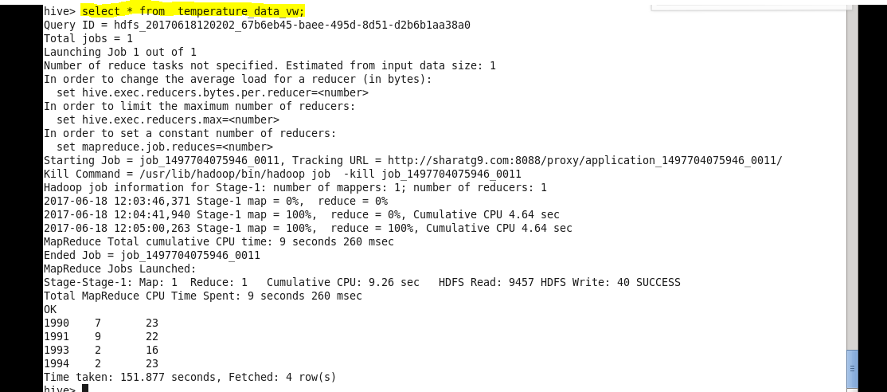

Export contents from temperature_data_vw to a file in local file system, such that each file is '|' delimited.



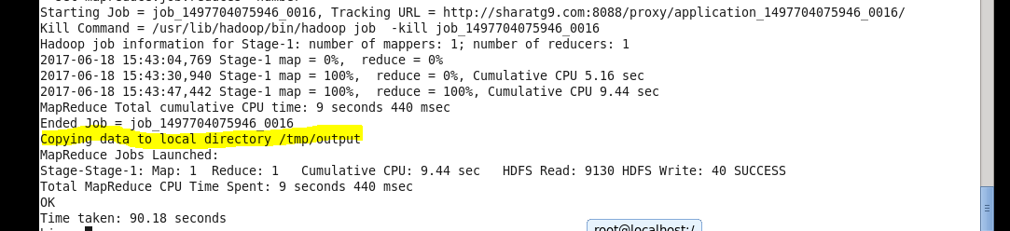

Output

