**1. Calculate the number of employees corresponding to each skill from the table 'employee' which is loaded in the Demo.**

Employee table is created.

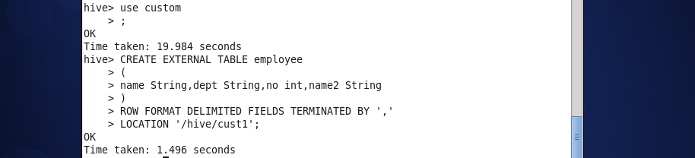

***Query***:

**Select dept, count (*) from employee group by dept;**

***Result:***

