**Task : Loading a dataset into the table**

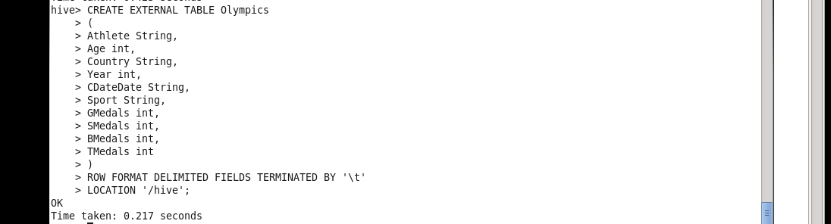

**1. Write a Hive program to find the number of medals won by each country in swimming.**

***Query****:*

**Select Country , sum(TMedals)**

**from Olympics**

**where Sport = ‘swimming’**

**group by Country ;**

***Result****:*



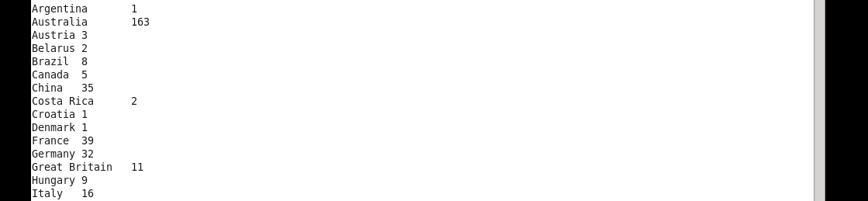

**2. Write a Hive program to find the number of medals that India won year wise.**

***Query****:*

**select Year , sum(TMedals)**

**from Olympics**

**where Country = 'India'**

**group by Year ;**

***Result:***

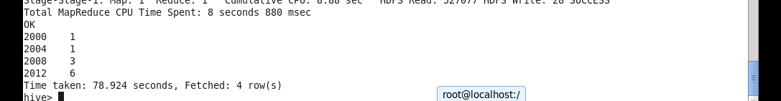

**3. Write a Hive Program to find the total number of medals each country won.**

***Query:***

**select country , sum(TMedals) from Olympics group by country ;**

***Result:***



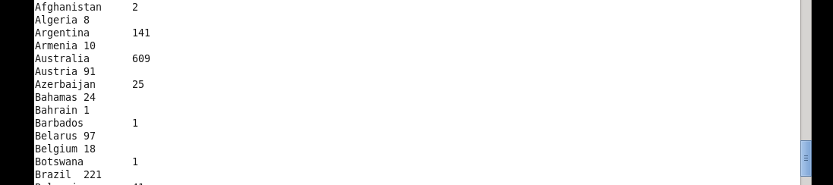

**4. Write a Hive program to find the number of gold medals each country won.**

***Query*:**

**select country , sum(GMedals) from Olympics group by country ;**

***Result:***



