Task1:

Checked whether /user/acadgild directory exists or not in the HDFS.

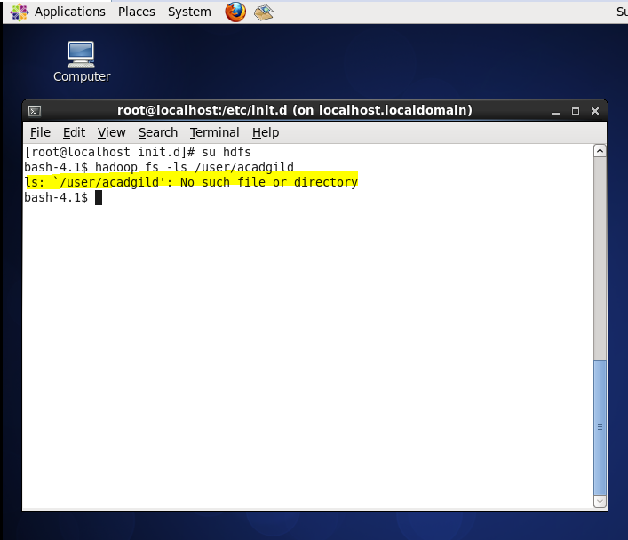

As the directory is not present in the HDFS

New directory with name /user/acadgild/hadoop is created.

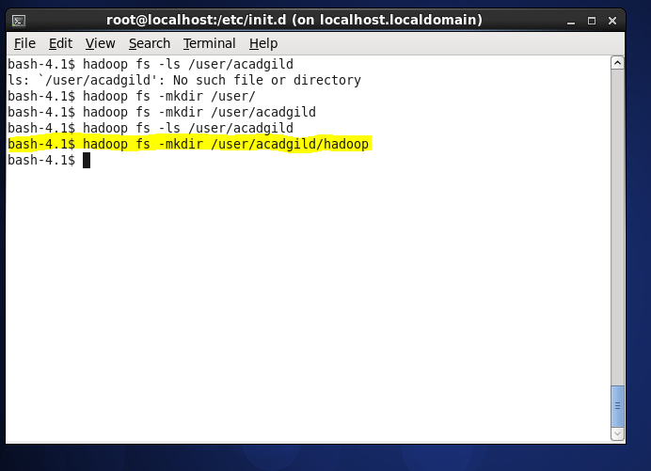

Task 2:

Created word-count.txt in HDFS file system(/user/acadglid/hadoop/word-count.txt) using **touchz** command .

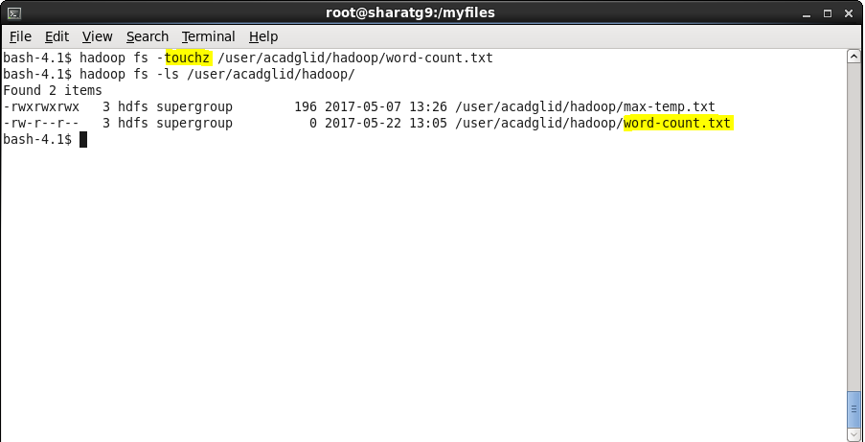

Opened word-count.txt in vi edit mode and wrote some line in that txt file.



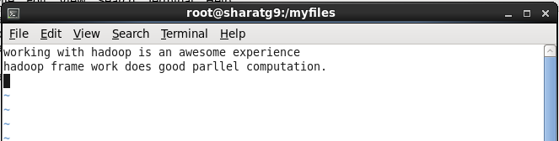

Appended the written content through –appendToFile command.

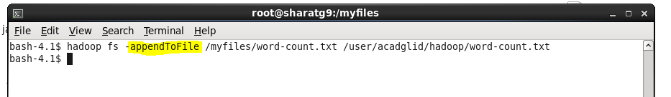

Using –cat viewed the written content.

