Task 1: Write a Map Reduce program to filter the “NA” content.

Mapper class:

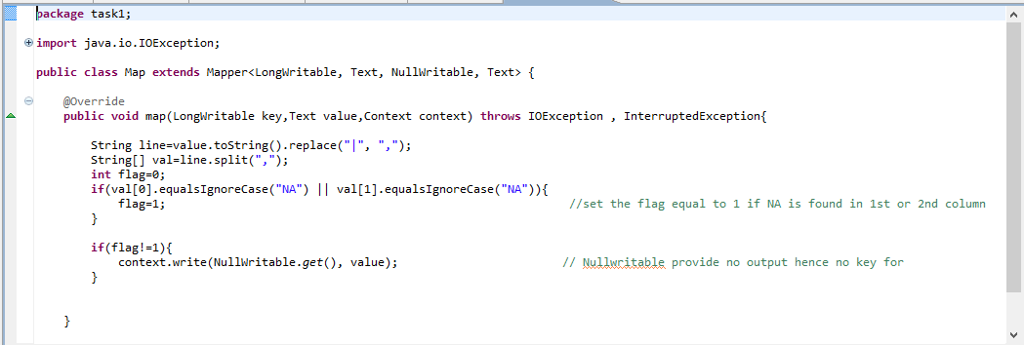

Driver class:

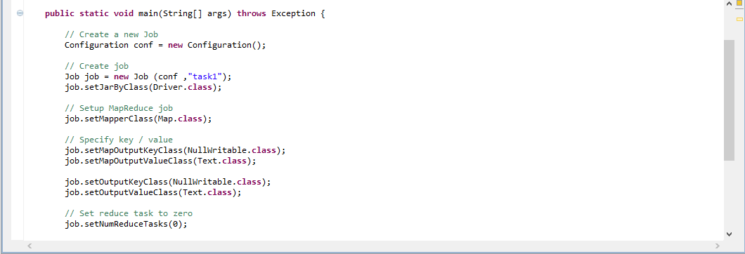

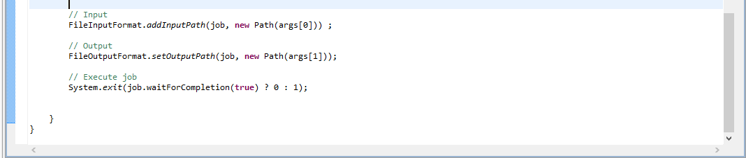

Executing jar file:

hadoop jar TV_filter.jar task1.Driver /project/television.txt /project/output

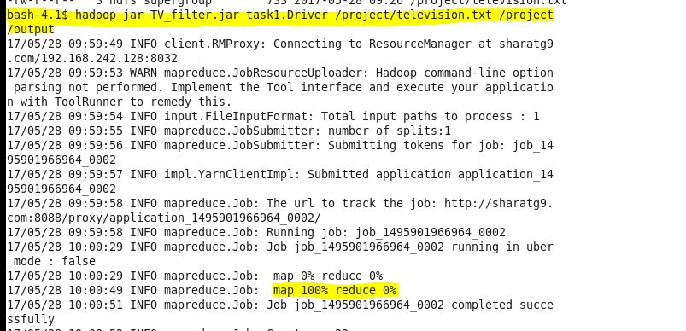

Output:

