Task 2: Write a Map Reduce program to calculate the total units sold for each Company

Mapper class:

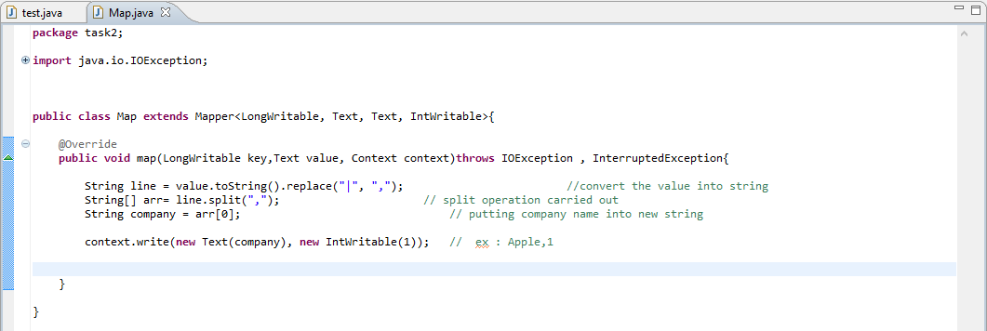

Reducer class:

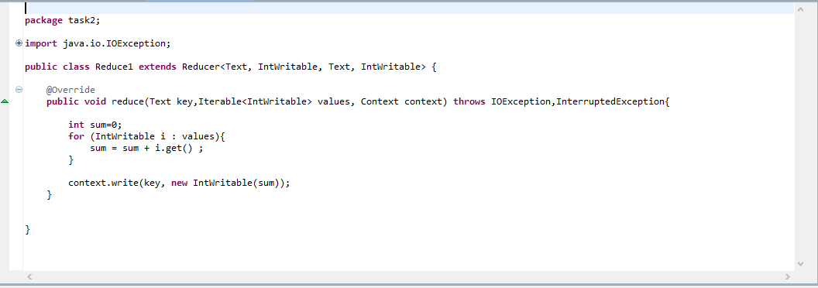

Driver class:

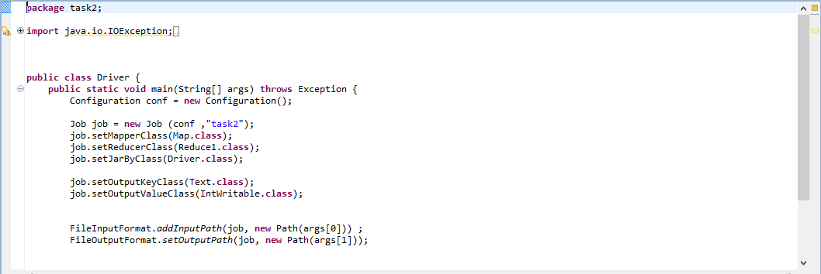

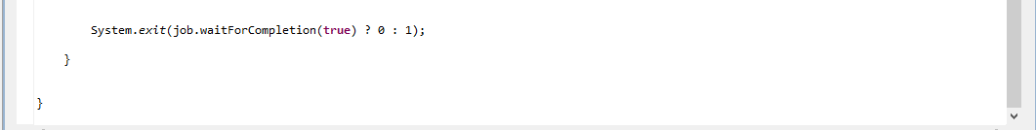

Executing jar file:

hadoop jar TV.jar task2.Driver /project/output/part-m-00000 /project/output1

/project/output/part-m-00000 – task1’s output were “NA” data is filtered out.



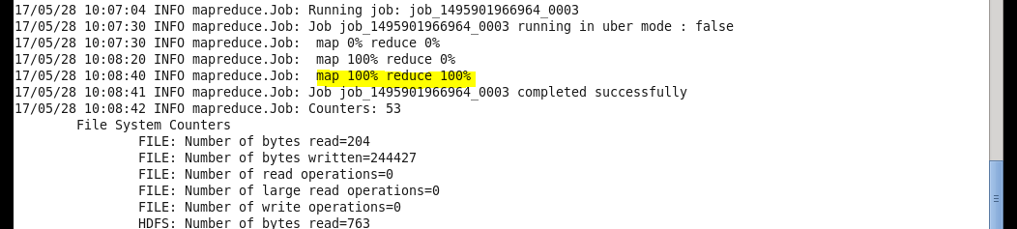

Output:

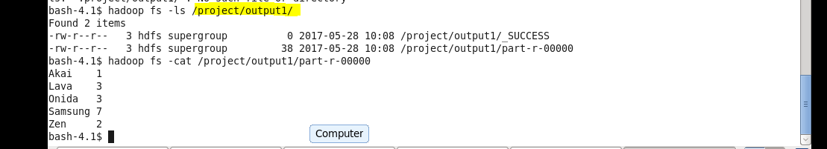

**Task 3: Write a Map Reduce program to calculate the total units sold in each state for ‘Onida’ Company.**

Mapper class:

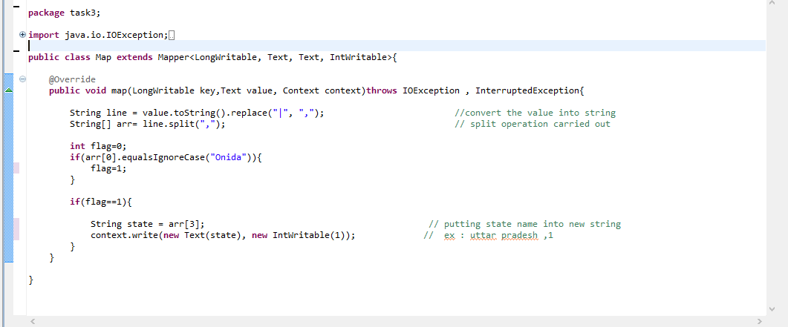

Reducer class:

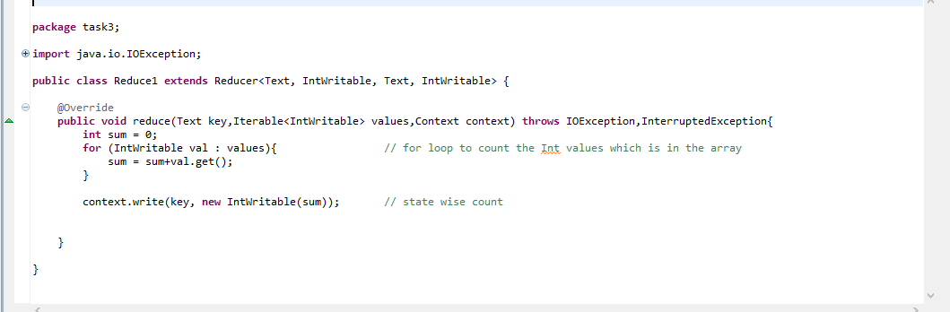

Driver class:

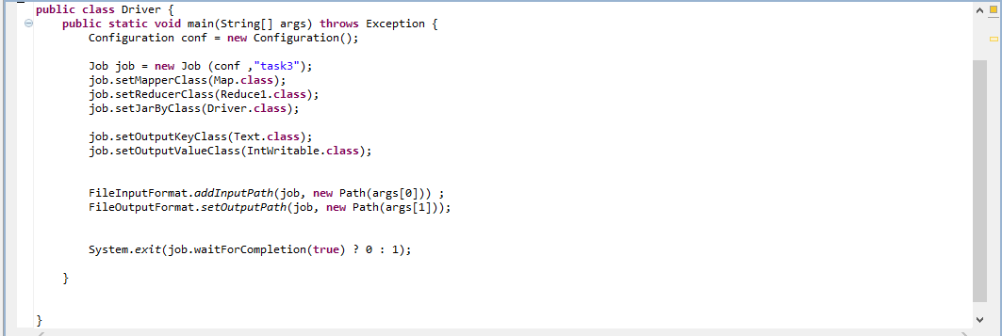

Executing:

hadoop jar TV.jar task3.Driver /project/output/part-m-00000 /project/output4



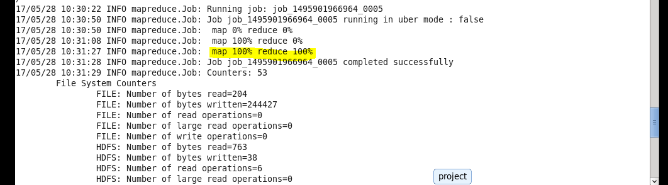

Output:

