Task 4: Write a Map Reduce program to modify Task 2 (refer session 4, assignment 2) to use a custom partitioner with 4 reducers.

Mapper class:

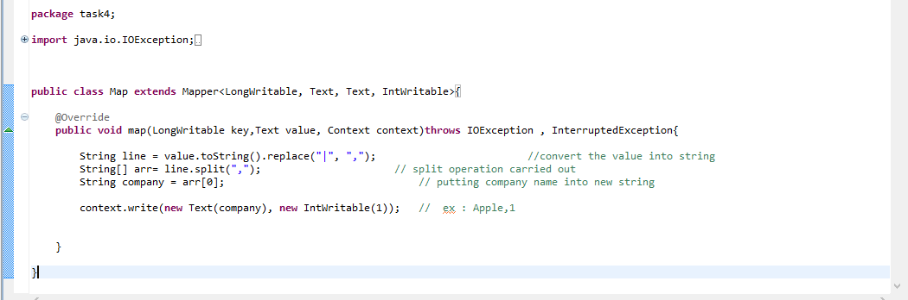

Reducer class:

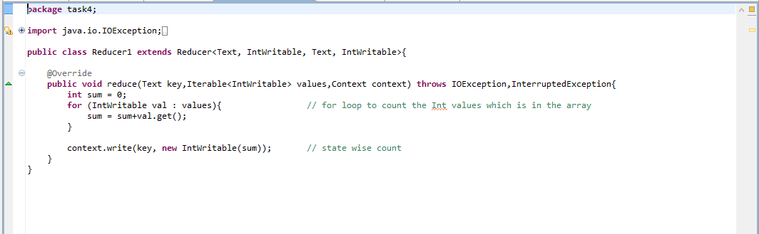

Driver class:

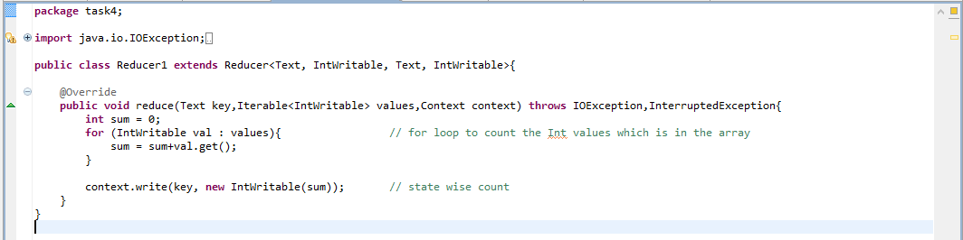

Partitionzer class:

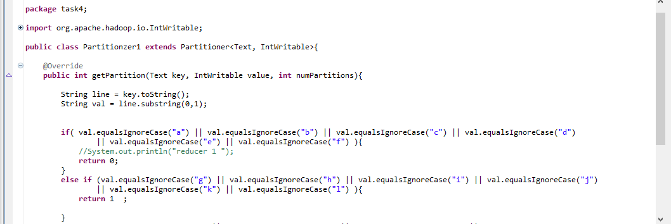

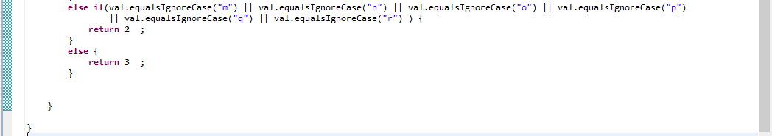

Executing jar file:

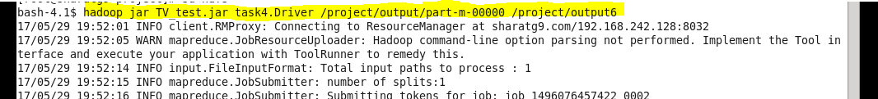

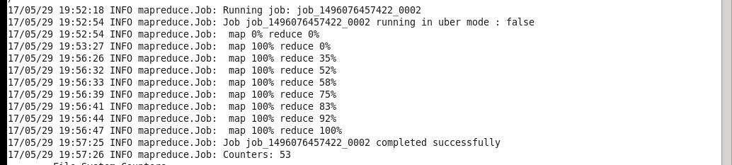

Output:

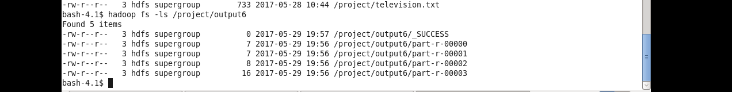

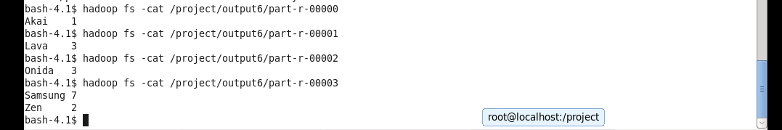

Task 5: Modify Task 2 (refer session 4, assignment 2) to take advantage of Combiner.

Mapper class:

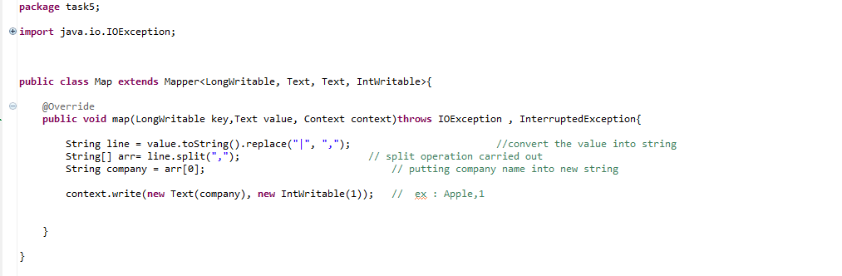

Reducer class:

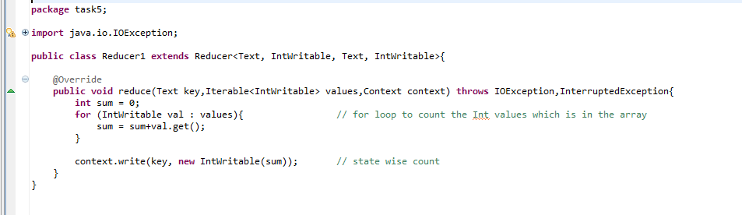

Drive class: 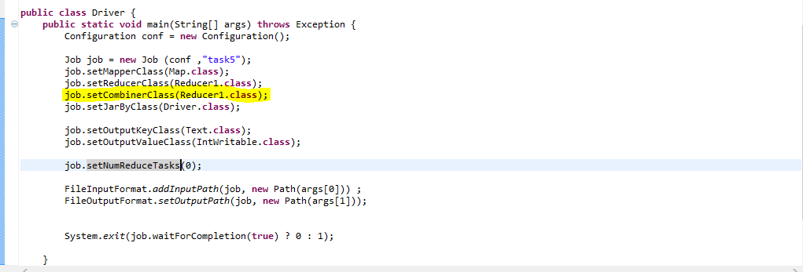

Execution:

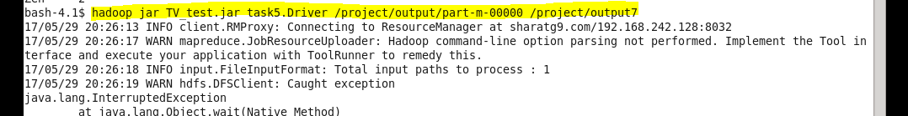

Output:

