**Task 6: Modify Task 3 (refer session 4, assignment 2) to take advantage of Combiner.**

**Mapper class:**

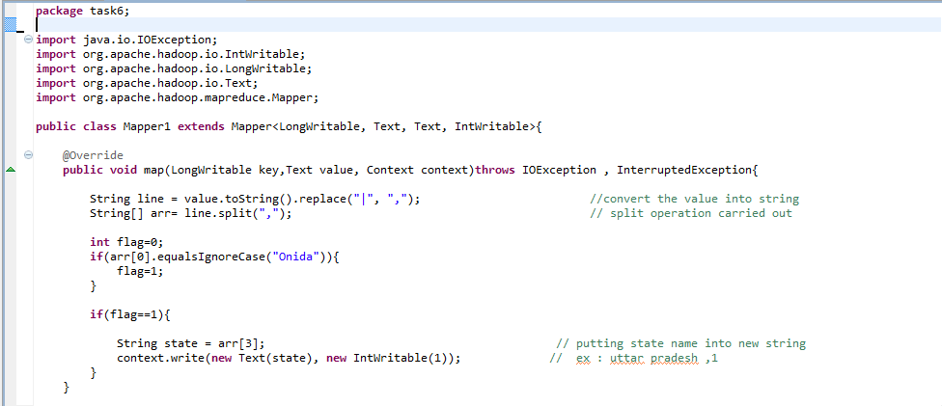

**Reducer class:**

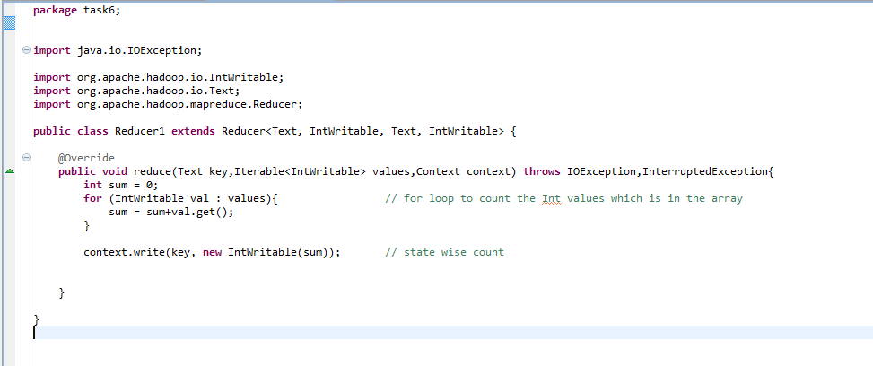

**Driver class:**

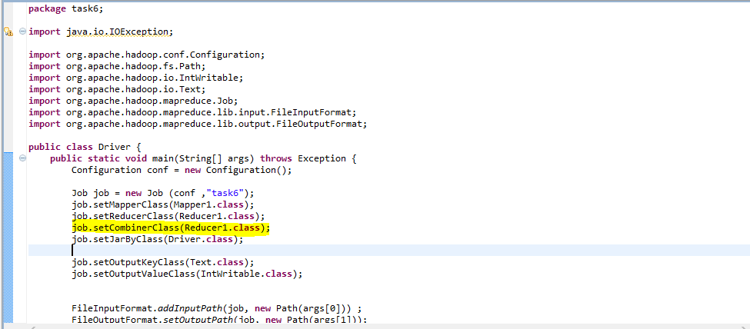

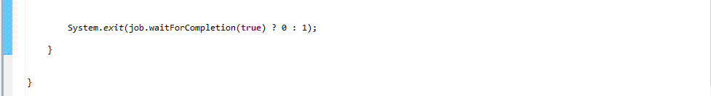

**Executing jar file:**

**hadoop jar TV_total.jar task6.Driver /project/output/part-m-00000 /project/output3**

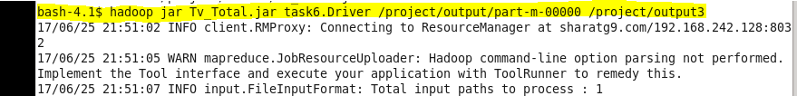

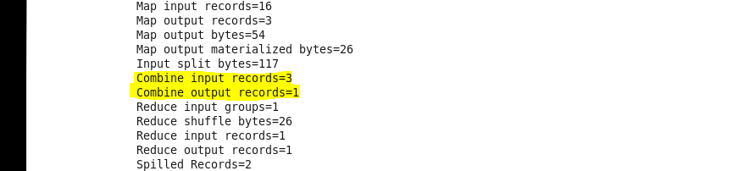

**Output:**



**Task 7: Write a Map Reduce program to view the total sales for each product for every Company corresponding to each size.**

**Mapper class:**

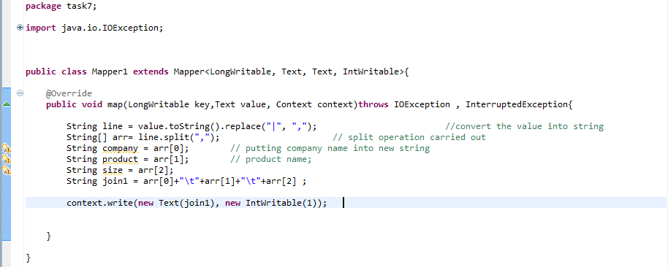

**Reducer class:**

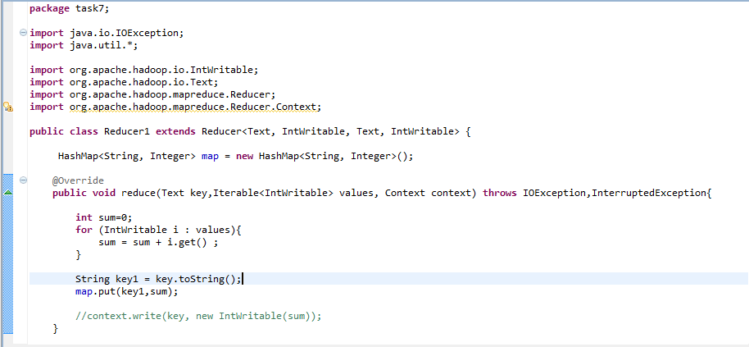

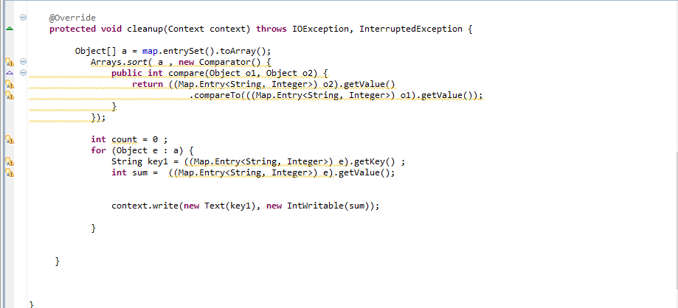

**Driver class:**

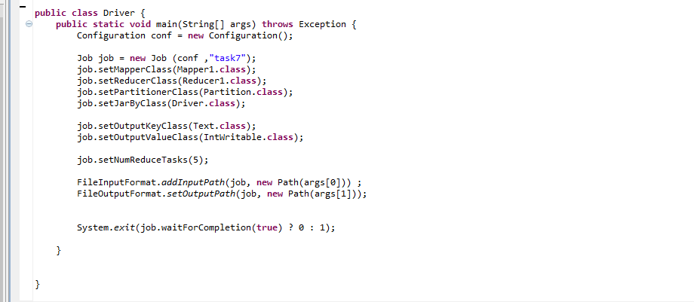

**Partitionzer :**

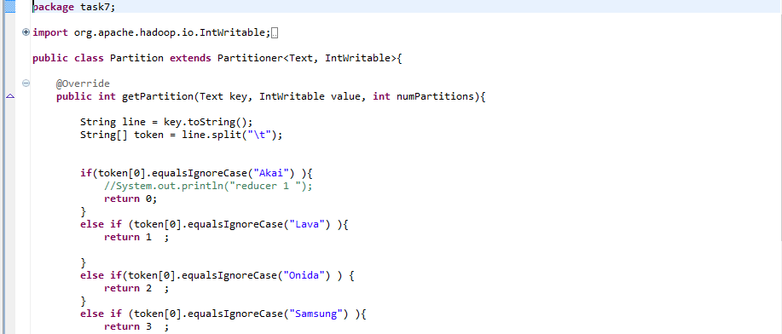

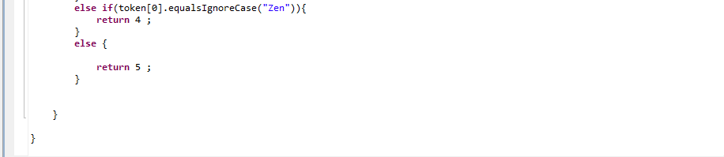

**Executing:**

**hadoop jar Tv_total.jar task7.Driver /project/output/part-m-00000 /project/output7**

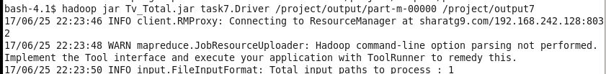

**Output:**

