**Task 8:** Write a Map Reduce program that takes the output of Task 5 (refer session 5, assignment 1) as input, and produce output which is sorted on the total units sold. You may use a single reducer for the sorting.

**Mapper class:**

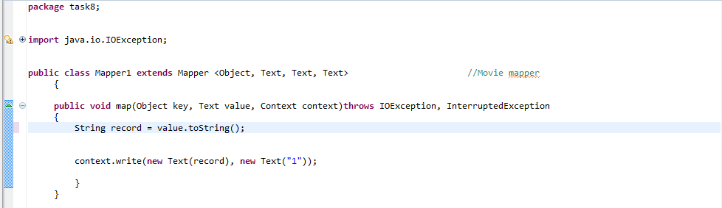

This Mapper takes output of task5 as a input and pass it to reducer to sort the output.

**Reducer:**

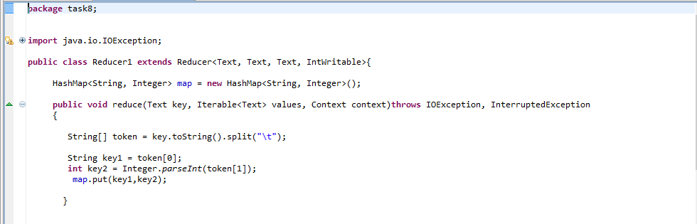

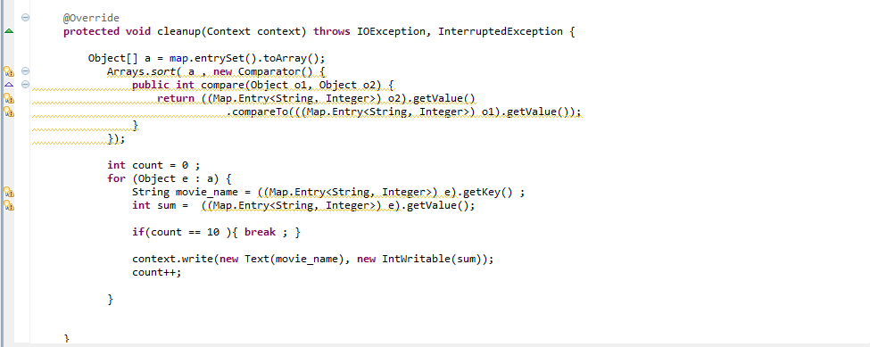

Key is Splited into two parts to key actual key and values. After I passed it to the map and get sorted done in ascending order

**Driver class:**

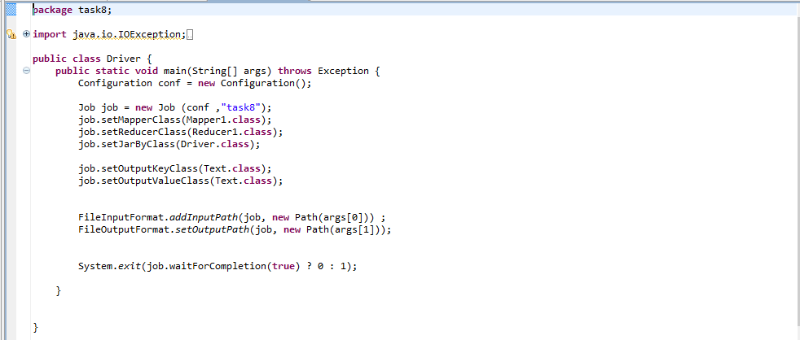

**Executing jar file:**

hadoop jar Tv_total24.jar task8.Driver /project/output10/part-r-00000 /project/final

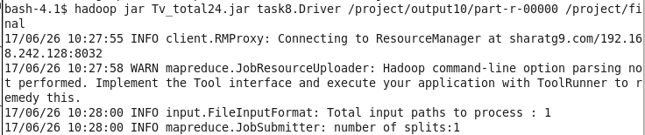

**Input:**

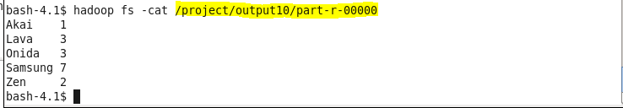

**Output:**

