**Task 10:** Enhance the task 8 (refer session 6, assignment 1) to calculate the top 3 state-wise sales for each company.

**Mapper class:**

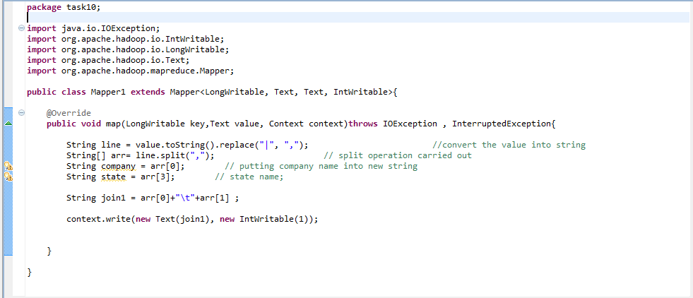

**Reducer:**

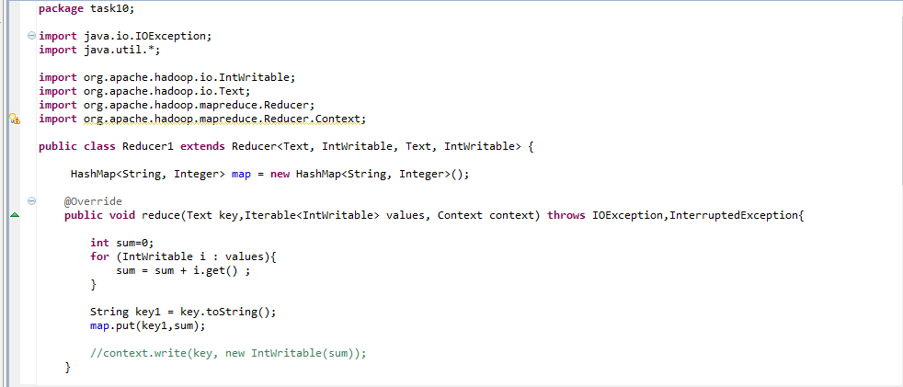

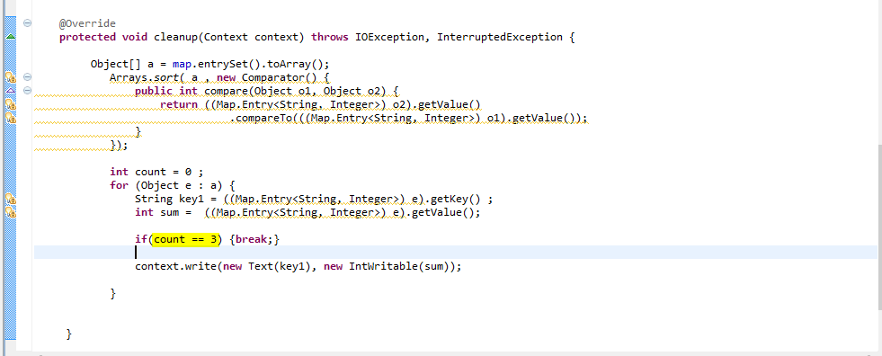

**Driver class:**

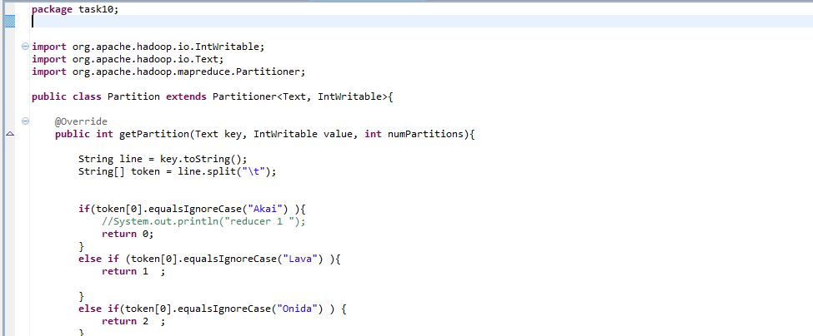

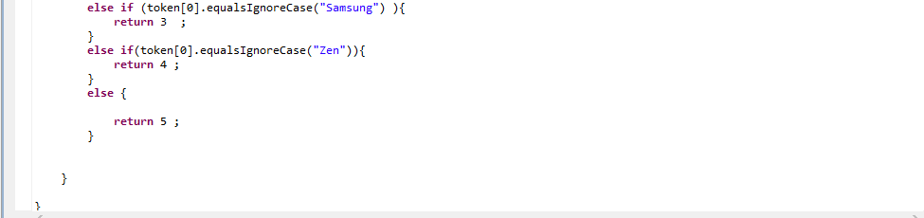s

**Executing jar file:**

hadoop jar Tv_task10.jar task10.Driver /project/output/part-m-00000 /project/final

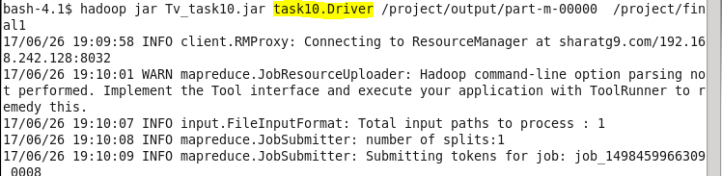

**Output:**

