Execution:

(a) Top 5 employees (employee id and employee name) with highest rating.

Pig –x local task1.pig

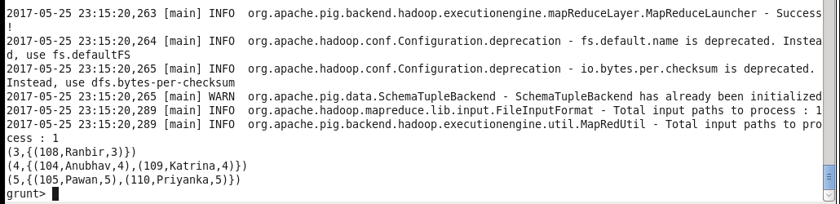

(b) Top 3 employees (employee id and employee name) with highest salary, whose employee id is an odd number.

Pig –x local task2.pig

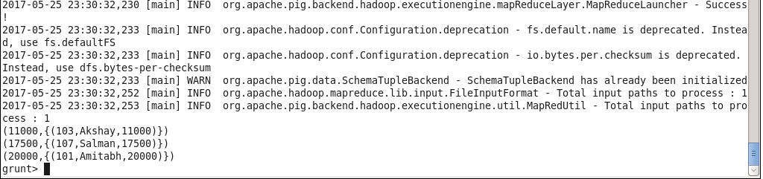

(c) Employee (employee id and employee name) with maximum expense

Pig –x local task3.pig

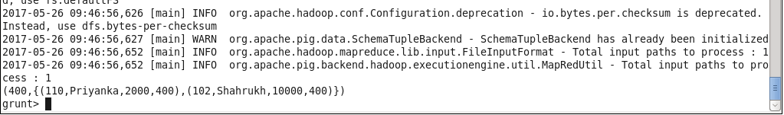

(d)List of employees (employee id and employee name) having entries in employee_expenses

Pig –x local task4.pig

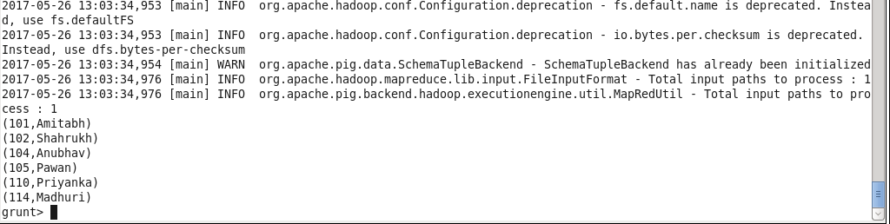

(E)List of employees (employee id and employee name) having no entry in employee_expenses

Pig –x local task5.pig

