1. Find the number of students who scored less than 5(50%).

Data = LOAD '/demo/test2.txt' USING PigStorage(',') ;

B = filter Data by $4 < 5 ;

C = foreach B generate $0;

dump C;

Result:



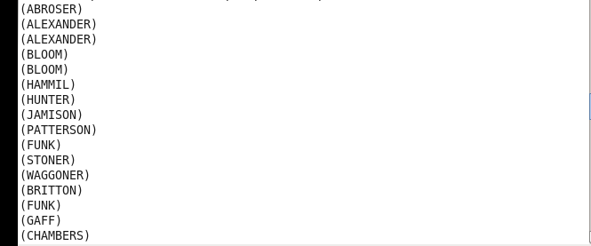

2. List the name of students who are from Alaska.

Data = LOAD '/demo/test2.txt' USING PigStorage(',') ;

B = filter Data by ($5 == 'alaska' );

C = foreach B generate $0 ;

dump C;

Result:





3. How many government collages are there in Alabama?

Data = LOAD '/demo/test2.txt' USING PigStorage(',') ;

B = foreach Data generate $1,$5 ;

C = filter B by ($0 == 'goverenment' and $1 == 'alabama' ) ;

D = group C ALL ;

E = foreach D generate COUNT(D.$1) ;

dump E;

Result:



4. List the name of students who are from Oregon and persuing BE.

Data = LOAD '/demo/test2.txt' USING PigStorage(',') ;

B = filter Data by ($5 == 'oregon' and $3 == 'BE' ) ;

C = foreach B generate $0 ;

dump C;

Result:



