**Assignment 1.1**

1. **centos 6.2 image is loaded VM**

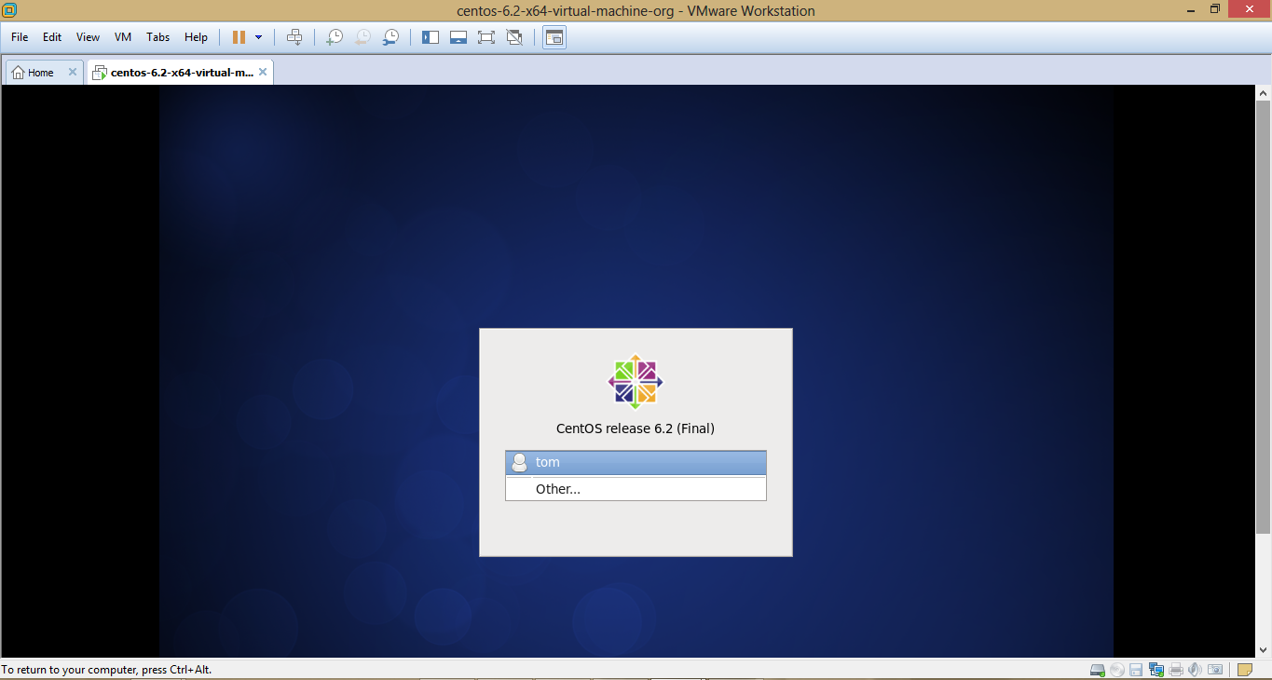

1. **All the daemons are started in VM.**

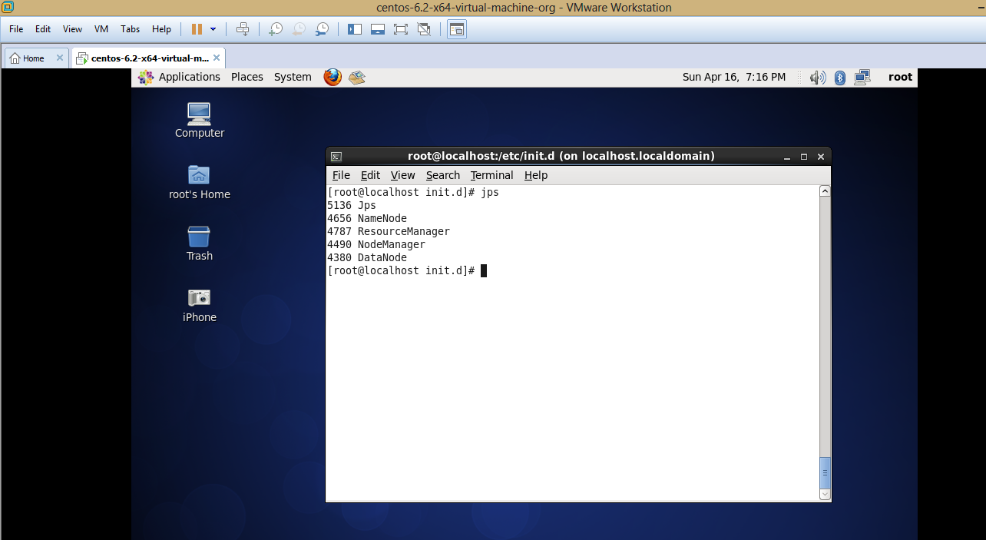

1. **PIG**

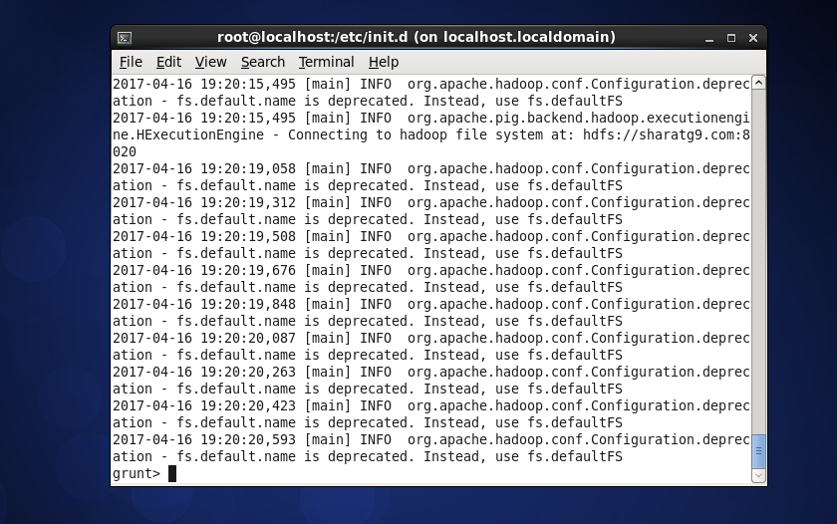

1. **Hive**

