Task 1: Write a MapReduce/Pig program to calculate the number of cases investigated under FBI code 32.

Mapper class:

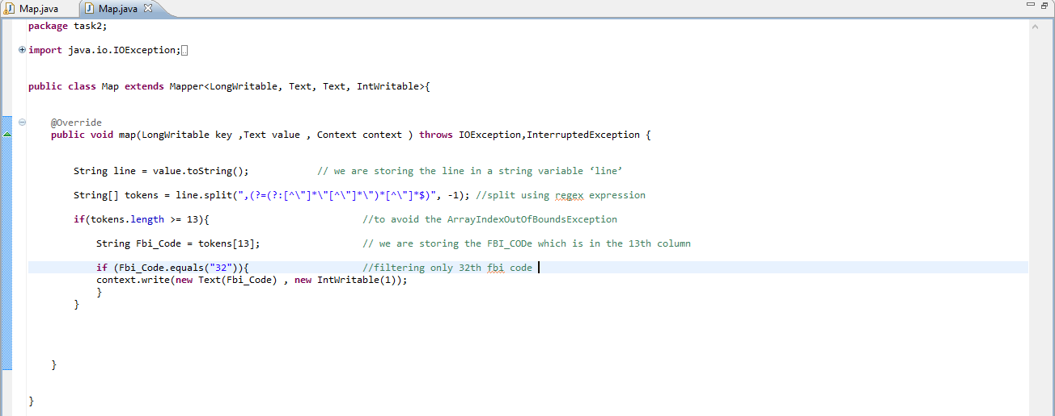

We are splitting the line by using “,(?=(?:[^\"]*\"[^\"]*\")*[^\"]*$)” delimiter and storing the values in a String Array so that all the columns in a row are stored in the string array. Then we are taking a condition if we have the string array length greater than 13 which means if the line or row has at least 13 columns then it will enter into the if condition and execute the code to eliminate the **ArrayIndexOutOfBoundsException.**

  We are storing the FBI code which is in the 13th column. Filtering 13th is equal to “32” FBI code. We are writing the key and value into the *context* which will be the output of the map method.

Reducer class:

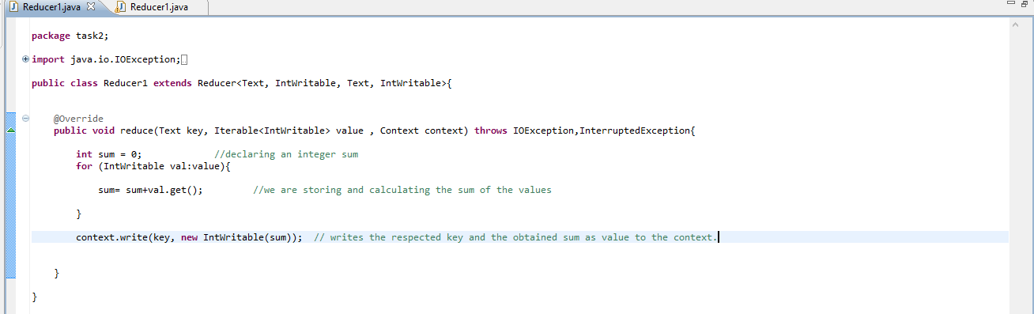

We are declaring an integer sum which will store the sum of all the ages of people in it. A for each loop is taken which will run each time for the values inside the *“Iterable values”* which are coming from the *shuffle* and *sort* phase after the Mapper phase.

We are storing and calculating the sum of the values.  We are performing the average of the obtained sum and write the respected key and the obtained sum as *value* to the context.

Driver class:

In Driver putting the small file in distributed cache and put the input file and Output file

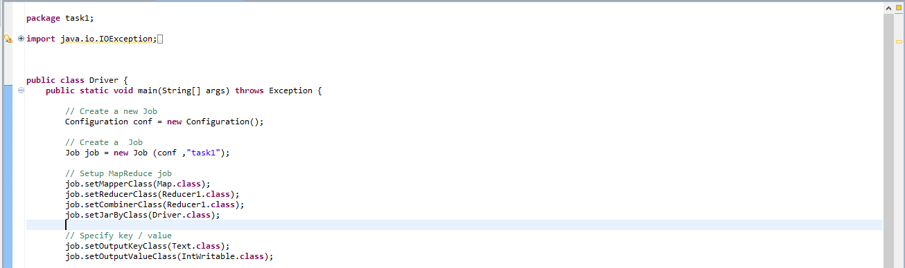

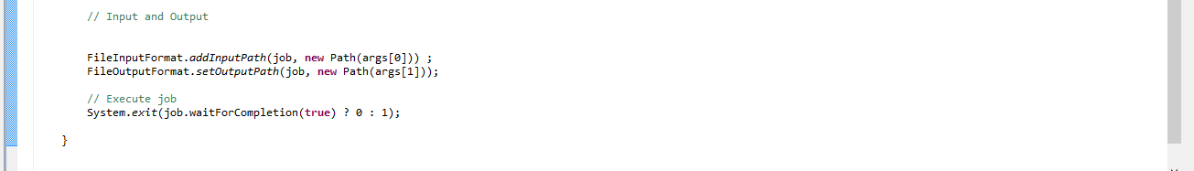

Executing jar file:

hadoop jar project1.jar task2.Driver /project_1/data.csv /project_1/output2

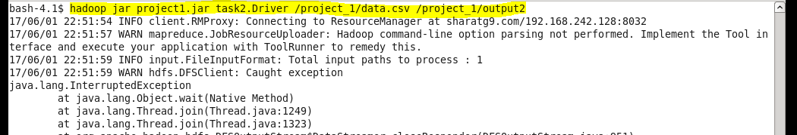

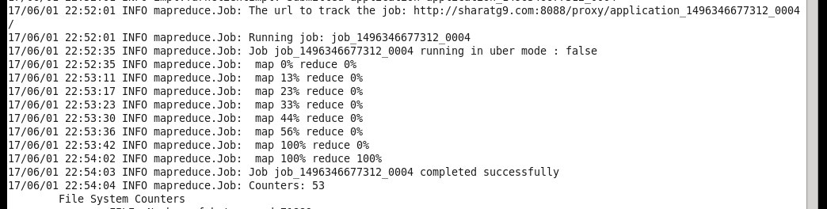

Output:

