1) Develop a C program to implement system process calls (fork(), exec(), wait(), create process, terminate process).

#include<stdio.h>
#include<stdlib.h>
#include<unistd.h>

void main()
{
pid_t pid=fork();
if(pid==-1)
{
printf("Fork Error");
exit(1);
}
if(pid==0)
{
execlp("/bin/date","date",NULL);
exit(1);
}
else
{
int status;
printf("Parent Process\n");
wait();
printf("Child Process Terminates\n");
}
}

Output:

2) Simulate the following CPU scheduling algorithms to find turnaround time and waiting time (a)FCFS, (b)SJF, (c)Priority, (d)Round Robin.

(a) FCFS-CPU Scheduling

#include<stdio.h>

int main() {
int n, bt[20], wt[20], tat[20], avwt = 0, avtat = 0, i, j;

printf("Enter total number of processes (maximum 20): ");
scanf("%d", &n);

printf("\nEnter Process Burst Time:\n");
for (i = 0; i < n; i++) {
printf("p[%d]:", i + 1);
scanf("%d", &bt[i]);
}

wt[0] = 0;
for (i = 1; i < n; i++) {
wt[i] = 0;
for (j = 0; j < i; j++) {
wt[i] += bt[j];
}
}
printf("\nProcess\tBurst Time\tWaiting Time\tTurnaround Time");
for (i = 0; i < n; i++) {
tat[i] = bt[i] + wt[i];
avwt += wt[i];
avtat += tat[i];
printf("\np[%d]\t\t%d\t\t%d\t\t%d", i + 1, bt[i], wt[i], tat[i]);
}
// Calculate averages
float avgwt = (float)avwt / n;
float avgtat = (float)avtat / n;

// Display averages
printf("\n\nAverage Waiting Time: %f", avgwt);
printf("\nAverage Turnaround Time: %f\n", avgtat);

return 0;
}

Output:
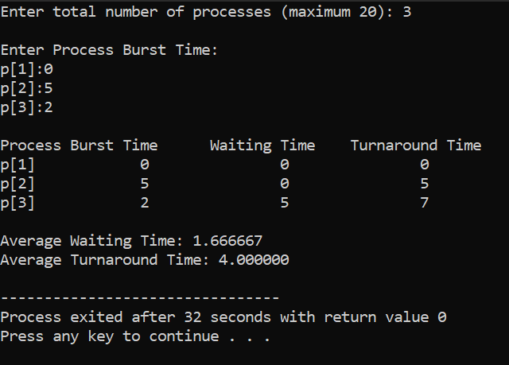

(b) SJF-CPU Scheduling

#include <stdio.h>

int main() {
int bt[20], p[20], wt[20], tat[20], i, j, n, totwt = 0, tottat = 0, pos, temp;
float avgwt, avgtat;
printf("Enter the number of processes:");
scanf("%d", &n);
printf("\nEnter Burst Time:\n");
for (i = 0; i < n; i++) {
printf("p%d:", i);
scanf("%d", &bt[i]);
p[i] = i;
}
for (i = 0; i < n; i++) {
pos = i;
for (j = i + 1; j < n; j++) {
if (bt[j] < bt[pos])
pos = j;
}
temp = bt[i];
bt[i] = bt[pos];
bt[pos] = temp;
temp = p[i];
p[i] = p[pos];
p[pos] = temp;
}
wt[0] = 0;
for (i = 1; i < n; i++) {
wt[i] = 0;
for (j = 0; j < i; j++) {
wt[i] += bt[j];
}
}
tottat = 0;
printf("\nProcess\tBurst Time\tWaiting Time\tTurnaround Time");
for (i = 0; i < n; i++) {
tat[i] = bt[i] + wt[i];
tottat += tat[i];
totwt += wt[i];
printf("\np%d\t\t%d\t\t%d\t\t\t%d", p[i], bt[i], wt[i], tat[i]);
}
avgwt = (float)totwt / n;
avgtat = (float)tottat / n;
printf("\n\nAverage Waiting Time = %f", avgwt);
printf("\nAverage Turnaround Time = %f\n", avgtat);
return 0;
}

Output:
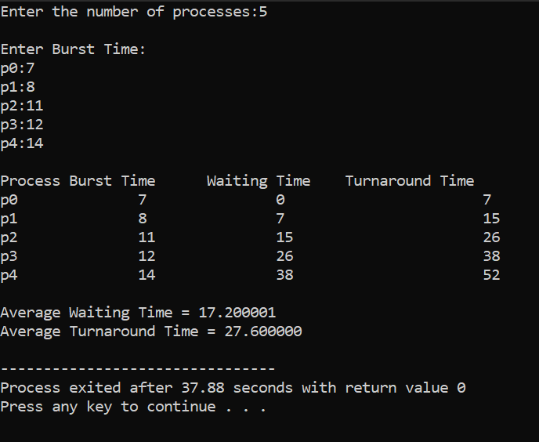

(c) Priority-CPU Scheduling

#include<stdio.h>
int main()
{
int bt[20],p[20],wt[20],tat[20],pr[20],i,j,n,total=0,pos,temp,avg_wt,avg_tat;
printf("Enter Total Number of Process:");
scanf("%d",&n);
printf("\n Enter Burst Time and Priority\n");
for(i=0;i<n;i++)
{
printf("\np[%d]\n",i+1);
printf("Burst Time:");
scanf("%d",&bt[i]);
printf("Priority:");
scanf("%d",&pr[i]);

p[i]=i+1;

}
for(i=0;i<n;i++)
{
pos=i;
for(j=i+1;j<n;j++)
{
if(pr[j]<pr[pos])
pos=j;
}
temp=pr[i];
pr[i]=pr[pos];
pr[pos]=temp;
temp=bt[i];
bt[i]=bt[pos];
bt[pos]=temp;
temp=p[i];
p[i]=p[pos];
p[pos]=temp;
}
wt[0]=0;
for(i=0;i<n;i++)
{
wt[i]=0;
for(j=0;j<i;j++)
wt[i]+=bt[j];
total+=wt[i];
}
avg_wt=total/n;
total=0;
printf("\n Process\tBurst Time\tWaiting Time\tTurnaround Time");
for(i=0; i<n; i++)
{
tat[i] = bt[i] + wt[i];
total += tat[i];
printf("\np[%d]\t\t%d\t\t%d\t\t%d", p[i], bt[i], wt[i], tat[i]);
}

avg_tat=total/n;
printf("\n\n Average Waiting Time=%d",avg_wt);
printf("\n Average Turnaround Time=%d\n",avg_tat);
return 0;
}

Output:
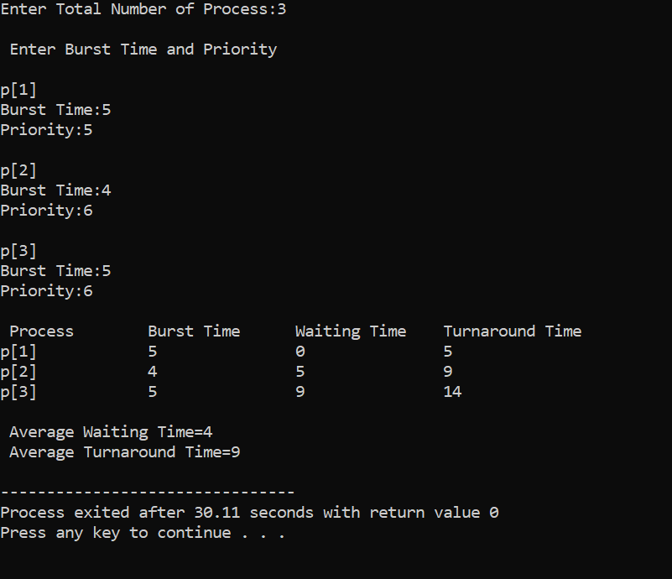

3) Develop a C program to simulate producer-consumer problem using semaphores.

#include<stdio.h>

void main()
{
int buffer[10],bufsize,in,out,produce,consume,choice=0;
in=0;
out=0;
bufsize=1;
while(choice!=3)
{
printf("\n1.Produce\t2.Consume\t3.Exit");
printf("\n Enter your choice:");
scanf("%d",&choice);
switch(choice){
case 1:if((in+1)%bufsize==out)
printf("\n Buffer is Full");
else
{
printf("\n Enter the value:");
scanf("%d",&produce);
buffer[in]=produce;
in=(in+1)%bufsize;
}
break;
case 2:if(in==out)
printf("\n Buffer is Empty");
else
{
consume=buffer[out];
printf("\n The consumed value is%d",consume);
out=(out+1)%bufsize;
}
break;
}
}
}

Output:
