**Example Of Seldon deployment step by step Procedures:**

**Create A K8S Cluster:**

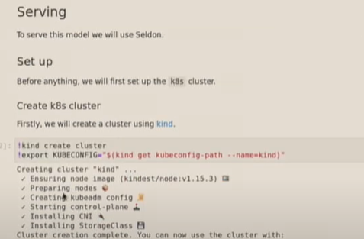

**Helm installation:-**

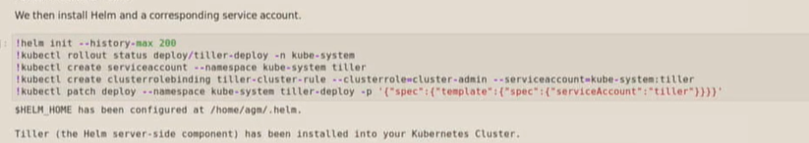

**Seldon- Core Installation:-**

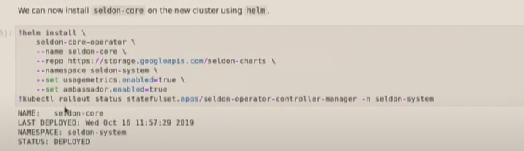

**Install Ambassador:-**



**Monitoring(Prometheus and Grafana):**

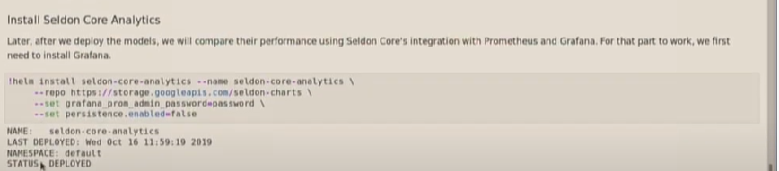

Deploying model to K8 Clusters:-

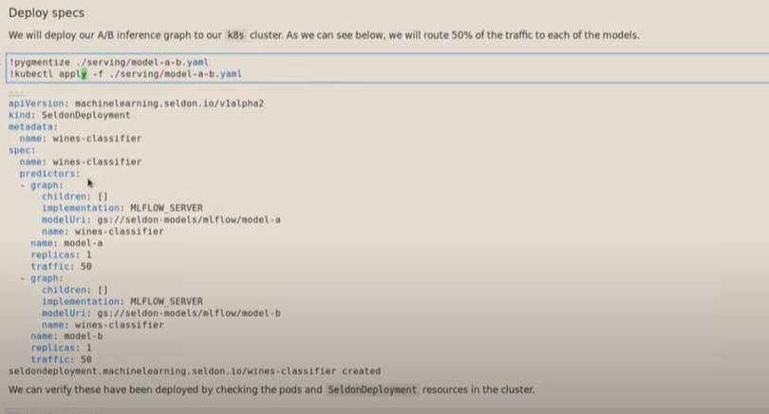

Verify the Pods

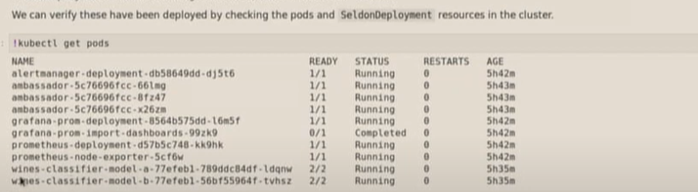

Verify the deployements:

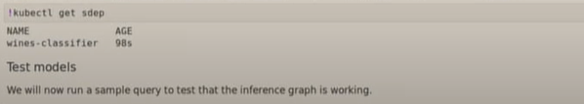

**Analystics:-**

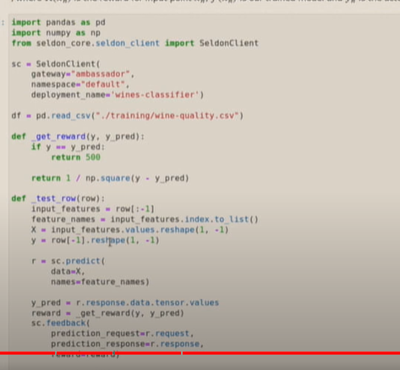

**Monitoring:**



