Smart Artificial Intelligence Based Online Proctoring System

Since Covid-19 education system fully migrated to online services to conduct examination and classes. While conducting online examination student must be watched to avoid cheating so we are employing Artificial Intelligence CNN algorithm which detect single and multiple person’s availability, notebook, mobile phone, student emotion and head pose movement.

To implement this project we have designed following modules

1. Generate & Load CNN Model: using this module we will generate and load CNN model and then calculate prediction accuracy
2. Webcam Based Proctoring System: using this module system will start webcam and then monitor student activities

SCREEN SHOTS

To run project double click on ‘run.bat’ file to get below screen

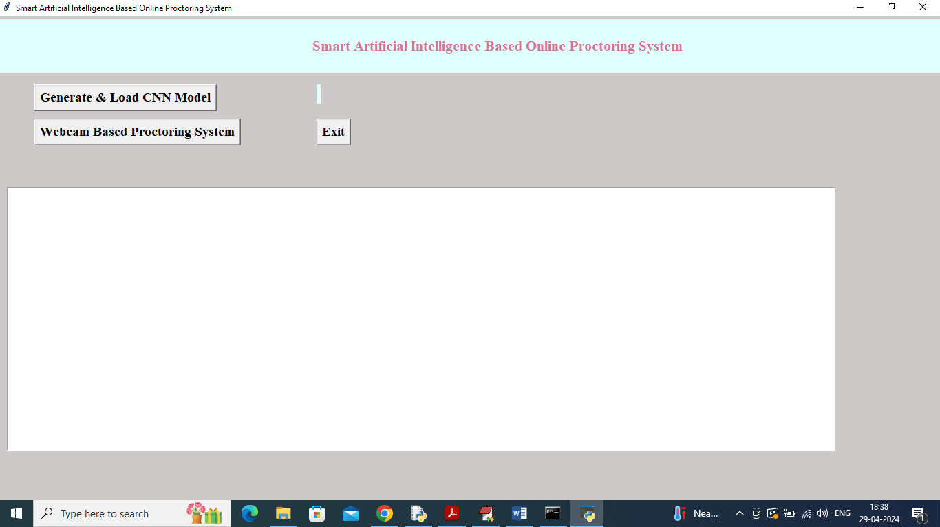

In above screen click on “Generate & Load CNN Model” button to load CNN and get below output

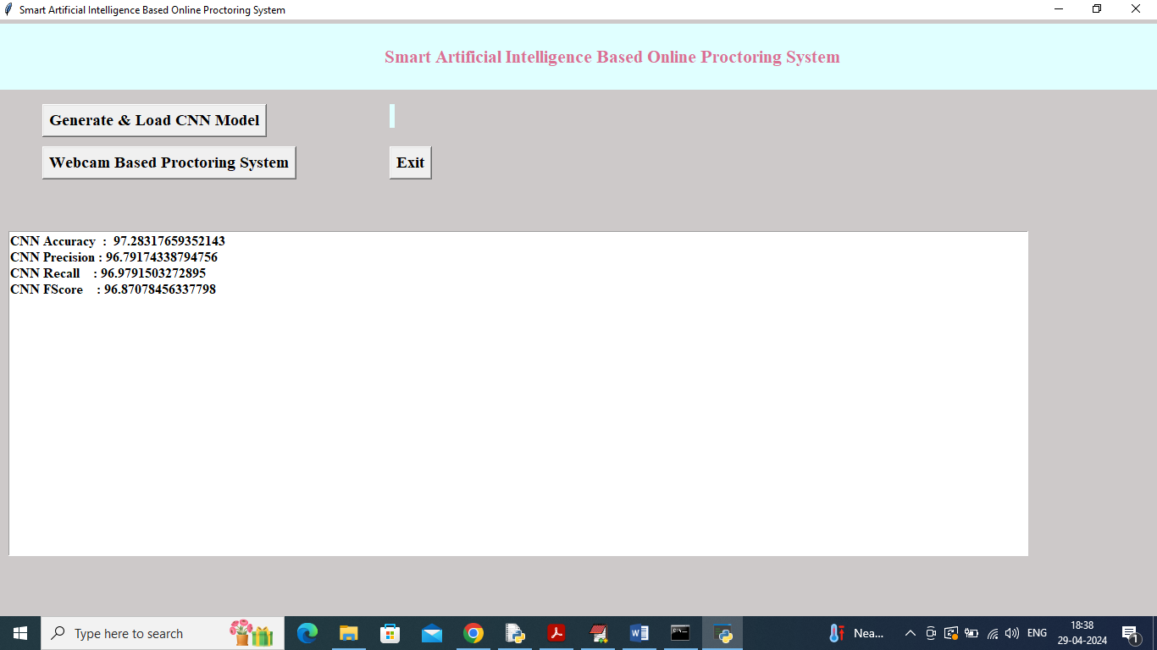

In above screen CNN model loaded and got accuracy as 97% and now click on ‘Webcam Based Proctoring System’ button to get below page

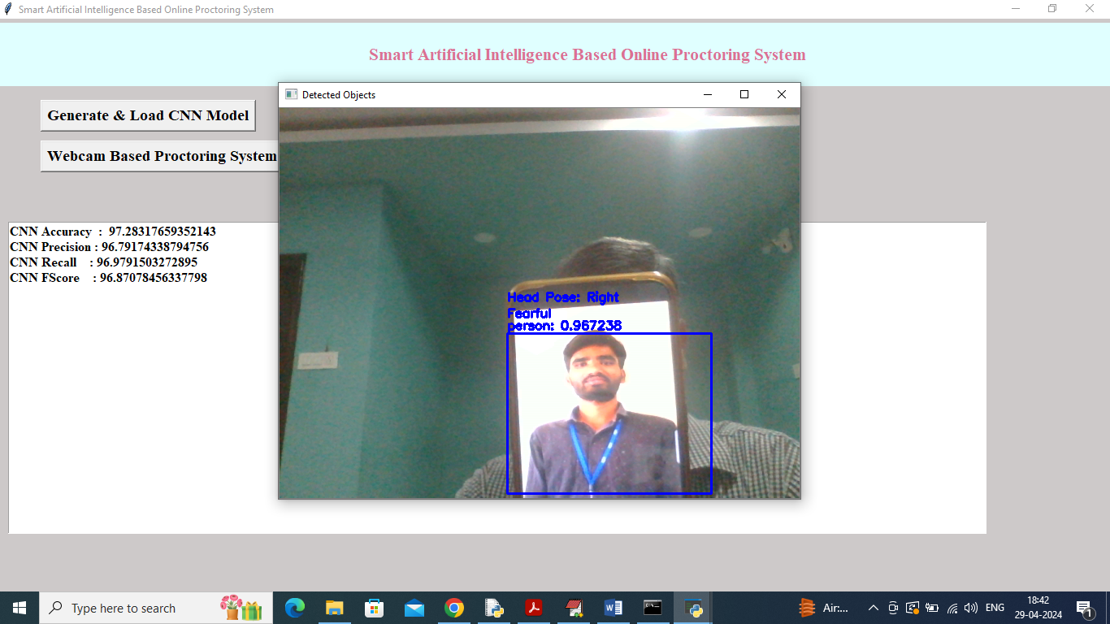

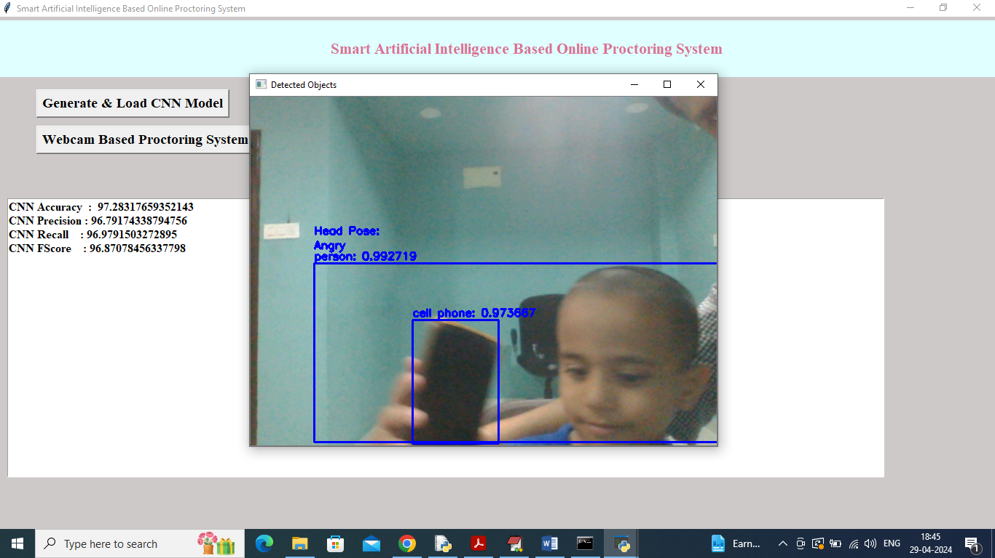

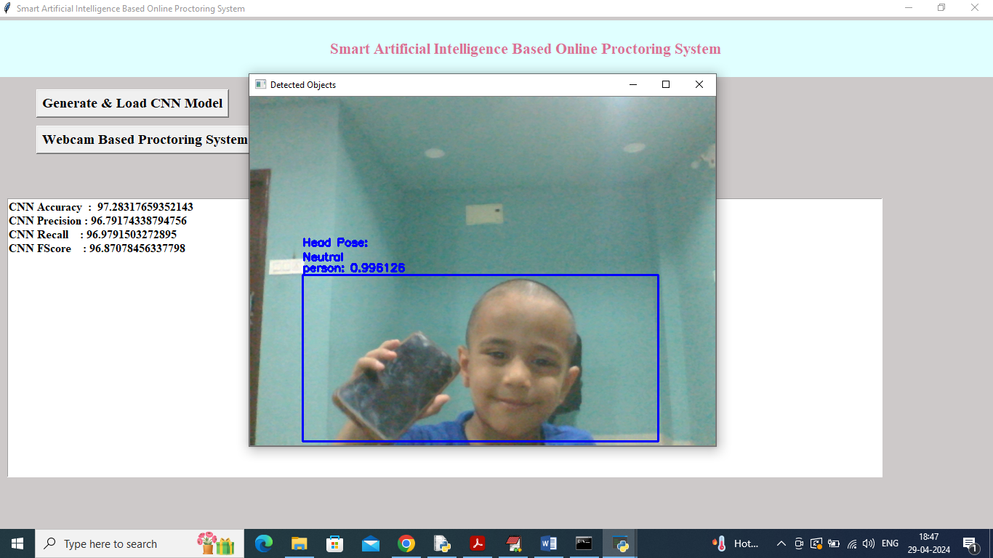

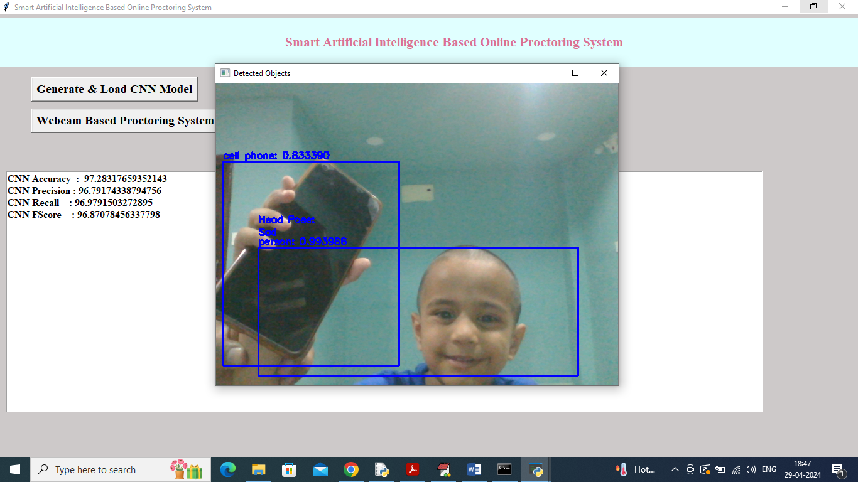

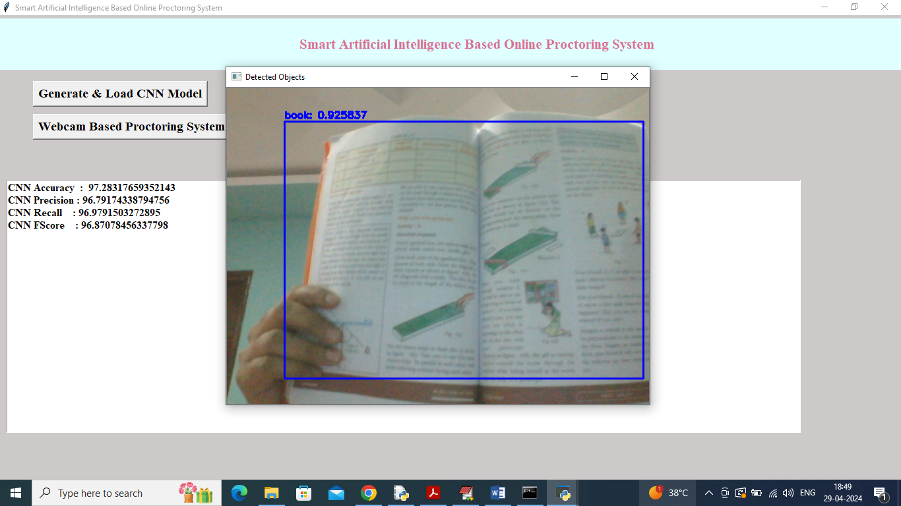

In above screens showing all possible detections and to get perfect emotions your system must be fast enough and face features must be accurate.