**SHARATH B SOMASHEKARAIAH**

**500 WALL ST.1314, SEATTLE, WA 98121**

**Ph.: +1 2067735287 Email: sharab@amazon.com**

**PROBLEM SLOVER||CONSTANT LEARNER ||THINKER|STORYTELLER||METHODICAL||AMBITIOUS||ADAPTABLE**

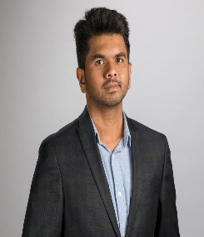

Starting my career in a non tech role, to be a **Sr.BI Engineer**, I have done what the role demands and fortunately it was in my self-interest too. During this journey, I have got into various roles like Catalog Associate, Subject Matter Expert, Business Analyst and BI Engineer in teams such as Operations, Retail, Program, Product, Analytics and Finance**.** These roles have taught me about a wide array of data problems and how to solve them as per customer needs. It has also taught me about making & managing tough decisions with clear communication and expectations.

To summarize, I would like to call myself a true agilest, with the right balance of technical and functional capabilities.

Outside work, I love to explore new things and do anything for an adrenaline rush within my limits. My current interests are riding motorcycles, YouTube Vlogging and Skiing. Apart from activities, I also like human Psychology, Philosophy, Leadership and Mindfulness. As a side gig, I do day/swing trading and working on building algo trading system. Lastly, I will also be ideating cool solutions for world problems in spare time & dreams.

**SME RBS**

**Bangalore**

**Retail Business Service**

Defect Reduction

**Nov 2015**

**to**

**Oct 2015**

**Visvesvaraya Technological University**

2008-2012

**B.E. Telecommunication**

A role with a broader scope of data problems where it is not just limited to reporting. I.e. using scientific methods to solve a problem to have a satisfaction of solving an impactful problem.

A role of a BI engineer along with scope of Data science and Technical Program Manager or Product Manager-Tech would be ideal.

Job

Objective

**Seattle**

**Display Ads**

* Head CT Tool
* Sponsored Display Data solution
* Total Display dashboard suite.

**Since May 2018**

**Sr. BIE Ads Finance**

* Over **7 years** of experience in amazon with ingrained its Leadership Principles.
* Designated as a Business intelligence engineer, have **designed and built end to end data solutions** of building the **database infrastructure**, to **data tables**, to **self-serving dashboards** for teams like RP, DG, COPS, Display ads, Sponsored Display and FP&A.
* Through simplification and automation saved more than **30 FTE manual work.**
* A thorough professional with a **proactive** attitude, with Big Data and analytical skills, capable of **thinking in and out of the box** and generating new solutions and ideas along with the ability to analyses business practices**, define and document optimal procedures** or practices.
* Excellent knowledge of **Advance SQL, ETL, Visualization tools, Excel, AWS services such as Redshift, S3, SNS and Athena**.
* Can **proficiently work with multiple stakeholders varying from Tech to Non-Tech** teams to build Roadmaps and analytical solution.
* **Excellent interpersonal, communication, and organizing** skills with proven abilities of leading and motivating teams towards achieving organizational goals.

Professional Synopsis

**BIE HS3C Analytics**

**Seattle**

**HS3C**

* RP Data solution
* COPS Data solution
* SEC Data solution

**May 2017**

**to**

**May 2018**

**Business analyst RP program**

**Seattle**

**Restricted Products**

* RP Report automation
* Self-Serving Reports
* ML classification support

**Aug 2016**

**to**

**May 2017**

**Business analyst COPS**

**Bangalore**

**Compliance Operations**

* Data reporting for COPS
* Associate scorecards
* Op2 planning & forecasting

**Oct 2015**

**to**

**Aug 2016**

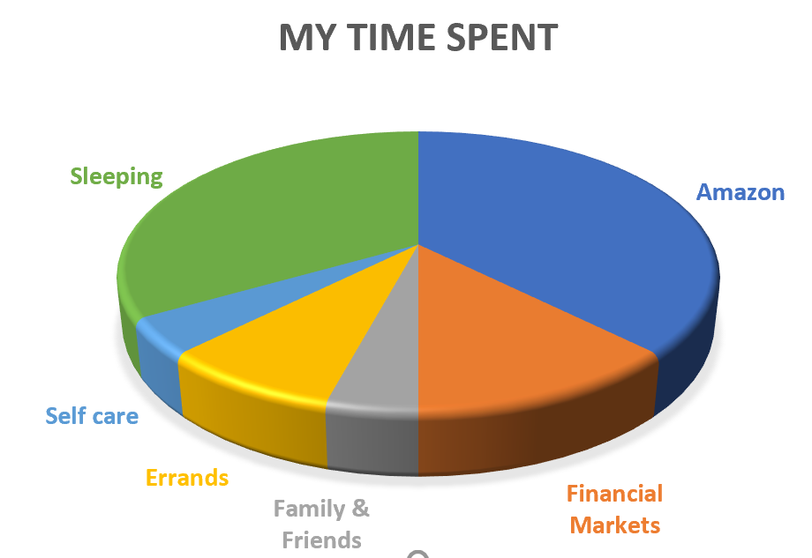

**CERTIFICATIONS**

Advance Excel Certified

Six Sigma Black Belt

Tableau Certified

**Catalog associate ISS**

**Bangalore**

**Retail Business Service**

Inbound Support Service (EU)

**Sep 2012**

**to**

**Nov 2013**

Technical Capabilities

Technical Capabilities

Technical Capabilities

* Python
* VBA
* MySQL
* Athena
* EDX
* Psycopg2 & Boto3 lib
* Hammerstone
* EC2
* Tableau
* SharePoint Developer

SKILLED

* ML Classification & Regression
* PowerShell
* Sage Maker
* Eider
* Lambda
* SQS
* Kibana
* GitHub

BEGINNER

* SQL
* DDL, DML
* Redshift
* Hoot
* Data net
* S3
* Excel
* Quick sight
* Microsoft Office suite

EXPERT

Technical Capabilities

Team and projects

Display ads finance team

* Head CT Tool

Situation: There was no robust system to collect the inputs and store and display the data in an automated way for leadership on a daily basis.

Task: To have better system than excel tracking to track the headcount life cycle foe entire Ads org.

Action: Created a SharePoint input forms to collect the manual information, created pipelines to bring in HR data stored them in Redshift and transferred the data with needed dimension into a table and used Quicksight to

Result

* Sponsored Display Data solution
* Total Display dashboard suite.
* Forecasting Display revenue based on Expected incremental

HS3C

* RP Data solution
* COPS Data solution
* SEC Data solution

Restricted Products

* RP Report automation
* Self-Serving Reports
* ML classification support

Compliance Operations

* Data reporting for COPS
* Associate scorecards
* Op2 forecasting

Mentoring and training