BITS Pilani - Machine Learning Operations (MLOps) AIMLCZG523
Assignment 01
End-to-End MLOps Pipeline for Heart Disease Risk Prediction
Experiment tracking, CI/CD, containerisation, Kubernetes deployment and monitoring
Item | Details
Student name | GANNU SHARATH
Student ID | 2025AF05071
Submission date | 19-10-2026
Code repository | https://github.com/sharath519/heart-disease-mlops
Demo video | https://youtu.be/L7lzhPoIddw
Deployed API | Local Kubernetes (Minikube, Docker driver) on the BITS lab machine, reached with kubectl port-forward on port 8080 (see Section 8)

1. Introduction and Problem Statement
Cardiovascular disease is one of the leading causes of death worldwide, and early risk screening can help clinicians prioritise patients for further tests. This project builds a binary classifier that predicts whether a patient is likely to have heart disease from routine clinical measurements, and wraps it in a reproducible MLOps pipeline: automated data handling, experiment tracking, tested and linted code, a CI/CD workflow, a Docker image, a Kubernetes deployment and basic monitoring.
The dataset is the Cleveland subset of the UCI Heart Disease repository: 303 patients, 13 input features (age, sex, chest pain type, resting blood pressure, cholesterol, fasting blood sugar, resting ECG, maximum heart rate, exercise-induced angina, ST depression, slope, number of major vessels, thalassemia) and a diagnosis label. The original label ranges from 0 to 4; it was converted to a binary target (0 = no disease, 1-4 = disease).
Because this is a screening task, missing a sick patient (false negative) is more harmful than flagging a healthy one (false positive). Recall is therefore tracked alongside accuracy, precision, F1 and ROC-AUC.

Tools used
Area | Tool
Modelling | Python 3.12, pandas, scikit-learn (Pipeline, ColumnTransformer, GridSearchCV)
Experiment tracking | MLflow (SQLite backend)
API | FastAPI + Uvicorn, Pydantic validation
Testing / quality | pytest, flake8
CI/CD | GitHub Actions
Containers / orchestration | Docker, Kubernetes (Minikube, Docker driver)
Monitoring | Prometheus + Grafana, prometheus-client, Python logging

2. Setup and Installation
Prerequisites: Python 3.11 or newer, Git, Docker, and a local Kubernetes (Minikube or Docker Desktop). The commands below reproduce the full project from a clean machine (Linux with conda, as used on the BITS lab machine). On Windows, python -m venv venv followed by venv\Scripts\activate works the same way.
git clone https://github.com/sharath519/heart-disease-mlops.git
cd heart-disease-mlops
conda create -n heart python=3.12 -y
conda activate heart
pip install -r requirements.txt

python -m src.download_data # fetch UCI data to data/raw/
python -m src.data # clean -> data/heart_clean.csv
python -m src.train # train, tune, track in MLflow, save model
pytest ; flake8 . # tests and lint
mlflow ui --backend-store-uri sqlite:///mlflow.db
The repository layout is: src/ (data, features, training, prediction), api/ (FastAPI app and schemas), tests/ (pytest), notebooks/ (EDA, training, inference), k8s/ (deployment, service, ingress), monitoring/ (Prometheus and Grafana config), .github/workflows/ci.yml, Dockerfile, docker-compose.yml, requirements.txt and requirements-api.txt. All dependency versions are pinned so a fresh environment behaves identically. The Docker image uses a smaller runtime-only requirements file. The pipeline was first validated on Windows with Docker Desktop and then run end to end on the BITS lab machine (Linux, Minikube), which produced the screenshots in this report.

3. Exploratory Data Analysis
Data acquisition is scripted (src/download_data.py), with a fallback to the ucimlrepo package. Missing values appear as "?" in the raw file. Cleaning (src/data.py) converts them to NaN, imputes the categorical columns ca (4 missing) and thal (2 missing) with their mode, converts the label to binary, and removes duplicate rows. The cleaned file has 303 rows and 14 columns. Imputing rather than dropping keeps all patients in a small dataset.

3.1 Class balance
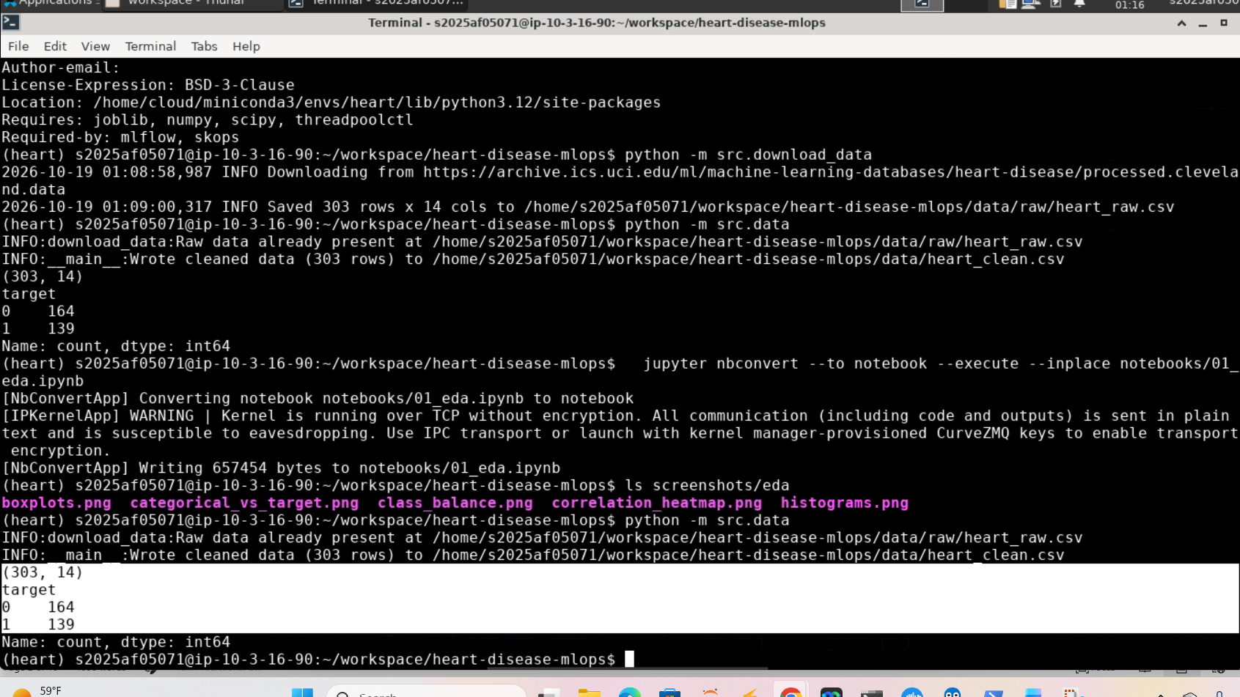

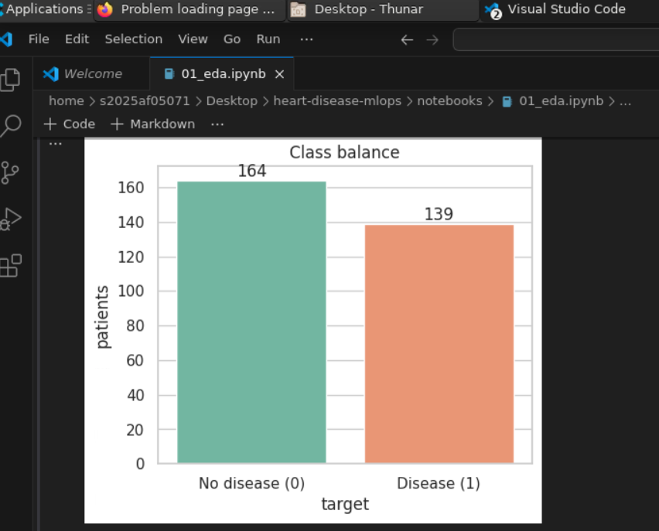

Figure 1: Data download and cleaning output (303 rows, 164 healthy / 139 diseased) and class distribution of the binary target
The classes are fairly balanced: 164 patients (54%) are healthy and 139 (46%) have heart disease, so no resampling is needed and accuracy is a meaningful metric. Recall is still emphasised because of the clinical cost of false negatives.

3.2 Feature distributions
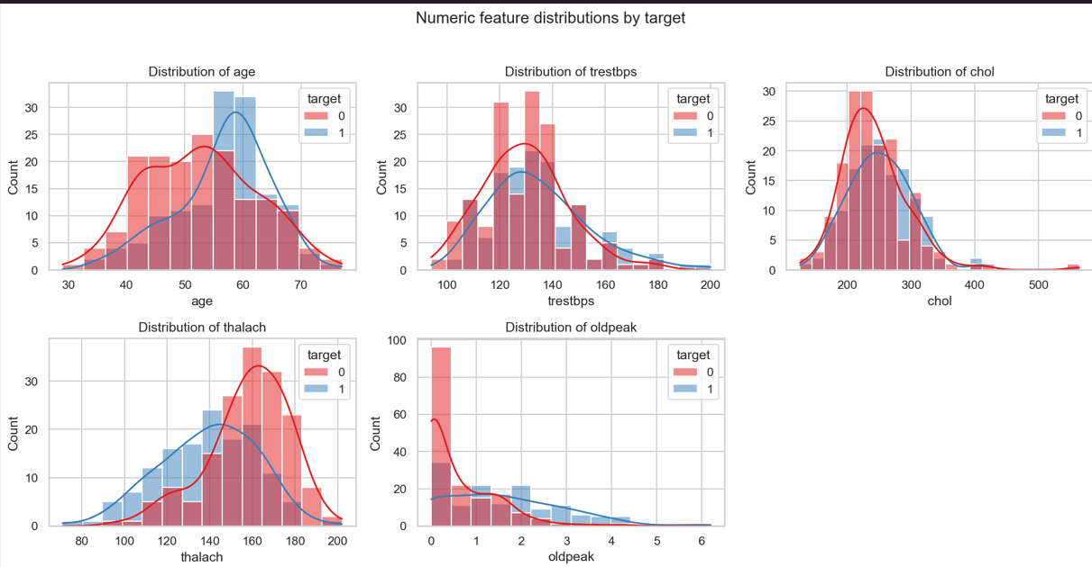Figure 2: Histograms of numeric features by target
Age is roughly bell-shaped and peaks in the 50s-60s. Maximum heart rate (thalach) is shifted lower in diseased patients, and ST depression (oldpeak) is right-skewed with many zeros and larger values mostly in the disease group. Cholesterol and resting blood pressure overlap heavily between groups. The medians confirm this: maximum heart rate is 161 in healthy patients versus 142 in diseased patients, and ST depression is 0.2 versus 1.4.

3.3 Correlation analysis
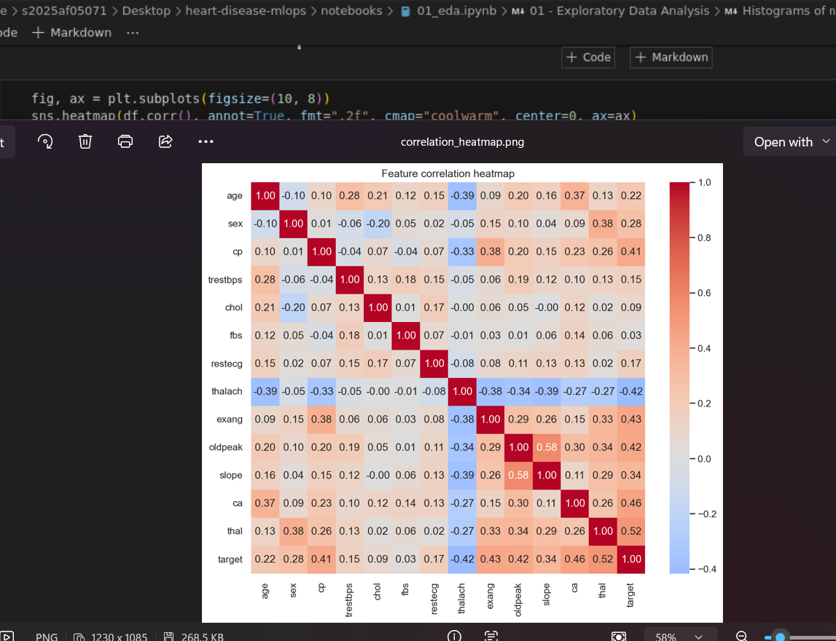Figure 3: Correlation heatmap
The strongest associations with the target are thal, ca, oldpeak, exang, cp and thalach (negative). Cholesterol and fasting blood sugar show almost no linear relationship. No pair of features is so strongly correlated that it would break a linear model, although oldpeak and slope are moderately related. In numbers, the correlations with the target are thal 0.52, ca 0.46, exang 0.43, oldpeak 0.42, cp 0.41 and thalach -0.42, while chol (0.09) and fbs (0.03) are close to zero. The only notable feature-to-feature correlation is oldpeak with slope (0.58).

3.4 Boxplots and categorical features
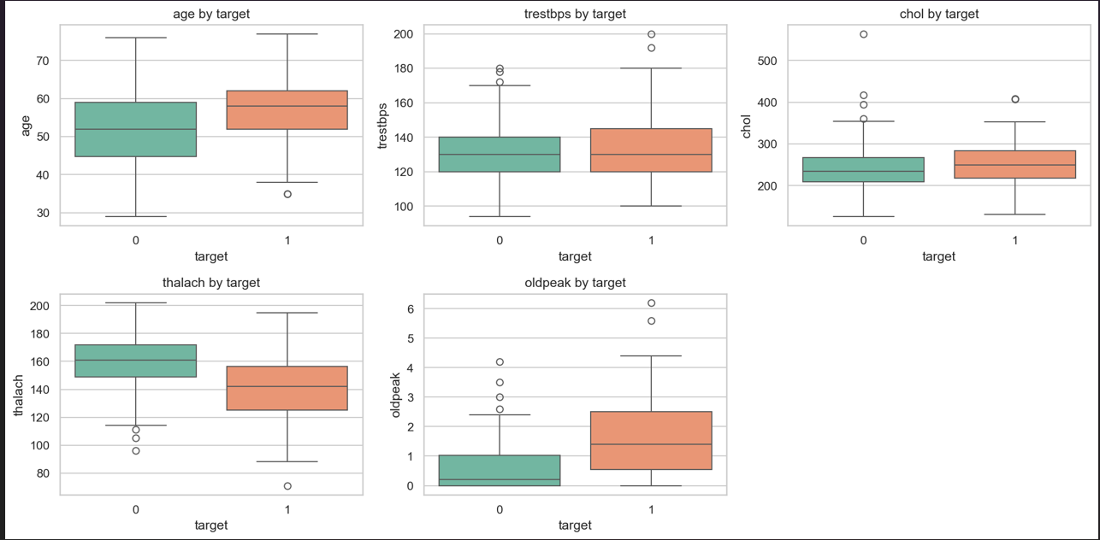Figure 4: Boxplots of numeric features and categorical features versus target
Diseased patients show lower median thalach and higher median oldpeak. Chest pain type 4 (asymptomatic), exercise-induced angina, one or more blocked vessels and reversible-defect thalassemia are strongly associated with disease. A few cholesterol outliers were kept because they are clinically plausible and the scaling and tree-based models limit their influence. The share of patients with disease is 73% for chest pain type 4 against 18-30% for the other types, 77% with exercise-induced angina against 31% without, 85% with three blocked vessels against 26% with none, and 76% for reversible-defect thalassemia against 23% for a normal result. Men (55%) are affected more often than women (26%) in this sample. The highest cholesterol value is 564 mg/dl.

4. Feature Engineering and Modelling

4.1 Preprocessing pipeline
All preprocessing is part of a single scikit-learn Pipeline so that training and serving apply identical transformations and the API needs no separate preprocessing code. A ColumnTransformer applies median imputation and StandardScaler to the numeric features (age, trestbps, chol, thalach, oldpeak) and most-frequent imputation and one-hot encoding to the categorical features (sex, cp, fbs, restecg, exang, slope, ca, thal), with handle_unknown set to ignore so unseen categories do not crash the API. The fitted pipeline, preprocessing plus model, is saved as one object.

4.2 Models and tuning
Three classifiers were trained, each as a baseline with default parameters and as a tuned model using GridSearchCV with stratified 5-fold cross-validation, optimising ROC-AUC. random_state is fixed to 42 everywhere for reproducibility.
Model | Hyper-parameter grid
Logistic Regression | C in {0.01, 0.1, 1, 10}, L2 penalty
Random Forest | n_estimators {100, 300}, max_depth {3, 5, None}, min_samples_leaf {1, 3}
Gradient Boosting | n_estimators {50, 100, 200}, learning_rate {0.03, 0.1}, max_depth {2, 3}

To limit optimistic bias from tuning, each model's final scores were computed with a cross-validation split using a different random seed from the one used for tuning.

4.3 Results
Table 1: cross-validated metrics (mean over 5 stratified folds) from reports/model_comparison.csv, sorted by ROC-AUC. The best run is in bold; fold-to-fold standard deviations are about 0.03 to 0.05 for accuracy and ROC-AUC.
Run | Accuracy | Precision | Recall | F1 | ROC-AUC
logistic_regression_tuned | 0.858 | 0.866 | 0.820 | 0.840 | 0.917
logistic_regression_baseline | 0.852 | 0.857 | 0.813 | 0.832 | 0.916
random_forest_tuned | 0.835 | 0.835 | 0.806 | 0.817 | 0.915
random_forest_baseline | 0.832 | 0.825 | 0.813 | 0.817 | 0.908
gradient_boosting_tuned | 0.819 | 0.828 | 0.770 | 0.795 | 0.904
gradient_boosting_baseline | 0.796 | 0.788 | 0.763 | 0.774 | 0.883

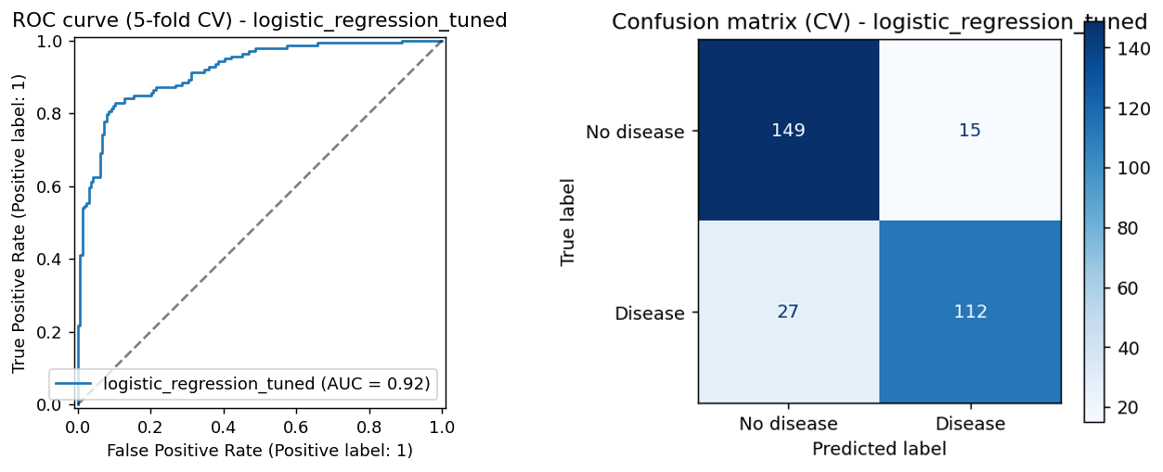
Figure 5: ROC curve (AUC 0.92) and confusion matrix of the selected model, from 5-fold cross-validation

4.4 Model selection
The final model is the tuned Logistic Regression (C = 0.1, L2 penalty). It has the highest mean cross-validated ROC-AUC (0.917) and also the best accuracy (0.858), precision (0.866), recall (0.820) and F1 (0.840) of the six runs. Its margin over the tuned Random Forest (ROC-AUC 0.915) is far smaller than the fold-to-fold standard deviation of about 0.03, so on 303 patients the two are practically tied; Logistic Regression was preferred because it is at least as accurate, simple to explain to a clinician through its coefficients, quick to train and cheap to serve. Gradient Boosting gained the most from tuning (ROC-AUC 0.883 to 0.904) but stayed the weakest model, which is common when a flexible model is fitted to a few hundred rows.
For a screening tool a missed patient costs more than a false alarm, so recall matters most. In the cross-validated confusion matrix (Figure 5) the model misses 27 of the 139 diseased patients (about 19%) and wrongly flags 15 of the 164 healthy patients (about 9%). If clinicians preferred fewer missed cases, the decision threshold could be lowered below 0.5 to trade some precision for higher recall.
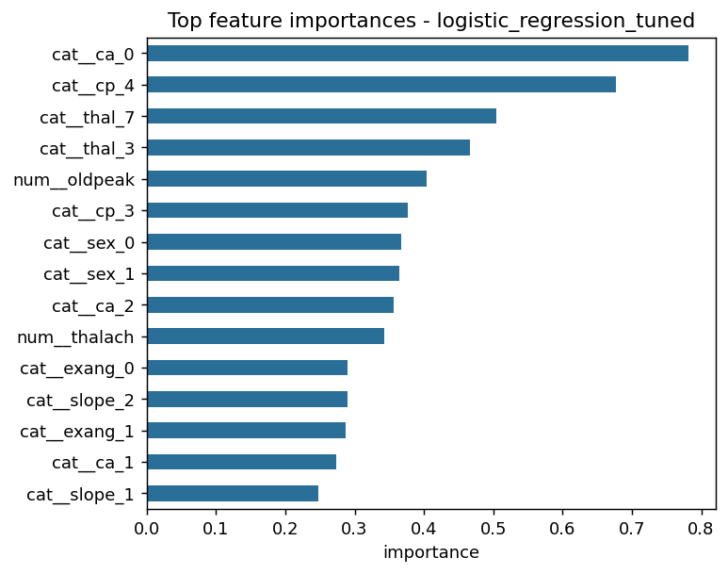
Figure 6: Feature importance (absolute coefficients) of the selected model
The strongest signals are no blocked vessels (ca = 0), asymptomatic chest pain (cp = 4), reversible-defect and normal thalassemia (thal = 7 and 3), ST depression (oldpeak) and maximum heart rate (thalach). This agrees with the EDA, where thal, ca, cp, oldpeak and thalach had the strongest relationships with the target, while fasting blood sugar and cholesterol were weak and do not appear among the top features. The plot shows magnitude only: following the EDA, ca = 0 and thal = 3 lower the predicted risk, whereas cp = 4 and thal = 7 raise it.

5. Experiment Tracking
Every training run is wrapped in mlflow.start_run() inside the experiment "heart-disease-classification". Each of the six runs logs its parameters (model type, hyper-parameters, CV folds, random state, sample count), cross-validated metrics (mean and std for accuracy, precision, recall, F1 and ROC-AUC), plots (ROC curve, confusion matrix, feature importance), the tuning grid results for tuned runs, and the fitted pipeline as an MLflow model with an input example. Runs are stored in a local SQLite database and browsed with the MLflow UI. The experiment contains 18 runs because the training script was executed three times while the pipeline was being validated; each execution logs the same six runs, and the results in Section 4.3 come from the most recent execution.
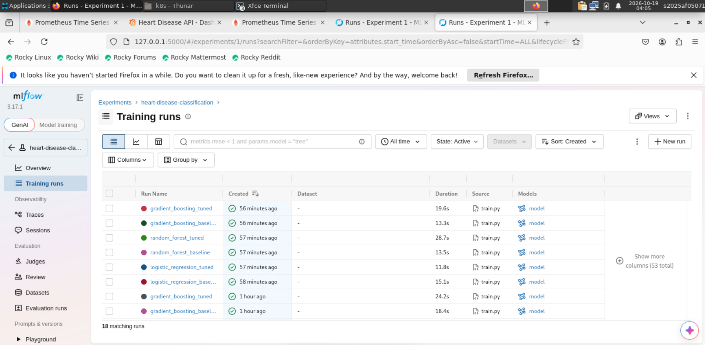
Figure 7: MLflow experiment runs (18 runs from three executions of the six-run training script)
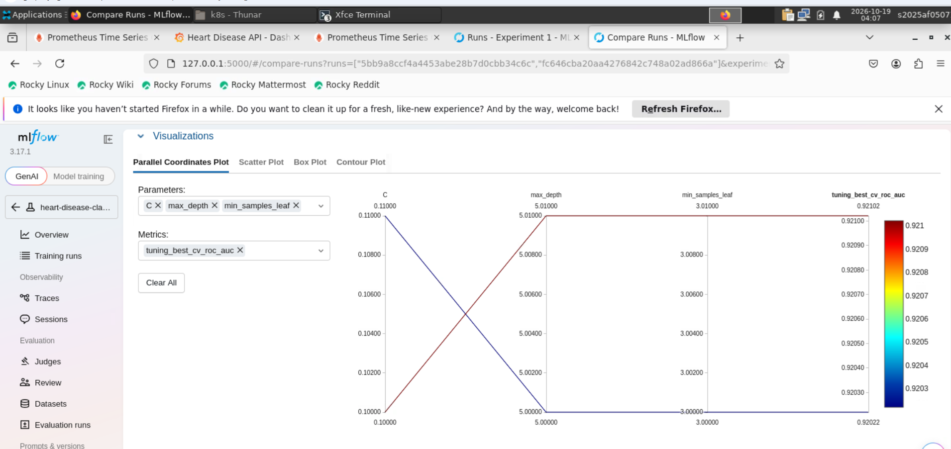
Figure 8: Parallel-coordinates comparison of the tuned Logistic Regression (C = 0.1) and tuned Random Forest (max_depth 5, min_samples_leaf 3), both with tuning ROC-AUC of about 0.92
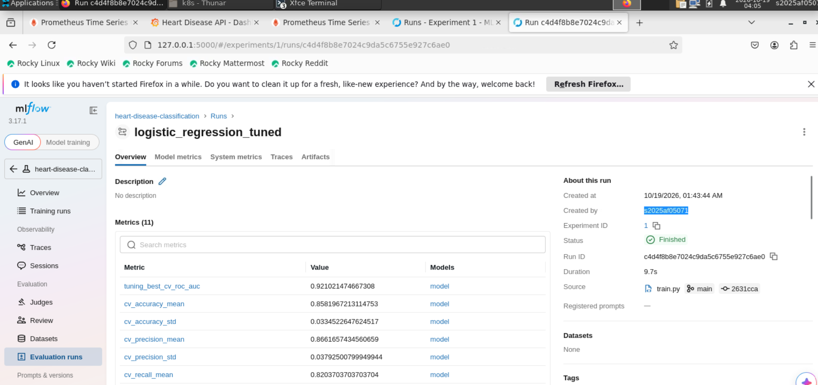
Figure 9: Metrics of the best run (logistic_regression_tuned) in MLflow; its artifacts include the ROC curve, confusion matrix, feature importance, grid results and the saved model
Summary: tuning gave small but consistent gains: ROC-AUC rose from 0.916 to 0.917 for Logistic Regression, from 0.908 to 0.915 for Random Forest and from 0.883 to 0.904 for Gradient Boosting. Logistic Regression was both the best and a stable model (standard deviation of ROC-AUC about 0.03), and the tuned runs agreed on a regularisation strength of C = 0.1 and a shallow forest (max_depth 5, min_samples_leaf 3). Having every run's parameters, metrics, plots and fitted pipeline in MLflow made the comparison easy and lets the selected model be reproduced exactly.

6. System Architecture
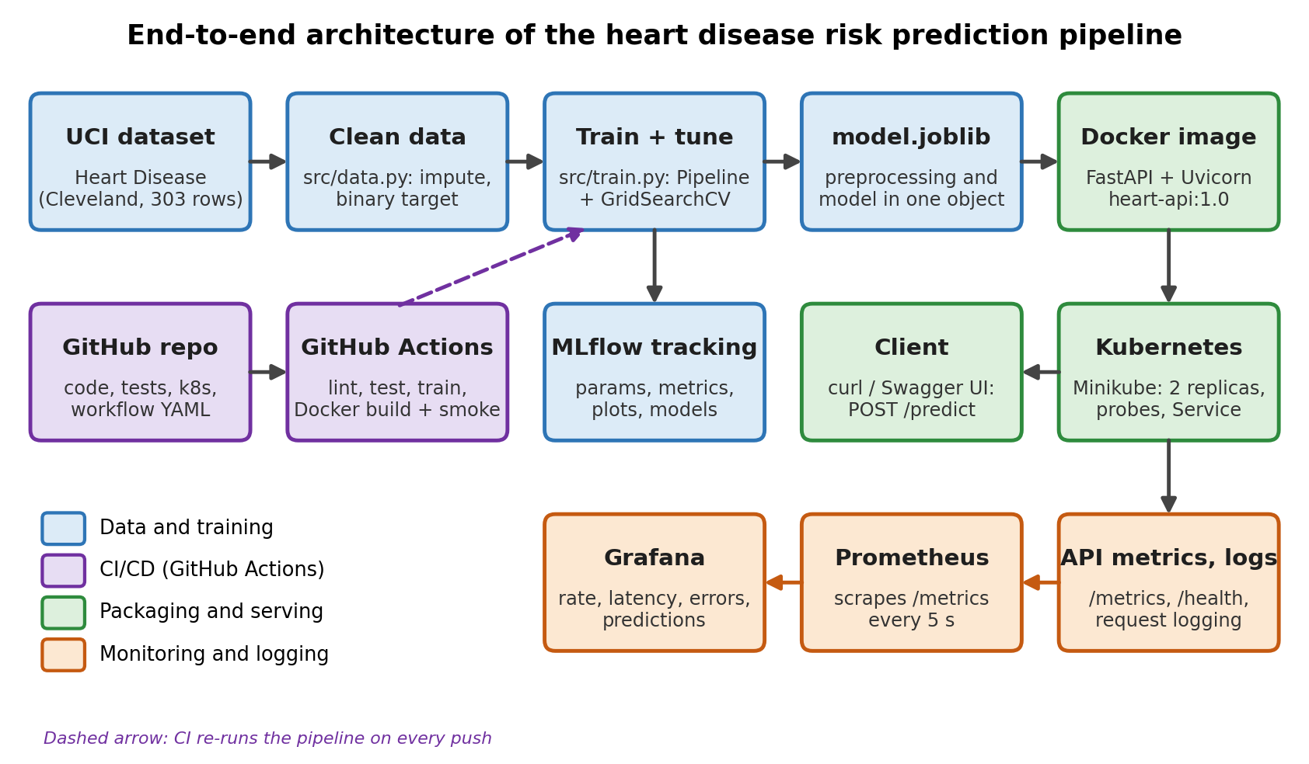
Figure 10: End-to-end architecture
The diagram shows the five parts of the system:
- Data: UCI repository -> download and clean scripts -> cleaned CSV
- Training: scikit-learn pipeline + GridSearchCV -> MLflow tracking -> saved model.joblib
- CI/CD: GitHub push -> GitHub Actions (lint, test, train, Docker build and smoke test) -> artifacts
- Serving: Docker image (FastAPI) -> Kubernetes (Minikube) Deployment with 2 replicas -> Service, reached through kubectl port-forward
- Monitoring: /metrics -> Prometheus -> Grafana dashboard; request logs via Python logging
Design decisions: preprocessing and model are stored as one scikit-learn pipeline (model.joblib), so training and serving cannot drift apart; the Docker image installs only runtime dependencies (requirements-api.txt) and copies the saved model, which keeps it small and quick to start; the CI workflow re-runs lint, tests and training and rebuilds and smoke-tests the image on every push; and the same /metrics endpoint feeds Prometheus and Grafana without any change to the API code.

7. CI/CD Pipeline and Automated Testing
The pytest suite (18 tests) covers data cleaning (placeholder handling, binary target, no missing values), the preprocessing pipeline (finite output, missing-value handling, scaling, unseen categories), model training (valid probabilities, reproducibility, metric computation, saved-pipeline inference) and the API (health, valid prediction, 422 on missing or out-of-range input, metrics endpoint). Tests use a small synthetic dataset with the Cleveland schema so they need no network access.
The GitHub Actions workflow (.github/workflows/ci.yml) runs on every push and pull request. Job 1 checks out the code, installs pinned dependencies, lints with flake8, runs pytest with a JUnit report, trains the model and uploads the model, reports and cleaned data as workflow artifacts. Job 2 trains the model, builds the Docker image, starts the container and smoke-tests /health and /predict. Any failing step stops the workflow and later steps do not run, so errors are visible in the logs.
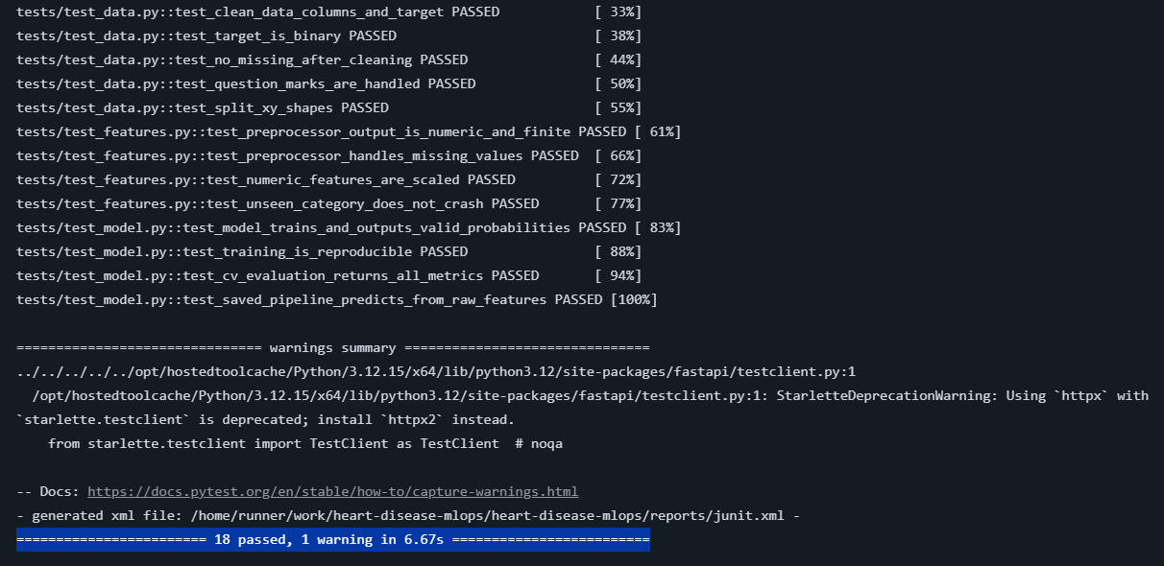
Figure 11: pytest output from the CI "Unit tests" step: all 18 tests pass (the preceding Lint (flake8) step also passed, see Figure 12)
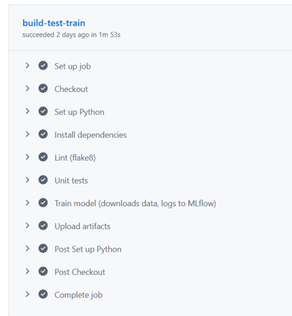
Figure 12: Successful CI run: the build-test-train job passed every step (flake8 lint, unit tests, model training, artifact upload) in 1m 53s
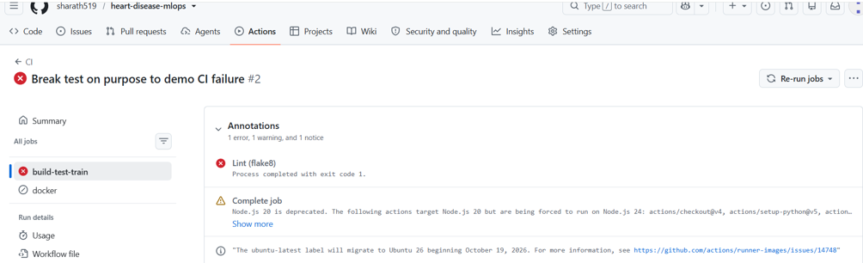
Figure 13: CI fails on a deliberately broken commit: the Lint (flake8) step exits with code 1 and the dependent docker job does not run
To demonstrate that the pipeline fails on errors, a commit ("Break test on purpose to demo CI failure") introduced a syntax error in an assertion in tests/test_data.py. The workflow run turned red at the first quality gate, the flake8 lint step, which reported the syntax error with its file and line; the later steps and the Docker job did not run. The commit was then reverted and the next run passed every step. Figure 13 shows the failed run and Figure 12 the passing run.

8. Containerisation and Deployment

8.1 API and Docker
The FastAPI service loads the saved pipeline at start-up and exposes the endpoints below. Inputs are validated with Pydantic (types, ranges and allowed category values), so invalid requests get HTTP 422.
Endpoint | Method | Purpose
/predict | POST | JSON with 13 features -> prediction (0/1), confidence, probability of disease, label
/health | GET | Liveness / readiness probe; reports whether the model is loaded
/metrics | GET | Prometheus metrics (request counts, latency histogram, predictions by class)

The Dockerfile uses python:3.12-slim, installs only the runtime requirements, copies the API, source and model, and runs as a non-root user with a health check. Figures 14, 15 and 20 come from the CI docker job, which builds this Dockerfile as heart-api:ci, runs it with docker run -p 8000:8000 and calls /health and /predict; the same Dockerfile was also built and run locally during development.
docker build -t heart-api:1.0 .
docker run -d --name heart-api -p 8000:8000 heart-api:1.0
curl http://localhost:8000/health
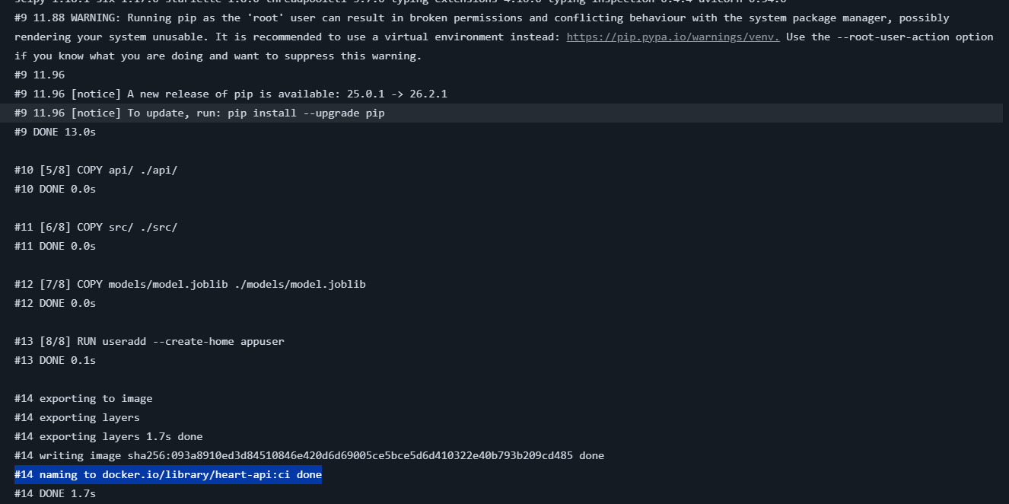
Figure 14: Docker image build in the CI docker job: the final build steps and the image named heart-api:ci
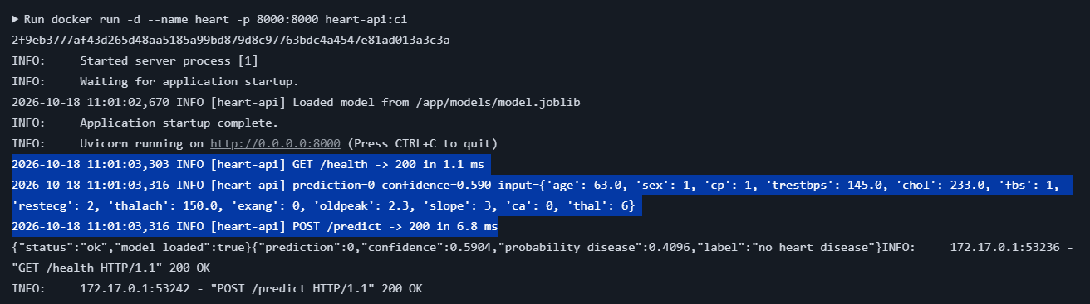
Figure 15: Container smoke test in the CI docker job: the container starts, /health returns ok and /predict returns a prediction (class 0, confidence 0.5904)

8.2 Kubernetes
The service was deployed to a local Kubernetes cluster created with Minikube (Docker driver, profile heart-api) on the lab machine, using the manifests in k8s/. Minikube keeps its own image store, so the locally built image was loaded into it. Figures 18 and 19 were captured on a Windows machine with Docker Desktop Kubernetes (kubeadm), using the same manifests and the same image; Figures 16 and 17 show the Minikube cluster on the lab machine.
Setting | Choice and reason
Replicas | 2, for availability and to show load balancing
Probes | Readiness and liveness HTTP checks on /health
Resources | Requests 100m CPU / 256Mi; limits 500m CPU / 512Mi
Service | LoadBalancer on port 80 -> container port 8000 (optional Ingress manifest provided). Minikube shows no external IP without a tunnel, so the API was reached with kubectl port-forward.
Image | heart-api:1.0 built locally and loaded into Minikube with minikube image load (imagePullPolicy IfNotPresent)

export KUBECONFIG=$HOME/.kube/minikube-heart-api.yaml
minikube start -p heart-api --driver=docker --cpus=2 --memory=2200
docker build -t heart-api:1.0 .
minikube -p heart-api image load heart-api:1.0
kubectl apply -f k8s/
kubectl rollout status deployment/heart-api
kubectl get pods,svc
kubectl port-forward svc/heart-api-service 8080:80 # then use http://localhost:8080
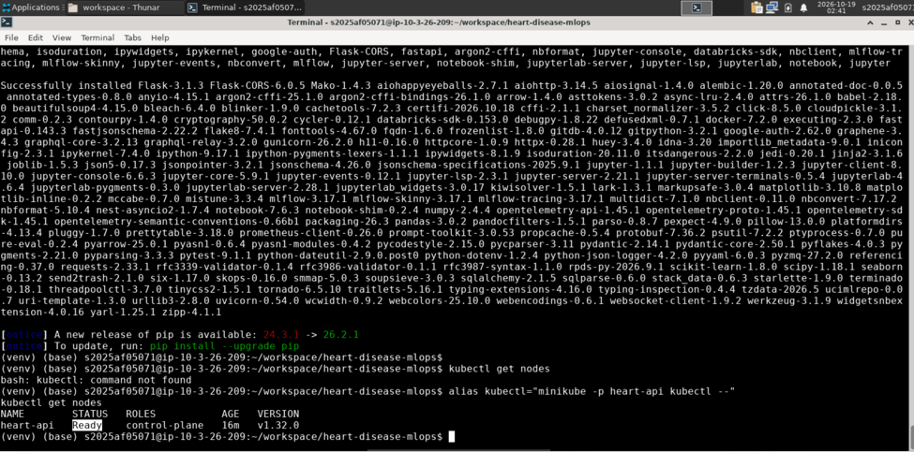
Figure 16: kubectl get nodes (through the minikube kubectl alias): the control-plane node of profile heart-api is Ready (Kubernetes v1.32.0)
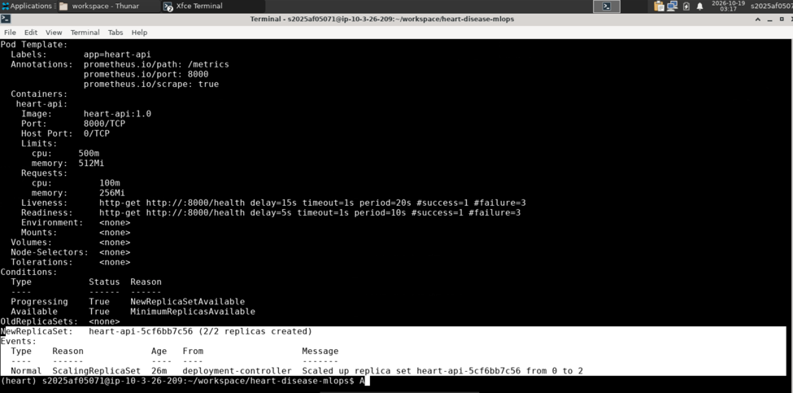
Figure 17: kubectl describe deployment heart-api: image, port 8000, resource limits, probes and the 2/2 replicas created
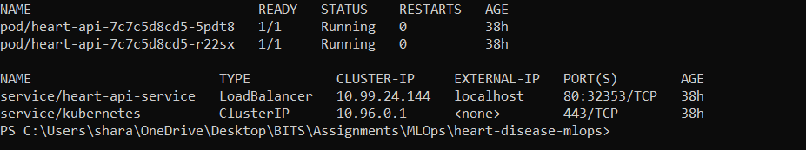
Figure 18: kubectl get pods,svc: two heart-api pods Running 1/1 with no restarts, and heart-api-service of type LoadBalancer on port 80
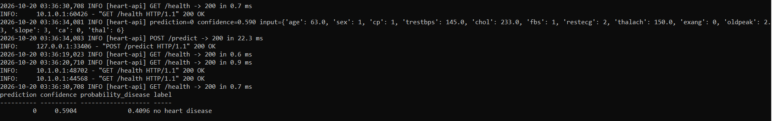
Figure 19: Prediction through the Kubernetes service (kubectl port-forward on localhost:8080) and the pod logs showing the matching request and prediction lines
Access instructions: the API runs inside the Minikube cluster on the lab machine. Start kubectl port-forward svc/heart-api-service 8080:80, then call GET http://localhost:8080/health or send a POST request with the 13 features to http://localhost:8080/predict. The same image can be run directly with docker run -p 8000:8000 heart-api:1.0 (http://localhost:8000), and interactive API documentation is available at /docs.

9. Monitoring and Logging
The API logs every request (method, path, status, latency) and every prediction (input values, class and confidence) using Python logging; logs are read with docker logs or kubectl logs. Prometheus metrics are exposed at /metrics: api_requests_total (by method, endpoint, status), api_request_latency_seconds (histogram) and api_predictions_total (by class). A docker-compose stack runs the API, Prometheus and Grafana, and Grafana is provisioned with a "Heart Disease API" dashboard.
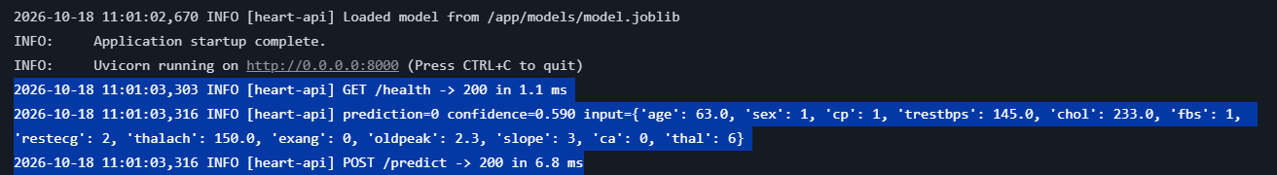
Figure 20: API request logging: model load, request lines with status and latency, and the prediction line with its input, class and confidence (crop of the output in Figure 15)
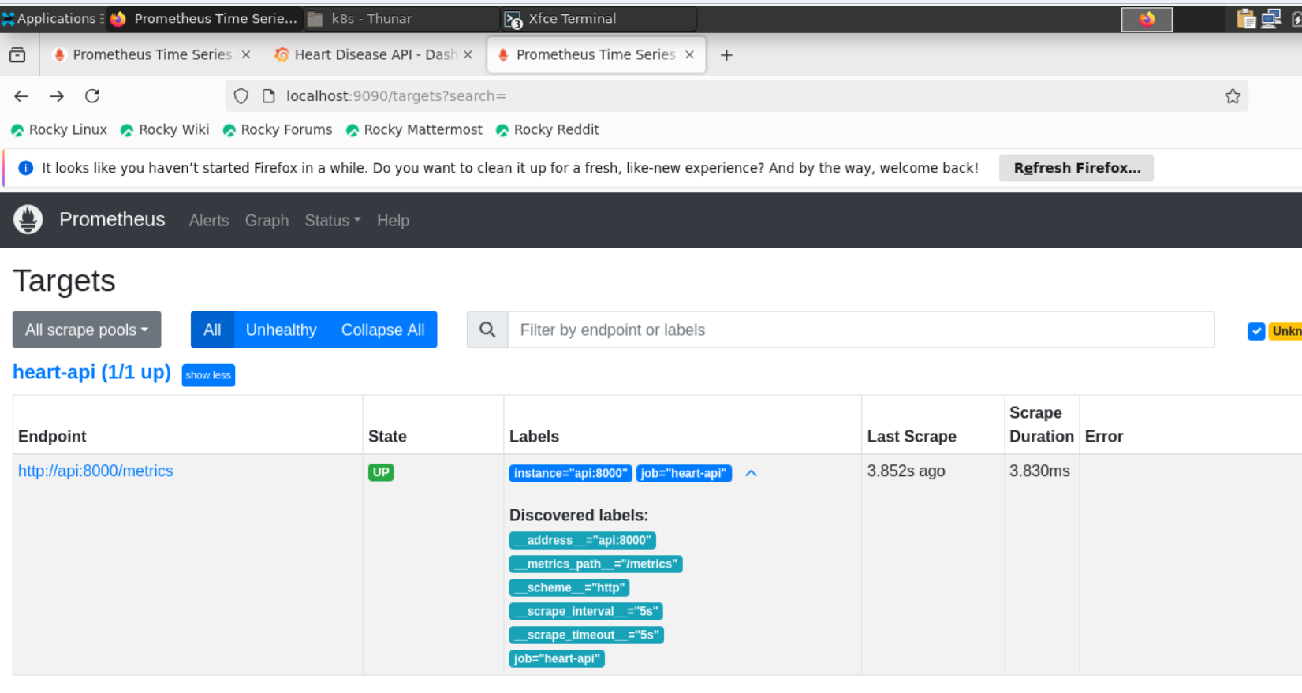
Figure 21: Prometheus scrape target heart-api (http://api:8000/metrics) in state UP
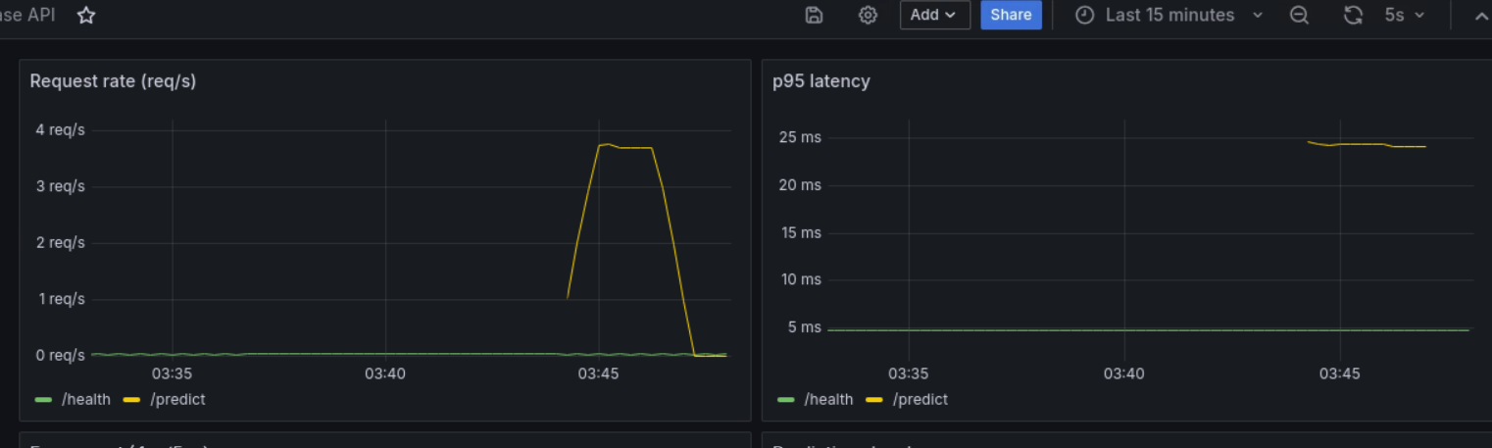
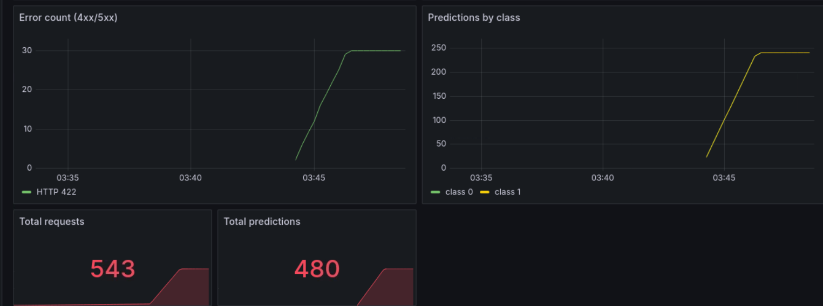
Figure 22: Grafana dashboard: request rate and p95 latency (top); error count, predictions by class and totals (bottom)
During the test the load generator produced a peak of about 3.7 requests per second on /predict. The p95 latency of /predict stayed at roughly 24 to 25 ms and that of /health at about 5 ms. The error panel shows 30 HTTP 422 responses, produced on purpose with invalid payloads, and no 5xx errors. The prediction panel shows both classes, 240 each (480 predictions out of 543 requests; the rest were the invalid requests and health checks). The monitoring stack observes the Docker Compose copy of the API; the Kubernetes pods expose the same /metrics endpoint and carry Prometheus scrape annotations.

10. Demo Video, Conclusion and Limitations
Demo video (pipeline walkthrough): It covers the repository, the CI run, the MLflow UI, the Docker run and prediction, the Kubernetes deployment, a /predict call and the Grafana dashboard.
Repository: https://github.com/sharath519/heart-disease-mlops
Conclusion: the project delivers a reproducible path from raw data to a monitored, containerised prediction service, with automated tests and CI that fail on errors. The selected Logistic Regression reached a cross-validated ROC-AUC of 0.917 and recall of 0.82, and the same code was validated on two machines (Windows with Docker Desktop, then the Linux lab machine with Minikube). The main lessons were that keeping preprocessing and model in one saved pipeline removes a whole class of serving bugs, that pinned dependencies and testing from a clean environment matter (the lab's default Python was too old, so a separate conda environment was needed), and that probes, logs and metrics make a deployed model observable.

Limitations and future work
- Small dataset (303 patients), so metrics have high variance; results should not be treated as clinical evidence.
- No model registry, drift monitoring or automated retraining; the model is baked into the image.
- Monitoring covers the Compose deployment; adding Prometheus to the cluster (ServiceMonitor or Helm) would cover the pods.
- Possible improvements: threshold tuning for higher recall, nested cross-validation, horizontal pod autoscaling, pushing images to a registry from CI.

