# A STUDY ON TRAINING & DEVELOPMENT SAGAR CEMENTS AT KADAPA

# A project report submitted to

**SRI VENKATESA PERUMAL COLLEGE OF ENGG.& TECH**

**(AUTONOMOUS)**

***Submitted in partial fulfillment of the requirements***

***For the award of the Degree of***

# MASTER OF BUSINESS ADMINISTRATION

## Submitted by A.SHARATH KUMAR REDDY

IV SEM MBA

(Regd. No. : 21G01E0003**)**

*Under the guidance of*

# Mrs.P.HEMAVATHI,M.B.A.,

Assistant Professor

## Dept. of Management studies

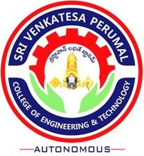

**SRI VENKATESA PERUMAL COLLEGE OF ENGG.& TECH**

## (AUTONOMOUS)

Approved by A.I.C.T.E., Affiliated to JNTUA,Anantapur.

(An ISO 9001:2000 Certified Institution),

R.V.S.Nagar,K.N.Road, PUTTUR,CHITTOOR DIST.,A.P

**2021-2023**

**DEPARTMENT OF MANAGEMENT STUDIES**

**SRI VENKATESA PERUMAL COLLEGE OF ENG & TECH**

**(AUTONOMOUS)**

**(An ISO 9001:2000 Certified Institution)**

**R.V.S.Nagar, K.N.Road,** **PUTTUR-517583**

# CERTIFICATE

# This is to certify that the project work entitled “A STUDY ON TRAINING & DEVELOPMENT SAGAR CEMENTS LTD AT KADAPA” is a bonafide work done and submitted by A.SHARATH KUMAR REDDY

# (Regd.No. : 21G01E0003) As a part of MBA IV Sem curricular activity of Jawaharlal Nehru Technological University, Anantapur, under the supervision of Mrs.P.HEMAVATHI, M.B.A.,, Assistant Professor. The data has been collected by the candidate from authentic source and the analysis result will be used for academic purpose only.

|  |  |
| --- | --- |
|  |  |
| Dr.K.Harun, MBA, Ph.D.,  Associate Professor  Head of the Department | Mrs.P.HEMAVATHI, M.B.A.,  Assistant Professor  Project Guide |

Submitted for the University Examination held on _____________

External Examiner

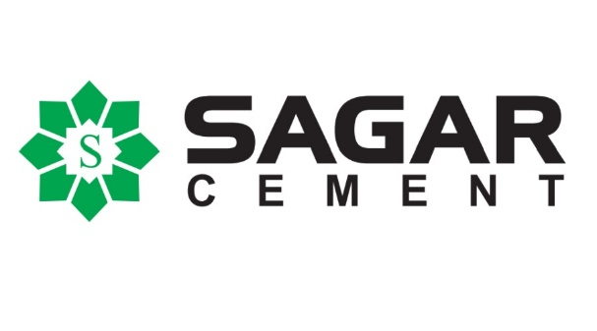

**DATE:**

**TO WHOM SO EVER IT MAY CONCERN**

This Is To Certify That **Mr.A.SHARATH KUMAR REDDY (REG.NO:21G01E0003),**

A Student Of Master Of Business Administration FROM **SRI VENKATESA PERUMAL**

**COLLEGE OF ENGINEERING AND TECHNOLOGY,PUTTUR** Affiliated To

Jntu,Anantapur Has Done The Project Work On “A STUDY ON **TRAINING&**

**DEVELOPMENT“.**In Our Oraganigation Successfully From 01-03-2023 To 20-08-2023.

The Project Work Carried Out By Him Was To The Entire Satisfaction Of Ours And We

Appreciate His Since Re And Exceklklent Work In This Regard.

We Wish All Success In This Future Endeavors

FOR SAGAR CEMENTS LTD.,

Authorized Signator

**DECLARATION**

# I hereby declare that the project report entitled “A STUDY ON TRAINING & DEVELOPMENT SAGAR CEMENTS AT KADAPA” is an original independent record of research work submitted by me in partial fulfillment for award of the degree of MBA under SRI VENKATESA PERUMAL COLLEGE OF ENGG.& TECH (AUTONOMOUS), Puttur. This work has been carried out by me and has not been submitted any research work and project previously by the award of the degree.

**A.SHARATH KUMAR REDDY**

**(Regd. No. : 21G01E0003)**

PLACE:

DATE:

**ACKNOWLEDGEMENT**

I thank to **Sri Dr. T. SUNIL KUMAR REDDY, M.Tech.,Ph.D Garu**

**PRINCIPAL, SRI VENKATESA PERUMAL COLLEGE OF ENG &**

**TECH, PUTTUR,** for making convenient for under taken a project work.

I am also thankful to HOD of MBA **Dr.K.HARUN, MBA,Ph.D** and other faculty members in the department of MBA for their moral support during the project work.

I would like to thank to our Project guide **Mrs.P.HEMAVATHI,M.B.A, M.B.A.,, Assistant Professor,** Department of Management Studies, Sri Venkatesa Perumal College of Engg. & Tech, Puttur, for his valuable guidance.

My sincere thanks to **HR-MANAGER**. For their co –operation and encouragement at every stage by providing necessary data and information to carry on the project work.

Special thanks to my friends and all well wishers for their encouragement and timely assistance throughout this work.

**A.SHARATH KUMAR REDDY**

**(Regd. No. :21G01E0003)**