CHAPTER 1
INTRODUCTION

1.1 Introduction of Embedded System
An Embedded System is a combination of computer hardware and software, and perhaps additional mechanical or other parts, designed to perform a specific function. A good example is the microwave oven. Almost every household has one, and tens of millions of them are used every day, but very few people realize that a processor and software are involved in the preparation of their lunch or dinner.
This is in direct contrast to the personal computer in the family room. It too is comprised of computer hardware and software and mechanical components (disk drives, for example). However, a personal computer is not designed to perform a specific function rather; it is able to do many different things. Many people use the term general-purpose computer to make this distinction clear. As shipped, a general-purpose computer is a blank slate; the manufacturer does not know what the customer will do wish it. One customer may use it for a network file server another may use it exclusively for playing games, and a third may use it to write the next great American novel.
Frequently, an embedded system is a component within some larger system. For example, modern cars and trucks contain many embedded systems. One embedded system controls the anti-lock brakes, other monitors and controls the vehicle's emissions, and a third displays information on the dashboard. In some cases, these embedded systems are connected by some sort of a communication network, but that is certainly not a requirement.
1. History and Future
Given the definition of embedded systems earlier is this chapter; the first such systems could not possibly have appeared before 1971. That was the year Intel introduced the world's first microprocessor. This chip, the 4004, was designed for use in a line of business calculators produced by the Japanese Company Busicom. In 1969, Busicom asked Intel to design a set of custom integrated circuits-one for each of their new calculator models. The 4004 was Intel's response rather than design custom hardware for each calculator, Intel proposed a general-purpose circuit that could be used throughout the entire line of calculators. Intel's idea was that the software would give each calculator its unique set of features.
2. Real Time Systems
One subclass of embedded is worthy of an introduction at this point. As commonly defined, a real-time system is a computer system that has timing constraints. In other words, a real-time system is partly specified in terms of its ability to make certain calculations or decisions in a timely manner. These important calculations are said to have deadlines for completion. And, for all practical purposes, a missed deadline is just as bad as a wrong answer.
The issue of what if a deadline is missed is a crucial one. For example, if the real-time system is part of an airplane's flight control system, it is possible for the lives of the passengers and crew to be endangered by a single missed deadline. However, if instead the system is involved in satellite communication, the damage could be limited to a single corrupt data packet. The more severe the consequences, the more likely it will be said that the deadline is "hard" and thus, the system is a hard real-time system. Real-time systems at the other end of this discussion are said to have "soft" deadlines.
3. Application Areas
Nearly 99 per cent of the processors manufactured end up in embedded systems. The embedded system market is one of the highest growth areas as these systems are used in very market segment- consumer electronics, office automation, industrial automation, biomedical engineering, wireless communication, data communication, telecommunications, transportation, military and so on.
4. Consumer appliances
At home we use a number of embedded systems which include digital camera, digital diary, DVD player, electronic toys, microwave oven, remote controls for TV and air-conditioner, VCO player, video game consoles, video recorders etc. Today’s high-tech car has about 20 embedded systems for transmission control, engine spark control, air-conditioning, navigation etc. Even wristwatches are now becoming embedded systems. The palmtops are powerful embedded systems using which we can carry out many general-purpose tasks such as playing games and word processing.

5. Office automation
The office automation products using em embedded systems are copying machine, fax machine, key telephone, modem, printer, scanner etc.
6. Industrial automation
Today a lot of industries use embedded systems for process control. These include pharmaceutical, cement, sugar, oil exploration, nuclear energy, electricity generation and transmission. The embedded systems for industrial use are designed to carry out specific tasks such as monitoring the temperature, pressure, humidity, voltage, current etc., and then take appropriate action based on the monitored levels to control other devices or to send information to a centralized monitoring station. In hazardous industrial environment, where human presence has to be avoided, robots are used, which are programmed to do specific jobs. The robots are now becoming very powerful and carry out many interesting and complicated tasks such as hardware assembly.
7. Medical electronics
Almost every medical equipment in the hospital is an embedded system. These equipments include diagnostic aids such as ECG, EEG, blood pressure measuring devices, X-ray scanners; equipment used in blood analysis, radiation, colonoscopy, endoscopy etc. Developments in medical electronics have paved way for more accurate diagnosis of diseases.
8. Wireless technologies
Advances in mobile communications are paving way for many interesting applications using embedded systems. The mobile phone is one of the marvels of the last decade of the 20’h century. It is a very powerful embedded system that provides voice communication while we are on the move. The Personal Digital Assistants and the palmtops can now be used to access multimedia services over the Internet. Mobile communication infrastructure such as base station controllers, mobile switching centers are also powerful embedded systems.
9. Security
Security of persons and information has always been a major issue. We need to protect our homes and offices; and also the information we transmit and store. Developing embedded systems for security applications is one of the most lucrative businesses nowadays. Security devices at homes, offices, airports etc. for authentication and verification are embedded systems. Encryption devices are nearly 99 per cent ofthe processors that are manufactured end up in~ embedded systems. Embedded systems find applications in every industrial segment- consumer electronics, transportation, avionics, biomedical engineering, manufacturing, process control and industrial automation, data communication, telecommunication, defense, security etc. Used to encrypt the data/voice being transmitted on communication links such as telephone lines. Biometric systems using fingerprint and face recognition are now being extensively used for user authentication in banking applications as well as for access control in high security buildings.
1.2 Overview of Embedded System Architecture
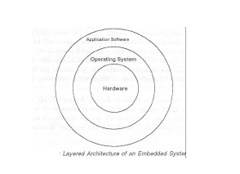
Every embedded system consists of custom-built hardware built around a Central Processing Unit (CPU). This hardware also contains memory chips onto which the software is loaded. The software residing on the memory chip is also called the ‘firmware’. The embedded system architecture can be represented as a layered architecture as shown in figure.
Fig 1.2.1 Layered Architecture of Embedded System
above the operating system. The same architecture is applicable to any computer including a desktop computer. However, there are significant differences. It is not compulsory to have an operating system in every embedded system. For small appliances such as remote control units, air conditioners, toys etc., there is no need for an operating system and you can write only the software specific to that application. For applications involving complex processing, it is advisable to have an operating system. In such a case, you need to integrate the application software with the operating system and then transfer the entire software on to the memory chip. Once the software is transferred to the memory chip, the software will continue to run for a long time you don’t need to reload new software.
Now, let us see the details of the various building blocks of the hardware of an embedded system.
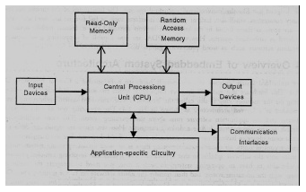
Fig:1.2.2 CPU

1.3 Central Processing Unit (CPU)
The Central Processing Unit (processor, in short) can be any of the following: microcontroller, microprocessor or Digital Signal Processor (DSP). A micro-controller is a low-cost processor. Its main attraction is that on the chip itself, there will be many other components such as memory, serial communication interface, analog-to digital converter etc. So, for small applications, a micro-controller is the best choice as the number of external components required will be very less. On the other hand, microprocessors are more powerful, but you need to use many external components with them. D5P is used mainly for applications in which signal processing is involved such as audio and video processing.
1. Memory
The memory is categorized as Random Access 11emory (RAM) and Read Only Memory (ROM). The contents of the RAM will be erased if power is switched off to the chip, whereas ROM retains the contents even if the power is switched off. So, the firmware is stored in the ROM. When power is switched on, the processor reads the ROM; the program is program is executed.
2. Input devices
Unlike the desktops, the input devices to an embedded system have very limited capability. There will be no keyboard or a mouse, and hence interacting with the embedded system is no easy task. Many embedded systems will have a small keypad-you press one key to give a specific command. A keypad may be used to input only the digits. Many embedded systems used in process control do not have any input device for user interaction; they take inputs from sensors or transducers 1’fnd produce electrical signals that are in turn fed to other systems.
3. Output devices
The output devices of the embedded systems also have very limited capability. Some embedded systems will have a few Light Emitting Diodes (LEDs) to indicate the health status of the system modules, or for visual indication of alarms. A small Liquid Crystal Display (LCD) may also be used to display some important parameters.
4. Communication interfaces
The embedded systems may need to, interact with other embedded systems at they may have to transmit data to a desktop. To facilitate this, the embedded systems are provided with one or a few communication interfaces such as RS232, RS422, RS485, Universal Serial Bus (USB), IEEE 1394, Ethernet etc.
5. Application-specific circuitry
Sensors, transducers, special processing and control circuitry may be required fat an embedded system, depending on its application. This circuitry interacts with the processor to carry out the necessary work. The entire hardware has to be given power supply either through the 230 volts main supply or through a battery. The hardware has to design in such a way that the power consumption is minimized.

1.4 BLOCK DIAGRAM:
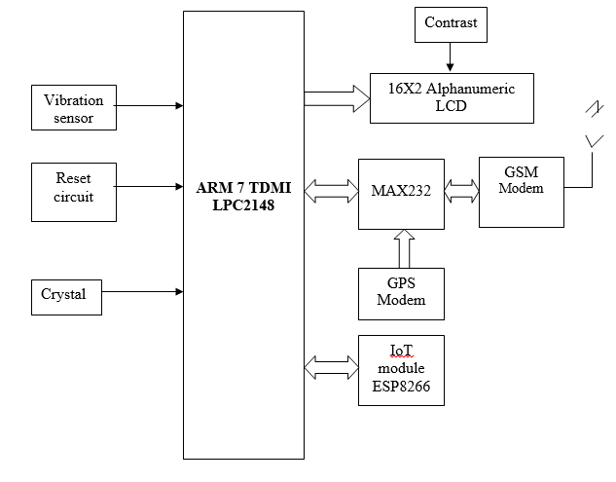

Fig: 1.4.1 Block Diagram

CHAPTER 2
HARDWARE AND SOFTWARE REQUIREMENTS

2.1 HARDWARE REQUIREMENTS
2.1.1 ARM PROCESSOR
Introduction to ARM:
Founded in November 1990, it is spun out of Acorn Computers, it Designs the ARM range of RISC processor cores. Licenses ARM core designs to semiconductor partners who fabricate and sell to their customers. ARM does not fabricate silicon itself, it also develop technologies to assist with the design-in of the ARM architecture. Software tools, boards, debug hardware, application software, bus architectures, peripherals etc.
The ARM processor core originates within a British computer company called Acorn. In the mid-1980s they were looking for replacement for the 6502 processor used in their BBC computer range, which were widely used in UK schools. None of the 16-bit architectures becoming available at that time met their requirements, so they designed their own 32-bit processor.
One important point about ARM is that it does not fabricate silicon itself, but instead just produces the design - we are an Intellectual Property (or IP) company. Instead silicon is produced by companies who license the ARM processor design.
Architectural overview:
The ARM7TDMI-S is a general purpose 32-bit microprocessor, which offers high performance and very low power consumption. The ARM architecture is based on Reduced Instruction Set Computer (RISC) principles, and the instruction set and related decode mechanism are much simpler than those of microprogrammed Complex Instruction Set Computers (CISC). This simplicity results in a high instruction throughput and impressive real-time interrupt response from a small and cost-effective processor core. Pipeline techniques are employed so that all parts of the processing and memory systems can operate continuously. Typically, while one instruction is being executed, its successor is being decoded, and a third instruction is being fetched from memory. The ARM7TDMI-S processor also employs a unique architectural strategy known as Thumb, which makes it ideally suited to high-volume applications with memory restrictions, or applications where code density is an issue. The key idea behind Thumb is that of a super-reduced instruction set. Essentially, the ARM7TDMI-S processor has two instruction sets:
• The standard 32-bit ARM set.
• A 16-bit Thumb set.
The Thumb set’s 16-bit instruction length allows it to approach twice the density of standard ARM code while retaining most of the ARM’s performance advantage over a traditional 16-bit processor using 16-bit registers. This is possible because Thumb code operates on the same 32-bit register set as ARM code. Thumb code is able to provide up to 65 % of the code size of ARM, and 160 % of the performance of an equivalent ARM processor connected to a 16-bit memory system. The particular flash implementation in the LPC2141/42/44/46/48 allows for full speed execution also in ARM mode. It is recommended to program performance critical and short code sections (such as interrupt service routines and DSP algorithms) in ARM mode. The impact on the overall code size will be minimal but the speed can be increased by 30% over Thumb mode.
2.1.2 Processor operating Modes
The ARM has seven basic operating modes:
  - User : unprivileged mode under which most tasks run
  - FIQ : entered when a high priority (fast) interrupt is raised
  - IRQ : entered when a low priority (normal) interrupt is raised
  - Supervisor : entered on reset and when a Software Interrupt instruction is executed
  - Abort : used to handle memory access violations
  - Undef : used to handle undefined instructions
  - System : privileged mode using the same registers as user mode
The Programmers Model can be split into two elements - first of all, the processor modes and secondly, the processor registers. So let’s start by looking at the modes. Now the typical application will run in an unprivileged mode know as “User” mode, whereas the various exception types will be dealt with in one of the privileged modes : Fast Interrupt, Supervisor, Abort, Normal Interrupt and Undefined (and we will look at what causes each of the exceptions later on).
NB - spell out the word FIQ, otherwise you are saying something rude in German!
One question here is what is the difference between the privileged and unprivileged modes? Well in reality very little really - the ARM core has an output signal (nTRANS on ARM7TDMI, In TRANS, DnTRANS on 9, or encoded as part of HPROT or BPROT in AMBA) which indicates whether the current mode is privileged or unprivileged, and this can be used, for instance, by a memory controller to only allow IO access in a privileged mode. In addition some operations are only permitted in a privileged mode, such as directly changing the mode and enabling of interrupts.
All current ARM cores implement system mode (added in architecture v4). This is simply a privileged version of user mode. Important for re-entrant exceptions because no exceptions can cause system mode to be entered.
2.1.3REGISTERS
ARM has 37 registers all of which are 32-bits long.
- 1 dedicated program counter
- 1 dedicated current program status register
- dedicated saved program status registers
- 30 general purpose registers
- The current processor mode governs which of several banks is accessible. Each mode can access a particular set of r0-r12 registers
- a particular r13 (the stack pointer, sp) and r14 (the link register, lr)
- the program counter, r15 (pc)
- the current program status register, cpsr
- Privileged modes (except System) can also access
- a particular spsr (saved program status register)
The ARM architecture provides a total of 37 registers, all of which are 32-bits long. However these are arranged into several banks, with the accessible bank being governed by the current processor mode. We will see this in more detail in a couple of slides. In summary though, in each mode, the core can access: A particular set of 13 general purpose registers (r0 - r12), A Particular r13 - which is typically used as a stack pointer. This will be a different r13 for each mode, so allowing each exception type to have its own stack, particular R14 - which is used as a link (or return address) registers Again this will be a different r14 for each mode. r15 - whose only use is as the Program counter. The CPSR (Current Program Status Register) - this stores additional information about the state of the processor and finally in privileged modes, a particular SPSR (Saved Program Status Register) this stores a copy of the previous CPSR value when an exception occurs. This combined with the link register allows exceptions to return without corrupting processor state.
2.1.4 PROGRAM COUNTER (R15)
- When the processor is executing in ARM state:
  - All instructions are 32 bits wide
  - All instructions must be word aligned
  - Therefore the pc value is stored in bits [31:2] with bits [1:0] undefined (as instruction cannot be half word or byte aligned).
- When the processor is executing in Thumb state:
  - All instructions are 16 bits wide
  - All instructions must be half word aligned
  - Therefore the pc value is stored in bits [31:1] with bit [0] undefined (as instruction cannot be byte aligned).
- When the processor is executing in Jazelle state:
  - All instructions are 8 bits wide
  - Processor performs a word access to read 4 instructions at once
ARM is designed to efficiently access memory using a single memory access cycle. So word accesses must be on a word address boundary, half word accesses must be on a half word address boundary. This includes instruction fetches.
Thumb
- Thumb is a 16-bit instruction set
  - Optimised for code density from C code (~65% of ARM code size)
  - Improved performance from narrow memory
  - Subset of the functionality of the ARM instruction set

Fig:2.1.1ARM7TDMI Processor Core

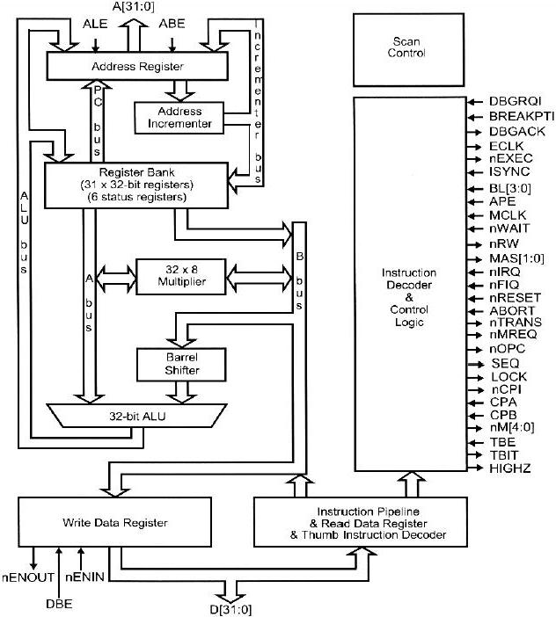
Fig:2.1.2ARM7TDMI Core Diagram

Fig:2.1.3 ARM7TDMI Interface Signals

- Clock control
  - All state change within the processor are controlled by mclk, the memory clock
  - Internal clock = mclk AND \wait
  - eclk clock output reflects the clock used by the core
- Memory interface
  - 32-bit address A[31:0], bidirectional data bus D[31:0], separate data out Dout[31:0], data in Din[31:0]
  - seq indicates that the memory address will be sequential to that used in the previous cycle
- Interrupt
  - \fiq, fast interrupt request, higher priority
  - \irq, normal interrupt request
  - isync, allow the interrupt synchronizer to be passed
- Initialization
  - \reset, starts the processor from a known state, executing from address

Processor family | # of pipeline stages | Memory organization | Clock Rate | MIPS/MHz
ARM6 | 3 | Von Neumann | 25 MHz
ARM7 | 3 | Von Neumann | 66 MHz | 0.9
ARM8 | 5 | Von Neumann | 72 MHz | 1.2
ARM9 | 5 | Harvard | 200 MHz | 1.1
ARM10 | 6 | Harvard | 400 MHz | 1.25
StrongARM | 5 | Harvard | 233 MHz | 1.15
ARM11 | 8 | Von Neumann/  Harvard | 550 MHz | 1.2

Table 2.1.1 ARM Processor Family
2.1.5 LPC2148 CONTROLLER
General description
The LPC2141/42/44/46/48 microcontrollers are based on a 16-bit/32-bit ARM7TDMI-CPU with real-time emulation and embedded trace support, that combine microcontroller with embedded high speed flash memory ranging from 32 kB to 512 kB. A 128-bit wide memory interface and unique accelerator architecture enable 32-bit code execution at the maximum clock rate. For critical code size applications, the alternative 16-bit Thumb mode reduces code by more than 30 % with minimal performance penalty. Due to their tiny size and low power consumption, LPC2141/42/44/46/48 are ideal for applications where miniaturization is a key requirement, such as access control and point-of-sale. Serial communications interfaces ranging from a USB 2.0 Full-speed device, multiple UARTs, SPI, SSP to I2C-bus and on-chip SRAM of 8 kB up to 40 kB, make these devices very well suited for communication gateways and protocol converters, soft modems, voice recognition and low end imaging, providing both large buffer size and high processing power. Various 32-bit timers, single or dual 10-bit ADC(s), 10-bit DAC, PWM channels and 45 fast GPIO lines with up to nine edge or level sensitive external interrupt pins make these microcontrollers suitable for industrial control and medical systems.
Features
- 16-bit/32-bit ARM7TDMI-S microcontroller in a tiny LQFP64 package.
- 8 kB to 40 kB of on-chip static RAM and 32 kB to 512 kB of on-chip flash memory.
- 128-bit wide interface/accelerator enables high-speed 60 MHz operation.
- In-System Programming/In-Application Programming (ISP/IAP) via on-chip boot loader
- Software. Single flash sector or full chip erase in 400 ms and programming of
- 256 bytes in 1 ms.
- EmbeddedICE RT and Embedded Trace interfaces offer real-time debugging with the
- On-chip RealMonitor software and high-speed tracing of instruction execution.
- USB 2.0 Full-speed compliant device controller with 2 kB of endpoint RAM.
- In addition, the LPC2146/48 provides 8 kB of on-chip RAM accessible to USB by DMA.
- One or two (LPC2141/42 vs. LPC2144/46/48) 10-bit ADCs provide a total of 6/14
- Analog inputs, with conversion times as low as 2.44 μs per channel.
- Single 10-bit DAC provides variable analog output (LPC2142/44/46/48 only).
- Two 32-bit timers/external event counters (with four capture and four compare
- Channels each), PWM unit (six outputs) and watchdog.
- Low power Real-Time Clock (RTC) with independent power and 32 kHz clock input
- Multiple serial interfaces including two UARTs (16C550), two Fast I2C-bus (400 kbit/s),
- SPI and SSP with buffering and variable data length capabilities.
- Vectored Interrupt Controller (VIC) with configurable priorities and vector addresses.
- Up to 45 of 5 V tolerant fast general purpose I/O pins in a tiny LQFP64 package.
- Up to 21 external interrupt pins available.
- 60 MHz maximum CPU clock available from programmable on-chip PLL with settling
- Time of 100 μs.
- On-chip integrated oscillator operates with an external crystal from 1 MHz to 25 MHz.
- Power saving modes include Idle and Power-down.
- Individual enable/disable of peripheral functions as well as peripheral clock scaling for
- Additional power optimization.
- Processor wake-up from Power-down mode via external interrupt or BOD.
- Single power supply chip with POR and BOD circuits:
- CPU operating voltage range of 3.0 V to 3.6 V (3.3 V ± 10 %) with 5 V tolerant I/O
Table 2.1.2 Ordering information
Table 2.1.3 Ordering Analysis
Pin Diagram of LPC2148:
Fig 2.1.4 Pin diagram
2.1.6 MEMORY ORGANIZATION
1. On-chip flash program memory
The LPC2141/42/44/46/48 incorporate a 32 kB, 64 kB, 128 kB, 256 kB and 512 kB flash memory system respectively. This memory may be used for both code and data storage. Programming of the flash memory may be accomplished in several ways. It may be programmed In System via the serial port. The application program may also erase and/or program the flash while the application is running, allowing a great degree of flexibility for data storage field firmware upgrades, etc. Due to the architectural solution chosen for an on-chip boot loader, flash memory available for user’s code on LPC2141/42/44/46/48 is 32 kB, 64 kB, 128 kB, 256 kB and 500 kB respectively. The LPC2141/42/44/46/48 flash memory provides a minimum of 100,000 erase/write cycles and 20 years of data-retention.
2. On-chip static RAM
On-chip static RAM may be used for code and/or data storage. The SRAM may be accessed as 8-bit, 16-bit, and 32-bit. The LPC2141, LPC2142/44 and LPC2146/48 provide 8 kB, 16 kB and 32 kB of static RAM respectively. In case of LPC2146/48 only, an 8 kB SRAM block intended to be utilized mainly by the USB can also be used as a general purpose RAM for data storage and code storage and execution.
3. Interrupt controller
The Vectored Interrupt Controller (VIC) accepts all of the interrupt request inputs and categorizes them as Fast Interrupt Request (FIQ), vectored Interrupt Request (IRQ), and non-vectored IRQ as defined by programmable settings. The programmable assignment scheme means that priorities of interrupts from the various peripherals can be dynamically assigned and adjusted. Fast interrupt request (FIQ) has the highest priority. If more than one request is assigned to FIQ, the VIC combines the requests to produce the FIQ signal to the ARM processor. The fastest possible FIQ latency is achieved when only one request is classified as FIQ, because then the FIQ service routine does not need to branch into the interrupt service routine but can run from the interrupt vector location. If more than one request is assigned to the FIQ class, the FIQ service routine will read a word from the VIC that identifies which FIQ source(s) is (are) requesting an interrupt. Vectored IRQs have the middle priority. Sixteen of the interrupt requests can be assigned to this category. Any of the interrupt requests can be assigned to any of the 16 vectored IRQ slots, among which slot 0 has the highest priority and slot 15 has the lowest.
4. Interrupt sources
Each peripheral device has one interrupt line connected to the Vectored Interrupt Controller, but may have several internal interrupt flags. Individual interrupt flags may also represent more than one interrupt source.
5. Pin connect block
The pin connect block allows selected pins of the microcontroller to have more than one function. Configuration registers control the multiplexers to allow connection between the pin and the on chip peripherals. Peripherals should be connected to the appropriate pins prior to being activated, and prior to any related interrupt(s) being enabled. Activity of any enabled peripheral function that is not mapped to a related pin should be considered undefined. The Pin Control Module with its pin select registers defines the functionality of the microcontroller in a given hardware enviroment. After reset all pins of Port 0 and 1 are configured as input with the following exceptions: If debug is enabled, the JTAG pins will assume their JTAG functionality; if trace is enabled, the Trace pins will asume their trace functionality. The pins associated with the I2C0 and I2C1 interface are open drain.
6. Fast general purpose parallel I/O (GPIO)
Device pins that are not connected to a specific peripheral function are controlled by the GPIO registers. Pins may be dynamically configured as inputs or outputs. Separate registers allow setting or clearing any number of outputs simultaneously. The value of the output register may be read back, as well as the current state of the port pins. LPC2141/42/44/46/48 introduce accelerated GPIO functions over prior LPC2000 devices:
- GPIO registers are relocated to the ARM local bus for the fastest possible I/O timing.
- Mask registers allow treating sets of port bits as a group, leaving other bits UN changed.
- All GPIO registers are byte addressable.
- Entire port value can be written in one instruction.
7. Features:
- Bit-level set and clear registers allow a single instruction set or clear of any number of bits in one port.
- Direction control of individual bits.
- Separate control of output set and clear.
- All I/O default to inputs after reset.
8. 10-bit ADC
The LPC2141/42 contains one and the LPC2144/46/48 contain two analog to digital converters. These converters are single 10-bit successive approximation analog to digital converters. While ADC0 has six channels, ADC1 has eight channels. Therefore, total number of available ADC inputs for LPC2141/42 is 6 and for LPC2144/46/48 is 14. The LPC2141/42 contains one and the LPC2144/46/48 contain two analog to digital converters. These converters are single 10-bit successive approximation analog to digital converters. While ADC0 has six channels, ADC1 has eight channels. Therefore, total number of available ADC inputs for LPC2141/42 is 6 and for LPC2144/46/48 is 14.
Features:
- 10 bit successive approximation analog to digital converter.
- Measurement range of 0 V to VREF (2.0 V ≤ VREF ≤ VDDA).
- Each converter capable of performing more than 400,000 10-bit samples per second.
- Every analog input has a dedicated result register to reduce interrupt overhead.
- Burst conversion mode for single or multiple inputs.
- Optional conversion on transition on input pin or timer match signal.
- Global Start command for both converters (LPC2142/44/46/48 only).
9. 10-bit DAC
The DAC enables the LPC2141/42/44/46/48 to generate a variable analog output. The maximum DAC output voltage is the VREF voltage.

10. USB 2.0 device controller
The USB is a 4-wire serial bus that supports communication between a host and a number (127 max) of peripherals. The host controller allocates the USB bandwidth to attached devices through a token based protocol. The bus supports hot plugging, unplugging, and dynamic configuration of the devices. All transactions are initiated by the host controller. The LPC2141/42/44/46/48 is equipped with a USB device controller that enables 12 Mbit/s data exchange with a USB host controller.
11. BOM of LPC2148:
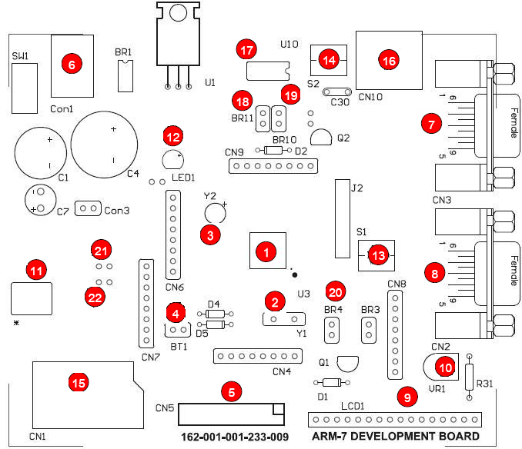
Fig: 2.1.4 BOM OF LPC2148 BOARD
- No.LPC2368 (100Pin LQFP).
- No.2 is 12MHz Crystal to be Time Base of MCU.
- No.3 is 32.768 KHz Crystal to be Time Base of RTC internal MCU.
- No.4 is 3V Battery for Backup of RTC.
- No.5 is JTAG ARM Connector for Real Time Debugging.
- No.6 is Power Supply Connector of board; it can be used with 7-12V AC/DC.
- No.7 is UART-0(RS232) Connector to use and Download Hex File into CPU.
- No.8 is UART-2(RS232) Connector to use.
- No.9 is Character LCD Connector; it can be used with +5V Supply LCD.
- No.10 is VR to adjust the contrast or brightness of Character LCD.
- No.11 is USB Connector to connect with USB Hub version 2.0.
- No.12 is LED to display status of Power +VDD (+3V3).
- No.13 is S1 that is ISP LOAD.
- No.14is S2 or RESET Switch.
- No.15 is socket to insert Memory Card; it can be used with both SD Memory Card and MMC Memory Card.
- No.16 is PS2 Connector to connect with PS2 keyboard.
- No.17 is External Memory.
- No.18 and No.19 is jumper to connect External Memory to MCU.
- No.20 is jumper to connect INT1.
- No.21 and No.22 is jumper to connect D- & D+ to the USB connector.
    - WIRELESS COMMUNICATION
In the world today, everything would be incredibly different if it were not for wireless communication devices. The fact that we can communicate with people in other parts of our own country and the world is amazing and has led to lots of changes in human history. There are various kinds of wireless communication tools and here we will look at a few different kinds as well as the benefits of having them.
1. Short Distances
Sometimes wireless communication does not happen across thousands of miles but only across a few feet. For instance, if you have a television with a remote control, there is communication happening between the two. The remote control tells the television what to do and this information is transferred without the use of any wires.
You could also use walkie talkies for this purpose. These are little devices that work like telephones except with different methods and will allow two people or a group of people to talk to each other from a small distance away, such as at a festival or celebration.
2. Benefits of Short Distance Wireless Communication
Having these short distance devices allows many things to happen. You do not have to get up to change the channel, for one thing. With walkie talkies you are able to communicate with a group of people, which means that people who need to work together such as police men or fire fighters or security guards can do so at special events without having to take the time to dial a phone number. This can save time and sometimes lives.
3. Medium and Long Distances
Anything that can connect to the internet is capable of going through medium or long distances. Many forms of wireless communication such as cell phones and laptop computers can send information from ten feet to thousands of miles because they can connect to the internet. Wireless communication of this form has changed the world dramatically.
4. Applications of Wireless Data Communications
Wireless data communications are an essential component of mobile computing. The various available technologies differ in local availability, coverage range and performance, and in some circumstances, users must be able to employ multiple connection types and switch between them. To simplify the experience for the user, connection manager software can be used, or a mobile VPN deployed to handle the multiple connections as a secure, single virtual network. Supporting technologies include:
5. Wi-Fi
Wireless local area network that enables portable computing devices to connect easily to the internet. Standardized as IEEE 802.11a,b,g,n, Wi-Fi approaches speeds of some types of wired Ethernet.
6. Cellular data service
It offers coverage within a range of 10-15 miles from the nearest cellsite. Speeds have increased as technologies have evolved, from earlier technologies such as GSM,CDMA and GPRS, to3G networks such as W-CDMA,EDGE or CDMA2000

7. Mobile Satellite Communications
It may be used where other wireless connections are unavailable, such as in largely rural areas or remote locations Satellite Communication are especially important for transportation, aviation, maritime and military.
2.1.8 GSM
Global System for Mobile (GSM) is a second generation cellular standard developed to cater voice services and data delivery using digital modulation.
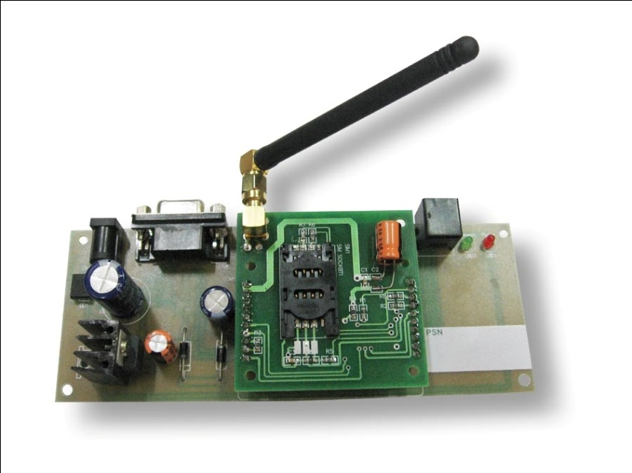

Fig 2.1.4 GSM module

1. GSM SERVICES
- Tele-services
- Bearer or Data Services
- Supplementary services
2. TELE-SERVICES
- Telecommunication services that enable voice communication
- via mobile phones
- Offered services
    - Mobile telephony
    - Emergency calling
3. OPERATION GSM:

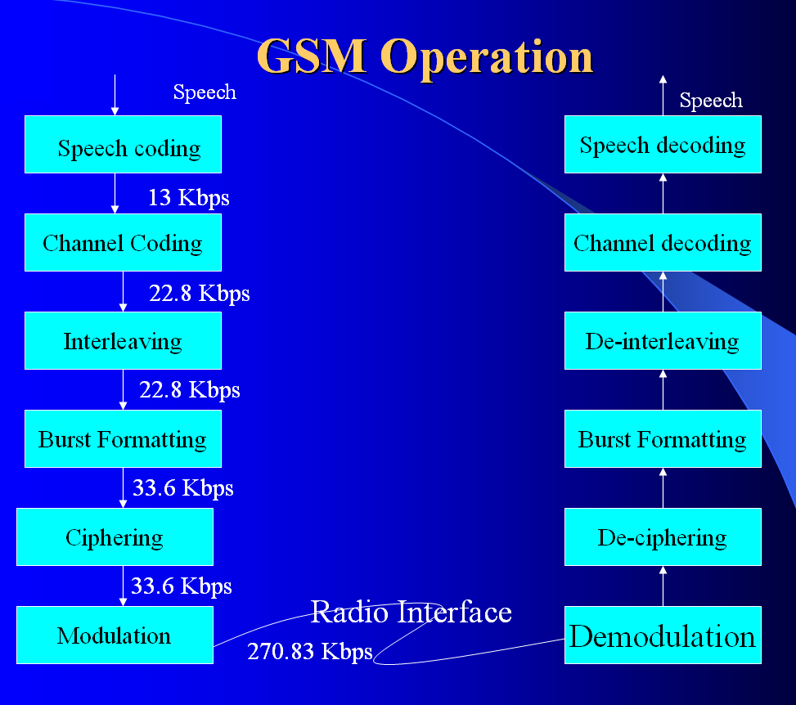
Fig:2.1.5Gsm Operation
4. CHARACTERISTICS OF GSM STANDARD
- Fully digital system using 900,1800 MHz frequency band.
- TDMA over radio carriers(200 KHz carrier spacing.
- 8 full rate or 16 half rate TDMA channels per carrier.
- User/terminal authentication for fraud control.
- Encryption of speech and data transmission over the radio path.
- Full international roaming capability.
- Low speed data services (upto 9.6 Kb/s).
- Compatibility with ISDN.
- Support of Short Message Service (SMS).
5. ADVANTAGES OF GSM OVER ANALOG SYSTEM:
- Capacity increases
- Reduced RF transmission power and longer battery life.
- International roaming capability.
- Better security against fraud (through terminal validation and user authentication).
- Encryption capability for information security and privacy.
- Compatibility with ISDN, leading to wider range of services
2.1.9 GPS
The Global Positioning System (GPS) is a U.S. space-based global navigation satellite system. It provides reliable positioning, navigation, and timing services to worldwide users on a continuous basis in all weather, day and night, anywhere on or near the Earth which has an unobstructed view of four or more GPS satellites.
GPS is made up of three segments: Space, Control and User. The Space Segment is composed of 24 to 32 satellites in Medium Earth Orbit and also includes the boosters required to launch them into orbit. The Control Segment is composed of a Master Control Station, an Alternate Master Control Station, and a host of dedicated and shared Ground Antennas and Monitor Stations. The User Segment is composed of hundreds of thousands of U.S. and allied military users of the secure GPS Precise Positioning Service, and tens of millions of civil, commercial and scientific users of the Standard Positioning Service (see GPS navigation devices). GPS satellites broadcast signals from space that GPS receivers use to provide three-dimensional location (latitude, longitude, and altitude) plus precise time.
GPS has become a widely used aid to navigation worldwide, and a useful tool for map-making, land surveying, commerce, scientific uses, tracking and surveillance, and hobbies such as geocaching and way marking. Also, the precise time reference is used in many applications including the scientific study of earthquakes and as a time synchronization source for cellular network protocols.

1. Position calculation introduction
To provide an introductory description of how a GPS receiver works, errors will be ignored in this section. Using messages received from a minimum of four visible satellites, a GPS receiver is able to determine the times sent and then the satellite positions corresponding to these times sent. The x, y, and z components of position, and the time sent, are designated as where the subscript i is the satellite number and has the value 1, 2, 3, or 4. Knowing the indicated time the message was received , the GPS receiver can compute the transit time of the message as . Assuming the message travelled at the speed of light, c, the distance traveled, can be computed as .

2. Basic concept of GPS
A GPS receiver calculates its position by precisely timing the signals sent by the GPS satellites high above the Earth. Each satellite continually transmits messages which include
- the time the message was transmitted
- precise orbital information (the ephemeris)
- the general system health and rough orbits of all GPS satellites (the almanac).
Three satellites might seem enough to solve for position, since space has three dimensions and a position on the Earth's surface can be assumed. However, even a very small clock error multiplied by the very large speed of light^{[20]}—the speed at which satellite signals propagate—results in a large positional error. Therefore receivers use four or more satellites to solve for the receiver's location and time. The very accurately computed time is effectively hidden by most GPS applications, which use only the location. A few specialized GPS applications do however use the time; these include time transfer, traffic signal timing, and synchronization of cell phone base stations.
2.1.10 EEPROM
In the design of all microprocessors-based systems, semiconductor memories are used as primary storage for code and data. Semiconductor memories are connected directly to the CPU and they are the memory that the CPU first asks for information (code and data). For this reason, semiconductor memories are sometimes referred to as primary memory.
EEPROM (Electrically Erasable Programmable Read only memory)
EEPROM has several advantages over other memory devices, such as the fact that its method of erasure is electrical and therefore instant. In addition, in EEPROM one can select which byte to be erased, in contrast to flash , in which the entire contents of ROM are erased. The main advantage of EEPROM is that one can program and erase its contents while it is in system board. It does not require physical removal of the memory chip from its socket. In general, the cost per bit for EEPROM is much higher when compared to other devices.
The EEPROM used in this project is 24C04 type.
DIP Pin Connections SO Pin Connection
Fig: 2.1.5 DIP and SO pin connection
Table 2.1.4 Signal Names

Fig 2.1.6: Logic Diagram

Descriptionof EEPROM
The 24C04 is a 4 Kbit electrically erasable programmable memory (EEPROM), organized as 2 blocks of 256 x8 bits. They are manufactured in ST Microelectronics’ Hi-Endurance Advanced CMOS technology which guarantees an endurance of one million erase/write cycles with a data retention of 40 years. Both Plastic Dual-in-Line and Plastic Small Outline packages are available. The memories are compatible with the I2C standard, two wire serial interface which uses a bi-directional data bus and serial clock. The memories carry a built-in 4 bit, unique device identification code (1010) corresponding to the I2C bus definition. This is used together with 2 chip enable inputs (E2, E1) so that up to 4 x 4K devices may be attached to the I2C bus and selected individually. The memories behave as a slave device in the I2C protocol with all memory operations synchronized by the serial clock. Read and write operations are initiated by a START condition generated by the bus master. The START condition is followed by a stream of 7 bits (identification code 1010), plus one read/write bit and terminated by an acknowledge bit.

Table2.1.5 Device Select Mode
Table 2.1.6 Operating Modes
When writing data to the memory it responds to the 8 bits received by asserting an acknowledge bit during the 9th bit time. When data is read by the bus master, it acknowledges the receipt of the data bytes in the same way. Data transfers are terminated with a STOP condition.
Protect Enable (PRE)
The PRE input pin, in addition to the status of the Block Address Pointer bit (b2, location 1FFh as in below figure), sets the PRE write protection active.

Fig 2.1.7 Memory Protection

Mode (MODE).
The MODE input is available on pin 7 and may be driven dynamically. It must be at VIL or VIH for the Byte Write mode, VIH for Multibyte Write mode or VIL for Page Write mode. When unconnected, the MODE input is internally read as VIH (Multibyte Write mode).
Write Control (WC).
An hardware Write Control feature (WC) is offered only for ST24W04 and ST25W04 versions on pin 7. This feature is useful to protect the contents of the memory from any erroneous erase/write cycle. The Write Control signal is used to enable (WC = VIH) or disable (WC =VIL) the internal write protection. When unconnected, the WC input is internally read as VIL and the memory area is not write protected.

Device operation
I2C Bus Background
The ST24/25x04 supports the I2C protocol. This protocol defines any device that sends data onto the bus as a transmitter and any device that reads the data as a receiver. The device that controls the data transfer is known as the master and the other as the slave. The master will always initiate a data transfer and will provide the serial clock for synchronization.
The ST24/25x04 is always slave devices in all communications.

Fig2.1.8 I2C Protocol Fig 2.1.9 AC Waveforms

Minimizing System Delays by Polling on ACK.
During the internal write cycle, the memory disconnects itself from the bus in order to copy the data from the internal latches to the memory cells. The maximum value of the write time (Tw) is given from the AC Characteristics, since the typical time is shorter, the time seen by the system may be reduced by an ACK polling sequence issued by the master.
Data in the upper block of 256 bytes of the memory may be write protected. The memory is write protected between a boundary address and the top of memory (address 1FFh) when the PRE input pin is taken high and when the Protect Flag (bit b2 in location 1FFh) is set to ’0’. The boundary address is user defined by writing it in the Block Address Pointer. The Block Address Pointer is an 8 bit EEPROM register located at the address 1FFh.

Fig:2.1.10 Write Cycle Polling using ACK

It is composed by 5 MSBs Address Pointer, which defines the bottom boundary address and 3 LSBs which must be programmed at ’0’. This Address Pointer can therefore address a boundary in steps of 8 bytes.
Acknowledge in Read Mode.
In all read modes the ST24/25x04 wait for an acknowledge during the 9th bit time. If the master does not pull the SDA line low during this time, the ST24/25x04 terminate the data transfer and switches to a standby state.
2.1.11 VIBRATION SENSOR
A vibration sensor is a device that uses the piezoelectric effect, to measure changes in pressure, acceleration, strain or force by converting them to an electrical charge. The prefix piezo- is Greek for 'press' or 'squeeze'.
The Minisense 100 from Measurement Specialties is a low-cost cantilever-type vibration sensor loaded by a mass to offer high sensitivity at low frequencies. Useful for detecting vibration and ‘tap’ inputs from a user. A small AC and large voltage (up to +/-90V) is created when the film moves back an forth. A simple resistor should get the voltage down to ADC levels. Can also be used for impact sensing or a flexible switch

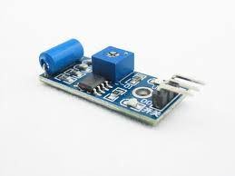
Fig: 2.1.12 Vibration Sensor
2.1.12 IOT (WIFI MODULE ESP8266EX)
Espressif Systems’ Smart Connectivity Platform (ESCP) is a set of high performance, high integration wireless SOCs, designed for space and power constrained mobile platform designers. It provides unsurpassed ability to embed WiFi capabilities within other systems, or to function as a standalone application, with the lowest cost, and minimal space requirement.ESP8266EX offers a complete and self-contained WiFi networking solution; it can be used to host the application or to offload WiFi networking functions from another application processor.
1. Features
- 802.11 b/g/n
- Integrated low power 32-bit MCU
- Integrated 10-bit ADC
- Integrated TCP/IP protocol stack
- Integrated TR switch, balun, LNA, power amplifier and matching network
- Integrated PLL, regulators, and power management units
- Supports antenna diversity
- WiFi 2.4 GHz, support WPA/WPA2
- Support STA/AP/STA+AP operation modes
- Support Smart Link Function for both Android and iOS devices
- SDIO 2.0, (H) SPI, UART, I2C, I2S, IR Remote Control, PWM, GPIO
- STBC, 1x1 MIMO, 2x1 MIMO
- A-MPDU & A-MSDU aggregation & 0.4s guard interval
- Deep sleep power <10uA, Power down leakage current < 5uA
- Wake up and transmit packets in < 2ms
- Standby power consumption of < 1.0mW (DTIM3)
- +20 dBm output power in 802.11b mode
- Operating temperature range -40C ~ 125C
- FCC, CE, TELEC, WiFi Alliance, and SRRC certified
3. Ultra Low Power Technology
ESP8266EX has been designed for mobile, wearable electronics and Internet of Things applications with the aim of achieving the lowest power consumption with a combination of several proprietary techniques. The power saving architecture operates mainly in 3 modes: active mode, sleep mode and deep sleep mode.
By using advance power management techniques and logic to power-down functions not required and to control switching between sleep and active modes, ESP8266EX consumes about than 60uA in deep sleep mode (with RTC clock still running) and less than 1.0mA (DTIM=3) or less than 0.5mA (DTIM=10) to stay connected to the access point.
.4. Hardware Overview
Pin Definitions

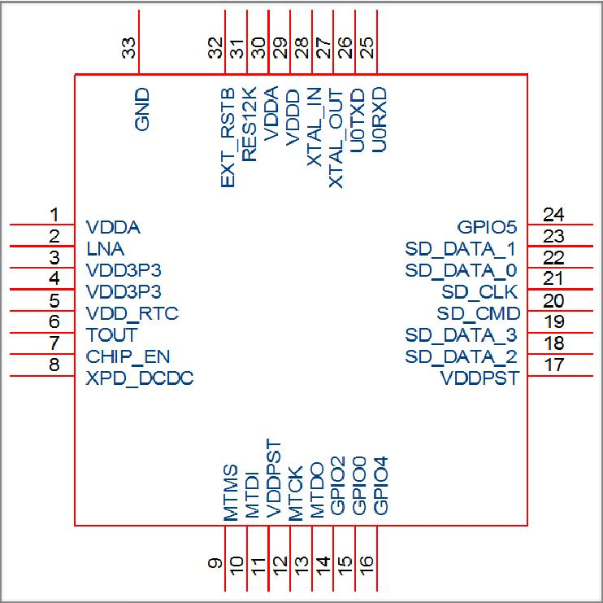

Fig 2.1.13 Pin design of ESP8266EX
2.1.13 LIQUID CRYSTAL DISPLAY
LCD stands for Liquid Crystal Display. LCD is finding wide spread use replacing LEDs (seven segment LEDs or other multi segment LEDs) because of the following reasons:
1. The declining prices of LCDs.
2. The ability to display numbers, characters and graphics. This is in contrast to LEDs, which are limited to numbers and a few characters.
3. Incorporation of a refreshing controller into the LCD, thereby relieving the CPU of the task of refreshing the LCD. In contrast, the LED must be refreshed by the CPU to keep displaying the data.
4. Ease of programming for characters and graphics.
These components are “specialized” for being used with the microcontrollers, which means that they cannot be activated by standard IC circuits. They areused for writing different messages on a miniature LCD.
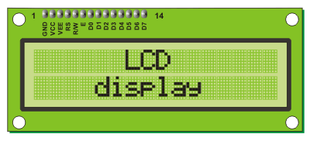
Fig2.1.14 LCD
A model described here is for its low price and great possibilities most frequently used in practice. It is based on the HD44780 microcontroller (Hitachi) and can display messages in two lines with 16 characters each. It displays all the alphabets, Greek letters, punctuation marks, mathematical symbols etc. In addition, it is possible to display symbols that user makes up on its own. Automatic shifting message on display (shift left and right), appearance of the pointer, backlight etc. are considered as useful characteristics.

Pins Functions
Function | Pin Number | Name | LogicState | Description
Ground | 1 | Vss | - | 0V
Power supply | 2 | Vdd | - | +5V
Contrast | 3 | Vee | - | 0 –Vdd
Control of operating | 4 | RS | 0  1 | D0 – D7 are interpreted as commands  D0 – D7 are interpreted as data
Control of operating | 5 | R/W | 0  1 | Write data (from controller to LCD)  Read data (from LCD to controller)
Control of operating | 6 | E | 0  1  From 1 to 0 | Access to LCD disabled  Normal operating  Data/commands are transferred to LCD
Data / commands | 7 | D0 | 0/1 | Bit 0 LSB
Data / commands | 8 | D1 | 0/1 | Bit 1
Data / commands | 9 | D2 | 0/1 | Bit 2
Data / commands | 10 | D3 | 0/1 | Bit 3
Data / commands | 11 | D4 | 0/1 | Bit 4
Data / commands | 12 | D5 | 0/1 | Bit 5
Data / commands | 13 | D6 | 0/1 | Bit 6
Data / commands | 14 | D7 | 0/1 | Bit 7 MSB
Table 2.1.8 LCD Pin Functions

2.2 SOFTWARE REQUIREMENTS:

Software Required:
The software required for this project to develop is as following
Windows XP:
This is an Operating System (OS) on which all the software applications required for our project are going to be run. This OS is flexible to any user to operate and easy to understood. Accessing the soft wares and using them is very convenient to user.

2.2.1 ORCAD
OrCAD is a proprietary software tool suite used primarily for electronic design automation. The software is used mainly to create electronic prints for manufacturing of printed circuit boards, by electronic design engineers and electronic technicians to manufacture electronic schematics.The name OrCAD is a portmanteau, reflecting the software's origins: Oregon + CAD.
The OrCAD product line is fully owned by Cadence Design Systems. The latest iteration has the ability to maintain a database of available integrated circuits. This database may be updated by the user by downloading packages from component manufacturers, such as Analog Devices or Texas Instruments. Another announcement was, that ST Micro electronics will offer OrCAD PSpice models for all the power and logic semiconductors, since PSpice is the most used circuit simulator. Intel offers reference PCBs designed with Cadence PCB Tools in the OrCAD Capture format for embedded and personal computers.

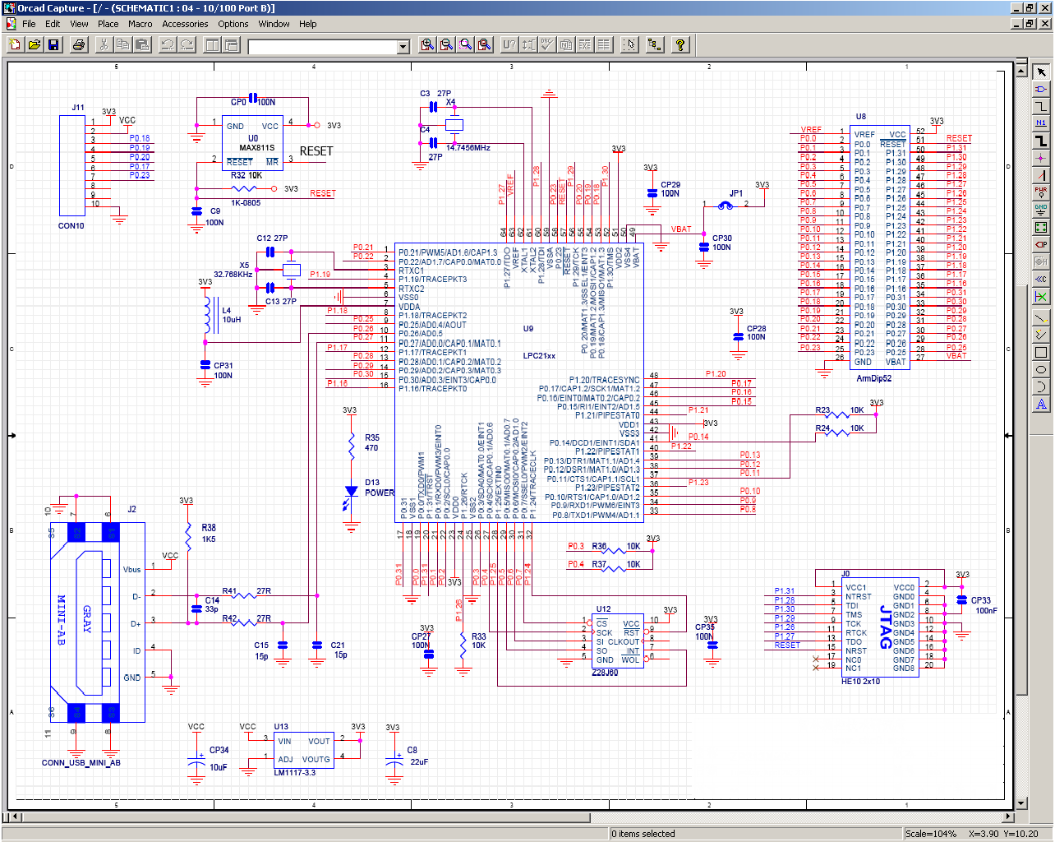
Fig 2.2.1 OrCAD software screenshot
OrCAD Capture CIS is a software tool used for circuit schematic capture. It is part of the OrCAD circuit design suite. Capture CIS is nearly identical to the similar OrCAD tool, Capture. The difference between the two tools comes in the addition of the component information system (CIS). The CIS links component information, such as printed circuit board package footprint data or simulation behavior data, with the circuit symbol in the schematic. When exported to other tools in the OrCAD design suite, the data stored in the CIS is also transferred to the other tool. Thus, when a design engineer exports a schematic to the circuit board layout utility, the majority of the circuit elements have footprints linked to them. This saves time for the design engineer.
Capture CIS has the ability to export netlists, representative of the circuit schematic which is currently open, to the OrCAD simulation utility, PSPICE. Capture CIS also exports a simulation configuration file, accessible through the simulation toolbar. This, coupled with the CIS, allows for quick simulations with data representative of how the circuit will behave. Capture may also export a net list to the SPICE simulation utility.
Capture may export a hardware description of the circuit schematic that is currently open, either in Verilog or VHDL. Capture also has the ability to export net lists to several different circuit board layout utilities, such as OrCAD Layout, Allegro, and others. When combined with the CIS, circuit board footprints are linked to this net list. This, combined with the pin to pin interconnect description of the net list, will open the correct part footprints, and, if the CIS data that CIS exported is correct, will connect all of the pads together with representative lines. This feature makes the circuit board design process easier for the design engineer.

2.2.2 KEIL MICRO VISION 3 IDE
The µVision development platform is easy-to-use and it helps you quickly create embedded programs that work. The µVision IDE (Integrated Development Environment) from Keil combines project management, source code editing, program debugging, and complete simulation in one powerful environment. Code written in ‘EMBEDDED C’
The µVision3 IDE is a Windows-based software development platform that combines a robust editor, project manager, and makes facility. µVision3 integrates all tools including the C compiler, macro assembler, linker/locator, and HEX file generator. µVision3 helps expedite the development process of your embedded applications by providing the following:
- Full-featured source code editor,
- Device database for configuring the development tool setting,
- Project manager for creating and maintaining your projects,
- Integrated make facility for assembling, compiling, and linking your embedded applications,
- Dialogs for all development tool settings,
- True integrated source-level Debugger with high-speed CPU and peripheral simulator,
- Advanced GDI interface for software debugging in the target hardware and for connection to Keil ULINK,
- Flash programming utility for downloading the application program into Flash ROM,
- Links to development tools manuals, device datasheets & user’s guides.
The µVision3 IDE offers numerous features and advantages that help you quickly and successfully develop embedded applications. They are easy to use and are guaranteed to help you achieve your design goals. The µVision3 IDE and Debugger is the central part of the Keil development tool chain. µVision3 offers a Build Mode and a Debug Mode.In the µVision3 Build Mode you maintain the project files and generate the application.

Software Development Cycle
When you use the Keil µVision3, the project development cycle is roughly the same as it is for any other software development project.
- Create a project, select the target chip from the device database, and configure the tool settings.
- Create source files in C or assembly.
- Build your application with the project manager.
- Correct errors in source files.
- Test the linked application.
The following block diagram illustrates the complete µVision3/ARM software development cycle. Each component is described below

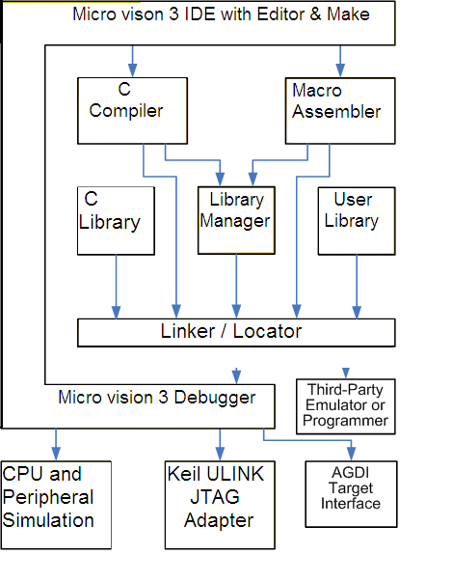
Fig 2.2.2 Software Development cycle in keil Software
In the µVision3 Debug Mode you verify your program either with a powerful CPU and peripheral simulator or with the Keil ULINK USB-JTAG Adapter (or other AGDI drivers) that connect the debugger to the target system. The ULINK allows you also to download your application into Flash ROM of your target system.
2.2.3 FLASH MAGIC SOFTWARE
How to Download Hex File into MCU of Board
The method to download Hex File into Flash Memory of MCU in Board is to use Program Flash Magic that is connected with MCU through Serial Port of computer PC. This program can be downloaded free without any charge from website http://www.flashmagictool.com/
Proceeding to Download Hex File into MCU
- Interface RS232 Cable between RS232 Serial Port of PC and Board UART-0 (CN3).
- Supply power into board; in this case, we can see red LED1 is in status ON.
- Set jumper BR4 (INT1) in ON state.
- Run Program Flash Magic, it will display result as shown in Figure 1.1
- Start setting the initial values into program as desired, so we configure values into program as follows;
- Select COM port corresponding with (in this example, it is COM1)
- Set the baud rate to 9600
- Set Device to be LPC2148
- Set Interface to be None ISP
- Set Crystal Oscillator with MHz corresponding with the value internal Board. In this case, it is 12.000MHz, so we must set to be 12.
- Press ISP LOAD Switch (S1) and RESET Switch (S2) on Board “ARM7 LPC2148 Development Board” to reset MCU to run in Boot Loader following the processes;
- Press ISP LOAD Switch (S1) and hold
- Press RESET Switch (S2) while ISP LOAD Switch (S1) is being held.
- Remove RESET Switch (S2) but ISP LOAD Switch (S1) is being held.
- Lastly, remove ISP LOAD Switch (S1).
- Select format of erasing data to be “Erase all Flash + Code Rd Prot”.
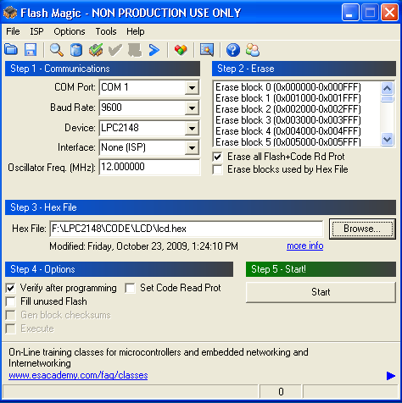
Fig 2.2.3 Flash Magic Software

7. Set Option to be “Verify after programming”.
8. Click “Browse” to select HEX File for downloading.
9. Click “Start”, Program Flash Magic will start downloading data into MCU instantly. In this case, we can see the status operation at Status Bar and we must wait for the operation until it is completed.
10. When the operation of program is complete, press RESET Switch (S2) on Board and MCU will start running follow the downloaded program instantly.

CHAPTER 3
DESIGN PROCEDURE

3.1 Power supply
Power supply is a reference to a source of electrical power. A device or system that supplies electrical or other types of energy to an output load or group of loads is called a power supply unit or PSU. The term is most commonly applied to electrical energy supplies, less often to mechanical ones, and rarely to others.
The term "power supply" is sometimes restricted to those devices that convert some other form of energy into electricity (such as solar power and fuel cells and generators). A more accurate term for devices that convert one form of electric power into another form (such as transformers and linear regulators) is power converter. The most common conversion is from AC to DC.
AQ regulated power supply or stabilized power supply is one that includes circuitry t Ao tightly control the output voltage and/or current to a specific value. The specific value is closely maintained despite variations in the load presented to the power supply's output, or any reasonable voltage variation at the power supply's input.
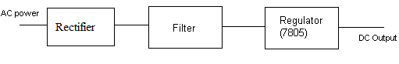
Fig 3.1.1 Power Supply Block diagram

The micro controller and other devices get power supply from AC to DC adapter through voltage regulator. The adapter output voltage will be 12V DC non-regulated. The 7805/7812 voltage regulators are used to convert 12V to 5VDC.
3.1.1 Rectifier
The output from the transformer is fed to the rectifier. It converts A.C. into pulsating D.C. The rectifier may be a half wave or a full wave rectifier. In this project, a bridge rectifier is used because of its merits like good stability and full wave rectification.
Fig 3.1.2 Bridge Rectifier
The Bridge rectifier is a circuit, which converts an ac voltage to dc voltage using both half cycles of the input ac voltage. The Bridge rectifier circuit is shown in the figure. The circuit has four diodes connected to form a bridge. The ac input voltage is applied to the diagonally opposite ends of the bridge. The load resistance is connected between the other two ends of the bridge.
For the positive half cycle of the input ac voltage, diodes D1 and D3 conduct, whereas diodes D2 and D4 remain in the OFF state. The conducting diodes will be in series with the load resistance R_{L} and hence the load current flows through R_{L.}For the negative half cycle of the input ac voltage, diodes D2 and D4 conduct whereas, D1 and D3 remain OFF.
Output wave forms:
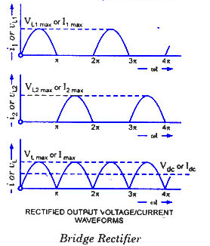
Fig 3.1.3 Bridged Rectifier Output Waveforms
1. Filter
Capacitive filter is used in this project. It removes the ripples from the output of rectifier and smoothens the D.C. Output received from this filter is constant until the mains voltage and load is maintained constant. However, if either of the two is varied, D.C. voltage received at this point changes. Therefore a regulator is applied at the output stage.
2. Regulator
As the name itself implies, it regulates the input applied to it. A voltage regulator is an electrical regulator designed to automatically maintain a constant voltage level. In this project, power supply of 5V and 12V are required. In order to obtain these voltage levels, 7805 and 7812 voltage regulators are to be used. The first number 78 represents positive supply and the numbers 05, 12 represent the required output voltage levels.
The L78xx series of three-terminal positive regulators is available in TO-220, TO-220FP, TO-3, D2PAK and DPAK packages and several fixed output voltages, making it useful in a wide range of applications. These regulators can provide local on-card regulation, eliminating the distribution problems associated with single point regulation. Each type employs internal current limiting, thermal shut-down and safe area protection, making it essentially indestructible. If adequate heat sinking is provided, they can deliver over 1 A output current. Although designed primarily as fixed voltage regulators, these devices can be used with external components to obtain adjustable voltage and currents.

Fig 3.1.4 Voltage Regulator

3.2 SWITCH AND LED INTERFACING WITH THE MICROCONTROLLER:
Switches and LEDs are the most widely used input/output devices of the ARM7. CPU accesses the switches through ports. Therefore these switches are connected to a microcontroller. This switch is connected between the supply and ground terminals. A single microcontroller (consisting of a microprocessor, RAM and EEPROM and several ports all on a single chip) takes care of hardware and software interfacing of the switch.
These switches are connected to an input port. When no switch is pressed, reading the input port will yield 1s since they are all connected to high (Vcc). But if any switch is pressed, one of the input port pins will have 0 since the switch pressed provides the path to ground. It is the function of the microcontroller to scan the switches continuously to detect and identify the switch pressed.The switches that we are using in our project are 4 leg micro switches of momentary type.

Vcc

P2.0
R

Gnd

Fig 3.2.1 Interfacing switch with the microcontroller

Thus now the two conditions are to be remembered:
- When the switch is open, the total supply i.e., Vcc appears at the port pin P2.0
P2.0 = 1
- When the switch is closed i.e., when it is pressed, the total supply path is provided to ground. Thus the voltage value at the port pin P2.0 will be zero.
P2.0 = 0
By reading the pin status, the microcontroller identifies whether the switch is pressed or not. When the switch is pressed, the corresponding related to this switch press written in the program will be executed.
3.2.1 LED INTERFACING
LED stands for Light Emitting Diode. Microcontroller port pins cannot drive these LEDs as these require high currents to switch on. Thus the positive terminal of LED is directly connected to Vcc, power supply and the negative terminal is connected to port pin through a current limiting resistor.
This current limiting resistor is connected to protect the port pins from sudden flow of high currents from the power supply.Thus in order to glow the LED, first there should be a current flow through the LED. In order to have a current flow, a voltage difference should exist between the LED terminals. To ensure the voltage difference between the terminals and as the positive terminal of LED is connected to power supply Vcc, the negative terminal has to be connected to ground. Thus this ground value is provided by the microcontroller port pin. This can be achieved by writing an instruction “CLR P1.0”. With this, the port pin P1.0 is initialized to zero and thus now a voltage difference is established between the LED terminals and accordingly, current flows and therefore the LED glows. LED and switches can be connected to any one of the four port pins.

Vcc

P1.0
Fig 3.2.2 LED Interfacing with the microcontroller

Light-emitting diode (LED)
Light-emitting diodes are elements for light signalization in electronics. They are manufactured in different shapes, colors and sizes. For their low price, low consumption and simple use, they have almost completely pushed aside other light sources- bulbs at first place. They perform similar to common diodes with the difference that they emit light when current flows through them.
Since the 8052 microcontrollers can provide only low input current and since their pins are configured as outputs when voltage level on them is equal to 0, direct connectining to LEDs is carried out as it is shown on figure (Low current LED, cathode is connected to output pin).

CHAPTER-4
TESTING PROCESS

In this section we will check our all components so far used. We will also discuss about its working conditions, problems faced across its testing.
4.1 TESTING OF POWER SUPPLY
To Design 5V, 500mA Power supply.
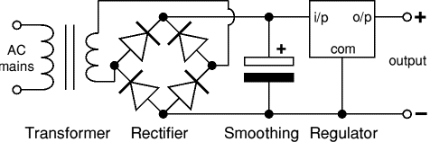
Fig 4.1
Circuit Diagram of Power Supply
1. TRANSFORMER
Here, AC mains 230V step down transformer is used. Hence, no. of turns in primary coil is more than in secondary coil. Since, it is step down transformer, so, it will reduce the voltage. Since, we cannot apply ideal transformer in practical uses. So, according to variations in input voltage, output voltage is calculated further.
2. RECTIFIER
Here, full wave bridge rectifier is used to convert AC to DC because four diodes are spent to make full wave bridge rectifier where two conduct on the positive half cycle, and the other two conduct on the negative half cycle. Hence, this said rectifier is used instead of half wave bridge rectifier.
3. CAPACITOR For this design an electrolytic capacitor of value 470$µ$F (calculated) is applied. This capacitor is applied for the smoothing purpose. We can use more than one capacitor but that is optional and based on our requirement.
4. REGULATOR
Voltage regulator is an electrical regulator designed to automatically maintain a constant voltage level.Now from the given datasheet we can see that we are obtaining 5V and current of 500mA fron this regulator. This (LM 7805) is most common voltage regulator that is still used in embedded designs. The features are listed below:-

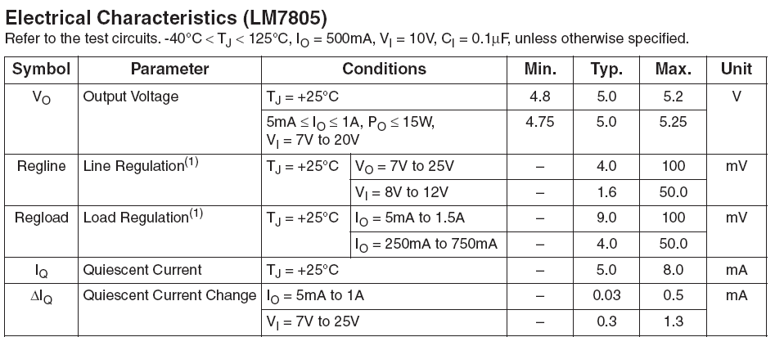Table 4.1: Features of LM7805
4.2 PROCEDURE
  - First, we have checked the output of transformer and noted that to be 12 V AC.
  - Later the bridge rectifier output was checked and found to be 12V DC
  - The output of the regulator was checked, it is 5V.
  - The input to the micro controller from the sensor is 3.3V
  - Now make sure that the GPS module is in working condition by checking the latitude and longitude values in the LCD screen.
  - Check the GSM module by LED blinking timeperiod on SIM 800.
  - Whenever the Vibration sensor generate the pulse, the system gets activated by changing the LCD screen to “ACCIDENT ALERT” and the GSM module gets activated by sending message to the enrolled mobile number with GPS data.
  - After pressing the safe button GSM module again activates and sends another safe message and ask the user to reset the system.
  - With this we have completed the full functional testing.

4.3 ADVANTAGES
- Sophisticated security
- Monitors all hazards and threats
- Alert message to mobile phone for remote information
- Mobile number can be changed at any time
4.4 APPLICATIONS
- Automotives and transport vehicles
- Security, Remote monitoring, Transportation and logistics
4.5 RESULT
This project is designed with LPC2148 BasedGPS-GSMintegration for enhancing public transportation. The Monitoring controller based on the closed loop algorithm is designed and implemented with ARM7 TDMI processor based LPC2148 controller in embedded system domain. This project implements a solution for enhancing public transportation management services based on GPS and GSM.
4.6 FUTURE SCOPE
The system can be made automatic by installing cameras at VEHICLES which can automatically read the area were accident have took place.

CONCLUSION
This project presents aLPC2148 based “Vehicle Accident Detection and Messaging System using GSM and GPS Modems”. In this project work, we have studied and implemented a complete working model using a Microcontroller. The programming and interfacing of microcontroller has been mastered during the implementation. This work includes the study of GSM and GPS modems using sensors.
The biggest advantage of using this project is, whenever the sensor is activated we will be getting the acknowledgement from GSM modem to our mobile numbers which are stored in EEPROM and GSM network operators have roaming facilities, and finding the location and sending information to user so that they can often continue to use there mobile phones when they travel to other countries etc..

- This system detects the Accident using Vibration sensor and intimates to enrolled mobile number..
- A micro controller, ARM 7 with LPC2148 controller is used as the main control element.
- A well regulated power supply was designed.
- This power supply produces 12v with 1 A current.
- A transistor/s was used to drive the relay.
- The relay was used to control the turn on or off of the particular source.
- We have gained the design techniques.
- We have developed testing skills.
- We practised the art of soldering.
- Finally, we thank the college and the university for providing us an excellent opportunity to transfrom our theoretical knowledge in to practical application.
- We have gained the confidence to handle similar projects in the future.

REFERENCES

Website:
- www.howstuffworks.com
- www.answers.com
- www.Wikipedia.com

Magazines:
- Electronics for you
- Electrikindia
Books:
- ARM Architecture Reference Manual,Second Edition by David Seal ,Addison-Wesley
- Kolban’s book on the ESP8266, Neil Kolbana
APPENDIX
#include<LPC214x.h>
#include<string.h>
#include<stdio.h>
#include<ctype.h>
#include<stdlib.h>
#include"lcd8.h"
#include"i2c.h"
#define BUZZ 10
#define NUM 12
#define VIB 16
voidsend_com(unsigned char *);
void Alarm(void);
void Wait();
unsigned char Key,Key1;
unsigned char buf[12];
unsigned char gsm_stno=0,i;
unsigned char pno[14];

unsigned char m,ii;
unsigned char buffer[36],ch;
unsigned char receive,received = 0,loc;
unsigned char lat[10],lon[10],buf1[20],buf2[20];
longlat_p,lon_p ;

void delay(unsigned long int count1)
{
while(count1 > 0) {count1--;} // Loop Decrease Counter
}

voidDelayMs(long ms) // delay 1 ms per count @ CCLK 60 MHz
{
longi,j;
for (i = 0; i<ms; i++ )
for (j = 0; j < 6659; j++ )
{

}
}

/////////////////////////////////////////////////////////////////////////////////////////////////////////////////////////////////////

void Delay()
{
unsignedinti,j;
for(i=0;i<50;i++)
for(j=0;j<700;j++);
}

/////////////////////////////////////////////////////////////////////////////////////////////////////////////////////////////////////

void Wait()
{
Delay();Delay();Delay();
Delay();Delay();Delay();
Delay();Delay(); Delay();
}

/////////////////////////////////////////////////////////////////////////////////////////////////////////////////////////////////////

void Alarm(void)
{
IOSET0 |= 1 << BUZZ;
Wait();Wait();
Wait();Wait();
IOCLR0 |= 1 << BUZZ;
Wait();Wait();
}

/////////////////////////////////////////////////////////////////////////////////////////////////////////////////////////////////////

voidEEPROM_Setup(intaddr,intval)
{
buf[0]=val;
m24xx_write(EEPROM_24XX04, addr , 0 , (char *)buf , 1);
delay(100);
}

///////////////////////////////////////////////////////////////////////////////////////////////////////////////////////////////////////

unsigned char eeprom_memread(unsigned char val)
{
m24xx_read(EEPROM_24XX04, val , 0 , (char *)buf , 1);
returnbuf[0];
}

///////////////////////////////////////////////////////////////////////////////////////////////////////////////////////////////////////

void set_pin0(unsigned char pin)
{
IOSET0 |= (1<<pin);
}

///////////////////////////////////////////////////////////////////////////////////////////////////////////////////////////////////////

void clr_pin0(unsigned char pin)
{
IOCLR0 |= (1<<pin);
}

///////////////////////////////////////////////////////////////////////////////////////////////////////////////////////////////////////

void uart0_init ()
{
/* initialize the serial interface */
PINSEL0 = 0x00000005; /* Enable RxD0 and TxD0 */
U0LCR = 0x83; /* 8 bits, no Parity, 1 Stop bit */
U0DLL = 97; /* 9600 Baud Rate @ 15MHz VPB Clock */
U0LCR = 0x03; /* DLAB = 0 */
}

/////////////////////////////////////////////////////////////////////////////////////////////////////////////////////////////////////

void Delay1(long ms)
{
longi,j;
for (i = 0; i<ms; i++ )
for (j = 0; j < 365; j++ );
}

/////////////////////////////////////////////////////////////////////////////////////////////////////////////////////////////////////////

voidsend_iot_field( unsigned char * dat1, unsigned char * dat2)
{
send_com("AT\n");
DelayMs(800);

send_com("AT+CIPSTART=\"TCP\",\"184.106.153.149\"\n");
DelayMs(1800);

send_com("AT+CIPSEND=68\n");
DelayMs(800);
send_com("GET /update?api_key=9HMOIE3YPNNFWCWJ&field1=");
send_com(dat1);

send_com("&field2=");
send_com(dat2);

send_com("\n\n");
DelayMs(1800);
}

/////////////////////////////////////////////////////////////////////////////////////////////////////////////////////////////////////

void txu0(unsigned char data)
{
while(!(U0LSR & 0x20));
U0THR=data;
DelayMs(10);
}

////////////////////////////////////////////////////////////////

voidsend_com(unsigned char *p)
{
while(1)
{
if(*p=='\0')
break;
txu0(*p++);
}
}

/////////////////////////////////////////////////////////////////////////////////////////////////////////////////////////////////////

voidsend_sms(unsigned char *p)
{
printf("AT\r");
DelayMs(800);
printf("AT+CMGS=");
putchar('"');
for(i=13;i<=25;i++)
{
putchar(eeprom_memread(i));
DelayMs(20);
}
putchar('"');
putchar('\r');
DelayMs(500);
printf(p);

printf(buf1);
printf(",");
printf(buf2);
printf(" ");
DelayMs(800);
putchar(0x1a);

}

/////////////////////////////////////////////////////////////////////////////////////////////////////////////////////////////////////////

void main(void)
{
PINSEL0 = 0x50000;
U1LCR = 0x83;
U1DLL = 97;
U1DLM = 0x00;
U1LCR = 0x03;

IO0DIR |= (1<<BUZZ);
LCD_init();
LCD_puts(0x80,"INITIALIZING.. ");

IO0DIR &= ~(1<<NUM);
IO0DIR &= ~(1<<VIB);

uart0_init();

IOCLR0 |= 1 << BUZZ;

send_com("AT\n");
printf("AT\r");
DelayMs(800);

printf("ATE0\r");
DelayMs(800);

send_com("AT+CWSAP=\"channels/218712\",\"12345678\",2,3\n");
printf("AT+CMGF=1\r");
DelayMs(800);

printf("AT+CMGD=1,4\r");
DelayMs(800);

LCD_cmd(0x01);

if (!(IOPIN0 & (1<<NUM)))
{
LCD_cmd(0x01);
LCD_puts(0x80,"WAITING FOR CALL");
send_com("AT+CWJAP=\"IOT\",\"carvingnotions\"\n");
printf("AT+CLIP=1\r");
DelayMs(800);
while(1)
{

while (!(U1LSR & 0x20)); //Recieve Data
Key = U1RBR;

if(Key=='"')
{
gsm_stno=1;
}

if(gsm_stno==1)
{
pno[i]=Key;
i++;
if(i==13)
{
gsm_stno=3;
Alarm();
}
}

if(gsm_stno==3)
{
DelayMs(50);
printf("ATH\r");
for(loc=13,i=0;loc<=25;loc++,i++)
{
EEPROM_Setup(loc,pno[i]);
}
LCD_cmd(0x01);
for(i=13;i<=25;i++)
{
LCD_putc(eeprom_memread(i));
DelayMs(20);
}
LCD_puts(0xc0,"RESTART SYSTEM ");
while(1);
}
}
}

sw_cnt=0;
LCD_cmd(0x01);
LCD_puts(0x80,"00.0000");
LCD_puts(0xc0,"00.0000");

while(1)
{
for(sw_cnt=0;sw_cnt<=10;sw_cnt++)
{

if ((IOPIN0 & (1<<VIB)))
{
LCD_puts(0x01," ACCIDENT ALERT ");
for(jj=0;jj<50;jj++)
{
Alarm();
DelayMs(100);
if (!(IOPIN0 & (1<<NUM)))
{
LCD_puts(0x01,"SAFE NO SMS SENT");
DelayMs(2000);
LCD_puts(0x01,"00.0000");
LCD_puts(0xc0,"00.0000");
goto first;
}
}
send_sms("ALERT!! ACCIDENT DETECTED AT LOCATION \n\r");
send_iot_field(buf1,buf2);
while(1)
{
Alarm();
DelayMs(200);
if (!(IOPIN0 & (1<<NUM)))
{
LCD_puts(0x01," SENDING SAFE ");
LCD_puts(0xc0," INTIMATION... ");
send_sms("SAFE INTIMATION AT LOCATION \n\r");
LCD_puts(0x01,"INTIMATION SENT");
LCD_puts(0xc0," RESTART SYSTEM ");
while(1)
{
IOSET0 |= 1 << BUZZ;
DelayMs(50);
IOCLR0 |= 1 << BUZZ;
DelayMs(500);
}
}
}
}
first:
while (!(U0LSR & 0x20));
Key1 = U0RBR;
if(Key1=='R')
{
received=1;
ch=receive=0;
}
if(received==1)
{
if(Key1=='A')
{
receive=1;
}
if(receive==1)
{
if(ch<36)
buffer[ch]=Key1;
ch++;
}
}

lat[0]=buffer[4];
lat[1]=buffer[5];
lat[2]=buffer[7];
lat[3]=buffer[8];
lat[4]=buffer[9];
lat[5]=buffer[10];

lat_p=atol(lat);
lat_p=lat_p/60;
sprintf(buf1,"%c%c.%ld",buffer[2],buffer[3],lat_p);
LCD_puts(0x80,buf1);

lon[0]=buffer[17];
lon[1]=buffer[18];
lon[2]=buffer[20];
lon[3]=buffer[21];
lon[4]=buffer[22];
lon[5]=buffer[23];

lon_p=atol(lon);
lon_p=lon_p/60;
sprintf(buf2,"%c%c.%ld",buffer[15],buffer[16],lon_p);
LCD_puts(0xc0,buf2);

printf("AT+CMGR=1\r");
DelayMs(1500);

if(gsm_stno==2)
{
Alarm();
printf("AT\r");
DelayMs(800);
printf("AT+CMGD=1,4\r");
DelayMs(800);
if(!strcmp(scan,"APPSTA"))
{
printf("AT+CMGS=");
putchar('"');
for(i=0;i<=12;i++)
{
putchar(pno[i]);
DelayMs(20);
}
putchar('"');
putchar('\r');
DelayMs(1200);
printf(buf1);
printf(",");
printf(buf2);
DelayMs(1500);
putchar(0x1a);
}
}
}
send_iot_field(buf1,buf2);
}
}

/////////////////////////////////////////////////////////////////////////////////////////////////////////////////////////////////////

