EXPERIMENT – 17
Change Hardware compatibility of a VM (Either by clone/create new one) which is already created and configured using vmware workstation.
Aim:
To change the hardware compatibility of an already created and configured VM using VMware Workstation.
Procedure:
- Open VMware Workstation and select the VM whose hardware compatibility needs to be changed.
- Ensure the VM is powered off.
- Right-click on the VM → select Manage → Change Hardware Compatibility.
- The Change Hardware Compatibility Wizard opens.
- Select the desired VMware Workstation version for compatibility (e.g., Workstation 15.x, 16.x, etc.).
- Choose whether to create a new clone of the VM or directly upgrade the existing one.
- Review the settings and click Finish.
- Once completed, start the VM to verify compatibility with the selected VMware version.

Output:
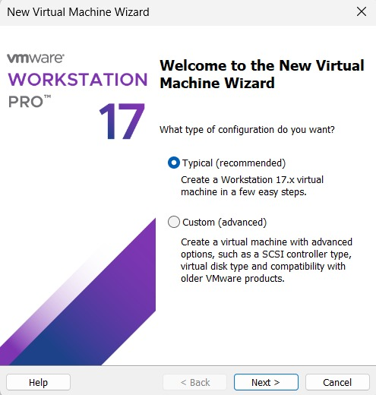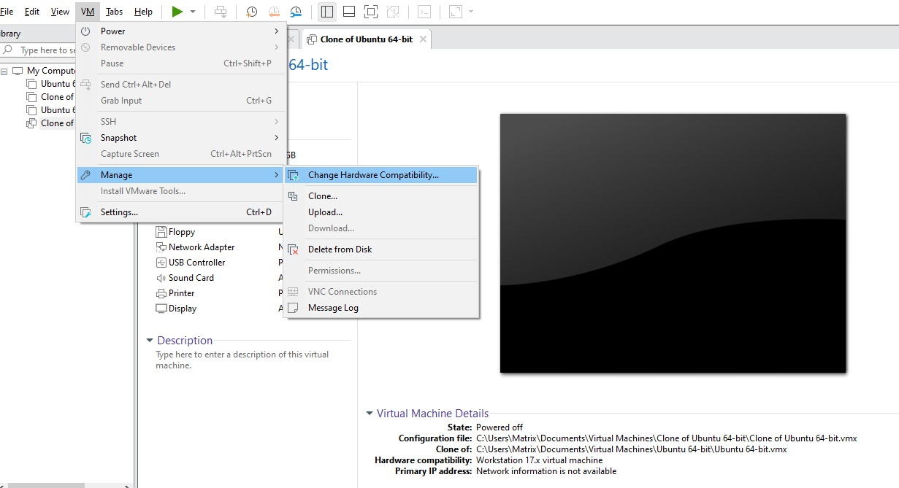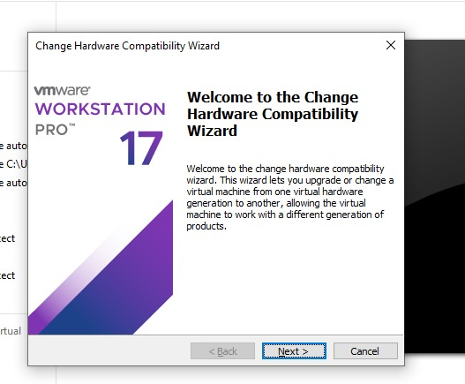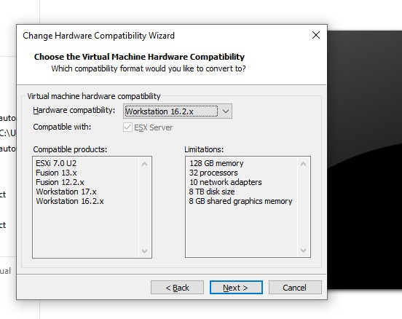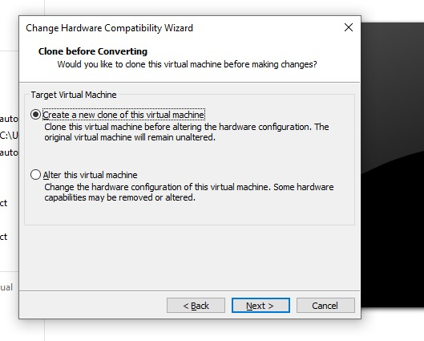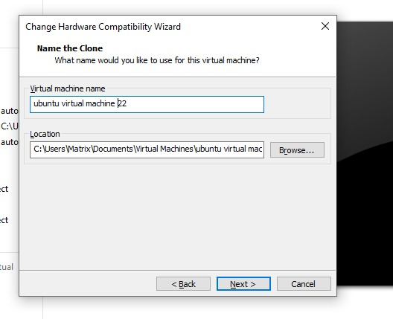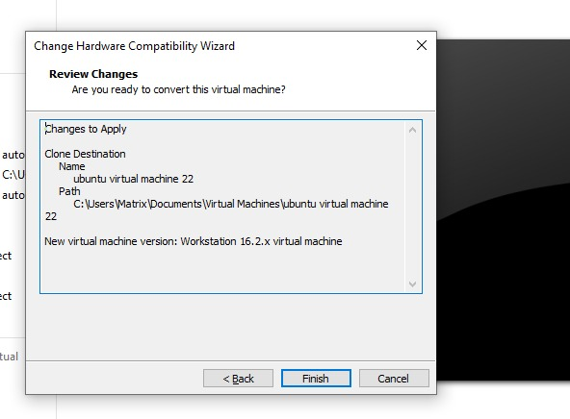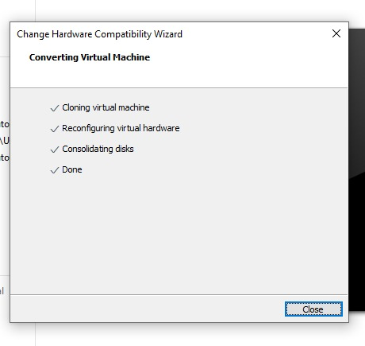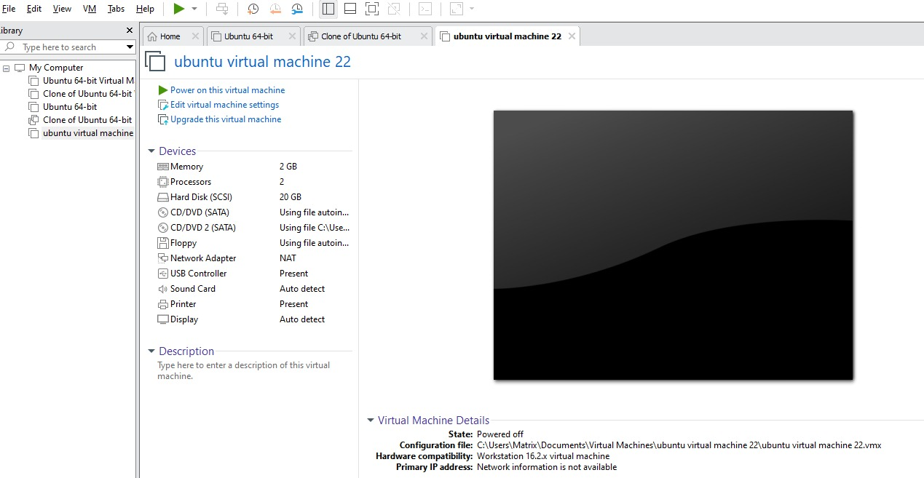Result:
The hardware compatibility of the VM was successfully changed to the selected VMware Workstation version, and the VM operated correctly after the upgrade.

