2.Create a simple cloud software application for Flight Reservation System using any Cloud Service Provider to demonstrate SaaS.

Aim
To design and deploy a simple Flight Reservation System as a cloud-based software using Zoho Creator, thereby demonstrating the concept of Software as a Service (SaaS).

Procedure
- Login to Zoho Creator with your Zoho account.
- Create a new application → Select “Create from Scratch”.
- Name the Application as Flight Reservation System.
- Design Forms for data entry:
- Passenger Details Form: Name, Age, Email, Phone.

- Flight Booking Form: Passenger Name (lookup), Source City, Destination City, Date of Journey, Preferred Time, Class (Economy/Business).
5. Create a Report to display all bookings in a table format with filters (by date, flight, city).
6. Publish the Application and generate a web link.
7. Test the System by submitting a new booking from the user interface

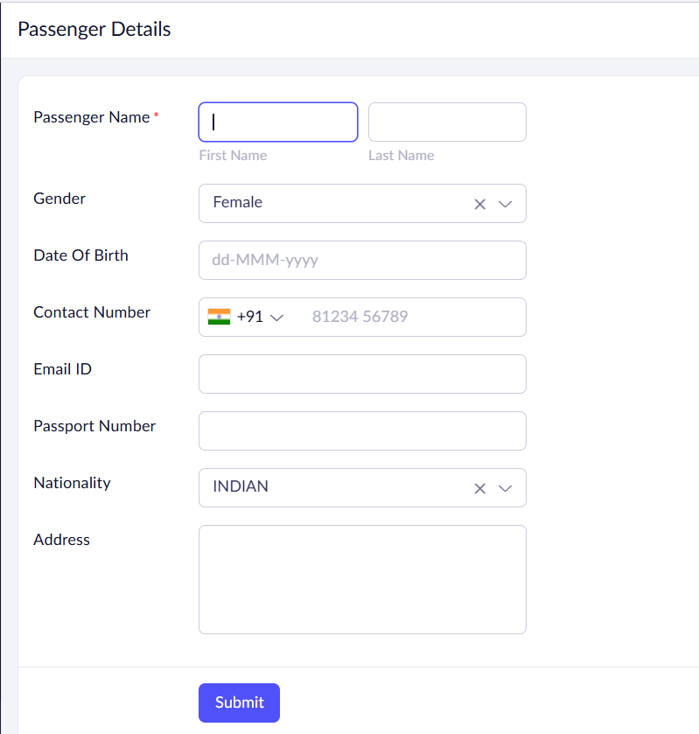
OUTPUT: 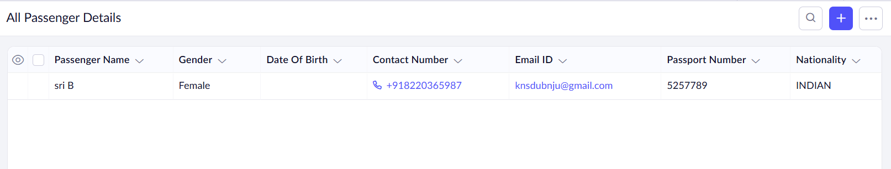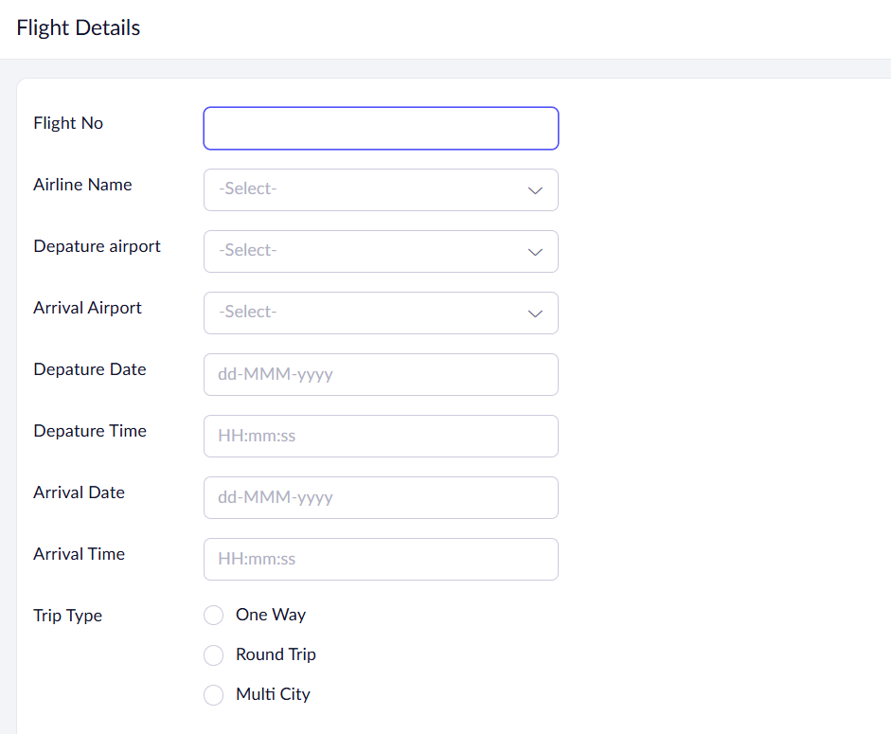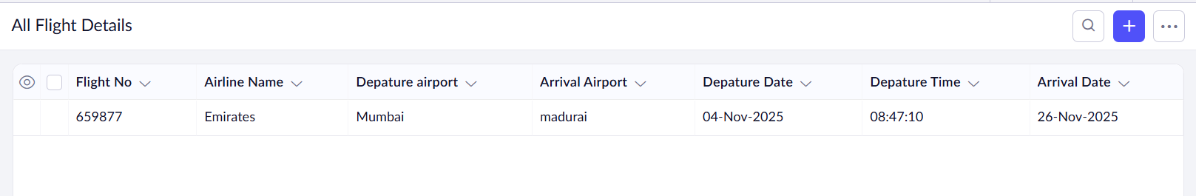
Result:
Thus the Flight Reservation System has been Sucessfully implemented using ZOHO Software

