ACTIVITY 11
NAME :Sharatha sree R COURSE: MOBILE COMPUTING
REG NO : 192421033 COURSE CODE: ITA0301

11. Design a wireframe for a mobile application that incorporates security measures using
Figma.

Aim: -
Using Figma design a wireframe for a mobile application (Bank app UI) that incorporates
security measures.

Procedure: -
1. open Figma
2. Create a new file
3. Select the Frames
4. Design Visual Elements
5. Make it Interactive
6. Add icons on the Frame
7. Incorporate Multimedia
8. Storyboard Animation
9. Review and edit the Prototype
10. Save and Share
Design: -
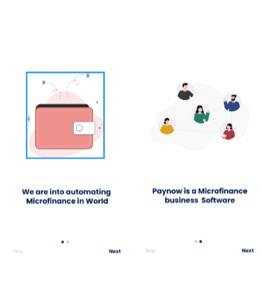
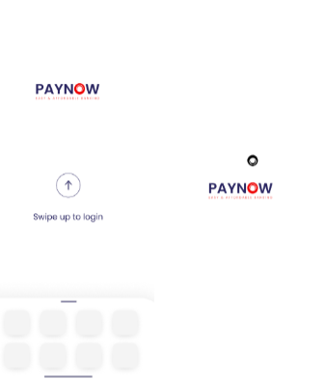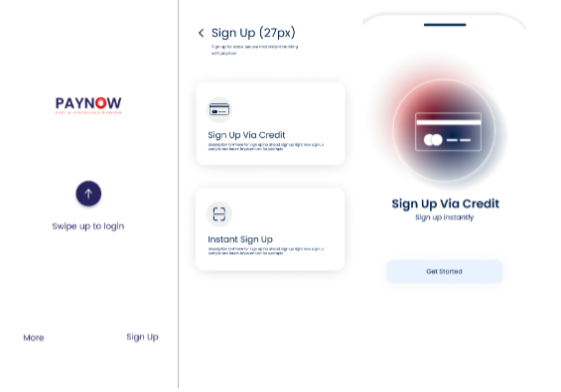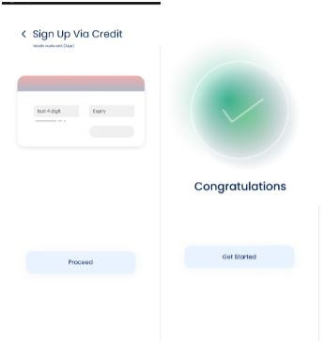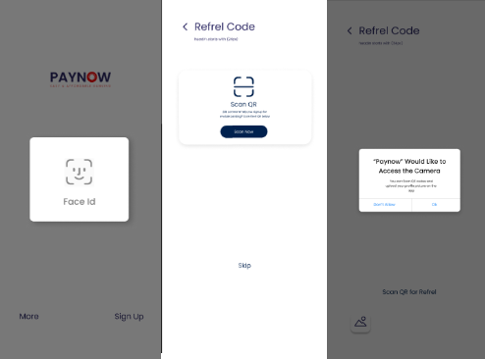
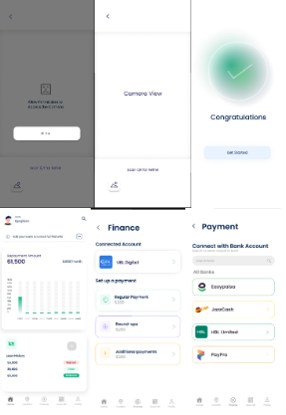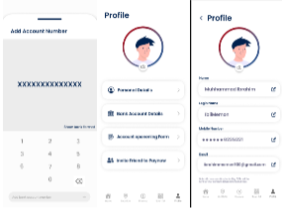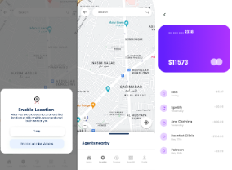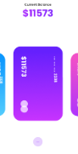
Prototype: -
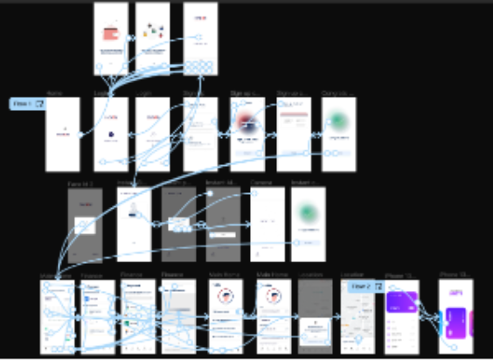

Result: -
A wireframe for a mobile application that incorporates security measures using Figma is created
and executed successfully

