ACTIVITY 12
NAME : Sharatha sree R COURSE: MOBILE COMPUTING
REG NO : 192421033 COURSE CODE: ITA0301

12. Use Figma to create an interactive diagram illustrating the evolution from 1G to 5G.
Aim: -
Design an interactive diagram illustrating the evolution from 1G to 5G using Figma.
Procedure: -
1. open Figma
2. Create a new file
3. Select the Frames
4. Fill in the content that is required for presentation
5. Design Visual Elements

6. Make it Interactive
7. Add Annotations and Explanations
8. Incorporate Multimedia
9. Storyboard Animation
11. Review and edit the Prototype
12. Save and Share
Design: -
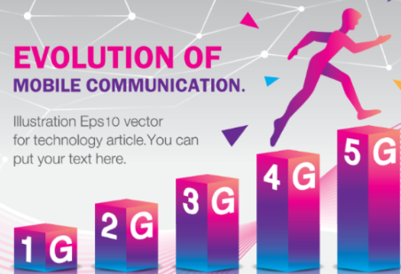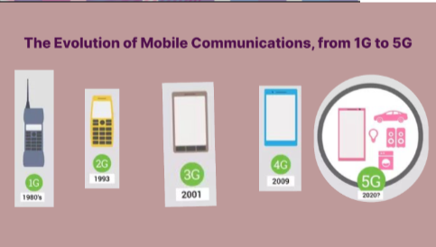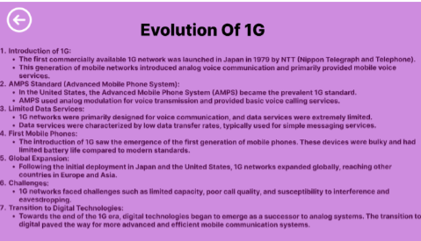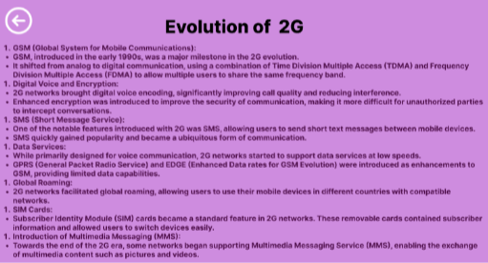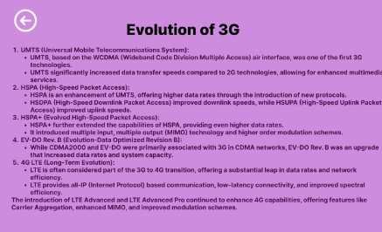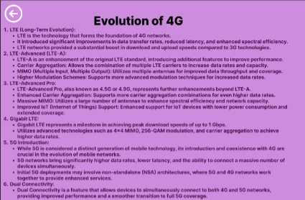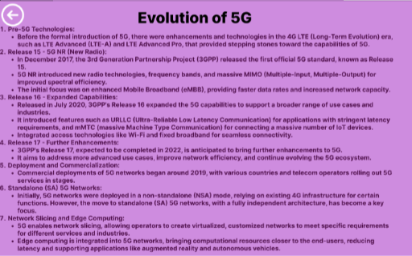

Prototype: -

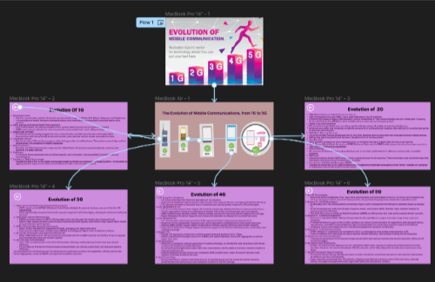
Result: -
Hence an interactive diagram illustrating the evolution from 1G to 5G in Figma is created and
executed successfully

