ACTIVITY 13

NAME : Sharatha sree R COURSE: MOBILE COMPUTING
REG NO : 192421033 COURSE CODE: ITA0301

13.Design an infographic in Figma comparing mobile communication and mobile
computing
Aim: -
Using Figma design an infographic comparing mobile communication and mobile computing
Procedure: -
1. open Figma
2. Create a new file
3. Select the Frames
4. Fill in the content that is required for presentation
5. Design Visual Elements
6. Make it Interactive
7. Add Annotations and Explanations
8. Incorporate Multimedia
9. Storyboard Animation
11. Review and edit the Prototype
12. Save and Share

Design: -
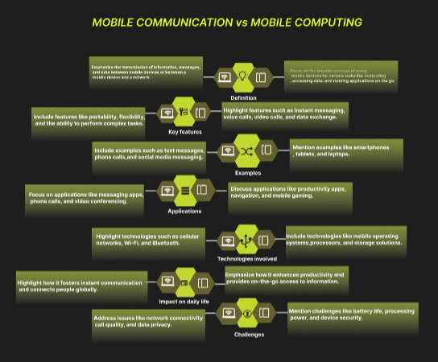
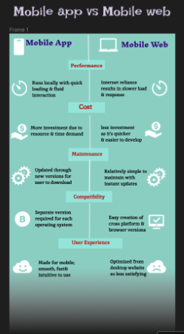
Result: -
An infographic design in Figma comparing mobile communication and mobile computing is
created successfully.

