ACTIVITY 8
NAME : Sharatha sree R COURSE: MOBILE COMPUTING
REG NO : 192421033 COURSE CODE: ITA0301

8. Create an infographic in Figma explaining the concept of Public Land Mobile Network
(PLMN).
Aim:
To create an infographic in Figma explaining the concept of Public Land Mobile Network
(PLMN).

Procedure:
1. Open Figma
2. Create a new file
3. Select the Frames
4. Fill in the content that is required for presentation
5. Design Visual Elements
6. Make it Interactive
7. Add Annotations and Explanations
8. Incorporate Multimedia
9. Storyboard Animation
10. Review and edit the Prototype
11. Save and Share
Design:
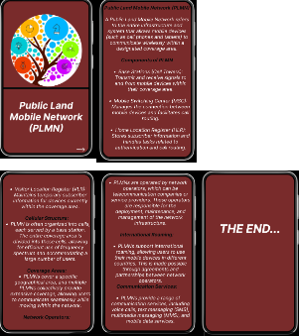

Prototype:
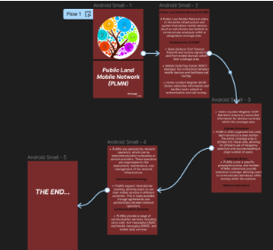

Result:
Hence created an infographic in Figma explaining the concept of Public Land Mobile Network
(PLMN).

