ACTIVITY 10
NAME : Sharatha sree R COURSE: MOBILE COMPUTING
REG NO : 192421033 COURSE CODE: ITA0301

10. Create a visual representation in Figma showcasing the differences between various
multiple access techniques.

Aim: To create a visual representation in Figma showcasing the differences between various
multiple access techniques.

Procedure:
1. Open Figma
2. Create a new file
3. Select the Frames
4. Fill in the content that is required for presentation
5. Design Visual Elements
6. Make it Interactive
7. Add Annotations and Explanations
8. Incorporate Multimedia
9. Storyboard Animation
10. Review and edit the Prototype
11. Save and Share

Design:
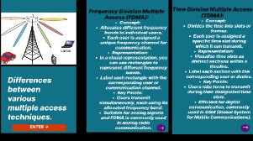
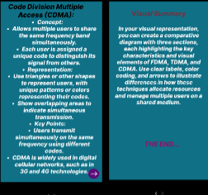
Prototype:
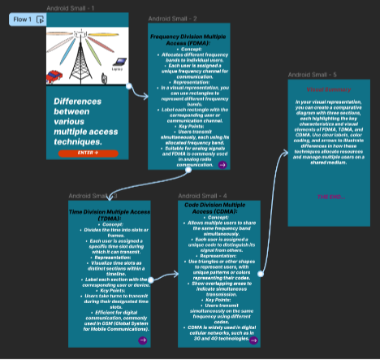
Result:
Hence created a visual representation in Figma showcasing the differences between various
multiple access techniques.

